The Pace of Life of Partial Migration

Scott Yanco, Nils Linek, Micheal Kearney, …, Martin Wikelski, Jesko Partecke

2022-08-22

## TODO:

* @Nils: fill in field methods, study area, data collection, data processing(?), etc…

## Introduction

* Life history is fundamental to ecology and evolution, blah blah.
  + Because life history, in its essence, is about the allocation of finite energy over finite time horizons, the POL theory posits that life history trade offs are physiologically/metabolically mediated
  + Examining the metabolic underpinning of POL has the added benefit of allowing us to measure the *strategy* rather than the outcome (e.g., a life table).
* Understanding if and how life history relates to behavioral phenotypes remains a key challenge in evolutionary ecology.
  + Such an understanding would help us make better predictions about the persistence or vulnerability of particular phenotypes under environmental change.
  + Furthermore, understanding how certain behavior types generate fitness promises to clarify how and why such behaviors emerge in the first place by describing both the ecological context and the evolutionary reward associated with such a behavior. -Some good examples with movement:
    - Campos Candela Ecol letters
    - Orr Spiegel sleepy lizards
    - The Corsican Blue Tit stuff
* Seasonal migration is one such behavior whose eco-evolutionary cause remains only poorly understood.
  + Review relevant lit here: Winger’s “Red Queen”, Zink papers, Yanco et al 2021, etc.
  + Futhermore, whether migratory behavior is consistently associated with a fast or slow pace of life is also debated:
    - Soriano-Redondo
    - Winger and Pegan
    - Wikelski stonechats
    - Yanco and Pierce, Anderson and Jetz (not mig specific)
* Therefore here we examine the metabolic dynamics across a full annual cycle for a partially migratory population of Blackbirds (*Turdus merla*). After controlling for differences in the metabolic cost of maintaining thermal homeostasis we examine individual metabolic at daily resolution for individuals that reside year-round in southern Germany and compare theese to birds that breed sympatrically with the resident population but overwinter in southern France.

## Methods/Results

# Libraries  
library(tidyverse)

## Warning: The packages `ellipsis` (>= 0.3.2) and `vctrs` (>= 0.3.8) are required  
## as of rlang 1.0.0.

## Warning: replacing previous import 'lifecycle::last_warnings' by  
## 'rlang::last_warnings' when loading 'tibble'

## Warning: replacing previous import 'ellipsis::check_dots_unnamed' by  
## 'rlang::check_dots_unnamed' when loading 'tibble'

## Warning: replacing previous import 'ellipsis::check_dots_used' by  
## 'rlang::check_dots_used' when loading 'tibble'

## Warning: replacing previous import 'ellipsis::check_dots_empty' by  
## 'rlang::check_dots_empty' when loading 'tibble'

## ── Attaching packages ─────────────────────────────────────────────────────────────────────────────────────────────────────────────────────────────────── tidyverse 1.3.0 ──

## ✓ ggplot2 3.3.0 ✓ purrr 0.3.4  
## ✓ tibble 3.0.1 ✓ dplyr 0.8.5  
## ✓ tidyr 1.0.2 ✓ stringr 1.4.0  
## ✓ readr 1.3.1 ✓ forcats 0.5.0

## ── Conflicts ────────────────────────────────────────────────────────────────────────────────────────────────────────────────────────────────────── tidyverse_conflicts() ──  
## x dplyr::filter() masks stats::filter()  
## x dplyr::lag() masks stats::lag()

library(ggplot2)  
library(mgcv)

## Loading required package: nlme

##   
## Attaching package: 'nlme'

## The following object is masked from 'package:dplyr':  
##   
## collapse

## This is mgcv 1.8-31. For overview type 'help("mgcv-package")'.

library(patchwork)  
  
# Color Pallette  
pal <- c("ws" = "#B1624EFF", "fm" = "#5CC8D7FF")

### Study area

Germany…

### Capture

Nils lived in a van and captured many birds…

### Biologgers

Nils did many bird surgeries…

### Full annual cycle metabolism

In order to compare metabolism between migrant and non-migrant blackbirds, we estimated daily metabolic rate for 61 individuals (17 migrants and 45 non-migrants) **why don’t these numbers sum correctly…?** for 2-210 days spanning fall capture dates to spring recaptures (mean 178.57 days). We estimated daily metabolic rate as a function of the observed average daily heart rate. To convert heart rate (in units of beats-per-minute) to Watts we first needed to estimate a function relating the two quantities. To do this, we subset the data to only non-migrant individuals and only included nocturnal periods of observation. Thus, this reduced data set only includes observations wherein metabolic activity (and heart rate) are expected to be related to basal metabolic rate plus thermoregulation. We then estimated the corresponding metabolic rate for these observations using the endotherm model (endoR function) from the nichemapr R package (Kearney XXXX). We supplied the model with observed ambient temperatures derived from [Nils insert here] as well as the observed body temperature recorded by the biologgers. The full set of input parameters for this model is included as Appendix A.

# NOT RUN  
conda activate nichemapr  
RScript ~/projects/blackbird_POL/src/workflow/night_ind.r

To estimate the functional relationship between the predicted metabolic output and observed heart rate we fit a generalized additive model (GAM) using the gam function from the mgcv R package (REF). The model included a smooth effect of Julian day to account for seasonal differences in e.g., body size, tissue anabolism/catabolism, etc. and a fixed effect of heart rate. To account for individual heterogeneity we included a random slope for heart rate nested within individual. We then used the predict function (excluding random effect variance) to estimate predicted metabolic rate from the full heart rate dataset, resulting in full annual metabolic curves for all individuals (Fig 2).

#observed met from hr  
nd <- tot_out_df %>%   
 # filter(strat == "ws") %>%   
 # select(heartrate, juian.bird) %>%   
 rename(hrt = heartrate)   
  
p <- predict(fm.m,  
 newdata = nd,  
 exclude = c("s(logger.id,hrt)","s(logger.id)"))  
  
pred <- cbind(nd, p) %>%   
 mutate(tot_min_therm = p-metab,  
 jbf = as.factor(julian.bird))   
  
#summarize across individuals (within each strategy-day)  
pred.sum <- pred %>%   
 group_by(strat, julian.bird) %>%   
 summarize(mhrt = mean(hrt),  
 mp = mean(p),  
 mmet = mean(metab),  
 mtemp = mean(temp),  
 mdiff = mean(tot_min_therm))

ggplot(pred) +   
 geom_line(aes(x=julian.bird, y=p, color = strat, group = band), alpha = 0.5) +  
 scale_color_manual(values = pal, labels = c("Residents", "Migrants"),  
 name = "Migratory Strategy") +  
 ylab("Metabolic Rate (W)") +  
 xlab("Julian Bird") +  
 theme_minimal()

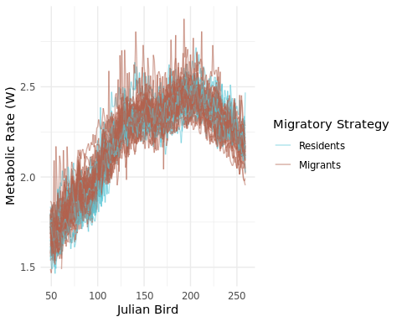

Figure 2. Estimated metabolic rate for 61 blackbirds

ggplot(pred) +   
 geom_boxplot(aes(x=as.factor(julian.bird), y=p, color = strat)) +  
 scale_color_manual(values = pal, labels = c("Residents", "Migrants"),  
 name = "Migratory Strategy") +  
 ylab("Metabolic Rate (W)") +  
 xlab("Julian Bird") +  
 theme_minimal()

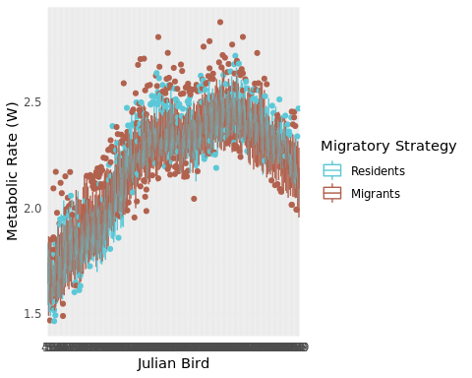 This analysis reveals no significant difference in total metabolic expenditure between the two migratory strategies. **[confirm with Nils that I’m analyzing this correctly - currently just visually assessing overlap in box plots. The approach here should match what he’s doing with heart rate in his other paper.]** However, because migrants and residents experience different weather regimes during migration and over-wintering, metabolic expenditures for thermoregulation may differ between the strategies. Moreover, differences in thermoregulatory expenditures between the strategies could result in differences in “metabolic remainder: (i.e., the metabolic activity after controlling for basal metabolic rate and thermoregulation) and thus mask possible differences in POL. Therefore we controlled for potential differences in thermoregulatory metabolism by again using the endoR function of the nichemapr package to estimate basal metabolic rate + thermoregulatory metabolism based on the observed ambient and body temperatures for the 61 blackbirds. Input parameters matched those supplied to the nighttime-only analysis (Appendix A) with the exception of solar irradiation. We estimated solar irradiation using the micro_global function from the nichemapr package which allows us to estimate daily solar irradiation for any location on earth. We used the approximate location of the shared breeding grounds (8.96691, 47.745237) for all individuals. The differing weather contexts during the wintering period resulted in markedly different metabolic costs of thermoregulation between the two strategies, with migrants expending substantially less energy (Fig. 3A) to maintain approximately equivalent body temperatures (Fig. 3B) **[@Nils we could model this directly but I can't remember if you're already doing this as part of you current paper - if you are we should just reference that here]** **[NB for the solar irradiation, we are currently using Radolfzell as the location for all birds - we probably want to match the same approach we use for temperature here; that said. this approach is conservative, so once we give the migrants even more solar energy, it will further reduce the metabolic costs of thermoregulation and thuis magnify the differences in the “metabolic remainder”…]**

# NOT RUN  
conda activate nichemapr  
RScript ~/projects/blackbird_POL/src/workflow/met_model_full.r

p1 <- ggplot(pred) +   
 geom_boxplot(aes(x=as.factor(julian.bird), y=metab, color = strat)) +  
 scale_color_manual(values = pal, labels = c("Residents", "Migrants"),  
 name = "Migratory Strategy") +  
 ylab("Thermoregulatory \n Metabolic Rate (W)") +  
 xlab("Julian Bird") +  
 theme_minimal()  
  
p2 <- ggplot(pred) +   
 geom_boxplot(aes(x=as.factor(julian.bird), y=temp, color = strat)) +  
 scale_color_manual(values = pal, labels = c("Residents", "Migrants"),  
 name = "Migratory Strategy") +  
 ylab("Body Temperature (C)") +  
 xlab("Julian Bird") +  
 theme_minimal() +  
 theme(legend.position = "none")  
  
p1 / p2 + plot_annotation(tag_levels = 'A')

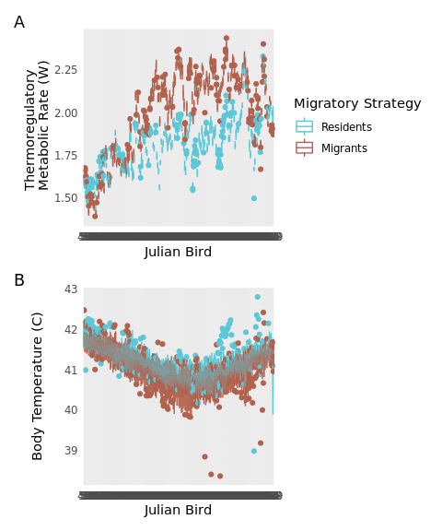

Fig. 3. A) Daily metabolic rate for basal metabolism and thermoregulation only for both migrant and resident blackbirds; B) Daily observed body temperatures for both migrant and resident blackbirds

To calculate the daily individual “metabolic remainder”, for each individual we subtracted the daily estimated metabolic expenditure for basal metabolism + thermoregulation from the estimated total daily metabolic rate. This metabolic remainder, then, describes the metabolic activity directed toward all other biological processes after controlling for basal metabolic rates and differential thermoregulatory costs between the two strategies.

ggplot(pred)+  
 geom_boxplot(aes(x = jbf, y = tot_min_therm, color = strat )) +  
 scale_color_manual(values = pal, labels = c("Residents", "Migrants"),  
 name = "Migratory Strategy") +  
 ylab("Metabolic Remainder (W)") +  
 xlab("Julian Bird") +  
 theme_minimal()

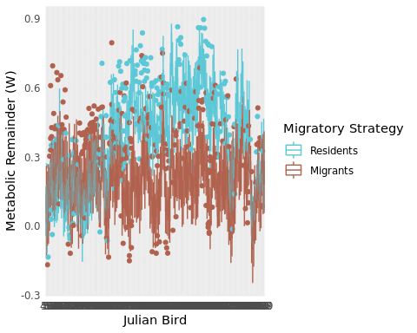

Fig. 4. Boxplot of daily metabolic remainder for migrant and resident blackbirds. metabolic remainder is the estimated daily metabolic expenditure after removing basal metabolism and themoregulatory expenses.

We find significant differences in the metabolic remainder across the two migratory strategies (Fig. 4. Specifically, between days XX and XX **[find a good way to calc this…]** migrants display substantially higher metabolic remainder (2-3X the metabolic remainder observed in year-round residents) suggesting a faster POL.

**[model this? could fit a gam with smooth by JD interacting tih strategy, RE of individual]**

We also considered whether the observed differences in metabolic remainder resulted in differences in body condition at the start of the breeding season. To do this, we subset our data to only include observations following the onset of spring arrival of migrants. We calculated body condition as $\text{body mass (g)}\text{tarsus length (mm)}$. We modeled body condition using the gam function in mgcv and considered it a smooth function of Julian date (to account for phenological effects on body mass), and a fixed effect of the interaction between sex and migratory strategy. We accounted for individual variation by including a random intercept by individual.

**[@Nils, should we right truncate too? i.e., are there some observations that are too far into the breeding season to be useful? Also, can we better control for days since arrival than just raw Julian date?]**

bodymass1 <- bodymass %>%   
 ungroup() %>%   
 left_join(tarsus) %>%   
 mutate(period = case_when(julian.bird < 150 ~ "pre",  
 julian.bird >= 150 ~ "post")) %>%   
 mutate(birdid.fk = factor(birdid.fk),  
 bc = bodymass/tarsus) %>%   
 filter(period == "post")

## Joining, by = c("birdid.fk", "non.breeding.strategy", "sex", "julian.bird")

fm.bm <-gam(bc ~ s(julian.bird) + non.breeding.strategy*sex + s(birdid.fk, bs = "re"), data = bodymass1, method = "REML")  
summary(fm.bm)

##   
## Family: gaussian   
## Link function: identity   
##   
## Formula:  
## bc ~ s(julian.bird) + non.breeding.strategy * sex + s(birdid.fk,   
## bs = "re")  
##   
## Parametric coefficients:  
## Estimate Std. Error t value Pr(>|t|)   
## (Intercept) 2.66553 0.04500 59.236 <2e-16 ***  
## non.breeding.strategyws 0.02509 0.05493 0.457 0.649   
## sexMale -0.05342 0.07295 -0.732 0.467   
## non.breeding.strategyws:sexMale -0.11485 0.08531 -1.346 0.183   
## ---  
## Signif. codes: 0 '***' 0.001 '**' 0.01 '*' 0.05 '.' 0.1 ' ' 1  
##   
## Approximate significance of smooth terms:  
## edf Ref.df F p-value   
## s(julian.bird) 6.074 7.177 3.625 0.00238 **  
## s(birdid.fk) 2.762 56.000 0.052 0.38253   
## ---  
## Signif. codes: 0 '***' 0.001 '**' 0.01 '*' 0.05 '.' 0.1 ' ' 1  
##   
## R-sq.(adj) = 0.363 Deviance explained = 46.6%  
## -REML = -19.041 Scale est. = 0.02088 n = 74

# calc cis using t distribution and SEs from the VCOV  
Vb <- vcov(fm.bm, unconditional = TRUE)  
se <- sqrt(diag(Vb))  
  
# rdf <- df.residual(fm.bm)  
# mult <- qt(0.975, df = rdf)  
#   
# cis <- se*mult  
# fm.bm2 <-lmer(bodymass ~ period + non.breeding.strategy*sex + (1|birdid.fk), data = bodymass1)  
# summary(fm.bm2)

We found no differences in body mass at the onset of the breeding season for migratory strategy (coefficient +/- SE: 0.0250851 $±$ 0.0601827), sex (coefficient +/- SE: -0.0534162 $±$ 0.0782538), or the interaction between the two (coefficient +/- SE: -0.1148465 $±$ 0.0928519) (Fig. 5).

ggplot(bodymass1) +  
 geom_boxplot(aes(x=sex, y = bc, fill = non.breeding.strategy)) +   
 scale_fill_manual(values = pal, labels = c("Residents", "Migrants"),  
 name = "Migratory Strategy") +  
 ylab("Body Condition (Mass/Tarsus Length)") +  
 xlab("Sex") +  
 theme_minimal()

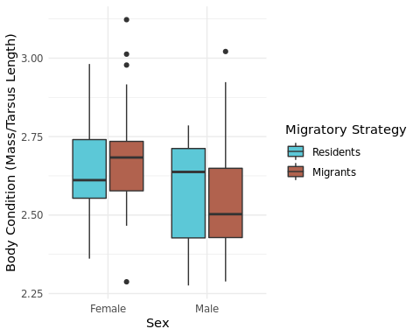

Fig. 5. Breeding season body condition (bodymass/tarsus length) by sex and migratory strategy

**DO WE WANT TO LEAVE THE ANLYSIS HERE OR STILL AIM FOR CONNECTING TO A DEB?**  
*Need to consider the ms complexity, timing of the availability of the DEB extension to nichemapr, target journal, as well as what exactly we could expect to get from the addition of a DEB etc.*  
*My $0.02: I think it would be nice to be able to point quantitatively to where we expect this to go - for which the DEB might be nice. That said, I suspect it might be very difficult to sensibly parameterize the DEB because the costs of migration itself are going to be very difficult to capture, especially those periods of tissue hypertrophy and atrophy that pre-/ante-cede migrations themselves and without those quantitatively account for, I’m not positive the DEB is going to be any more convincing than reasoning by logic alone… (see the bullet points in the discussion as of now)*

## Discussion

* We observed clear differences in the metabolic dynamics during the over wintering period between migrants and year-round residents.
  + Differences in the weather context to which individuals were exposed during the wintering period resulted in markedly different metabolic costs of maintaining body temperature set point, despite approximately equivalent observed body temperatures between the two strategies.
  + This resulted in substantial differences in the ’metabolic remainder”. The metabolic activity of migrants was 2-3X higher than that of residents during the wintering period by virtue of milder weather conditions.
* Clutch size in Blackbirds is markedly invariant and there is no evidence of differential reproductive investment between the two strategies **[@Nils please confirm/elaborate - this is based on a super quick read of some of the lit]**
  + Therefore, it is unlikely that this excess metabolic activity is being used to increase annual fecundity.
  + Instead, we suggest that this increase metabolic activity is used to pay for the costs of migration.
  + While there is debate about the direct costs of migration itself, clearly migration requires substantial physiological adaptation which are metabolically expensive - this metabolic remainder which is enabled by the milder conditions that migration provides, in turn, pay for the costs of migrating in the first place.
  + Interestingly, this results in indistinguishable cumulative metabolic throughput (though with varying dynamics - ref Nils’ in prep ms here).
* There are multiple theoretical explanations for the maintenance of partial migration as an evolutionary stable strategy within an admixing population. (refs to Hannah Kokko work, Taylor and Norris, my Ecology paper, etc). All essentially imply different pathways to equivalent individual performance (though many invoke density dependence to get there).
  + Because we assume annual reproductive investment to be equivalent, life history theory would then predict roughly equivalent survival risks across strategies.
  + Intepretting top line metabolic rate as a rough proxy for pace of life, total metabolic rate between residents and migrants in this study were indistinguishable, as predicted by theory.
  + However, the metabolic dynamics, and specifically the relative allocation to metabolic objectives varied between these strategies such that the beneficial conditions offered by migration balance out the energetic costs of the behavior to generate equivalent individual performance.
    - This finding uncovers a potential physiological mechanism by which individual heterogeneity in behavior type (migration) can emerge even when life histroy strategy does not.
    - Furthermore this suggests a novel explanation for the emergence and maintenance of partial migration - namely that the net costs-benefits of the two strategies are equivalent while the ration between costs/benefits is not. **[make sure this really is novel…]**
* Something about how this can also help us understand the location of seasonal ranges:
  + Blackbirds are wintering in a location that exactly allows them to balance the cost-benefit equation of migration. If they were able to make that net value exceed that of residency then we would expect (all else being equal) migration to take over as the dominant or exclusive phenotype.
  + Clearly there are other factors influencing this equation, especially in other systems where extrinsic mortality is of particularly high risk, or migratory routes involving truly risky flights (e.g., oceanic crossings).
  + However, that all being said, this is more in keeping with a Winger Red Queen type explanation for the emergence and maintenance of migration that it is an “optimal annual routine” explanation.

## Acknowledgements

Thanks for all the fish.

## Literature Cited

## Appendices