This homework is about to classify sentiment, the original image looks like:

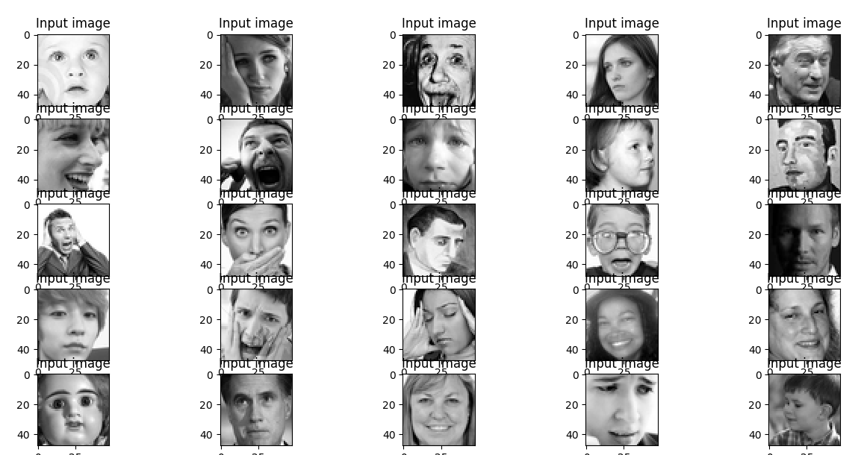

I’m lazy, but just use CPU is too slow, so finally, I make up my mind to install tensorflow-gpu.

I really don't know why last time I failed to install cuda and cudnn. But this time, everything goes so smooth like dream. Anyway, nice to see this:



But, everything’s fine in HW2, but while doing HW3, new problems, I don't know if it’s because of small RAM?

When I run it on Spyder, it just tell me kernel died, but no reason

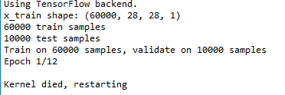

So run it in Anaoconda prompt:

o-oh, can’t find the history, but it tell me the reason is something like:

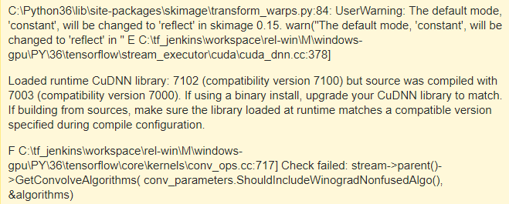

The solution is:



<https://stackoverflow.com/questions/49489572/unable-to-run-tensorflow-keras-with-gpu/49496788#49496788>

Link to cuDNN:

<https://developer.nvidia.com/rdp/cudnn-download>

after download cuDNN 7.0.5, unzip it, and replace the folders in CUDA with the unzipped folders:

unzipped cuDNN

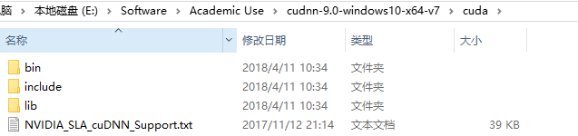

Copy them to CUDA folder,

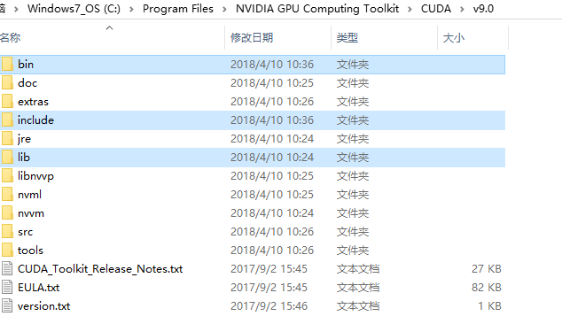

Then, IT WORKS!!!!!!!!!! I want to CRY!!!!



But, new problems come:

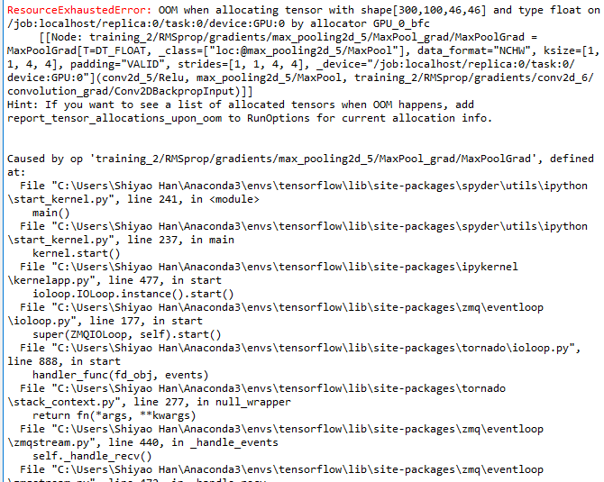

!!!!!!!!!!!!!

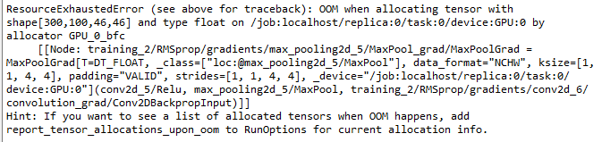

Solution:

1. Decrease the size of batch (300->100)
2. Decrease the number of filters

Some intermediate result:

Th

