目前查阅大量数据集，发现最合适的是TCIA（造影数据）+ GDC Data Portal（临床与病理数据），但数据很难对齐，目前找到的最好的已经整合好的是汉考克|多模态头颈癌数据集，十分齐全，763个样本4.5TB（生成的json和数据集中的样本例子放在最后了）

主要工作集中在医学肿瘤学指南研究、癌症医学影像数据集探索、以及学术会议追踪等方面。
- 临床肿瘤学指南与文献研读
NCCN（美国国家综合癌症网络）：使用了NCCN指南导航和LogicNets专家系统。重点研读了前列腺癌的筛查与检测指南（prostate.pdf, prostate_detection.pdf）、结直肠癌筛查指南以及骨肿瘤指南的更新解读。
ASCO（美国临床肿瘤学会）：重点查阅了转移性去势抵抗性前列腺癌、阴茎癌、早期与转移性乳腺癌等系统性治疗及放射治疗指南。
ACR（美国放射学会）：查阅了其适当性标准（Appropriateness Criteria）的简介。
国内指南与文献数据库：查阅了国家卫健委的《结直肠癌诊治规范》，以及《中国抗癌协会乳腺癌诊治指南与规范（2026年版）》。在文献检索方面，访问了UpToDate临床决策系统、PubMed和EBSCO等研究数据库。
- 癌症医学影像数据集（TCIA）
广泛检索并浏览了多种癌症类型的医学影像数据集
涵盖了乳腺癌（如QIN-BREAST-02、SLN-BREAST、杜克大学MRI及超声基准数据集等）、前列腺癌（PROSTATE-DIAGNOSIS, CMB-PCA）、胶质母细胞瘤（CFB-GBM）、结直肠癌（CMB-CRC）、胃癌（CPTAC-STAD）以及肺部病变（LIDC-IDRI、脑转移肺MRI等）。访问了UCSF ChimeraX主页，以及GitHub上与医学影像信息学相关的数据组织仓库（ImagingInformatics/hackathon-dataset）。查看了基于MIMIC-IV数据库关于动脉穿刺（aline）研究的复现代码项目（alistairewj/mimic-iv-aline-study）
{
"case_id": "HNC_Multimodal_Patient_1",
"metadata": {
"patient_info": "65岁男性，既往吸烟史 [cite: 2]。确诊为右侧下咽癌伴双侧结节性甲状腺肿 [cite: 50, 52]。",
"pathway_type": "Advanced_Hypopharyngeal_Cancer_Surgery_to_Adjuvant_Pathway",
"evaluation_guidelines": "NCCN Head and Neck Cancers Guidelines"
},
"reasoning_trace": [
{
"step": 1,
"task": "术前临床分期与手术指征评估 (Pre-op Staging & Surgical Indication)",
"modality": "Clinical History & Laboratory (临床病史与实验室检查)",
"input_data": "[patient_1.docx - Medical history & Laboratory]",
"step_1_findings": {
"section_name": "客观特征提取 (Objective Findings)",
"content": "临床及超声/CT影像学提示为右侧下咽喉癌，分期为 cT3 cN2b [cite: 50, 51]。患者双侧甲状腺存在大于 2 cm 的结节性甲状腺肿 [cite: 52]。术前实验室凝血功能 (PT 100%, aPTT 25.6s)、血常规 (Hb 15.4 g/dl, 淋巴细胞 1.26 x10^3/µl) 及肾功能 (肌酐 0.93 mg/dl) 均处于可接受的手术耐受范围内 [cite: 8]。未见初始远处转移 (primarily_metastasis: no) [cite: 2]。"
},
"step_2_thought_process": {
"section_name": "临床推理链 (Step-by-Step Reasoning)",
"content": "1. 肿瘤负荷与分期评估：患者临床分期为 cT3 cN2b，属于局部晚期头颈部鳞癌，存在多发或显著的颈部淋巴结转移风险。2. 治疗意图与方案选择：经详细讨论，确立了以治愈为目的 (curative intent) 的首选局部手术治疗策略 [cite: 2, 53]。3. 手术范围推导：鉴于原发灶范围及双侧甲状腺结节，手术需大范围切除以保证切缘安全。干预推导：具备明确的手术指征，需执行喉全切除、部分咽切除、双侧颈淋巴结清扫及甲状腺半切除术 [cite: 54]。"
},
"step_3_impression": {
"section_name": "诊断意见 (Impression)",
"content": "右侧下咽喉癌 (cT3 cN2b)，伴双侧结节性甲状腺肿，具备根治性手术指征 [cite: 51, 52, 54]。"
},
"step_4_management": {
"section_name": "下一步干预 (Next Action)",
"content": "实施喉全切除术伴部分咽切除术，双侧颈部淋巴结清扫术，及左侧甲状腺半切除术 [cite: 54]。"
}
},
{
"step": 2,
"task": "术中探查与冰冻病理评估 (Intraoperative Exploration & Frozen Section)",
"modality": "Surgery Report (手术报告文本)",
"input_data": "[patient_1.docx - Surgery report]",
"step_1_findings": {
"section_name": "客观特征提取 (Objective Findings)",
"content": "术中探查发现右侧颈部 II、III 区至 IV 区存在广泛的转移性淋巴结融合团块，与周围组织粘连紧密，分离颈内静脉困难，且向内侧延伸至迷走神经 [cite: 71, 72, 73]。左侧甲状腺叶突出且结节外观可疑，遂行左侧甲状腺半切除术 [cite: 93]。术中对肿瘤标本进行边缘采样并送冰冻切片，冰冻病理提示切缘无肿瘤细胞 (tumor-free resection margin) [cite: 105, 106]。"
},
"step_2_thought_process": {
"section_name": "临床推理链 (Step-by-Step Reasoning)",
"content": "1. 术中局部侵犯评估：颈部广泛的转移性融合团块证实了术前 N2b 的重度淋巴结负荷，且表现出明显的囊外侵犯及周围组织粘连特征。2. 神经血管保护：尽管粘连紧密，术中仍成功进行了迷走神经及舌下神经的游离和保护 (Neurolysis and re-embedding)，避免了严重的术后神经功能障碍 [cite: 74, 86]。3. 切缘评估：术中冰冻切片确认切缘阴性是局部晚期头颈肿瘤手术成功的核心前提。干预推导：基于冰冻切片提示的 R0 状态 [cite: 106]，可安全结束肿瘤切除阶段，进行咽部重建与缝合，并等待最终常规石蜡病理学报告以制定后续方案。"
},
"step_3_impression": {
"section_name": "诊断意见 (Impression)",
"content": "局部晚期下咽癌伴广泛右颈淋巴结转移团块，术中冰冻切片提示切缘阴性 (R0 状态) [cite: 71, 106]。"
},
"step_4_management": {
"section_name": "下一步干预 (Next Action)",
"content": "完成咽部 T 型缝合及造口重建，放置引流，术后继续抗生素治疗五天 [cite: 112, 116, 120]；等待最终组织病理学与多模态免疫微环境 (TMA) 结果以决定辅助治疗。"
}
},
{
"step": 3,
"task": "术后大体病理与高危因素确诊 (Post-op Pathology & High-Risk Assessment)",
"modality": "Pathology Report & Multimodal Slides (大体病理学与数字病理全切片)",
"input_data": "[patient_1.docx - Pathology report, Slides 10-42]",
"step_1_findings": {
"section_name": "客观特征提取 (Objective Findings)",
"content": "原发肿瘤部位为下咽，组织学类型为基底细胞样鳞状细胞癌 (SCC_Basaloid)，浸润深度高达 19 mm，肿瘤分级为 G3 (低分化) [cite: 4]。病理分期上调为 pT4a pN2b [cite: 4]。切除的 61 枚淋巴结中有 3 枚阳性 [cite: 4]。检出多重极高危病理特征：存在结节外侵犯 (Perinodal invasion: yes) 和脉管侵犯 (Lymphovascular invasion: yes) [cite: 4]。虽然整体切除状态为 R0，但最近切缘距离小于 0.1 cm [cite: 4]。"
},
"step_2_thought_process": {
"section_name": "临床推理链 (Step-by-Step Reasoning)",
"content": "1. 分期与分级评估：病理证实为 pT4a pN2b G3 的基底细胞样鳞癌，属于侵袭性极强、局部晚期的病变。2. 核心高危特征锁定：根据 NCCN 指南，淋巴结包膜外侵犯 (Perinodal invasion) 和切缘极度狭窄 (<0.1 cm，虽属 R0 但临床视为极高危的 close margin) [cite: 4] 是头颈部鳞癌术后局部复发和远处转移的绝对高危因素。此外，脉管侵犯 (L: yes) [cite: 4] 进一步增加了微转移风险。3. 辅助治疗策略推导：对于具备包膜外侵犯和切缘不足特征的局部晚期下咽癌患者，单纯的辅助放疗不足以控制复发风险，【强烈推荐】必须在术后采用同步放化疗 (Adjuvant Radiochemotherapy) 作为标准化补救及维持策略。"
},
"step_3_impression": {
"section_name": "诊断意见 (Impression)",
"content": "下咽基底细胞样鳞状细胞癌，病理分期 pT4a pN2b G3，伴淋巴结包膜外侵犯及极近切缘 (<0.1cm) [cite: 4]。"
},
"step_4_management": {
"section_name": "下一步干预 (Next Action)",
"content": "启动多学科肿瘤会诊 (MDT)，制定以治愈为目的的术后辅助同步放化疗方案 [cite: 2]。"
}
}
],
"gt_final_management": {
"section_name": "最终综合治疗方案 (MDT Final Management Plan)",
"content": "患者确诊为局部晚期下咽基底细胞样鳞癌 (pT4a pN2b G3) [cite: 4]。鉴于病理证实存在淋巴结包膜外侵犯、脉管侵犯及不足 0.1 cm 的高危安全边缘 [cite: 4]，MDT 最终制定如下方案：\n1. 辅助放射治疗：实施治愈性经皮外照射放疗 (Percutaneous radiotherapy) 以控制局部肿瘤床及颈部引流区 [cite: 2]。\n2. 辅助全身系统性治疗：为强化放疗敏感性并控制远处微转移风险，联合使用氟尿嘧啶与顺铂 (Fluorouracil + Cisplatin) 的全身化学治疗 [cite: 2]。\n3. 长期随访：患者经此辅助同步放化疗 (Adjuvant radiochemotherapy) 后，随访期内未见肿瘤复发及进展 (recurrence: no, progress_1: no) [cite: 2]，长期生存状态良好 [cite: 2]。"
}
}

两日工作：

。

临床数据
year_of_initial_diagnosis | 2015
age_at_initial_diagnosis | 65
sex | male
smoking_status | former
primarily_metastasis | no
survival_status | living
survival_status_with_cause | living
days_to_last_information | 2258
first_treatment_intent | curative
first_treatment_modality | local surgery
days_to_first_treatment | 28
adjuvant_treatment_intent | curative
adjuvant_radiotherapy | yes
adjuvant_radiotherapy_modality | percutaneous radiotherapy
adjuvant_systemic_therapy | yes
adjuvant_systemic_therapy_modality | fluorouracil + cisplatin
adjuvant_radiochemotherapy | yes
recurrence | no
progress_1 | no
Pathology report
primary_tumor_site | Hypopharynx
pT_stage | pT4a
pN_stage | pN2b
grading_hpv | G3
hpv_association_p16 | not_tested
number_of_positive_lymph_nodes | 3
number_of_resected_lymph_nodes | 61
perinodal_invasion | yes
lymphovascular_invasion_L | yes
vascular_invasion_V | no
perineural_invasion_Pn | no
resection_status | R0
resection_status_carcinoma_in_situ | CIS Absent
carcinoma_in_situ | no
closest_resection_margin_in_cm | <0.1
histologic_type | SCC_Basaloid
infiltration_depth_in_mm | 19
Laboratory
Results of laboratory tests performed in the context of the patient's surgery. For each analyte, the corresponding parameter group and LOINC code is given.
Analyte | Value | Unit | Group | LOINC | LOINC Code
aPPT | 25.6 | s | Routine | Activated partial thromboplastin time (aPTT) in Blood by Coagulation assay | 3173-2
Basophils | 0.02 | x10^3/µl | Hematology | Basophils [#/volume] in Blood | 26444-0
Basophils % | 0.3 | % | Hematology | Basophils/100 leukocytes in Blood | 30180-4
Calcium | 2.52 | mmol/l | Mineral; bone; joint; connective tissue | Calcium [Moles/volume] in Serum or Plasma | 2000-8
Chloride | 106 | mmol/l | Electrolytes - single valence | Chloride [Moles/volume] in Serum or Plasma | 2075-0
Creatinine | 0.93 | mg/dl | Renal function | Creatinine [Mass/volume] in Serum or Plasma | 2160-0
Eosinophils | 0.06 | x10^3/µl | Hematology | Eosinophils [#/volume] in Blood | 26449-9
Eosinophils % | 0.9 | % | Hematology | Eosinophils/100 leukocytes in Blood | 26450-7
Erythrocytes | 5.29 | x10^6/µl | Hematology | Erythrocytes [#/volume] in Blood | 26453-1
Glomerular filtration rate | 60.0002 | ml/min | OG | Glomerular filtration rate/1.73 sq M.predicted by Creatinine-based formula (MDRD) | 33914-3
Granulocytes | 4.86 | x10^3/µl | Hematology | Granulocytes [#/volume] in Blood | 30394-1
Granulocytes % | 72 | % | Hematology | Granulocytes/100 leukocytes in Blood by Automated count | 19023-1
Hematocrit | 43.4 | % | Hematology | Hematocrit [Volume Fraction] of Blood | 20570-8
Hemoglobin | 15.4 | g/dl | Hematology | Hemoglobin [Mass/volume] in Blood | 718-7
Immature Granulocytyes | 0.7 | % | Hematology | Granulocytes Immature/100 leukocytes in Blood | 38518-7
INR | 0.89 |  | Routine | INR in Blood by Coagulation assay | 34714-6
Leukocytes | 6.75 | x10^3/µl | Hematology | Leukocytes [#/volume] in Blood | 26464-8
Lymphocytes | 1.26 | x10^3/µl | Hematology | Lymphocytes [#/volume] in Blood | 26474-7
Lymphocytes % | 18.7 | % | Hematology | Lymphocytes/100 leukocytes in Blood | 26478-8
MCH | 29.1 | pg | Hematology | Erythrocyte mean corpuscular hemoglobin [Entitic mass] | 28539-5
MCV | 82 | fl | Hematology | Erythrocyte mean corpuscular volume [Entitic volume] | 30428-7
MHCH | 35.5 | g/dl | Hematology | Erythrocyte mean corpuscular hemoglobin concentration [Mass/volume] | 28540-3
Monocytes | 0.55 | x10^3/µl | Hematology | Monocytes [#/volume] in Blood | 26484-6
Monocytes % | 8.1 | % | Hematology | Monocytes/100 leukocytes in Blood | 26485-3
MPV | 10.3 | fl | Hematology | Platelet mean volume [Entitic volume] in Blood | 28542-9
Normoblasts | 0 | % | Hematology | Normoblasts/100 leukocytes [Ratio] in Blood | 33990-3
PDW | 13.6 | fl | Hematology | Platelet distribution width [Entitic volume] in Blood by Automated count | 32207-3
Platelets | 156 | x10^3/µl | Hematology | Platelets [#/volume] in Blood | 26515-7
PLCR | 28.8 | % | Hematology | Platelets Large/Platelets in Blood by Automated count | 48386-7
Potassium | 4.3 | mmol/l | Electrolytes - single valence | Potassium [Moles/volume] in Serum or Plasma | 2823-3
PT | 100 | % | Routine | Prothrombin time (PT) actual/normal in Platelet poor plasma by Coagulation assay | 5894-1
RDW | 13.7 | % | Hematology | Erythrocyte distribution width [Ratio] | 30385-9
Sodium | 141 | mmol/l | Electrolytes - single valence | Sodium [Moles/volume] in Serum or Plasma | 2951-2
Thrombin time | 16.2 | s | Routine | Thrombin time in Platelet poor plasma by Coagulation assay | 3243-3
Slides
HE, Primary tumor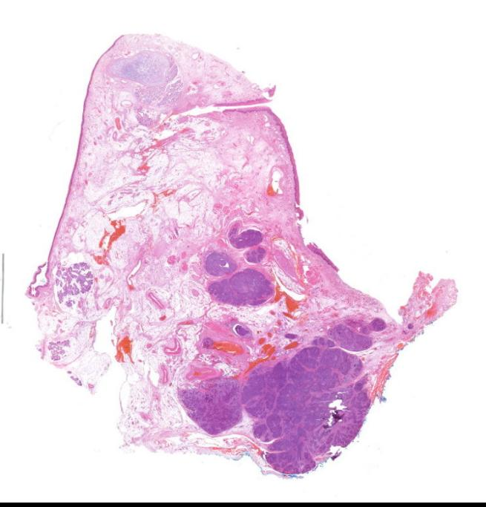HE, Lymph node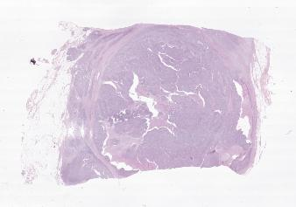

TMAs
CD163, InvasionFront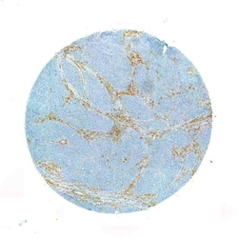CD163, InvasionFront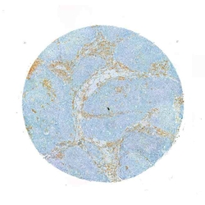CD163, TumorCenter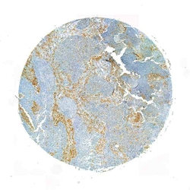CD163, TumorCenter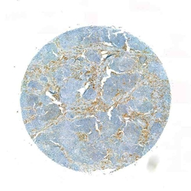CD3, InvasionFront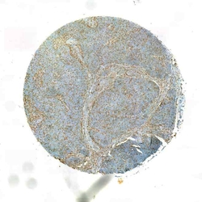CD3, InvasionFront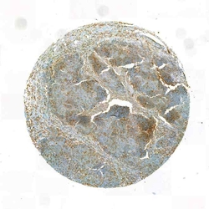CD3, TumorCenter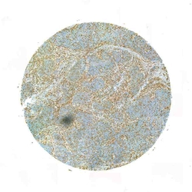CD3, TumorCenter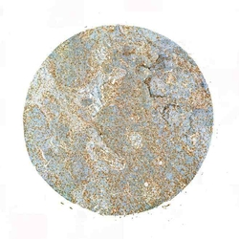CD56, InvasionFront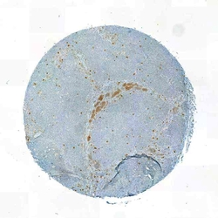CD56, InvasionFront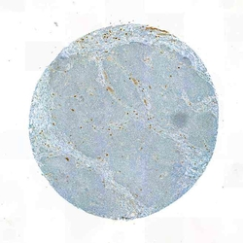CD56, TumorCenter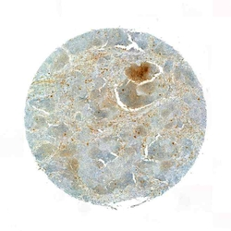CD56, TumorCenter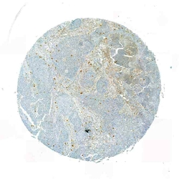CD68, TumorCenter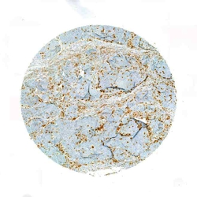CD68, TumorCenter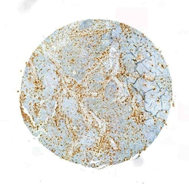CD8, InvasionFront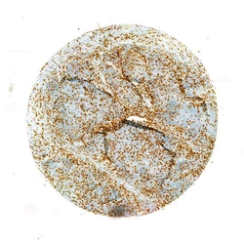CD8, InvasionFront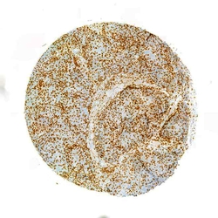CD8, TumorCenter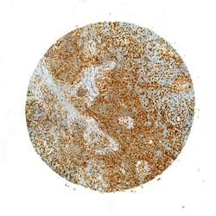CD8, TumorCenter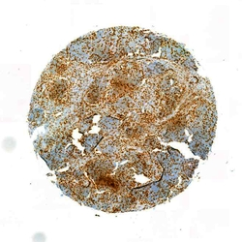HE, InvasionFront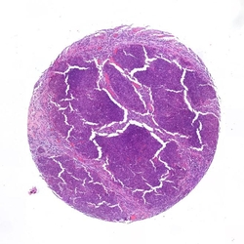HE, InvasionFront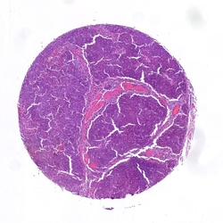HE, TumorCenter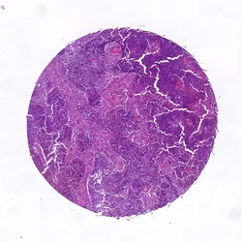HE, TumorCenter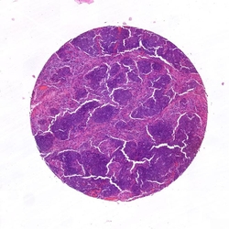MHC1, InvasionFront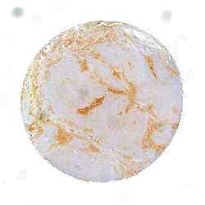MHC1, InvasionFront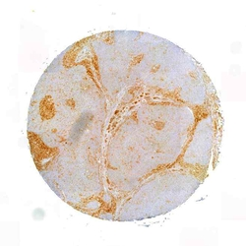MHC1, TumorCenter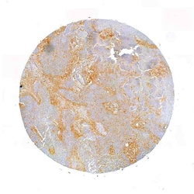MHC1, TumorCenter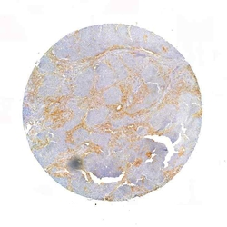PD-L1, InvasionFront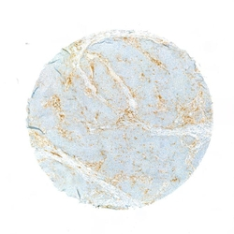PD-L1, InvasionFront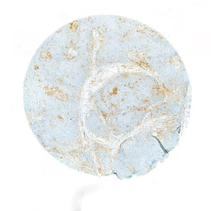PD-L1, TumorCenter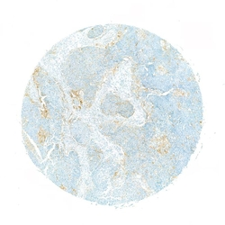PD-L1, TumorCenter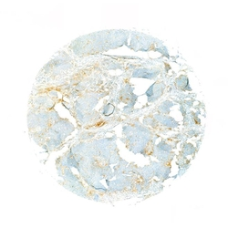

- Surgery report
TU resection, Neck dissection bilateral
Diagnosis / ICD codes
C13.9, C32.9, C77.0 B
Tests and treatments / OPS codes
5-303.2x, 5-403.04 B, 5-312.2, 1-610.0, 1-611.x, 1-631.0
Medical historyTranslated from German using DeepL
In the patient, a G3-differentiated cT3 hypopharyngeal laryngeal carcinoma of the right side was histologically confirmed <2015>. Clinically as well as sonographically and computed tomography cT3 cN2b. In addition, nodular goiter on both sides with nodes > 2 cm each. All common tumor options (surgery versus primary radiochemotherapy) were discussed in detail with the patient in advance. There is now an indication for surgical treatment in the form of a laryngectomy with partial pharyngectomy, neck dissection on both sides and hemi-thyroidectomy. The patient had ample opportunity to ask questions about the procedure before the operation.
Surgery reportTranslated from German using DeepL
After active patient identification, the patient is brought into the operating theater. Carrying out the team time-out. Introductory consultation with the anesthesia department. Induction of anesthesia and orotracheal intubation of the patient. Initial positioning of the patient by the surgeon. First, a new panendoscopy is performed to plan the surgical procedure. Insertion of the mouth guard and insertion of the size C small bore tube. This confirms the size expansion described above. Subsequent placement of a nasogastric feeding tube without any problems. Positioning of the patient in head reclination. Superficial skin disinfection. Infiltration anesthesia with a total of 15 ml xylocaine with adrenaline added in the area of the incision for the planned apron flap. Subsequent ablation of the surgical area and sterile draping. First mark the planned incision. Skin incision and lifting of a broad-based apron flap, with strictly subplatysmal preparation. Insertion of the chain dog. First start of neck dissection on the right side. Exposure of the sternocleidomastoid muscle and the omohyoid muscle as the caudal border and the posterior digastric venter muscle as the cranial border. Expose the capsule of the submandibular gland. Turning to the cervical vascular sheath. Exposure of the internal jugular vein and the venous angle including protection of the facial vein. Exposure of the common carotid artery, the bifurcation and the internal and external carotid artery. Exposure of the accessorius nerve and the hypoglossal nerve. The cervical artery cannot be spared intraoperatively. An extensive metastatic conglomerate can now be seen in levels II and III up to just before level IV, which appears to be firmly attached to the surrounding area. The soft tissue metastasis can only be separated from the internal jugular vein with difficulty. The metastatic conglomerate extends very far medially and reaches the vagus nerve. Therefore, first relocation, neurolysis and re-embedding of the vagus nerve. This can be spared. Intraoperatively, the border cord appears to be firmly attached to the metastatic conglomerate. First develop the lateral neck preparation, whereby the cervical plexus branches can largely be spared here. Turn to the medial neck preparation. The hypoglossal nerve is also exposed here. Displacement, neurolysis and re-embedding of the hypoglossal nerve. Protection of the nerve. Successive development of the medial neck preparation. Moving on to the left side: the same procedure in principle here. First expose the sternocleidomastoid muscle and the omohyoid muscle as the caudal border and the posterior digastric venter muscle as the cranial border. Turning to the cervical vascular sheath. Exposure of the internal jugular vein from the caudal to the cranial border. Exposure of the facial vein and protection of the same. Exposure of the common carotid artery, the bifurcation and the internal and external carotid artery. Exposure of the accessorius nerve, displacement, neurolysis and re-embedding of the same. Protection of the nerve. Development of the lateral neck preparation while sparing the cervical plexus branches. Exposure of the submandibular gland capsule and the hypoglossal nerve. Displacement, neurolysis and re-embedding of the nerve. Development of the medial neck preparation. Transition to visualization of the hypoid. Subsequent separation of the infrahyoid muscles using the electric knife. The sternohyoid muscle is cut caudally. Then supply the upper laryngeal bundle on both sides. Exposure of the thyroid cartilage horn on the left side. Incision of the perichondrium and release of the left-sided piriform sinus with the raspatory as well as with the pedicle swab. Subsequent exposure of the trachea and the thyroid isthmus. Dissection of the isthmus and repositioning of the isthmus. Exposure, displacement, neurolysis and re-embedding of the vagus nerve. This shows the large thyroid nodus described by sonography and computed tomography. Due to the prominent left-sided thyroid lobe and the slightly suspicious intraoperative appearance of the nodule, the decision was made to perform a hemithyroidectomy on the left side. Care is taken to preserve the epithelial bodies. The ventral trachea is then exposed. Proceed to the tracheotomy. Enter below the 1st tracheal clasp and transfer to an LE tube. Then open the pharynx infrahyoidally in the median line. Expose the upper edge of the epiglottis. Grasp the epiglottis and dislocate it through a relatively small pharyngotomy. You now have a good view of the extent of the tumor. First start resection in the area of the left-sided aryepiglottic fold. Mucosa-sparing incision up to just before the arytenoid cartilage. Then widen the incision caudally and in the area of the postcricoid. Hemostasis of several small bleedings from the laryngopharyngeal plexus. Subsequent counter-preparation from the left side. Here, too, the incision is made in the area of the aryepiglottic fold, whereby this is extended into the pharynx due to the tumor extension into the right-sided piriform sinus. In between, further release of the laryngeal skeleton with the attached soft tissue cuff. Deposition of the trachea at the level of the 1st tracheal cartilage and resection of the larynx and the right-sided piriform sinus in toto. The specimen is sent in thread-marked for definitive histology. Meticulous inspection of the tumor specimen and subsequent removal of corresponding marginal samples, which are sent for intraoperative frozen section diagnostics. In the meantime, meticulous hemostasis. Announcement of the intraoperative frozen section diagnosis: This shows a tumor-free resection margin, which is why an R0 situation can be assumed intraoperatively. Perform a rather restrained myotomy in the area of the upper esophageal sphincter so as not to provoke reflux problems postoperatively. The placement of a Provox prosthesis is deliberately avoided for the time being due to the relatively narrow remaining pharyngeal tube. Dissection of the left-sided sternal part of the sternocleidomastoid muscle. This results in slightly more severe venous bleeding, which can be stopped with the aid of three inversion stitches. Then perform the inverting pharyngeal suture with Vicryl 3.0 RB-1 using the single-button suture technique. This is performed in a T-shaped configuration. Extremely meticulous work is carried out at the base of the tongue and caudally at the level of the stoma in order to further reduce the risk of fistula formation at these predilection sites. Grasping the lateral musculature and suturing it using a continuous overlocking suture technique in the sense of a second layer. Application of a layer of TachoSil. Grasping of the remaining peripheral soft tissue, which is additionally stitched over the pharyngeal suture as a fourth layer. The sternohyoid muscle, which has previously been folded caudally, is also stitched over the wound bed. Then irrigate the wound with H2O2 and Ringer's solution. Insertion of two 10-gauge Redon drains and circular epithelialization of the tracheostoma. Subcutaneous suturing with Vicryl 4.0 and skin suturing with Ethilon 5.0. Application of a pressure dressing and transfer of the patient to a 10-gauge high-volume low-pressure cannula. Completion of the procedure without complications. Final consultation with the anesthesia department. The patient received 3 g Unacid i.v. intraoperatively. Antibiotics should be continued postoperatively for five days.

