临床数据
year_of_initial_diagnosis | 2015
age_at_initial_diagnosis | 65
sex | male
smoking_status | former
primarily_metastasis | no
survival_status | living
survival_status_with_cause | living
days_to_last_information | 2258
first_treatment_intent | curative
first_treatment_modality | local surgery
days_to_first_treatment | 28
adjuvant_treatment_intent | curative
adjuvant_radiotherapy | yes
adjuvant_radiotherapy_modality | percutaneous radiotherapy
adjuvant_systemic_therapy | yes
adjuvant_systemic_therapy_modality | fluorouracil + cisplatin
adjuvant_radiochemotherapy | yes
recurrence | no
progress_1 | no
Pathology report
primary_tumor_site | Hypopharynx
pT_stage | pT4a
pN_stage | pN2b
grading_hpv | G3
hpv_association_p16 | not_tested
number_of_positive_lymph_nodes | 3
number_of_resected_lymph_nodes | 61
perinodal_invasion | yes
lymphovascular_invasion_L | yes
vascular_invasion_V | no
perineural_invasion_Pn | no
resection_status | R0
resection_status_carcinoma_in_situ | CIS Absent
carcinoma_in_situ | no
closest_resection_margin_in_cm | <0.1
histologic_type | SCC_Basaloid
infiltration_depth_in_mm | 19
Laboratory
Results of laboratory tests performed in the context of the patient's surgery. For each analyte, the corresponding parameter group and LOINC code is given.
Analyte | Value | Unit | Group | LOINC | LOINC Code
aPPT | 25.6 | s | Routine | Activated partial thromboplastin time (aPTT) in Blood by Coagulation assay | 3173-2
Basophils | 0.02 | x10^3/µl | Hematology | Basophils [#/volume] in Blood | 26444-0
Basophils % | 0.3 | % | Hematology | Basophils/100 leukocytes in Blood | 30180-4
Calcium | 2.52 | mmol/l | Mineral; bone; joint; connective tissue | Calcium [Moles/volume] in Serum or Plasma | 2000-8
Chloride | 106 | mmol/l | Electrolytes - single valence | Chloride [Moles/volume] in Serum or Plasma | 2075-0
Creatinine | 0.93 | mg/dl | Renal function | Creatinine [Mass/volume] in Serum or Plasma | 2160-0
Eosinophils | 0.06 | x10^3/µl | Hematology | Eosinophils [#/volume] in Blood | 26449-9
Eosinophils % | 0.9 | % | Hematology | Eosinophils/100 leukocytes in Blood | 26450-7
Erythrocytes | 5.29 | x10^6/µl | Hematology | Erythrocytes [#/volume] in Blood | 26453-1
Glomerular filtration rate | 60.0002 | ml/min | OG | Glomerular filtration rate/1.73 sq M.predicted by Creatinine-based formula (MDRD) | 33914-3
Granulocytes | 4.86 | x10^3/µl | Hematology | Granulocytes [#/volume] in Blood | 30394-1
Granulocytes % | 72 | % | Hematology | Granulocytes/100 leukocytes in Blood by Automated count | 19023-1
Hematocrit | 43.4 | % | Hematology | Hematocrit [Volume Fraction] of Blood | 20570-8
Hemoglobin | 15.4 | g/dl | Hematology | Hemoglobin [Mass/volume] in Blood | 718-7
Immature Granulocytyes | 0.7 | % | Hematology | Granulocytes Immature/100 leukocytes in Blood | 38518-7
INR | 0.89 |  | Routine | INR in Blood by Coagulation assay | 34714-6
Leukocytes | 6.75 | x10^3/µl | Hematology | Leukocytes [#/volume] in Blood | 26464-8
Lymphocytes | 1.26 | x10^3/µl | Hematology | Lymphocytes [#/volume] in Blood | 26474-7
Lymphocytes % | 18.7 | % | Hematology | Lymphocytes/100 leukocytes in Blood | 26478-8
MCH | 29.1 | pg | Hematology | Erythrocyte mean corpuscular hemoglobin [Entitic mass] | 28539-5
MCV | 82 | fl | Hematology | Erythrocyte mean corpuscular volume [Entitic volume] | 30428-7
MHCH | 35.5 | g/dl | Hematology | Erythrocyte mean corpuscular hemoglobin concentration [Mass/volume] | 28540-3
Monocytes | 0.55 | x10^3/µl | Hematology | Monocytes [#/volume] in Blood | 26484-6
Monocytes % | 8.1 | % | Hematology | Monocytes/100 leukocytes in Blood | 26485-3
MPV | 10.3 | fl | Hematology | Platelet mean volume [Entitic volume] in Blood | 28542-9
Normoblasts | 0 | % | Hematology | Normoblasts/100 leukocytes [Ratio] in Blood | 33990-3
PDW | 13.6 | fl | Hematology | Platelet distribution width [Entitic volume] in Blood by Automated count | 32207-3
Platelets | 156 | x10^3/µl | Hematology | Platelets [#/volume] in Blood | 26515-7
PLCR | 28.8 | % | Hematology | Platelets Large/Platelets in Blood by Automated count | 48386-7
Potassium | 4.3 | mmol/l | Electrolytes - single valence | Potassium [Moles/volume] in Serum or Plasma | 2823-3
PT | 100 | % | Routine | Prothrombin time (PT) actual/normal in Platelet poor plasma by Coagulation assay | 5894-1
RDW | 13.7 | % | Hematology | Erythrocyte distribution width [Ratio] | 30385-9
Sodium | 141 | mmol/l | Electrolytes - single valence | Sodium [Moles/volume] in Serum or Plasma | 2951-2
Thrombin time | 16.2 | s | Routine | Thrombin time in Platelet poor plasma by Coagulation assay | 3243-3
Slides
HE, Primary tumor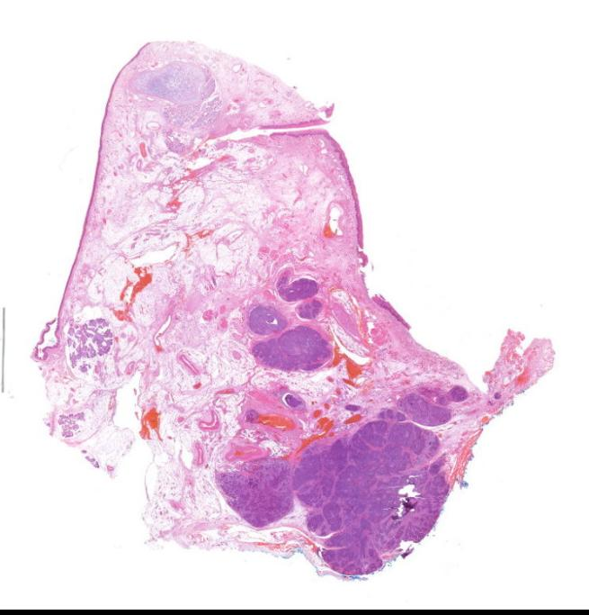HE, Lymph node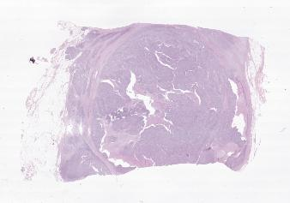

TMAs
CD163, InvasionFront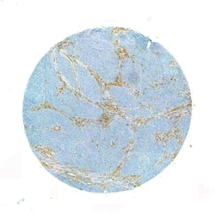CD163, InvasionFront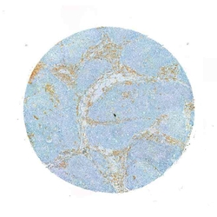CD163, TumorCenter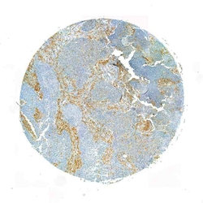CD163, TumorCenter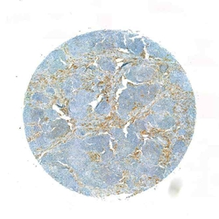CD3, InvasionFront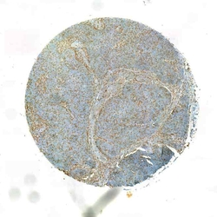CD3, InvasionFront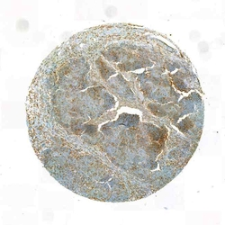CD3, TumorCenter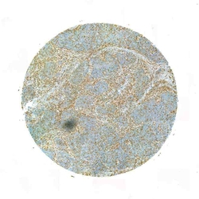CD3, TumorCenter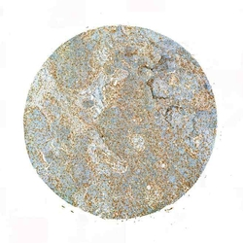CD56, InvasionFront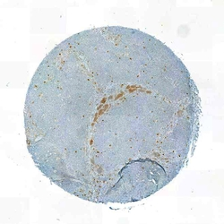CD56, InvasionFront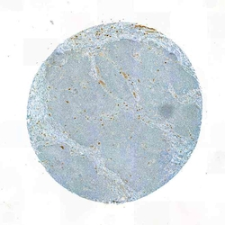CD56, TumorCenter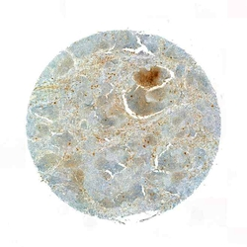CD56, TumorCenter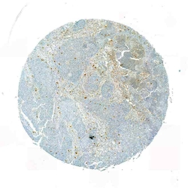CD68, TumorCenter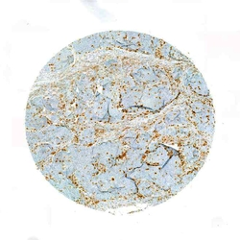CD68, TumorCenter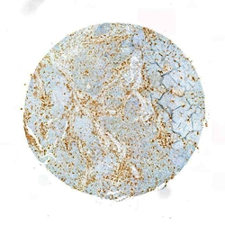CD8, InvasionFront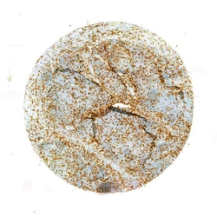CD8, InvasionFront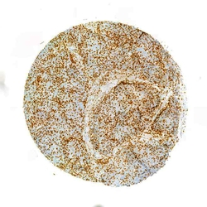CD8, TumorCenter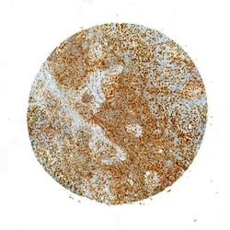CD8, TumorCenter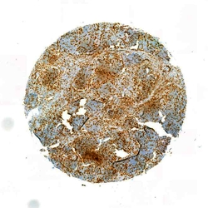HE, InvasionFront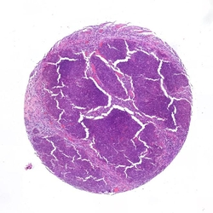HE, InvasionFront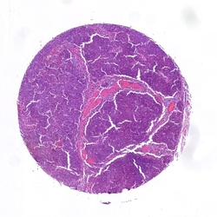HE, TumorCenter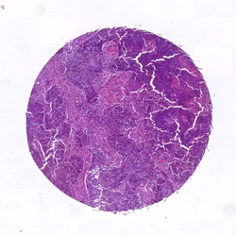HE, TumorCenter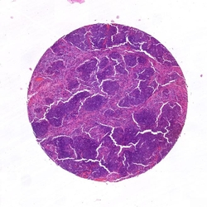MHC1, InvasionFront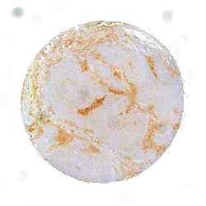MHC1, InvasionFront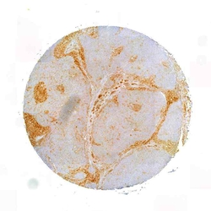MHC1, TumorCenter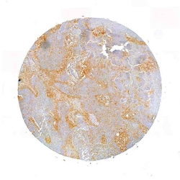MHC1, TumorCenter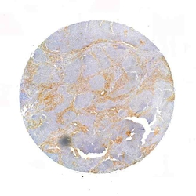PD-L1, InvasionFront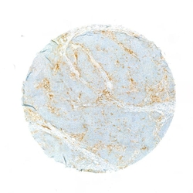PD-L1, InvasionFront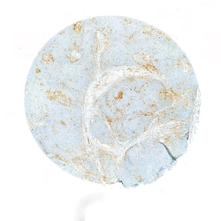PD-L1, TumorCenter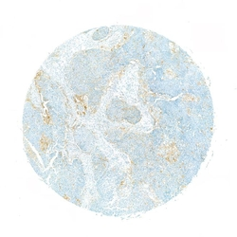PD-L1, TumorCenter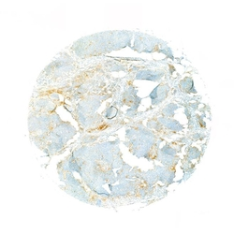

- Surgery report
TU resection, Neck dissection bilateral
Diagnosis / ICD codes
C13.9, C32.9, C77.0 B
Tests and treatments / OPS codes
5-303.2x, 5-403.04 B, 5-312.2, 1-610.0, 1-611.x, 1-631.0
Medical historyTranslated from German using DeepL
In the patient, a G3-differentiated cT3 hypopharyngeal laryngeal carcinoma of the right side was histologically confirmed <2015>. Clinically as well as sonographically and computed tomography cT3 cN2b. In addition, nodular goiter on both sides with nodes > 2 cm each. All common tumor options (surgery versus primary radiochemotherapy) were discussed in detail with the patient in advance. There is now an indication for surgical treatment in the form of a laryngectomy with partial pharyngectomy, neck dissection on both sides and hemi-thyroidectomy. The patient had ample opportunity to ask questions about the procedure before the operation.
Surgery reportTranslated from German using DeepL
After active patient identification, the patient is brought into the operating theater. Carrying out the team time-out. Introductory consultation with the anesthesia department. Induction of anesthesia and orotracheal intubation of the patient. Initial positioning of the patient by the surgeon. First, a new panendoscopy is performed to plan the surgical procedure. Insertion of the mouth guard and insertion of the size C small bore tube. This confirms the size expansion described above. Subsequent placement of a nasogastric feeding tube without any problems. Positioning of the patient in head reclination. Superficial skin disinfection. Infiltration anesthesia with a total of 15 ml xylocaine with adrenaline added in the area of the incision for the planned apron flap. Subsequent ablation of the surgical area and sterile draping. First mark the planned incision. Skin incision and lifting of a broad-based apron flap, with strictly subplatysmal preparation. Insertion of the chain dog. First start of neck dissection on the right side. Exposure of the sternocleidomastoid muscle and the omohyoid muscle as the caudal border and the posterior digastric venter muscle as the cranial border. Expose the capsule of the submandibular gland. Turning to the cervical vascular sheath. Exposure of the internal jugular vein and the venous angle including protection of the facial vein. Exposure of the common carotid artery, the bifurcation and the internal and external carotid artery. Exposure of the accessorius nerve and the hypoglossal nerve. The cervical artery cannot be spared intraoperatively. An extensive metastatic conglomerate can now be seen in levels II and III up to just before level IV, which appears to be firmly attached to the surrounding area. The soft tissue metastasis can only be separated from the internal jugular vein with difficulty. The metastatic conglomerate extends very far medially and reaches the vagus nerve. Therefore, first relocation, neurolysis and re-embedding of the vagus nerve. This can be spared. Intraoperatively, the border cord appears to be firmly attached to the metastatic conglomerate. First develop the lateral neck preparation, whereby the cervical plexus branches can largely be spared here. Turn to the medial neck preparation. The hypoglossal nerve is also exposed here. Displacement, neurolysis and re-embedding of the hypoglossal nerve. Protection of the nerve. Successive development of the medial neck preparation. Moving on to the left side: the same procedure in principle here. First expose the sternocleidomastoid muscle and the omohyoid muscle as the caudal border and the posterior digastric venter muscle as the cranial border. Turning to the cervical vascular sheath. Exposure of the internal jugular vein from the caudal to the cranial border. Exposure of the facial vein and protection of the same. Exposure of the common carotid artery, the bifurcation and the internal and external carotid artery. Exposure of the accessorius nerve, displacement, neurolysis and re-embedding of the same. Protection of the nerve. Development of the lateral neck preparation while sparing the cervical plexus branches. Exposure of the submandibular gland capsule and the hypoglossal nerve. Displacement, neurolysis and re-embedding of the nerve. Development of the medial neck preparation. Transition to visualization of the hypoid. Subsequent separation of the infrahyoid muscles using the electric knife. The sternohyoid muscle is cut caudally. Then supply the upper laryngeal bundle on both sides. Exposure of the thyroid cartilage horn on the left side. Incision of the perichondrium and release of the left-sided piriform sinus with the raspatory as well as with the pedicle swab. Subsequent exposure of the trachea and the thyroid isthmus. Dissection of the isthmus and repositioning of the isthmus. Exposure, displacement, neurolysis and re-embedding of the vagus nerve. This shows the large thyroid nodus described by sonography and computed tomography. Due to the prominent left-sided thyroid lobe and the slightly suspicious intraoperative appearance of the nodule, the decision was made to perform a hemithyroidectomy on the left side. Care is taken to preserve the epithelial bodies. The ventral trachea is then exposed. Proceed to the tracheotomy. Enter below the 1st tracheal clasp and transfer to an LE tube. Then open the pharynx infrahyoidally in the median line. Expose the upper edge of the epiglottis. Grasp the epiglottis and dislocate it through a relatively small pharyngotomy. You now have a good view of the extent of the tumor. First start resection in the area of the left-sided aryepiglottic fold. Mucosa-sparing incision up to just before the arytenoid cartilage. Then widen the incision caudally and in the area of the postcricoid. Hemostasis of several small bleedings from the laryngopharyngeal plexus. Subsequent counter-preparation from the left side. Here, too, the incision is made in the area of the aryepiglottic fold, whereby this is extended into the pharynx due to the tumor extension into the right-sided piriform sinus. In between, further release of the laryngeal skeleton with the attached soft tissue cuff. Deposition of the trachea at the level of the 1st tracheal cartilage and resection of the larynx and the right-sided piriform sinus in toto. The specimen is sent in thread-marked for definitive histology. Meticulous inspection of the tumor specimen and subsequent removal of corresponding marginal samples, which are sent for intraoperative frozen section diagnostics. In the meantime, meticulous hemostasis. Announcement of the intraoperative frozen section diagnosis: This shows a tumor-free resection margin, which is why an R0 situation can be assumed intraoperatively. Perform a rather restrained myotomy in the area of the upper esophageal sphincter so as not to provoke reflux problems postoperatively. The placement of a Provox prosthesis is deliberately avoided for the time being due to the relatively narrow remaining pharyngeal tube. Dissection of the left-sided sternal part of the sternocleidomastoid muscle. This results in slightly more severe venous bleeding, which can be stopped with the aid of three inversion stitches. Then perform the inverting pharyngeal suture with Vicryl 3.0 RB-1 using the single-button suture technique. This is performed in a T-shaped configuration. Extremely meticulous work is carried out at the base of the tongue and caudally at the level of the stoma in order to further reduce the risk of fistula formation at these predilection sites. Grasping the lateral musculature and suturing it using a continuous overlocking suture technique in the sense of a second layer. Application of a layer of TachoSil. Grasping of the remaining peripheral soft tissue, which is additionally stitched over the pharyngeal suture as a fourth layer. The sternohyoid muscle, which has previously been folded caudally, is also stitched over the wound bed. Then irrigate the wound with H2O2 and Ringer's solution. Insertion of two 10-gauge Redon drains and circular epithelialization of the tracheostoma. Subcutaneous suturing with Vicryl 4.0 and skin suturing with Ethilon 5.0. Application of a pressure dressing and transfer of the patient to a 10-gauge high-volume low-pressure cannula. Completion of the procedure without complications. Final consultation with the anesthesia department. The patient received 3 g Unacid i.v. intraoperatively. Antibiotics should be continued postoperatively for five days.

