PATHFINDING

Pathfinding est un terme anglais qui peut se traduire en « **Trouver son chemin** ».

Notre véhicule devra donc être capable à partir d’un point de départ A de se déplacer jusqu’au point B en utilisant le chemin le plus court tout en suivant la route.

|  |  |  |  |  |  |  |  |  |  |  |  |  |  |  |  |  |
| --- | --- | --- | --- | --- | --- | --- | --- | --- | --- | --- | --- | --- | --- | --- | --- | --- |
| 0,0 | **1** | **2** | **3** | **4** | **5** | **6** | **7** | **8** | **9** | **10** | **11** | **12** | **13** | **14** | **15** | **16** |
| **1** |  | **1** |  |  |  | **1** |  |  |  |  |  |  |  |  |  |  |
| **2** |  |  | **1** |  | **1** |  |  |  |  |  |  |  |  |  |  |  |
| **3** |  |  |  | **1** |  |  |  |  |  |  |  |  |  |  |  |  |
| **4** |  |  |  |  | **1** |  | **1** |  |  |  |  |  |  |  |  |  |
| **5** |  | **1** |  |  |  | **1** |  |  |  |  |  |  |  |  |  |  |
| **6** | **1** |  |  |  |  |  |  |  |  | **1** |  |  |  |  |  |  |
| **7** |  |  |  |  |  |  |  | **1** |  |  |  |  | **1** |  |  |  |
| **8** |  |  |  |  |  |  |  |  | **1** |  |  |  |  |  |  |  |
| **9** |  |  |  |  |  |  |  |  |  | **1** | **1** |  |  |  |  |  |
| **10** |  |  |  |  |  |  |  |  |  |  | **1** |  |  |  |  |  |
| **11** |  |  |  |  |  |  |  |  |  |  |  | **1** |  |  |  |  |
| **12** |  |  |  |  |  |  |  |  |  |  |  |  | **1** |  |  |  |
| **13** |  |  |  |  |  | **1** |  |  |  |  |  |  |  | **1** |  | **1** |
| **14** |  |  |  |  |  |  |  |  |  |  |  |  | **1** |  | **1** |  |
| **15** |  |  |  |  |  |  |  |  |  |  |  |  |  |  |  | **1** |
| **16** | **1** |  |  |  |  |  |  |  |  |  |  |  |  |  |  |  |

Tab1 : TABLEAU DE POINTS ET D’INDICES

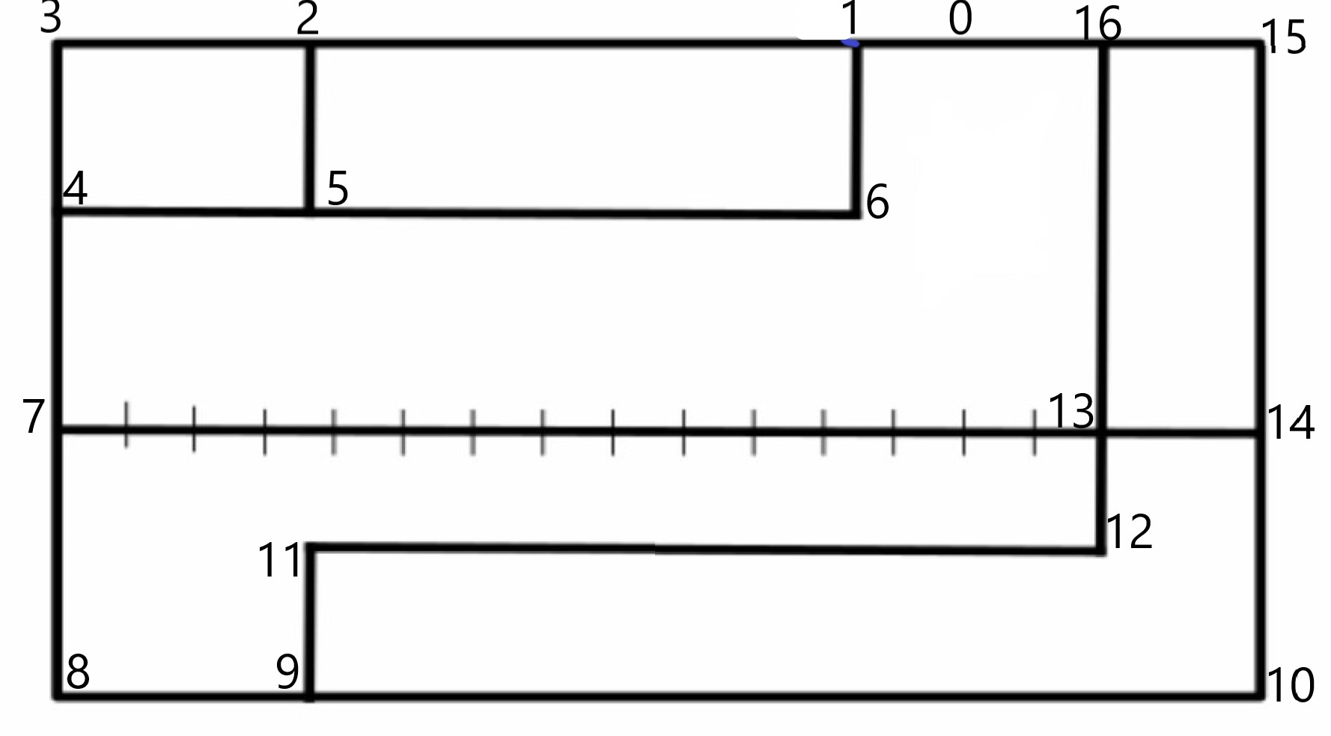

MAP

|  |  |  |  |
| --- | --- | --- | --- |
| **Points d’origine** | **Destination 1** | **Destination 2** | **Destination 3** |
| 1 | 2 | 6 |  |
| 2 | 3 | 5 |  |
| 3 | 4 |  |  |
| 4 | 7 | 5 |  |
| 5 | 6 | 2 |  |
| 6 | 1 |  |  |
| 7 | 8 | 13 |  |
| 8 | 9 |  |  |
| 9 | 10 | 11 |  |
| 10 | 14 |  |  |
| 11 | 12 |  |  |
| 12 | 13 |  |  |
| 13 | 7 | 14 | 16 |
| 14 | 15 | 13 |  |
| 15 | 16 |  |  |
| 16 | 1 |  |  |
|  |  |  |  |

Tab3 : TABLEAU DES DESTINATIONS