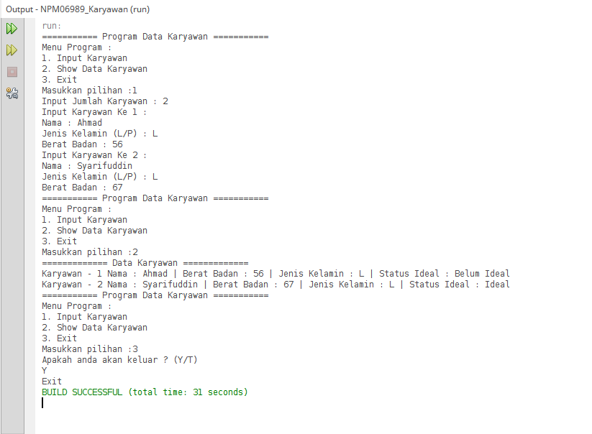

Keterangan Source Code :

----------------------------------------------------------------------------------------------------------------------------------------------------------------------------------------------------------------------------------------------------------------------------------------------------------------------------------------------------------------------------------------------------------------------------------------------------------------------------------------------------------------------------------------------------------------------------------------------------------------------------------------------------------------------------------------------------------------------------------------------------------------------------------------------------------------------------------------------------------------------------------------------------------------------------------------------------------------------------------------------------------------------------------------------------------------------------------------------------------------------------------------------------------------------------------------------------------------------------------------------------------------------------------------------------------------------------------------------------------------------------------------------------------------------------------------------------------------------------------------------------------------------------------------------------------------------------------------------------------------------------------------------------------------------------------------------------------------------------------------------------------------------------------------------------------------------------------------------------------------------------------------------------------------------------------------------------------------------------------------------------------------------------------------------------------------------------------------------------------------------------------------------------------------------------------------------------------------------------------------------------------------------------------------------------------------------------------------------------------------------------------------------------------------------------------------------------------------------------------------------------------------------------------------------------------------------------------------------------------------------------------------------------------------------------------------------------------------------------------------------------------------------------------------------------------------------------------------------------------------------------------------------------------------------------------------------------------------------------------------------------------------------------------------------------------------------------------------------------------------------------------------------------------------------------------------------------------------------------------------------------------------------------------------------------------------------------------------------------------------------------------------------------------------------------------------------------------------------------------------------------------------------------------------------------------------------------------------------------------------------------------------------------------------------------------------------------------------------------------------------------------------------------------------------------------------------------------------------------------------------------------------------------------------------------------------------------------------------------------------------------------------------------------------------------------------------------------------------------------------------------------------------------------------------------------------------------------------------------------------------------------------------------------------------------------------------------------------------------------------------------------------------------------------------------------------------------------------------------------------------------------------------------------------------------------------------------------------------------------------------------------------------------------------------------------------------------------------------------------------------------------------------------------------------------------------------------------------------------------------------------------------------------------------------------------------------------------------------------------------------------------------------------------------------------------------------------------------------------------------------------------------------------------------------------------------------------------------------------------------------------------------------------------------------------------------------------------------------------------------------------------------------------------------------------------------------------------------------------------------------------------------------------------------------------------------------------------------------------------------------------------------------------------------------------------------------------------------------------------------------------------------------------------------------------------------------------------------------------------------------------------------------------------------------------------------------------------------------------------------------------------------------------------------------------------------------------------------------------------------------------------------------------------------------------------------------------------------------------------------------------------------------------------------------------------------------------------------------------------------------------------------------------------------------------------------------------------------------------------------------------------------------------------------------------------------------------------------------------------------------------------------------------------------------------------------------------------------------------------------------------------------------------------------------------------------------------------------------------------------------------------------------------------------------------------------------------------------------------------------------------------------------------------------------------------------------------------------------------------------------------------------------------------------------------------------------------