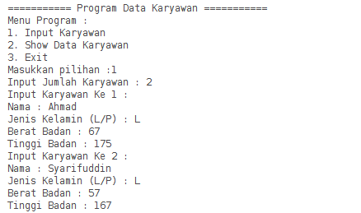

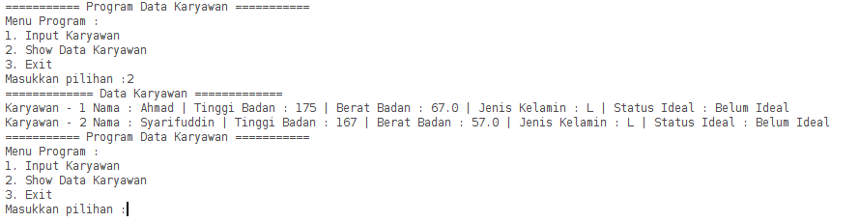

Keterangan Source Code :

--------------------------------------------------------------------------------------------------------------------------------------------------------------------------------------------------------------------------------------------------------------------------------------------------------------------------------------------------------------------------------------------------------------------------------------------------------------------------------------------------------------------------------------------------------------------------------------------------------------------------------------------------------------------------------------------------------------------------------------------------------

--------------------------------------------------------------------------------------------------------------------------------------------------------------------------------------