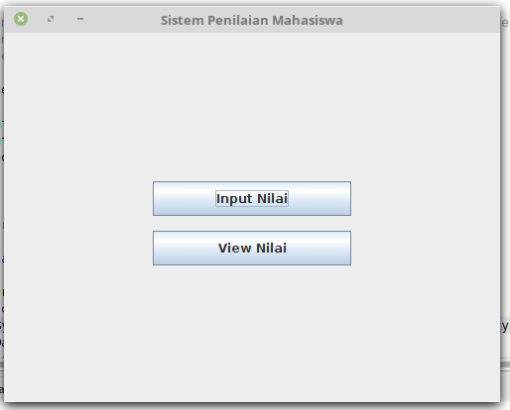

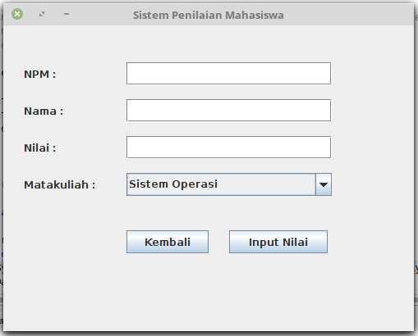

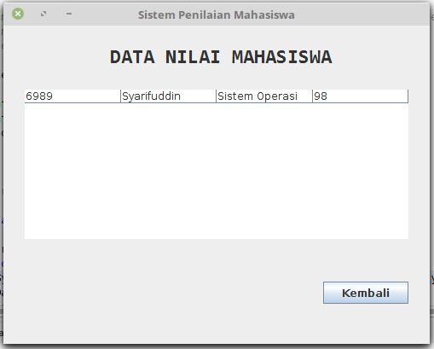

Keterangan Source Code :

--------------------------------------------------------------------------------------------------------------------------------------------------------------------------------------------------------------------------------------------------------------------------------------------------------------------------------------------------------------------------------------------------------------------------------------------------------------------------------------------------------------------------------------------------------------------------------------------------------------------------------------------------------------------------------------------------------------------------------------------------------

-----------------------------------------------------------------------------------------------------------------------------------------------------------------------------------------------------------------------------------------------------------------------------------------------------------------------------------------------------------------------------------------------------------------------------------------------------------------------