Nama : Danang fauzi

Npm : 16421042

Mata kuliah : B.inggris

Hy my, name is DANANG FAUZI I am from BANDAR LAMPUNG city , I am 19 years old.



I works at staurant but I don’t work on weekends but my

friends work on weekends and leave

work in the midnight on weekends.



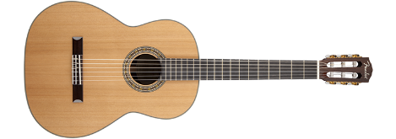In my home Ihave jeans it’s nice I like it because it’s cheaper than jacket.

By the way, do you like play guitar I play it everyday whould you like to play,too?

At the bus stop in the morning I am waiting a bus people are waiting a bus, at than time, too.