TECHNICAL REPORT

PROJECT BACKGROUND
We are given the task of implementing a project entitled Queuing System, this project is continuity from customer or user requirement. We had made a survey to determine the problems customer had to face. In the survey, we found that there is some company still use inappropriate queuing system. We took an approach to make some ideas for generating a queuing system to produce a quality, efficient and systematic system. There are several functions that are in our system, the system meet current customer needs.

PROBLEM STATEMENT
- There is no queuing system that meet such quality parallel with current needs.
- Customers need to queue long to wait for the turn of their names to be called
- Current system the arrangement of numbers for customers is not systematic
- Time interval between one customer to the next are not consistent
- Lagging occurred in such system

PROJECT GOAL
To introduce a new interactive queuing system with specific function that satisfy with current needs.

OBJECTIVE
1. To create a queuing system that can satisfy the needs of consumers and current needs
2. To develop a multitasking queuing system that can produce an alert sound at the same time display the calling number on screen.
3. To make a systematic queuing system that generate a perfect sequence number
4. To estimate a service time and set timer between customer’s changes
5. To make code simple and efficiency

PROJECT FLOWCHART
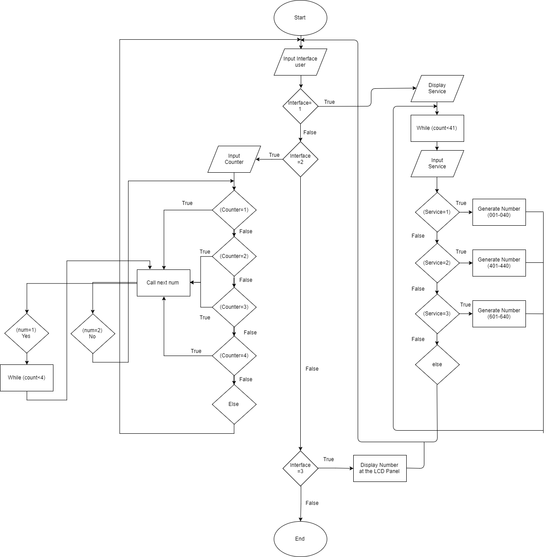

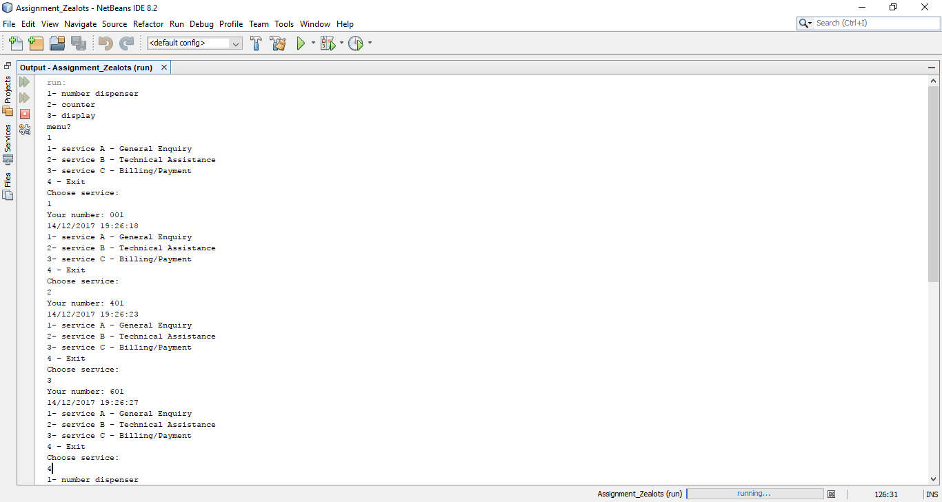
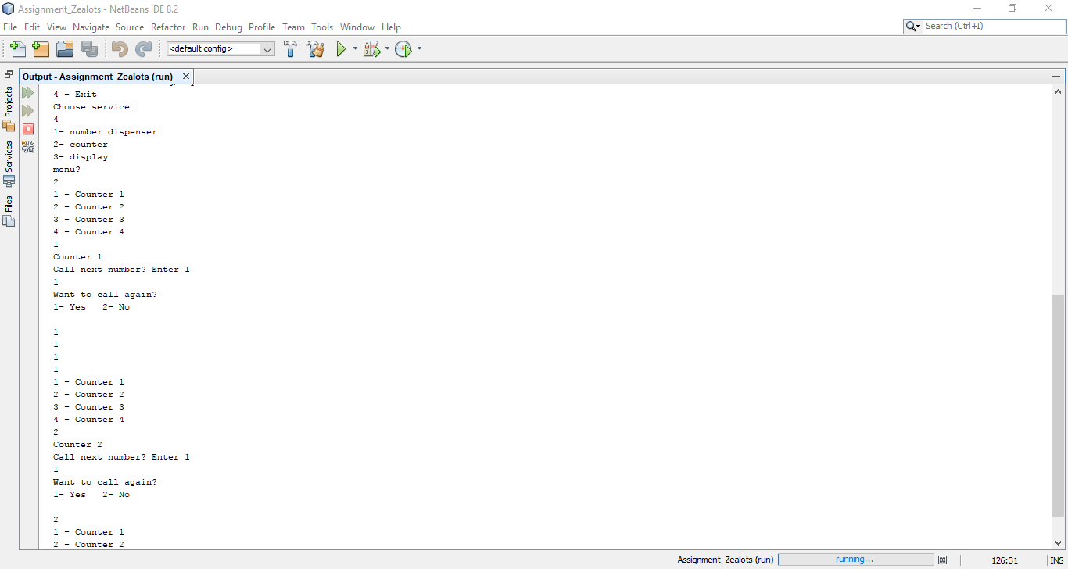
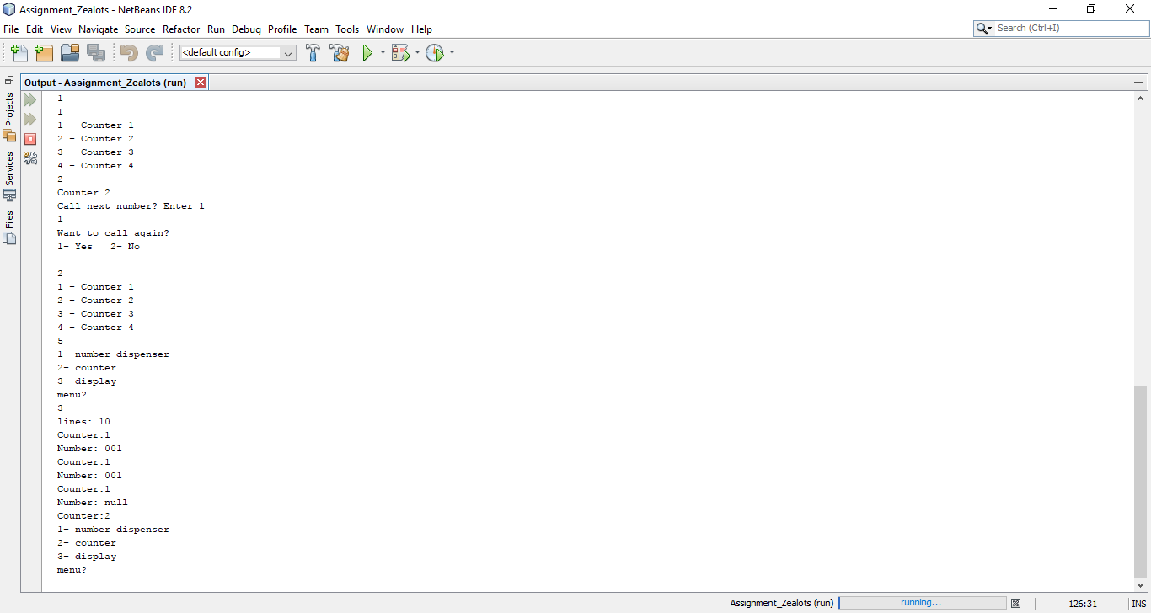
SAMPLE SNAPSHOT OF THE PROGRAM OUTPUT

