Common Thomas Network Analysis Interface

Specification v1.0

Adam Streck

14.10.2012

Table of contents
1 Introduction 2
1.1 Purpose of this document 2
1.2 Scope of the project 2
1.3 Definitions 2
1.3.1 Terms 2
1.3.2 Names 2
1.4 Overview of the document 2
2 General system description 3
2.1 Overview of pages 3
2.1.1 Home 3
2.1.2 Analyze 4
2.1.3 Documentation 4
2.1.4 Log/Sign in 4
2.1.5 Registration form 4
2.2 Account system overview 4
2.2.1 File access 5
2.2.2 Resource access 5
2.3 Widgets overview 5
2.3.1 Model widget 5
2.3.2 Formula widget 6
2.3.3 TomClass parametrizations restriction widget 6
2.3.4 TomClass Parsybone widget 6
2.3.5 TomClass NuSMV widget 6
2.3.6 Parameter view widget 6
2.3.7 Parameter filter widget 6
2.3.8 Behavior map widget 7
2.4 File tree overview 7
2.4.1 Inclusion system 7
3 Design proposals 7
3.1 File system 7
3.2 Widgets access 7
4 Tradeoffs and further development 7

Introduction
This is a specification of interface purposed for user-friendly manipulation with current and future tools for parameter identification in Thomas networks. The specification is not required to be followed in detail nor to be taken literally and should serve as a mere set of suggestion.
The document expects the reader to have a basic understanding of Thomas formalism and tools specified within the document.

Purpose of this document
This document should serve as a specification and reference for further design of the Common Thomas Network Analysis Interface (work-title). This document is does not describe design of the application itself and does not specify methods and technologies that should be used to achieve required goals.

Scope of the project
Main purpose of the interface is to provide uniform and easy-to-use access to applications already existing or in development. The interface should be usable either on publicly accessible server or in offline mode on a single computer and therefore there should be no assumptions about
- hardware platform,
- operating system,
- file system and access rights of of the scope of the application folder.
The application should provide best-effort functionality on any platform.
The application should be strictly sever-based. No code should be executed on the client side and no data should be stored either.
For data manipulation the application should use only external programs. The interface itself should merely provide the data and pass user requests and relevant to the underlying applications. For every sort of application the data should be stored in separated files.

Definitions
In this section we define, for clarity, terms associated with the methodology and names of tools and methods referenced throughout the document.

Terms
Context: A set of regulations of a component.
Parameter: A target value associated with a context.
Parametrization: A set of parameters for all the contexts of the model.

Names
Classifier: An adapter for the TomClass application. The adapter uses external tool e.g. NuSMV for analysis of the network.
CytoscapeWeb: Publicly available web based implementation of the Cytoscape tool.
Interface: The application specified in this document.
Parsybone: A compiled tool for LTL model checking on Thomas networks
TomClass: An application for ranking of parametrizations in Thomas network.

Overview of the document
Note that parts given in grey font are not to be included in the current version of the tool, however their additional implementation should be anticipated and therefore the current implementation should ease their possible addition.

General system description
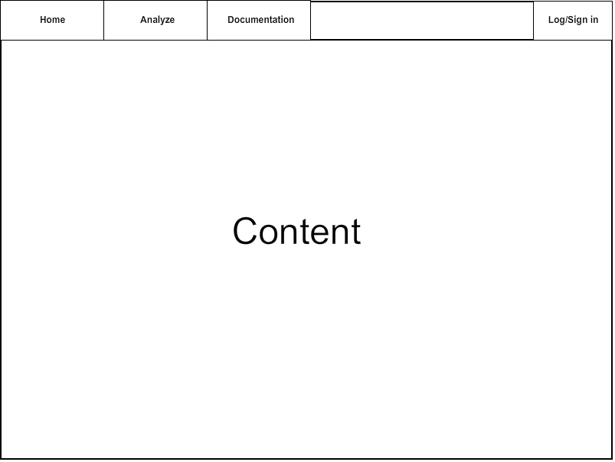
The system is based on a set of server-based applications that are executed on demand. This set should be accessible through a single web-page using an internal adapters providing the required functionality and content through a possibly extensible set of widgets. Given that the interface should be publicly available, this web page should be accompanied by other web pages which allow to manage user accounts and provide additional information. The structure of the web might be following:

Overview of pages
This section contains short description of individual pages that are accessible through HTTP links. Other than what is named here there should be no other independent page file.

Home
This page should display short description of the tool, short list of references and general legal info. Also short site map with links to other pages should be included.
The home button might be replaced with actual name / logotype of the tool.

Analyse
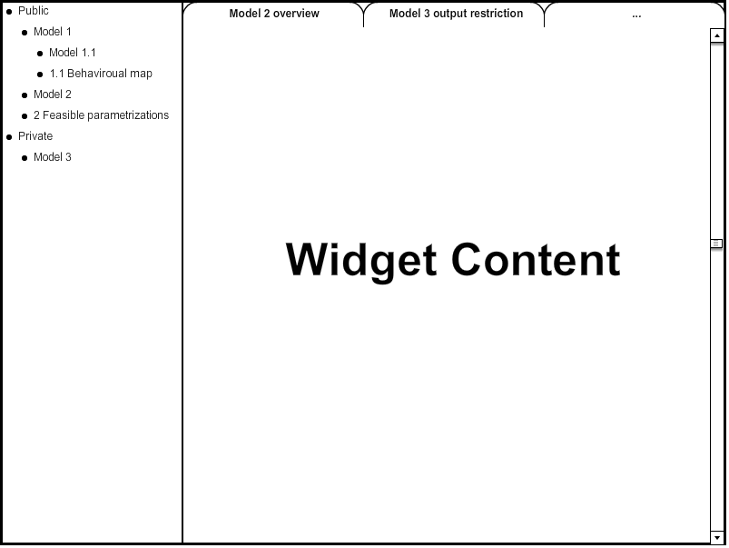
The analysis interface should be accessible wholly in the analysis page. For this purpose the page itself must provide capabilities for content access. The page should be divided into two panes. The left pane should host a file tree and provide instant accessibility for any file. The right pane is intended for displaying of file contents – as the content of each file should be pre-processed before the right pane should actually contain a widget for utilization of the content and a series of tabs for listing between open files. For clarity we present a sketch of the layout of analysis page content:

Documentation
This page might be actually divided in several sub-pages if necessary, however we do expect documentation to be present usually in form of PDF files and therefore this page should merely provide access to such files and their short description for easy navigation.

Log/Sign in
Access policies are necessary for management of resources and therefore basic account management must be included in the interface. This page should contain only options to log in using name and password or to sign in. Should the user choose to sign in, content of this page should be replaced with another page containing the registration form. After logging in the Log/Sign in button should be replaced with label containing current user's name and smaller button for logout underneath.

Registration form
Accessible only from the login page. This form should ask for basic account information e.g. user name, password, e-mail for verification and occupation/institute.

Account system overview
Functionality should be mainly available only for registered and logged users as usage of the analysis tool is likely to consume servers resources. Demo files may be available within the analysis tool for unregistered users to give an idea of the functionality.

File access
Each file can have different policies based on the status of the user, which may be:
- Owner of the file.
- Member of one of the groups specified in the file.
- Other user.
For each of the files user can have one of the following permissions:
- Change (write) the file.
- Read the file.
- Use the file in tools (execute).
In the basic system model should owner of the file all the privileges and other users none unless the owner says otherwise. Also only the owner can change the file policies.
For simplicity only one user should be allowed to write the file at the time. If the file is being edited, other users should be restricted from access, even if the request is made by the owner. Restriction may be enforced fully or allow the user to access the file in read-only mode. Further development may allow for more firm access privileges.
Execution of the file, meaning the process of producing some sort of result based on the file, produces files that belong to the user that started the execution whoever might be the owner.

Resource access
To avoid congestion of the server, we must endorse rather strict resource access. Each user should have 10GB of accessible data storage and two processes running while logged in.
When logged in the user is not allowed to actually to overcome 5GB limit. The exception is existence of a single file which is the one that broke the limit and which is not saved when the user logs off.
Restriction on two processes means that apart from the thread used for actual communication with the user, the user can also start two tools/programs on the server. After that the user can not start new computation until one of the processes ends. Should the user log off while two of his processes are running, the later should be killed.

Widgets overview
The functionality itself should be available through set of widgets each of which purposed for different sort of file. Here we give basic description of widgets and underlying files.

Model widget
This is an entry point for model analysis, which holds specification of the model itself and allows for its editing.
The file should contain the name of the model and a short description given by the author. Second part of this widget should be a way how to edit the model, either in a text file or using forms or using visual editor, probably based on CytoscapeWeb.
There should be multiple levels of components the model can contain based on their effect on parametrization space and visual clues telling the user to which level the model currently belongs. These levels are:
- Number of components and their value range. Defines transition graph.
- Edges and their thresholds. Defines regulatory contexts.
- Edge labels. Defines possible parametrizations.
From this widget the user can start TomClass tool, namely any of its Classifiers. It should be also possible to enumerate the whole set of possible parametrizations, being effectively equal to using TomClass with no classifier.
Saved changes in the model should create a copy of the model and not rewrite the model if there are additional files attached to the model, as they would become invalid!

Formula widget
Formula can be specified using:
- Büchi automaton
- Time series
- CTL
The widget is linked with the level 1 of the model at least and therefore user should be lead to using only propositions that are valid for the model. For this again text file/forms/CytoscapeWeb can be used.

TomClass parametrizations restriction widget
Additional restrictions on parametrization space are allowed using formulas of answer set programming system. This parametrizations however test each parametrization independently and therefore it is sensible to employ them only as a classifier. The widget takes a model and requires the user to specify
This widget produces parametrizations database file and should close on execution.

TomClass Parsybone widget
Visual interface for the Parsybone tool used for classification of parametrizations, the widget takes a model and an LTL formula / time series.
This widget produces parametrizations database file and should close on execution.

TomClass NuSMV widget
Visual interface for the NuSMV based analysis using a CTL formula.
This widget produces parametrizations database file and should close on execution.

Parameter view widget
This widget operates over a database with classified parametrizations and its main purpose is display and possibility for picking. User should have option to restrict the set of parametrizations and to restrict properties stored with the set. Newly formed tables can be saved as a same sort of file.

Parameter filter widget
This widget takes a database and restrictions on the database e.g. highest cost value. This restrictions should be stored separately from the database together with the model. Application of the restrictions should create a single file connected to the restrictions.

Behaviour map widget
This widget should present a behaviour map for parametrizations picked in the parameter view widget. This view should incorporate CytoscapeWeb for manipulation with the map as layouting is not expected.

File tree overview
The file tree pane should contain all the files the user has access to. Each node of the tree should be given by a model file. Since models can be partially ordered, the structure of the tree should be generated automatically based on model inclusion.
Each node should have assigned all the files that are attached to the model e.g. LTL formula, behaviour map, parametrizations table... This files may be listed freely or clustered in folders by their kind.
Opening a file should create a new tab in the content pane containing an appropriate widget for the job.

Inclusion system
Newly created model should be automatically inserted in the tree structure. Its position is defined by its specification level as proposed in Section 2.3.1. Node should be sorted as an ancestor of a node with higher level of specification if they on the specification level of the ancestor the models are equal.
If models A and B share the same level, A should be considered ancestor of B if and only if:
- They are both on level 1 and the transition system of B is a strict subset of the transition system of A.
- They are both on level 2, they are equal on level 1 and the set of interactions of A is a strict subset of the set of interactions of B.
- They are both on level 3, they are equal on level 2 and the set of edge constrains of A is a strict subset of the set of edge constrains of B.

Comparison system
One of the main purposes of the interface is capability for easy comparison of parametrizations and their respective properties. For this it should be possible to share classifiers between the models for which these classifications are common, e.g. LTL formula for all the models with the same structure.
Also it should be possible to merge tables. This merge should create an over-approximation (full outer join in the terms of SQL) with a new classification specifying the origin.

Design proposals
In this section we suggest a design approach to some parts of the interface. This should be however treated as merely a suggestion.

File system
To keep track of files of a single user, the file tree may be actually sorted in a tree of directories. It is however necessary to store somehow access rights to the files, which can be done in a single file in each directory. This way it is also easy to check if the data storage quota has not been exceeded.
To keep track of public files, a single file with their locations may be used.
To avoid data loss, each model should be auto-saved as frequently as possible.
It is also important to note, that some widgets use the same input file type e.g. model file, and some take more than one input file type. We actually propose for each widget to have a single associated file type, which saves all the data given by user.

Widgets access
This document does not give exact specification of how the user can start underlying tools and create new files from the interface as we expect that this should be chosen by the creator based on the technology used, however we would like to propose some options.
New files are usually created as an output of a tool. For this, the user must be able to start the tool at least, which is however somewhat based on the nature of the tool. It is up to discussion whether the widgets should be accessible without a file to work with, which behaviour we actually suggest to omit – even the Model widget should be started, probably from the file tree, with an empty file unsorted in the file tree at the moment. Widgets that process files, like TomClass might be accessible from the file icon in the file tree or from the widget responsible for its input file managing widget, in this case the Model widget.

Comparison system
Ability to compare results from analyses is one of the main advantages the tool should provide. To do such a task efficiently, the user should know which files contain comparable results, should be able to pick them in a simple manner and result of their merge/comparison should be readable to say at least.
File tree with its files might be sufficient for the first two tasks, as well as the currently proposed structure of widgets might be just enough for the third one, however it is important to keep this properties in mind when designing widget access and files storage.

General proposals
- There should be easy enough interface for files manipulation. User should be able to create new files, rename files, duplicate files and save current files easily

