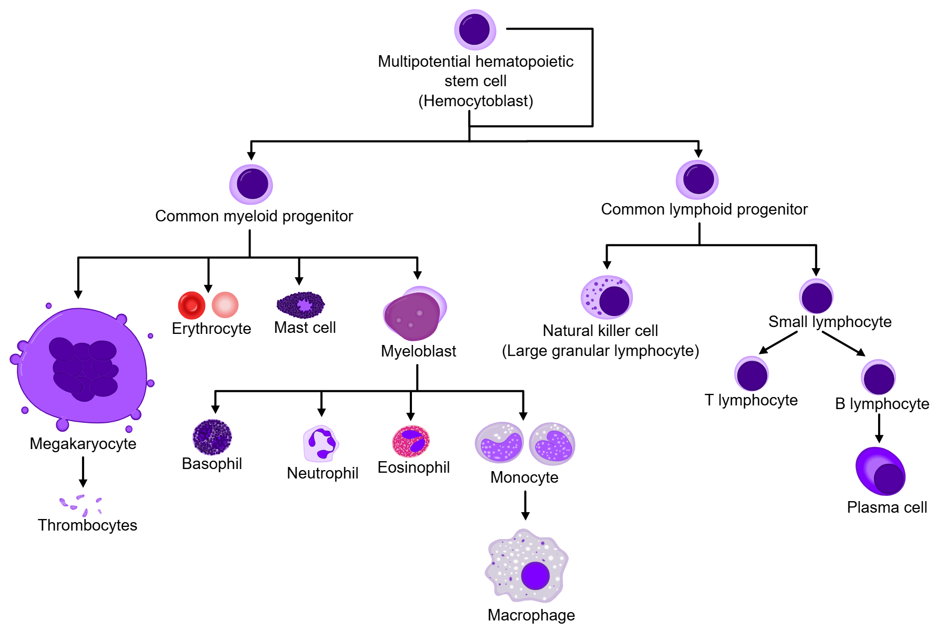

Genes expected UP in macrophages

Gene | Why useful
Adgre1 (F4/80) | Classic mouse macrophage marker
Csf1r | Macrophage lineage receptor
Lyz2 | Strong myeloid/macrophage marker
Ctss | Antigen processing in macrophages
Tyrobp | Myeloid immune signaling

Genes expected UP in MPP (multpotential progenitors)

Gene | Why useful
Kit | Stem/progenitor marker
Ly6a (Sca1) | Hematopoietic progenitor marker
Flt3 | Early progenitor marker

Genes expected UP in erythrocites

Gene | Why useful
Hbb-bs / Hbb-bt | Hemoglobin beta chains
Hba-a1 / Hba-a2 | Hemoglobin alpha chains
Alas2 | Erythroid heme synthesis
Gata1 | Master erythroid transcription factor
Epor | Erythropoietin receptor

Genes expected UP in B cells

Marker gene | Biological meaning
Cd79a | B-cell receptor complex
Ms4a1 (CD20) | Mature B-cell marker
Cd37 | B-cell surface protein
Cd74 | MHC II antigen presentation
H2-Ab1 | MHC II molecule

Genes expected UP in NK cells

Marker gene | Biological meaning
Nkg7 | Cytotoxic lymphocyte marker
Klrd1 (CD94) | NK-cell receptor
Klrk1 (NKG2D) | NK activation receptor
Prf1 | Cytotoxic granule protein
Gzmb | Granzyme/cytotoxic function

POSSIBLE IDENTITIES

Cell type | Positive markers
Macrophage | Adgre1 (ENSMUSG00000004730), Csf1r (ENSMUSG00000024621), Lyz2 (ENSMUSG00000069516)
Erythrocyte | Hbb (ENSMUSG00000085700), Alas2 (ENSMUSG00000025270), Gata1 (ENSMUSG00000031162)
B cell | Cd79a (ENSMUSG00000003379), Ms4a1 (ENSMUSG00000024673), Cd74 (ENSMUSG00000024610)
NK cell | Nkg7 (ENSMUSG00000004612), Klrd1 (ENSMUSG00000030165), Prf1 (ENSMUSG00000037202)
Multipotent progenitor | Kit (ENSMUSG00000005672), Ly6a (ENSMUSG00000075602), Flt3 (ENSMUSG00000042817)

DATASET 1 ____________________________________________________________________

DATASET 2 ____________________________________________________________________

DATASET 3 ____________________________________________________________________

