**Group name: Rebel Geek**

**Course code: CSC 469**

**Section: EVE**

**Use Case Diagram text**

**Title: YouDecide- An online proposal and voting platform.**

**Actors: 1. User**

**2. Manager**

**3. Admin**

**Description:**

1. **User:** It wants to register then login and post any proposal. It can to see there profiles. Users can to give proposal, to participant any debates and voting. It wants to need hide their details participation from manager.
2. **Manager:** It will login into the manager level. It will be pass manager work panel. It able to manage proposal insert, delete, update etc. it can choose a debates as proposal where other will able to votes. It will privileged to see all registered users. It will under my domain and reset/ recovers their passwords. However their participation will be huddle to itself.
3. **Admin:** It will login to admin panel from where it will manage any manager and able to add new. Any activates and reports will be available to generate. Also it can manage any users, manager profiles as well as seeing their activity.

**Use Case Diagram:**

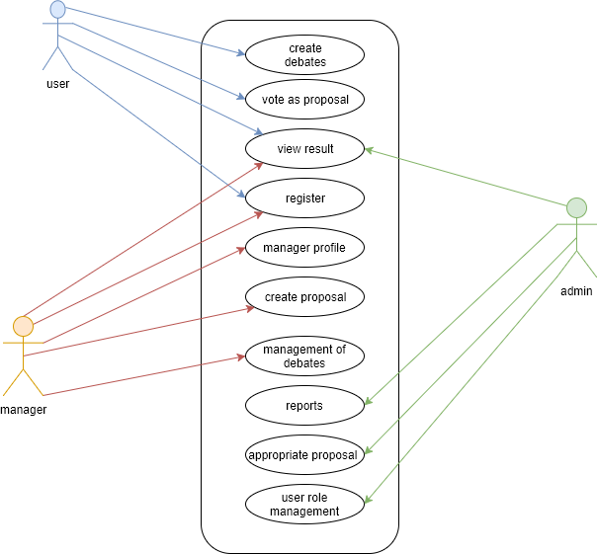

**Activities diagram:**

