<https://7.iottalk.tw/RemoteControl/109550087>



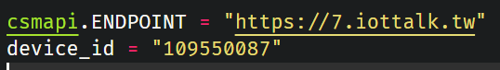

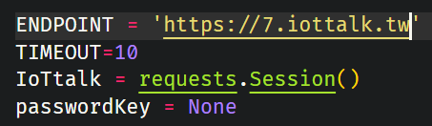

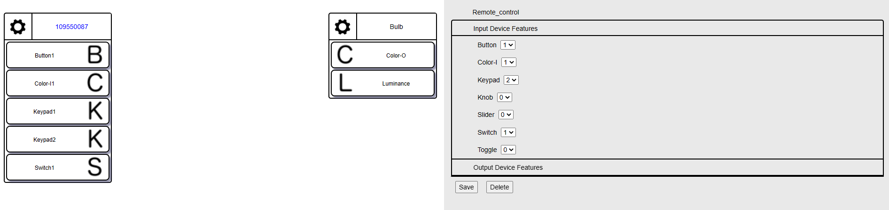

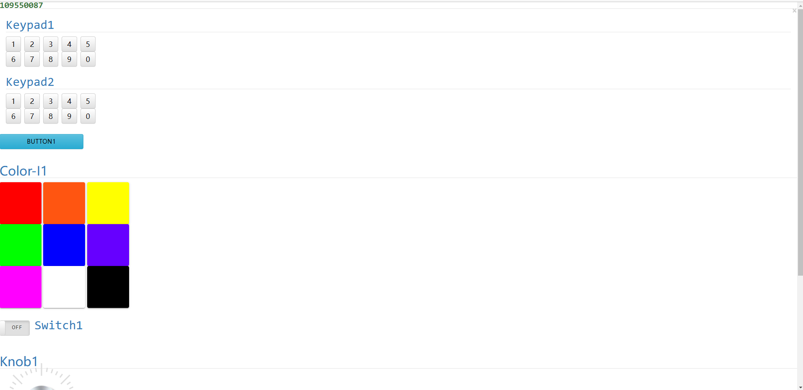

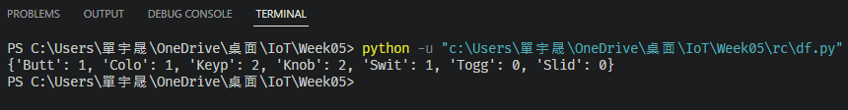

SwitchExample/csmapi.py

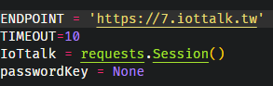

SwitchExample/app.py

