Project: TypingTutor

Java HW3 Student: ***401410081 Jovy Cheng***

### Introduction

This program helps users learn to "touch type". Users will be randomly given a pangram from a set of pangrams to type.

All key pressess are displayed with a virtual keyboard on the screen, and the character input is shown in a textarea.

To start over again from the beginning of the pangram, users can hit ENTER key, practicing more.

After closing the TypingTutor window, a plain-text report file will be created in the same directory.

Users can see which keys they have difficulty with and also the number of correct/incorrect keystrokes.

### How to run the program

Thanks to the Makefile, we can easily compile and run the program with simple commands.

To compile the program, use "$make" to help you.

And to run the program, "$make run" will do the trick.

Simply close the TypingTutor window will stop the app. After you close the window, the typing assessment report will be saved as a plain-text file, “TypingTutor-AssessmentReport-***Month***-***Day***-***Hour***-***Minute***”, where the current local time will be at the end of the file name.

As for cleaning up, use "$make clean" to do so.

### The implementation

For the GUI, the instruction and hint on top of the screen are JLabels, the text display is a JTextArea, and the virtual keyboard is a JPanel with many JButtons in it.

The TypingTutor class implements the interface KeyListener, and therefore we have three methods keyTyped(), keyPressed(), and keyReleased() to help us monitor the KeyEvents. In keyTyped(), the character is appended to the JTextArea and also, the class TypingAssessment is used to help assessing the users’ typing as well as generate the final report; in keyPressed(), we highlight the corresponding virtual key on the screen, and in keyReleased(), we undo the highlight.

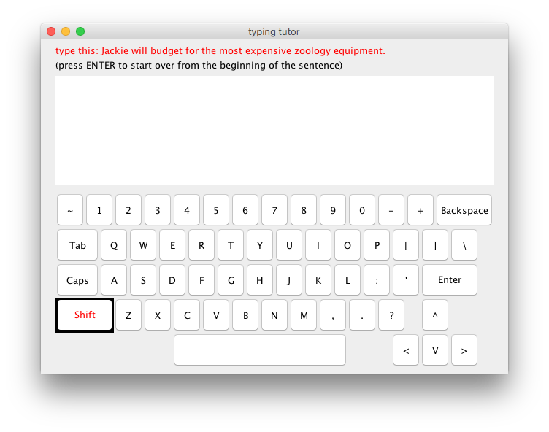

The screenshot above is the TypingTutor GUI, the pangram required is indicated in red on top, and it is picked randomly from a set of pangrams. And we can infer that the SHIFT key is being pressed since the pressed keys will have black background and red forground before they are released.