

Republic of the Philippines

**Department of Education**

Region VII, Central Visayas

**DIVISION OF MANDAUE CITY**

**Automatic Eco Waste Collecting Arduino – Based Surface Faring Portable**

**(W.A.S.P.) Drone**

**A Science Expo Innovation**

**Presented to the Department of Education**

**Region VII**

**by:**

**Kyle Christian Ballar**

**Kyle Adrian del Castillo**

**Christopher Roch Mendoza**

**Coach:**

**Erlinda A. Parba**

**September 2019**

TABLE OF CONTENTS

**Page**

**CONTENTS2**

**ABSTRACT4**

**ACKNOWLEDGEMENT5**

**CHAPTER I - The Problem: Rationale and Background7**

**CHAPTER II - Methodology13**

**CHAPTER III - Results and Discussions22**

**CHAPTER IV – Conclusion and Recommendations34**

**CHAPTER V - Bibliography35**

**Appendices36**

**Appendix A: Charts37**

**Appendix B: Data37**

**Appendix C: Documentation42**

**Appendix D: Design Diagrams45**

**Appendix E: Statistical Treatment and Program Codes46**

**ABSTRACT**

In the pursuit of environmental rehabilitation and as an investment in cleanliness and recyclable resources, the researcher sought to address the problem of excessive waste pollution in local bodies of water, hence the idea of the development of the Autonomous Eco Waste Collecting Arduino – Based Surface Faring Portable Drone, with the main objective of functionality in water traversal and efficacy in waste collection, the study underwent Concept Design and Analysis, Drone Construction, Drone Programming, Drone Testing and Customer Survey. The Drone Testing consists of trash collection capacity and rate of trash collection. The Afterwards the drone is advertised to government officials and workers who are involved in river clean-ups as part of the Customer Survey. After testing, the results were analyzed and interpreted, the researcher then concluded that the Eco W.A.S.P. Drone brings a significant improvement at trash collection.

**ACKNOWLEDGEMENT**

The goal of this research is to discover new techniques and medication that will aide in slowing down the development of carcinoma cells with the use of crude toxin extracts from Crown of Thorns Starfish. This goal will not be made possible without the assistance from different people who extended their help towards the researchers as the study goes into further processes.

Above all, the researchers would like to thank God, the omnipotent artist of every particle that exists in our world and all the other unknown worlds, yet to be discovered. He gives all praise to Him, for providing him everything he needed to conduct this study: time, motivation, and nature itself.

Second, to the Principal, Mrs..Arlina Yap-Amante who continuously supported the researchers’ endeavour and never gave up in providing the researchers enthusiasm and morale support.

Third, to Mrs. Erlinda A. Parba, our Investigatory Project Adviser, who was with us in every step of the study. The researchers also acknowledge the knowledge and information imparted by her, for without it, the group would not be guided in the research done.

Fourth, to the members of the Department of Natural Resources Region VII for offering us their time and energy.

Fifth, to the researchers’ families, friends and colleagues who continue to give moral support and motivation to the group. The unconditional love and support paved its way to the success of the study. The encouragement given by these people is one of the driving forces in accomplishing this study.

Lastly, to Mandaue City Science High School, the institution with its constituents, for opening up the opportunity for this investigatory project and for sharing ideas and facts. Without them, this experiment would not have been thought of in the first place.

**CHAPTER 1**

**THE PROBLEM: RATIONALE AND BACKGROUND**

1. **Rationale**

The Philippines generates 2.7 million tons of plastic waste annually and 20 per cent or half a million tons of plastic waste leaks into the oceans ranking the Philippines as the third-largest source of discarded plastic that ends up in the ocean, behind two other Asian nations: China and Indonesia on the 2015 report on plastic pollution by the Ocean Conservation charity and the McKinsey Centre for Business and Environment (SCMP, 2018).

As logic would dictate, huge packets of marine debris in oceans come from bodies of water in the locality, making it ideal to eliminate small bodies of plastic waste before they end up in the great pacific. Moreover, these trashes in creeks and rivers cause problems when it overflows due to heavy rain giving out a low rate of Disaster Risk Management. Even with waste collection efforts in the nation, the problem of plastic waste leakage persists, which calls for an advanced waste collection system that allows continuous maintenance and cleaning of lakes, dams, and various small bodies of water.

Moreover, Urban environmental problems such as air and water pollution, and solid wastes are grave concerns which the local communities and the government need to address. Water supply shortage (along with pollution, degrading water quality and poor sanitation) is one of the major constraints for Metro Cebu to develop into its full potentials. The highly polluted Butuanon River- which flows from Cebu City’s mountain barangays through residential, commercial and industrial areas of the cities of Cebu and Mandaue, before it drains into Mactan Channel – best exemplify the ‘water and sanitation’ issue in the country.

With this, local government units have been trying to clean up rivers in the locality, but it takes a huge amount of labor force and so usually the government take out volunteers and cleans the rivers seldomly. This is the market that the inventors are trying to gasp on; government-based costumers with the intent of cleaning the rivers and no added labor cost. Promotion of the product can be done through capitalizing on this problem with the investors providing a permanent solution.

The Eco W.A.S.P Drone utilizes an open-source electronics platform based on easy-to-use hardware and software. It has a semi-autonomous water movement which can be controlled by user or commanded to automatically patrol for waste. The drone is equipped with a conveyor belt that collects waste and stores it in a compartment; the process is all automatic upon the detection of plastic waste through 4 capacitance sensors and 2 proximity sensors. Eco W.A.S.P Drone’s driving force is the 12V DC motors powering 2 3D – printed propellers from used exhaust fans attached in the 36” x 9” x 4” expanded polystyrene frame optimized for efficient fluid dynamics to ensure smooth water drifting. This is all founded upon Arduino boards that can read inputs - light on a sensor, a finger on a button, or any mechanical prompt and turn it into various outputs. Essentially, it allows for the automation of the inventor’s design which is an unmanned Drone programmed to clean out rivers one trash at a time.

1. **Problem Identification**

This innovation is produced to create an autonomous plastic waste collecting surface fairing drone using Arduino – based systems to operate within trash - filled local bodies of water.

1. **Objectives**

Specifically, this innovation aims to attain the following objectives.

Main Objectives:

* + - 1. To develop an **Unmanned Surface Drone** with the capability of traversing through water.
      2. To create a **feasible electronic system** for autonomous aquatic plastic waste collection within small bodies of water.
      3. To develop a**mechanism made for collecting wastes** durable enough to collect plastic wastes, plastic bottles, organic wastes which include crop debris, food wastes & any type of wastes floating on water.
      4. To develop a device that will utilize the **least human interference** that is to avoid the interference of the operator. This will happen only by the adoption and sustained usage of technology in the workspace.
      5. To develop a waste collecting device that must collect approximately 14 kg of waste at a time when it is being left to the water.
      6. **Easy disposal of waste**: Waste collected from bodies of water are stored within the drone and are disposed after it reaches maximum capacity or runs low on battery.
      7. **Drone Stability**: The Eco W.A.S.P. Drone is designed to operate smoothly within bodies of water which involves calculations on center of gravity and center of buoyancy.
      8. **Ecologically friendly:** It should not harm the aquatic animals. It must not have any property that has adverse effects on the water it traverses.

Specific Objectives

* + 1. To develop an unmanned surface drone with the dimensions 36” x 24” x 17” capable of the collection of waste.
    2. To develop an electronic system capable of drone movement control via Bluetooth.
    3. To test efficacy of the Eco W.A.S.P. Drone through comparison of amount of trash collected and trash collection rate with regular labor trash collection.

1. **Significance of the Study**

**This study is significant to the following:**

**PEOPLE AND COMMUNITY.** This study will have a great effect on the community’s capability of reducing plastic wastes that end up in bodies of water.

**MARINE ECOLOGY.** The automated collection of waste will prove beneficial to many marine ecological systems, as plastic waste is an intrusive substance that threatens the growth and life of most marine species.

**FIELD OF ROBOTICS.** The Arduino-based drone will prove a remarkable standard for further research and development on electronic systems focusing on collection of aquatic plastic wastes and discover new frontiers in robotic programming.

**FIELD OF ECOSYSTEM REHABILITATION.**  This study could effectively solve the lack of manpower in our local government units and aid them by providing an unmanned drone that will takeover in the cleaning process.

1. **Existing Method/ Solution**

**Global:**

1. The existing system of cleaning rivers all throughout the world is the manual picking of trashes done by a large enough labor force to clean out an area in the local bodies of water; in Liverpool however there are River Cleaning Trash Skimmers, these skimmers are large boats that requires to be manned and does not have the capability of traversing into small rivers and streams filled with trashes.

**Local:**

1. Locally, there currently are no solutions about trash collection but solely the government’s reliance to its workers in picking up trashes in the local bodies of water.
2. **Definition of Terms**

**Arduino Mega -** Is an open source microcontroller board based on the Microchip ATMEGA32 microcontroller and developed by Arduino cc (“www.arduino.cc”, 2018). In this study, the microcontroller used by the researcher is connected the different sensors and motors of the device.

**L298N Motor Drivers -** The L298N  Motor Driver Module is a high voltage Dual H-Bridge manufactured by ST company. It is designed to accept standard TTL voltage levels. H-bridge drivers are used to drive inductive loads that requires forward and reverse function with speed control such as DC Motors, and Stepper Motors. This Dual H-Bridge driver is capable of driving voltages up to 46V and continuous current up to 2A in each channels.

**HC-05 Bluetooth Module -** HC-05 is a Bluetooth device used for wireless communication. It works on serial communication (USART)It is a 6 pin module. The device can be used in 2 modes; data mode and command mode.The module HC-05 Bluetooth module has 3.3 V level for RX/TX and the microcontroller can detect 3.3 V level, so, no need to shift transmit level of the HC-05 module. But we need to shift the transmit voltage level from the microcontroller to RX of HC-05 module.

**USV-**are boats that operate on the surface of the water without a crew, in this study the drone is considered as an Unmanned Surface Drone, which incurs the least human involvement in waste collection .

**CHAPTER II**

**Methodology**

1. **Conept Design and Analysis**

The Concept Design and Analysis Phase of the invention is concluded in 3 parts, which proceeds as:

* 1. **W.A.S.P. Drone Conceptual Design**

The W.A.S.P. Drone’s initial design is drawn in paper, as a guide for a pending detailed design.

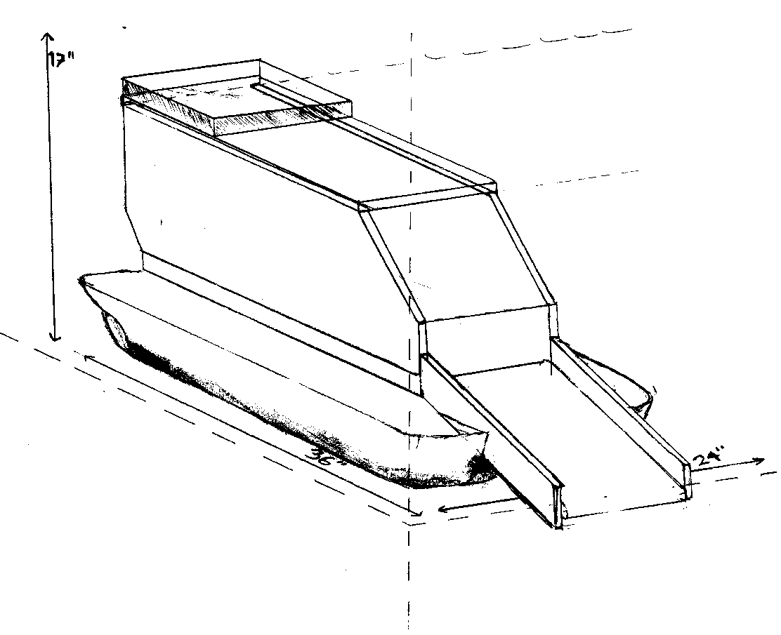

* 1. 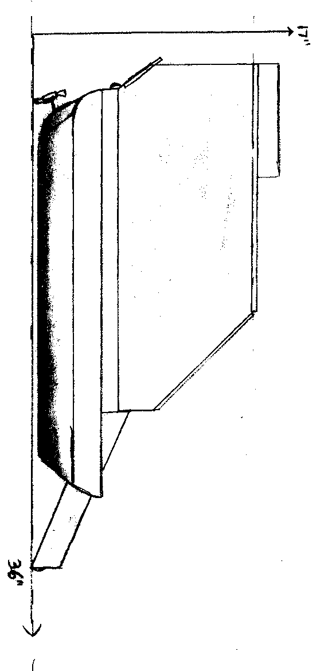**W.A.S.P. Drone Detailed Design**

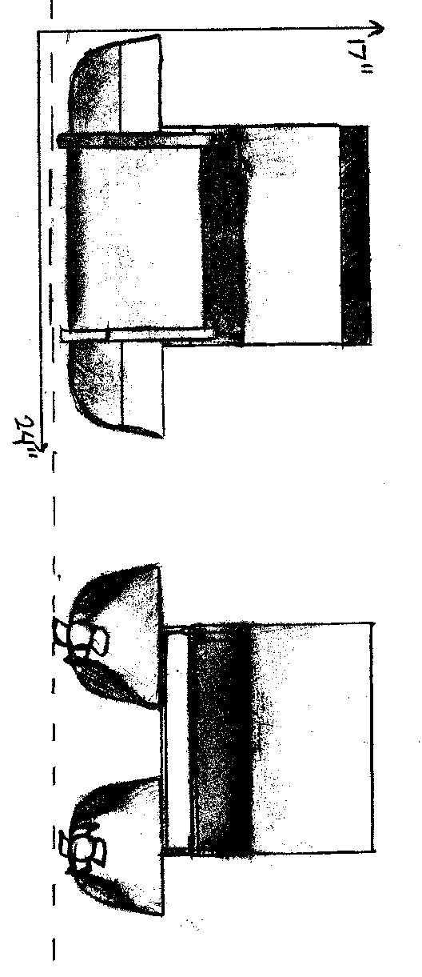The W.A.S.P. Drone’s detailed design is created to guide the assembly of the drone.

* 1. **W.A.S.P. Drone buoyancy calculations**

Maximum drone density ***ρ*d**is calculated where in ***ρ*d ≤ $500 {kg}/{m^{3}}$**

Where $500 {kg}/{m^{3}}$ is theoretical density attained when height of submerged hull in water***h*≤ 2.5 inches**.

Drone density is calculated as:

***ρ*d**= $\frac{{m_{1}+m_{2}}_{}}{V}$,

where: ***m1* =** Drone mass,

***m2***= Drone load,

***V***= Hull Theoretical Volume

*Therefore,*

***ρ*d= $\frac{9kg+0 (initial load)}{3204 {in}^{3}}$**

***ρ*d= 169.51 kg/m3**

Moreover, theoretical height of hull submerged***y*** in water is calculated as:

***y* = $\frac{ρd}{ρwater} h$** ,

where: $ρd$**=** Drone density

$ρwater$ = Water density, which is **1000 kg/m3**(fresh water)

***h***= Height of hull

*Therefore,*

***y* = $\frac{169.51}{1000} h$** ,

***y* = (0.16951) 5 in.**

***y* = 0.84755 ≈ 0.85 inches**

Based on the calculations, the W.A.S.P. Drone’s Theoretical initial state height of hull submerged is **≈ 0.85 inches.**

In conclusion, theoretical maximum load of drone is calculated as:

**500 kg/m3=** ,

**=17.547045 kg**

Based on the calculations, the theoretical maximum load is **≈ 17.55 kg.**

1. **Drone Construction**
2. **W.A.S.P Drone Frame**
3. Used expanded polystyrene cooler boxes and plyboard pieces were gathered from the houses of the inventors. (36x24x17)(Figure1)
4. **W.A.S.P Drone Electronics**
5. All electrical parts were bought in Bitstoc; Tres Borces Padres St., Cebu City. (Arduino Mega, L298N Motor Drivers , 4 DC Motors , 2 servo Motors, HC05 Bluetooth Module, half – sized breadboard, 6 – Port 1.5 volt Batter holder)
6. **Polystyrene-Plyboard Frame**
7. **The Hull**
8. Expanded polystyrene were marked with the specific measurements (36” x 9” x5”)
9. Carving and cutting the polystyrene
10. **The Walls**
11. Expanded polystyrene were marked with the specific measurements (15”x 0.1” x 15”) 1pc, (26”x0.1”x13”) 2 pcs.
12. Carving and cutting the polystyrene
13. **The Base**
14. The base is made of ply board (26” x 15” x 2.5”)
15. **The Conveyor**
    * + 1. The conveyor belt is made of rubber conveyor belt (77” x 14”)
16. **Assembling of Arduino Systems Circuitry**
17. **Blackbox**
18. The base is the cover of a used expanded polystyrene cooler box.
19. The circuit is attached on the base.
20. **Systems Build-up**
21. The inventors mounted the parts on the base.
    1. Arduino Mega on the right most side.
    2. 2 pcs L298N Motor Drivers on the left most side.
    3. HC-05 Bluetooth Module beside the motors.
    4. 2 pcs 6 – Port 1.5 Volt Battery Holder
    5. Half sized Breadboard
22. The inventors then connected all components in the Arduino – SystemsCircuitry.
23. **W.A.S.P Drone Programming**
24. 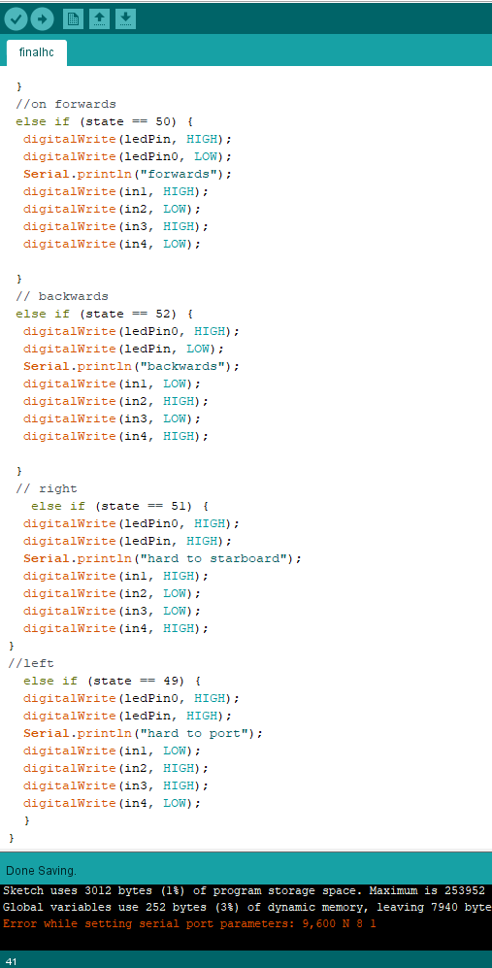**Drone Startup**
25. 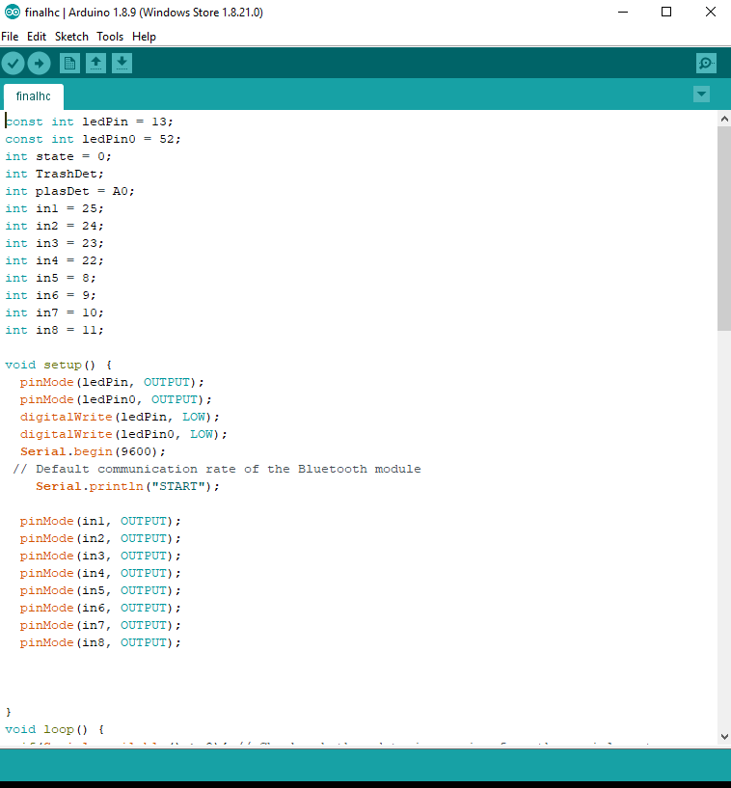**Bluetooth Motor Control**
26. **Autonomous Waste Collection**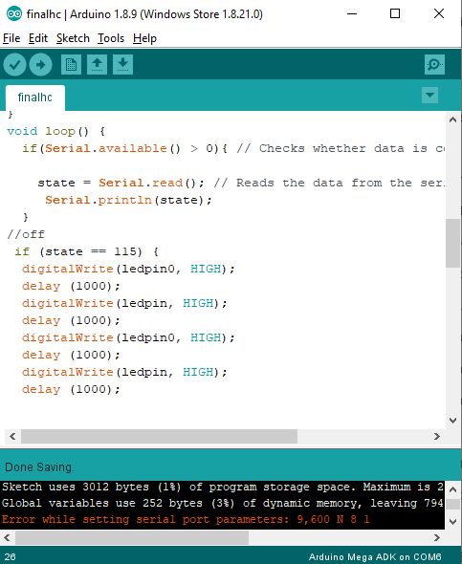
27. **The Eco W.A.S.P Drone**
28. **The inventors attached the Circuit on the frame.**
29. **Insertion of Motors and Propellers**
30. **Attachment of batteries**
31. **The Eco W.A.S.P Drone Control**
32. **Arduino Bluetooth Controller**
33. The inventor downloaded the application on a mobile phone and is connected to the drone via Bluetooth, which allows control over drone through Bluetooth.
34. **Efficacy of W.A.S.P Drone**
35. **Motor Functionality Test**
    * + 1. The drone was placed on a 5 ft deep swimming pool, and was tested for:

i. Forward Movement

ii. Backward Movement.

1. **Drone Power Test**
   * + 1. The drone’s 6-port 1.5v battery powered dual motors were tested for their life span in operation:

i. Propeller Life Span Test:

This test consists of:

* Moving Test: Lifespan of batteries while propellers are working
* Steady Test: Lifespan of batteries while propellers are on standby
  + 1. Conveyor Life Span Test
* Working Test: Lifespan of batteries while conveyor is working
* Steady Test: Lifespan of batteries while conveyor is on standby

1. **Rate of Trash Collecting**
2. The Drone was placed on a 5 ft swimming pool filled with trashes which simulates a river filled with trash, a stop watch was then utilized which was lapped every time a trash was collected, the trash was then weighed to determine the rate of trash being collected (grams / seconds) (10 Trials).
3. **Amount of trash collected**
4. Trashes were weighed and placed on top of the W.A.S.P Drone until it begins to sink to determine its capacity. A mark was placed on the hull 2.5 inches from the bottom; the mark must not be passed. (5Trials)
5. **Customer Survey**
   * + 1. The inventors conducted a survey to determine the advantages and disadvantages of the current solution in cleaning out trashes in local bodies of water (Manual picking of trashes) to be compared with the efficacy of data produced by the W.A.S.P Drone.

Customers:

1. Local Government Units
2. Barangay Officials
3. City Cleaners

**CHAPTER III**

**Results and Discussion**

**Efficacy of W.A.S.P Drone**

1. **Motor Functionality Test**
   * 1. **Forward Movement**
     2. Forward

|  |  |  |  |
| --- | --- | --- | --- |
| **Trials** | **Distance** | **Time** | **Rate** |
| **1** | **10m** | **10.59 s** | **0.91 m/s** |
| **2** | **10m** | **10.19s** | **0.97 m/s** |
| **3** | **10m** | **11.7s** | **0.90 m/s** |
| **Mean** | **10m** | **10.50 s** | **0.95 m/s** |

Descriptive Results:

After 3 trials of drone traversal through 10m of water, the drone completed trial 1 within 10.59s with a speed of 0.91 m/s, trial 2 within 10.19s with a speed of 0.97 m/s, trial 3 within 11.7s with a speed of 0.90 m/s. The average time the drone takes to travel 10m is 10.50s, and its average movement speed is 0.95 m/s.

* + 1. Backward Movement

|  |  |  |  |
| --- | --- | --- | --- |
| **Trials** | **Distance** | **Time** | **Rate** |
| **1** | **10m** | **10.89 s** | **0.92 m/s** |
| **2** | **10m** | **10.79s** | **0.93 m/s** |
| **3** | **10m** | **10.02 s** | **1.0 m/s** |
| **Mean** | **10m** | **10.57 s** | **0.95 m/s** |

DescriDescriptive Results:

After 3 trials of drone backward traversal through 10m of water, the drone completed trial 1 within 10.89s with a speed of 0.92 m/s, trial 2 within 10.79s with a speed of 0.93 m/s, trial 3 within 10.02 s with a speed of 1.0 m/s. The average time the drone takes to travel 10m backwards is 10.57s, and its average speed is 0.95 m/s.

1. **Drone Propeller Power Test**
   * 1. Propeller Moving Test

|  |  |
| --- | --- |
| **Trials** | **Life Span** |
| **1** | **10.50 hours** |
| **2** | **10.49 hours** |
| **3** | **10.50 hours** |
| **Mean** | **10.50 hours** |

* + 1. Propeller Steady Test

|  |  |
| --- | --- |
| **Trials** | **Life Span** |
| **1** | **72 hours** |
| **2** | **71.99 hours** |
| **3** | **71.98 hours** |
| **Mean** | **71.99 hours** |

Descriptive Results:

After 3 trials of propeller power moving and steady test, the inventors have concluded that the propellers can last up to 10.50 hours while moving and up to 72 hours while steady.

1. **Drone Conveyor Power Test**
   * 1. Conveyor Moving Test

|  |  |
| --- | --- |
| **Trials** | **Life Span** |
| **1** | **10.5 hours** |
| **2** | **10.5 hours** |
| **3** | **10.49 hours** |
| **Mean** | **10.5 hours** |

* + 1. Conveyor Steady Test

|  |  |
| --- | --- |
| **Trials** | **Life Span** |
| **1** | **72.00 hours** |
| **2** | **72.00 hours** |
| **3** | **71.99 hours** |
| **Mean** | **72.00 hours** |

Descriptive Results:

After 3 trials of conveyor power moving and steady test, the inventors have concluded that the conveyor motors can last up to 10.5 hours while moving and up to 72 hours while steady.

1. **Trash Collection Rate**

|  |  |  |  |
| --- | --- | --- | --- |
| **Trials** | **Type of Trash** | **Time** | **Rate** |
| **1** | **Plastic Bottle**  **(14.31 g)** | **4.37 s** | **3.27 g/s** |
| **2** | **Tetra pack**  **(7.32 g)** | **3.33 s** | **2.2 g/s** |
| **3** | **Plastic Bag**  **(5.41 g)** | **2.1 s** | **2.6 g/s** |
| **4** | **Plastic Bag**  **(6.32 g)** | **2.23 s** | **2.9 g/s** |
| **5** | **Cigarette Butt**  **(1.3 g)** | **1.95 s** | **0.67 g/s** |
| **6** | **Food packaging**  **(8.12 g)** | **3.21 s** | **2.53 g/s** |
| **7** | **Plastic Bag**  **(6.2 g)** | **4.2 s** | **1.48 g/s** |
| **8** | **Bottle Cap**  **(.92 g)** | **2.37 s** | **.39 g/s** |
| **9** | **Plastic Bottle**  **(12.3 g)** | **4.5 s** | **2.73 g/s** |
| **10** | **Tetra pack**  **(7.2 g)** | **2.47 s** | **2.91 g/s** |
| **Mean** | **6.94 g** | **3.073 s** | **2.26 g/s** |

Figure 1.1 Data of Trash Collection Rate

**Arithmetic:**

* 1. g/s x 1 kg/ 1000 g x 3600s/1hr = 8.136 kg/hr

Descriptive Results:

Figure 1.1 shows the average weight the trashes can yield taking into consideration the type of trash which is 6.94 grams. The average time was then taken which is 3.073 seconds to determine the average rate. With the data gathered the average rate for trash collection is 2.26 grams/second.

1. **Amount of Trash Collected**

Figure 2.1 Data of Customer Response

|  |  |  |  |
| --- | --- | --- | --- |
| **Trials** | **Weight of Trash** | **Height Submerged** | **Distance from the Mark** |
| **1** | **14.3 kg** | **2.41 inches** | **0.3 inches** |
| **2** | **15 kg** | **2.52 inches** | **0.52 inches** |
| **3** | **14.8 kg** | **2.49 inches** | **0.1 inch** |
| **4** | **15 kg** | **2.52 inches** | **-0.04 inches** |
| **5** | **14.5 kg** | **2.48 inches** | **0.02 inches** |
| **6** | **14.1 kg** | **2.32 inches** | **0.18 inches** |
| **7** | **14.6 kg** | **2.38 inches** | **0.12 inches** |
| **8** | **15.5 kg** | **2.62 inches** | **-0.07 inches** |
| **9** | **14.9 kg** | **2.5 inches** | **0.00 inches** |
| **10** | **15.3 kg** | **2.57 inches** | **.04 inches** |
| **Mean** | **14.8 kg** | **2.483 inches** |  |

Figure 1.2 Data of Trash Collection Amount

**Arithmetic:**

Maximumload whereinheight submerged ≤ 2.5 inches

14.8 kg ÷ 2.483 inches = 5.96 kg/inch

5.96 kg/inch × 2.5 inches = 14.9 kg

Maximum load = **14.9 kg**

Descriptive Results:

Figure 1.2 determined the average mass the Drone carried which was 14.8 kilograms and submerged the hull with an average height of 2.483 inches. With this, the investors computed the Drone’s maximum load which is 14.9 kilograms.

**Customer Survey**

The inventors conducted a survey to determine the advantages and disadvantages of the current solution in cleaning out trashes in local bodies of water (Manual picking of trashes) to be compared with the efficacy of data produced by the W.A.S.P Drone.

1. Customers:
   * + 1. Local Government Units
       2. Barangay Officials
       3. City Cleaners
2. 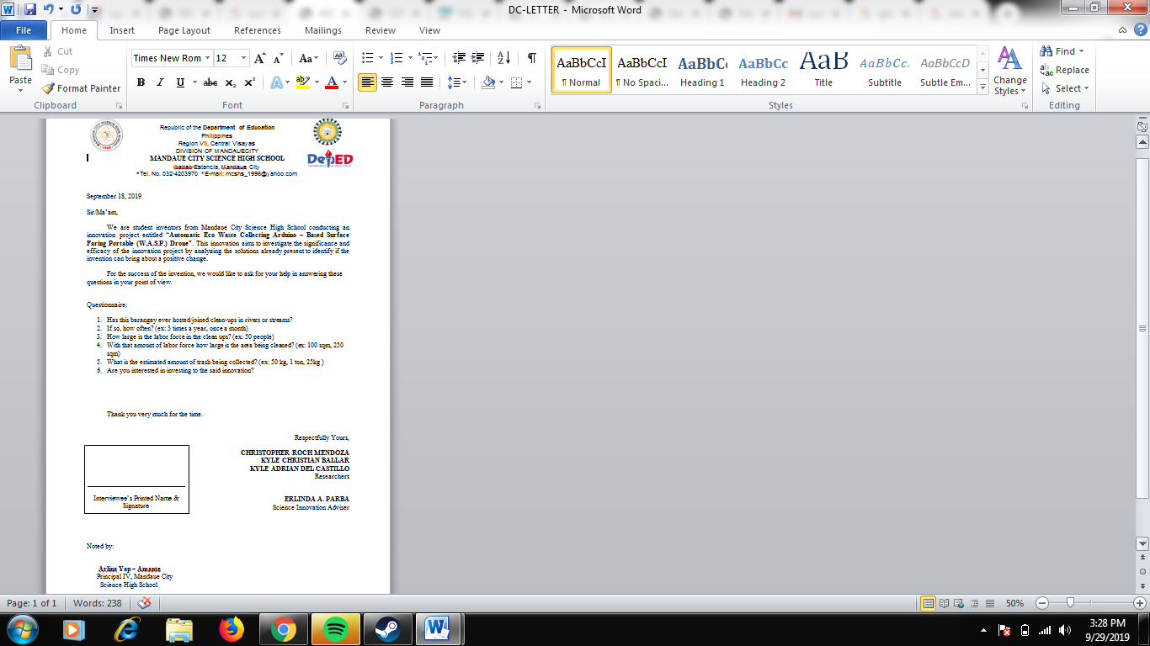Survey Questionnaire:

**CUSTOMER SURVERY MATRIX**

|  |  |  |  |  |  |  |  |  |
| --- | --- | --- | --- | --- | --- | --- | --- | --- |
| **RAW DATA MANUAL BRGY CLEAN UPS** | | | | | | | | |
|  | **Customer Name** | **Experienced Brgy River Clean-ups** | **How often?** | **Amount of labor force** | **Amount of trash collected** | **Time spent in the clean –up** | **Interested in investing**  **(W.A.S.P Drone)** | **Reason of interest** |
|  | **Dexter J. Omolon**  **( Brgy. Kagawad)** | **Yes** | **4 times a year** | **300 people** | **4000 kg** | **5 hours** | **Yes** | **Less Labor Force** |
|  | **Lucilyn Mendoza**  **( City Health Officer)** | **Yes** | **4 times a year** | **400 people** | **3500 kg** | **4 hours** | **Yes** | **Safer Method ( Clean ups are a health risk)** |
|  | **Eldie Rosales**  **( Clean up volunteer** | **Yes** | **4 times a year** | **350 people** | **5000 kg** | **3 hours** | **Yes** | **Less Labor Force** |
|  | **Kevin Rosales**  **( Clean up volunteer)** | **Yes** | **4 times a year** | **300 people** | **4000 kg** | **4 hours** | **Yes** | **Cleaning rivers is not my job.** |
|  | **Thomas Edison Villarosa**  **(BPSO)** | **Yes** | **4 times a year** | **500 people** | **3000 kg** | **5 hours** | **Yes** | **Less Labor Force** |
|  | **Jose F. Layese Jr.**  **(SCWERC Provincial Director)** | **Yes** | **4 times a year** | **400 people** | **4500 kg** | **4 hours** | **Yes** | **Less Margin of Error** |
|  | **Maria ThereasaLayese**  **(FMB Project Management)** | **Yes** | **4 times a year** | **450 people** | **2500 kg** | **4 hours** | **Yes** | **Less Margin of Error** |
|  | **Mean** |  | **4** | **385 people** | **3785 kg** | **4 hours** |  |  |

**Arithmetic:**

3785 kg ÷ 385 people ÷ 4 hours

= 2.46 kg/hr per person

= 0.683 g/s 3785kg/4 hours

Figure 2.3 Data on W.A.S.P Drone vs. Manual Clean-up

= **946.25 kg**

Descriptive Results:

Figure 2.2 shows the experience and testimony of customers regarding the clean-up drive for butuanon river, including their interest and reason of interest in the Eco W.A.S.P. Drone. It is shown that a mean of 3785 kg of trash is collected per clean up and and average of 4 hours is spent to finish.

Moreover, it is shown that all 7 out of 7 customers are interested in the Eco W.A.S.P. Drone, with the prevailing reason of interest of “Less Labor Force”

|  |  |  |  |  |
| --- | --- | --- | --- | --- |
| **COMPARISON** | | | | |
|  | **Amount of trash collected per hour** | **Labor Force Equivalence (946.25 kg of trash)** | **Health Risk** | **Times it can clean (with proper maintenance)** |
| **W.A.S.P**  **Drone** | **8.136 kg per Drone** | **116 Drones** | **None** | **Everyday** |
| **Manual Clean - Up** | **2.46 kg per person** | **385 people** | **Present** | **4 times a year** |

**Comparison of Manual Labor vs W.A.S.P. Drone**

Descriptive Results:

Figure 2.3 portrays a comparison table for the W.A.S.P Drone and Manual Clean –up. W.A.S.P Drone showed the highest amount of trash collected with the least labor force equivalence in cleaning up 3785 kg of trash. The drone in rivers poses no health risk and is capable to function every day.

**CHAPTER IV**

**Conclusion**

The Automatic Eco Waste Collecting Arduino – Based Surface Faring Portable (W.A.S.P.) Drone was tested through its trash collection rate and trash capacity. It was then compared to the Manual Clean – up with the same parameters in which its data was gathered through a survey to the potential costumers. The inventors noticed a huge difference between the results of the Drone and that of the Manual Clean-up.

A T – test was done to the data results of both the Drone and Manual Clean – up, which gave a significant difference that yielded positive greater values for the Drone in the given parameters.

The Drone which sole purpose is to clean out small bodies of water filled with trashes like rivers did not only prove to be a more effective method of cleaning, but it also provided customer benefits. With less human interference and no risk of meeting contaminants in water as to compared to manual cleaning the W.A.S.P. Drone could truly be the key to a sustainable community with clean bodies of water.

As far as the innovation is concerned, the inventors have drawn, through the data gathered from the statistical test and from observations, that Automatic Eco Waste Collecting Arduino – Based Surface Faring Portable (W.A.S.P.) Drone, when used as a river cleaning method may bring about a positive change to the current disposition.

**CHAPTER V**

**BIBLIOGRAPHY**

[1] Steven F. Barrett. Arduino Microcontroller Processing for Everyone! Third Edition, August 2013. 17(7): p. 317-320 Retrieved July 2019 from

<https://www.researchgate.net/publication/245551160>

[2]Vincent A. Balogun, Omonigho B. Otanocha, Bankole I. Oladapo. (2017) Development of smart linear velocity measuring device by embedding sensors with the arduino microcontroller. *Proceedings of the 1st International Conference on Internet of Things and Machine Learning - IML '17*, May 2018. 332, 1-5. doi:10.1088/1742-6596/662/1/012031

[3] Tchoketch Kebir, Mounir Bouhedda, Slimane Mekaoui, Mohamed Guesmi, Abderrahim Dou. (2016) Gesture control of mobile robot based arduino microcontroller. *2016 8th International Conference on Modelling, Identification and Control (ICMIC)*, 1081-1085.

[4] Cunningham, D. J., & Wilson, S. P. (2003). Marine debris on beaches of the Greater Sydney Region. Journal of Coastal Research, 19(2), 421-430. Retrieved July 2019 from

<https://researchers.mq.edu.au/en/publications/marine-debris-on-beaches-of-the-greater-sydney-region>

[5] Smith, S.D., & Edgar, R.J. (2014). Documenting the Density of Subtidal Marine Debris across Multiple Marine and Coastal Habitats. PLOS ONE, 9(4). Retrieved July 2019, from <https://www.ncbi.nlm.nih.gov/pmc/articles/PMC3990570/>

[6] Gregory MR (2009) Environmental implications of plastic debris in marine settings-entanglement, ingestion, smothering, hangers-on, hitch-hiking and alien invasions. Philos Trans R Soc Lond B Biol Sci364: 2013–2025. Retrieved July 2019 from <https://www.ncbi.nlm.nih.gov/pmc/articles/PMC3990570/>

[7] Smith SDA (2012) Marine debris: A proximate threat to marine sustainability in Bootless Bay, Papua New Guinea. Mar Pollut Bull 64: 1880–1883. Retrieved July 2019 from <https://www.ncbi.nlm.nih.gov/pmc/articles/PMC3990570/>

[8] Picardal, J., Bendoy, A., Calumba, J., &Marababol, M. (2012). Impacts of Waste Disposal Practices and Water Utilization of Riverside Dwellers on Physicochemical and Microbiological Properties of Butuanon River, Central Visayas. CNU Journal Of Higher Education, 6(1), 78-100. Retrieved from <http://jhe.cnu.edu.ph/index.php/cnujhe/article/view/125>

[9] Martin (2014) Product Design – The Complete Guide. Retrieved July 19, 2019, from <https://www.cleverism.com/product-design/>

[10] The Butuanon River Rehabilitation: A Test Case 3 THE BUTUANON RIVER EMB-7 (2000), retrieved July 19 2019, from <https://www.sunstar.com.ph/article/105089>

**APPENDIX A**

- Investment Intentions

**CHART 1**

**CHART 2 –**Trash Collection Rate

**APPENDIX B**

**TABLE 1 – Trash Collection Rate**

|  |  |  |  |
| --- | --- | --- | --- |
| **Trials** | **Type of Trash** | **Time** | **Rate** |
| **1** | **Plastic Bottle**  **(14.31 g)** | **4.37 s** | **3.27 g/s** |
| **2** | **Tetra pack**  **(7.32 g)** | **3.33 s** | **2.2 g/s** |
| **3** | **Plastic Bag**  **(5.41 g)** | **2.1 s** | **2.6 g/s** |
| **4** | **Plastic Bag**  **(6.32 g)** | **2.23 s** | **2.9 g/s** |
| **5** | **Cigarette Butt**  **(1.3 g)** | **1.95 s** | **0.67 g/s** |
| **6** | **Food packaging**  **(8.12 g)** | **3.21 s** | **2.53 g/s** |
| **7** | **Plastic Bag**  **(6.2 g)** | **4.2 s** | **1.48 g/s** |
| **8** | **Bottle Cap**  **(.92 g)** | **2.37 s** | **.39 g/s** |
| **9** | **Plastic Bottle**  **(12.3 g)** | **4.5 s** | **2.73 g/s** |
| **10** | **Tetra pack**  **(7.2 g)** | **2.47 s** | **2.91 g/s** |
| **Mean** | **6.94 g** | **3.073 s** | **2.26 g/s** |

**TABLE 2 – Amount of Trash Collected**

|  |  |  |  |
| --- | --- | --- | --- |
| **Trials** | **Weight of Trash** | **Height Submerged** | **Distance from the Mark** |
| **1** | **14.3 kg** | **2.41 inches** | **0.3 inches** |
| **2** | **15 kg** | **2.52 inches** | **0.52 inches** |
| **3** | **14.8 kg** | **2.49 inches** | **0.1 inch** |
| **4** | **15 kg** | **2.52 inches** | **-0.04 inches** |
| **5** | **14.5 kg** | **2.48 inches** | **0.02 inches** |
| **6** | **14.1 kg** | **2.32 inches** | **0.18 inches** |
| **7** | **14.6 kg** | **2.38 inches** | **0.12 inches** |
| **8** | **15.5 kg** | **2.62 inches** | **-0.07 inches** |
| **9** | **14.9 kg** | **2.5 inches** | **0.00 inches** |
| **10** | **15.3 kg** | **2.57 inches** | **.04 inches** |
| **Mean** | **14.8 kg** | **2.483 inches** |  |

**TABLE 3 -Customer Survey Matrix**

|  |  |  |  |  |  |  |  |
| --- | --- | --- | --- | --- | --- | --- | --- |
| **Customer Name** | **Experienced Brgy River Clean-ups** | **How often?** | **Amount of labor force** | **Amount of trash collected** | **Time spent in the clean –up** | **Interested in investing**  **(W.A.S.P Drone)** | **Reason of interest** |
| **Dexter J. Omolon**  **( Brgy. Kagawad)** | **Yes** | **4 times a year** | **300 people** | **4000 kg** | **5 hours** | **Yes** | **Less Labor Force** |
| **Lucilyn Mendoza**  **( City Health Officer)** | **Yes** | **4 times a year** | **400 people** | **3500 kg** | **4 hours** | **Yes** | **Safer Method ( Clean ups are a health risk)** |
| **Eldie Rosales**  **( Clean up volunteer** | **Yes** | **4 times a year** | **350 people** | **5000 kg** | **3 hours** | **Yes** | **Less Labor Force** |
| **Kevin Rosales**  **( Clean up volunteer)** | **Yes** | **4 times a year** | **300 people** | **4000 kg** | **4 hours** | **Yes** | **Cleaning rivers is not my job.** |
| **Thomas Edison Villarosa**  **(BPSO)** | **Yes** | **4 times a year** | **500 people** | **3000 kg** | **5 hours** | **Yes** | **Less Labor Force** |
| **Jose F. Layese Jr.**  **(SCWERC Provincial Director)** | **Yes** | **4 times a year** | **400 people** | **4500 kg** | **4 hours** | **Yes** | **Less Margin of Error** |
| **Maria ThereasaLayese**  **(FMB Project Management)** | **Yes** | **4 times a year** | **450 people** | **2500 kg** | **4 hours** | **Yes** | **Less Margin of Error** |
| **Mean** |  | **4** | **385 people** | **3785 kg** | **4 hours** |  |  |

**TABLE 4 – Comparison of Manual Labor vs W.A.S.P. Drone**

|  |  |  |  |  |
| --- | --- | --- | --- | --- |
| **COMPARISON** | | | | |
|  | **Amount of trash collected per hour** | **Labor Force Equivalence (946.25 kg of trash)** | **Health Risk** | **Times it can clean (with proper maintenance)** |
| **W.A.S.P**  **Drone** | **8.136 kg per Drone** | **116 Drones** | **None** | **Everyday** |
| **Manual Clean - Up** | **2.46 kg per person** | **385 people** | **Present** | **4 times a year** |

**APPENDIX C**

**DOCUMENTATI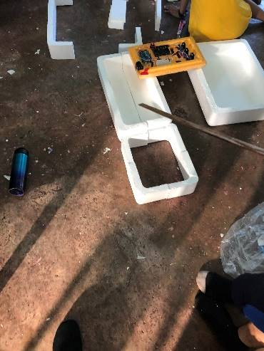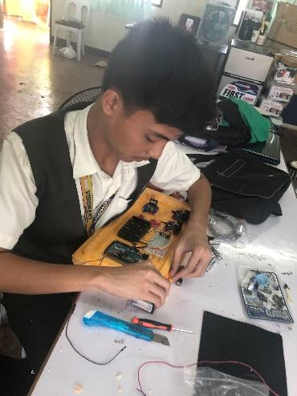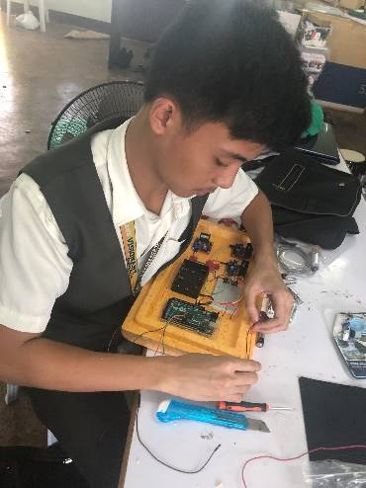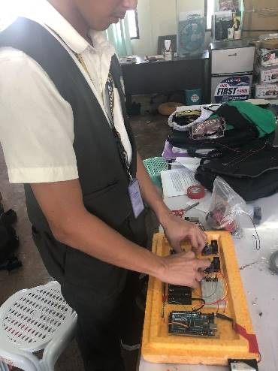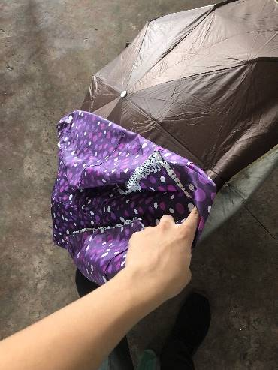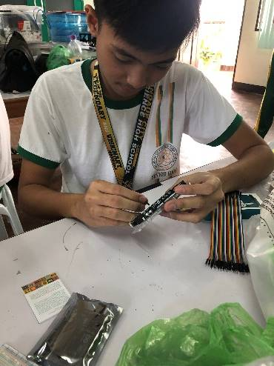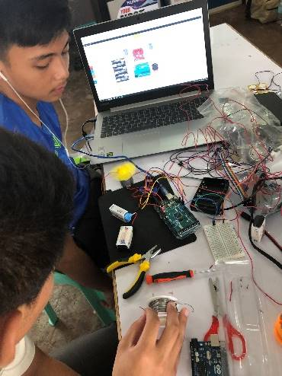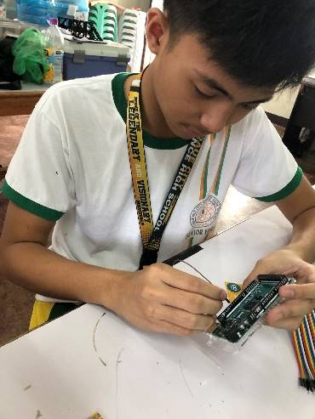ON**

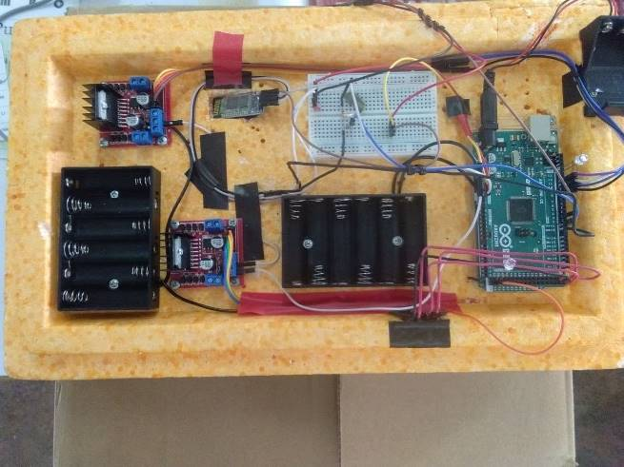

**APPENDIX D**

**DESIGN DIAGRAMS**

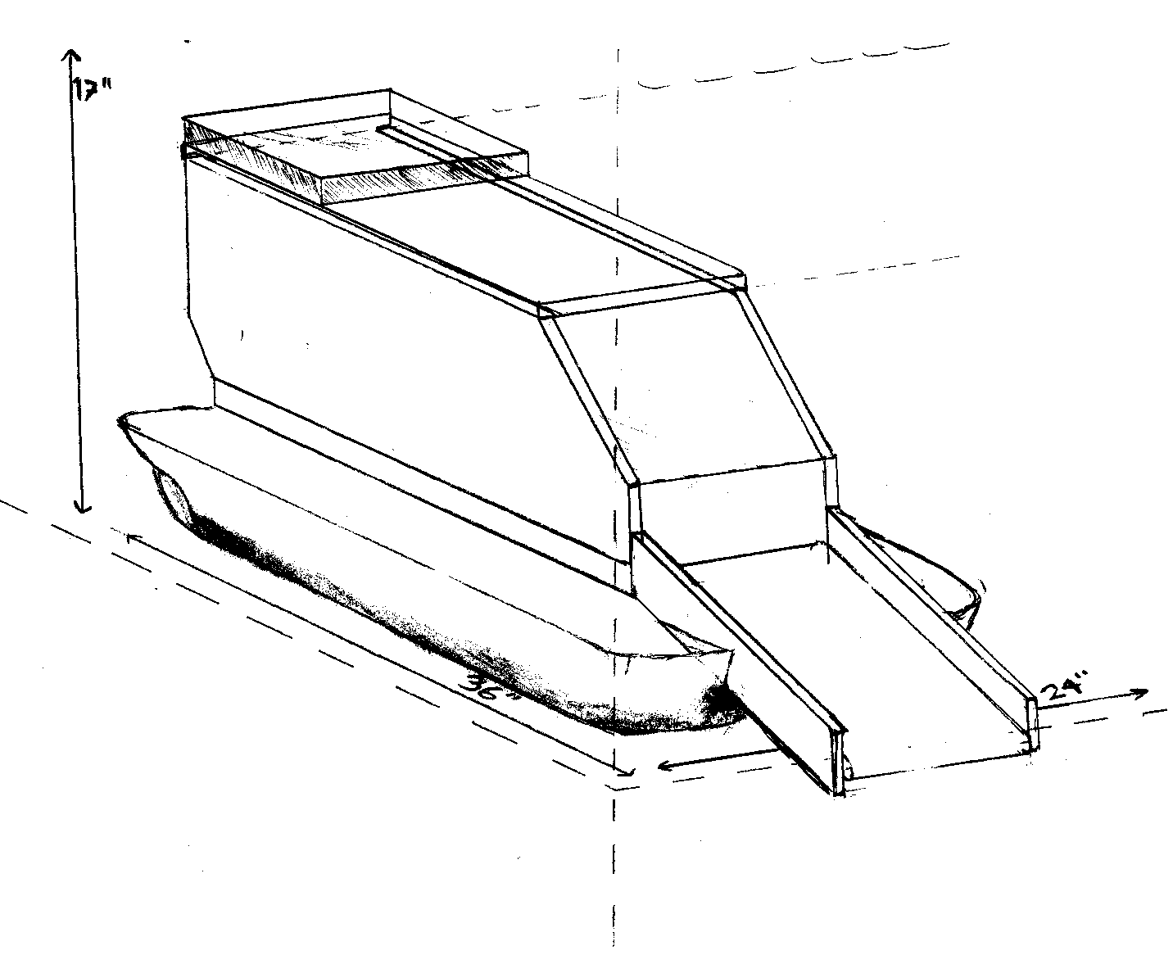





**APPENDIX E**

**STATISTICAL TREATMENT & PROGRAM CODES**

|  |  |  |  |
| --- | --- | --- | --- |
| Trials | mass (g) | time (s) | rate (g/s) |
| 1 | 14.31 | 4.37 | 3.27 |
| 2 | 7.32 | 3.33 | 2.2 |
| 3 | 5.41 | 2.1 | 2.6 |
| 4 | 6.32 | 2.23 | 2.9 |
| 5 | 1.3 | 1.95 | 0.67 |
| 6 | 8.12 | 3.21 | 2.53 |
| 7 | 6.2 | 4.2 | 1.48 |
| 8 | 0.92 | 2.37 | 0.39 |
| 9 | 12.3 | 4.5 | 2.73 |
| 10 | 7.2 | 2.47 | 2.91 |
| ave | 6.94 g | 3.073 | 2.26 |
| SD |  |  | 0.99 |

**T - test**

|  |
| --- |
| Result |
| There is significant mean gain |

|  |  |  |  |  |  |  |  |
| --- | --- | --- | --- | --- | --- | --- | --- |
| Trials |  | Average | Standard Deviation |  | p-value | level of significance |  |
| 10 | 0.683 | 2.2600 | 0.9896 | 5.0393 | 1.0x10-5 | 0.05 |  |

**Conclusion: The drone has attained significant mean gain, which proves its efficacy and superiority in trash collection.**

1. **Drone Startup**
2. **Bluetooth Motor Control**
3. **Autonomous Waste Collection**