ELEC 3300 Project Summary Sheet
This is a ONE Page Summary Sheet, Content more than 1 page will be deleted.
All the fonts used in this Sheet should be in Times New Roman at 12 points

Group Number | 17
Project Title | LED Spinning Display
Name of Student 1 | DoHoon Kim
Name of Student 2 | YangSoo Yoon

Please attach ONE photo of your project here


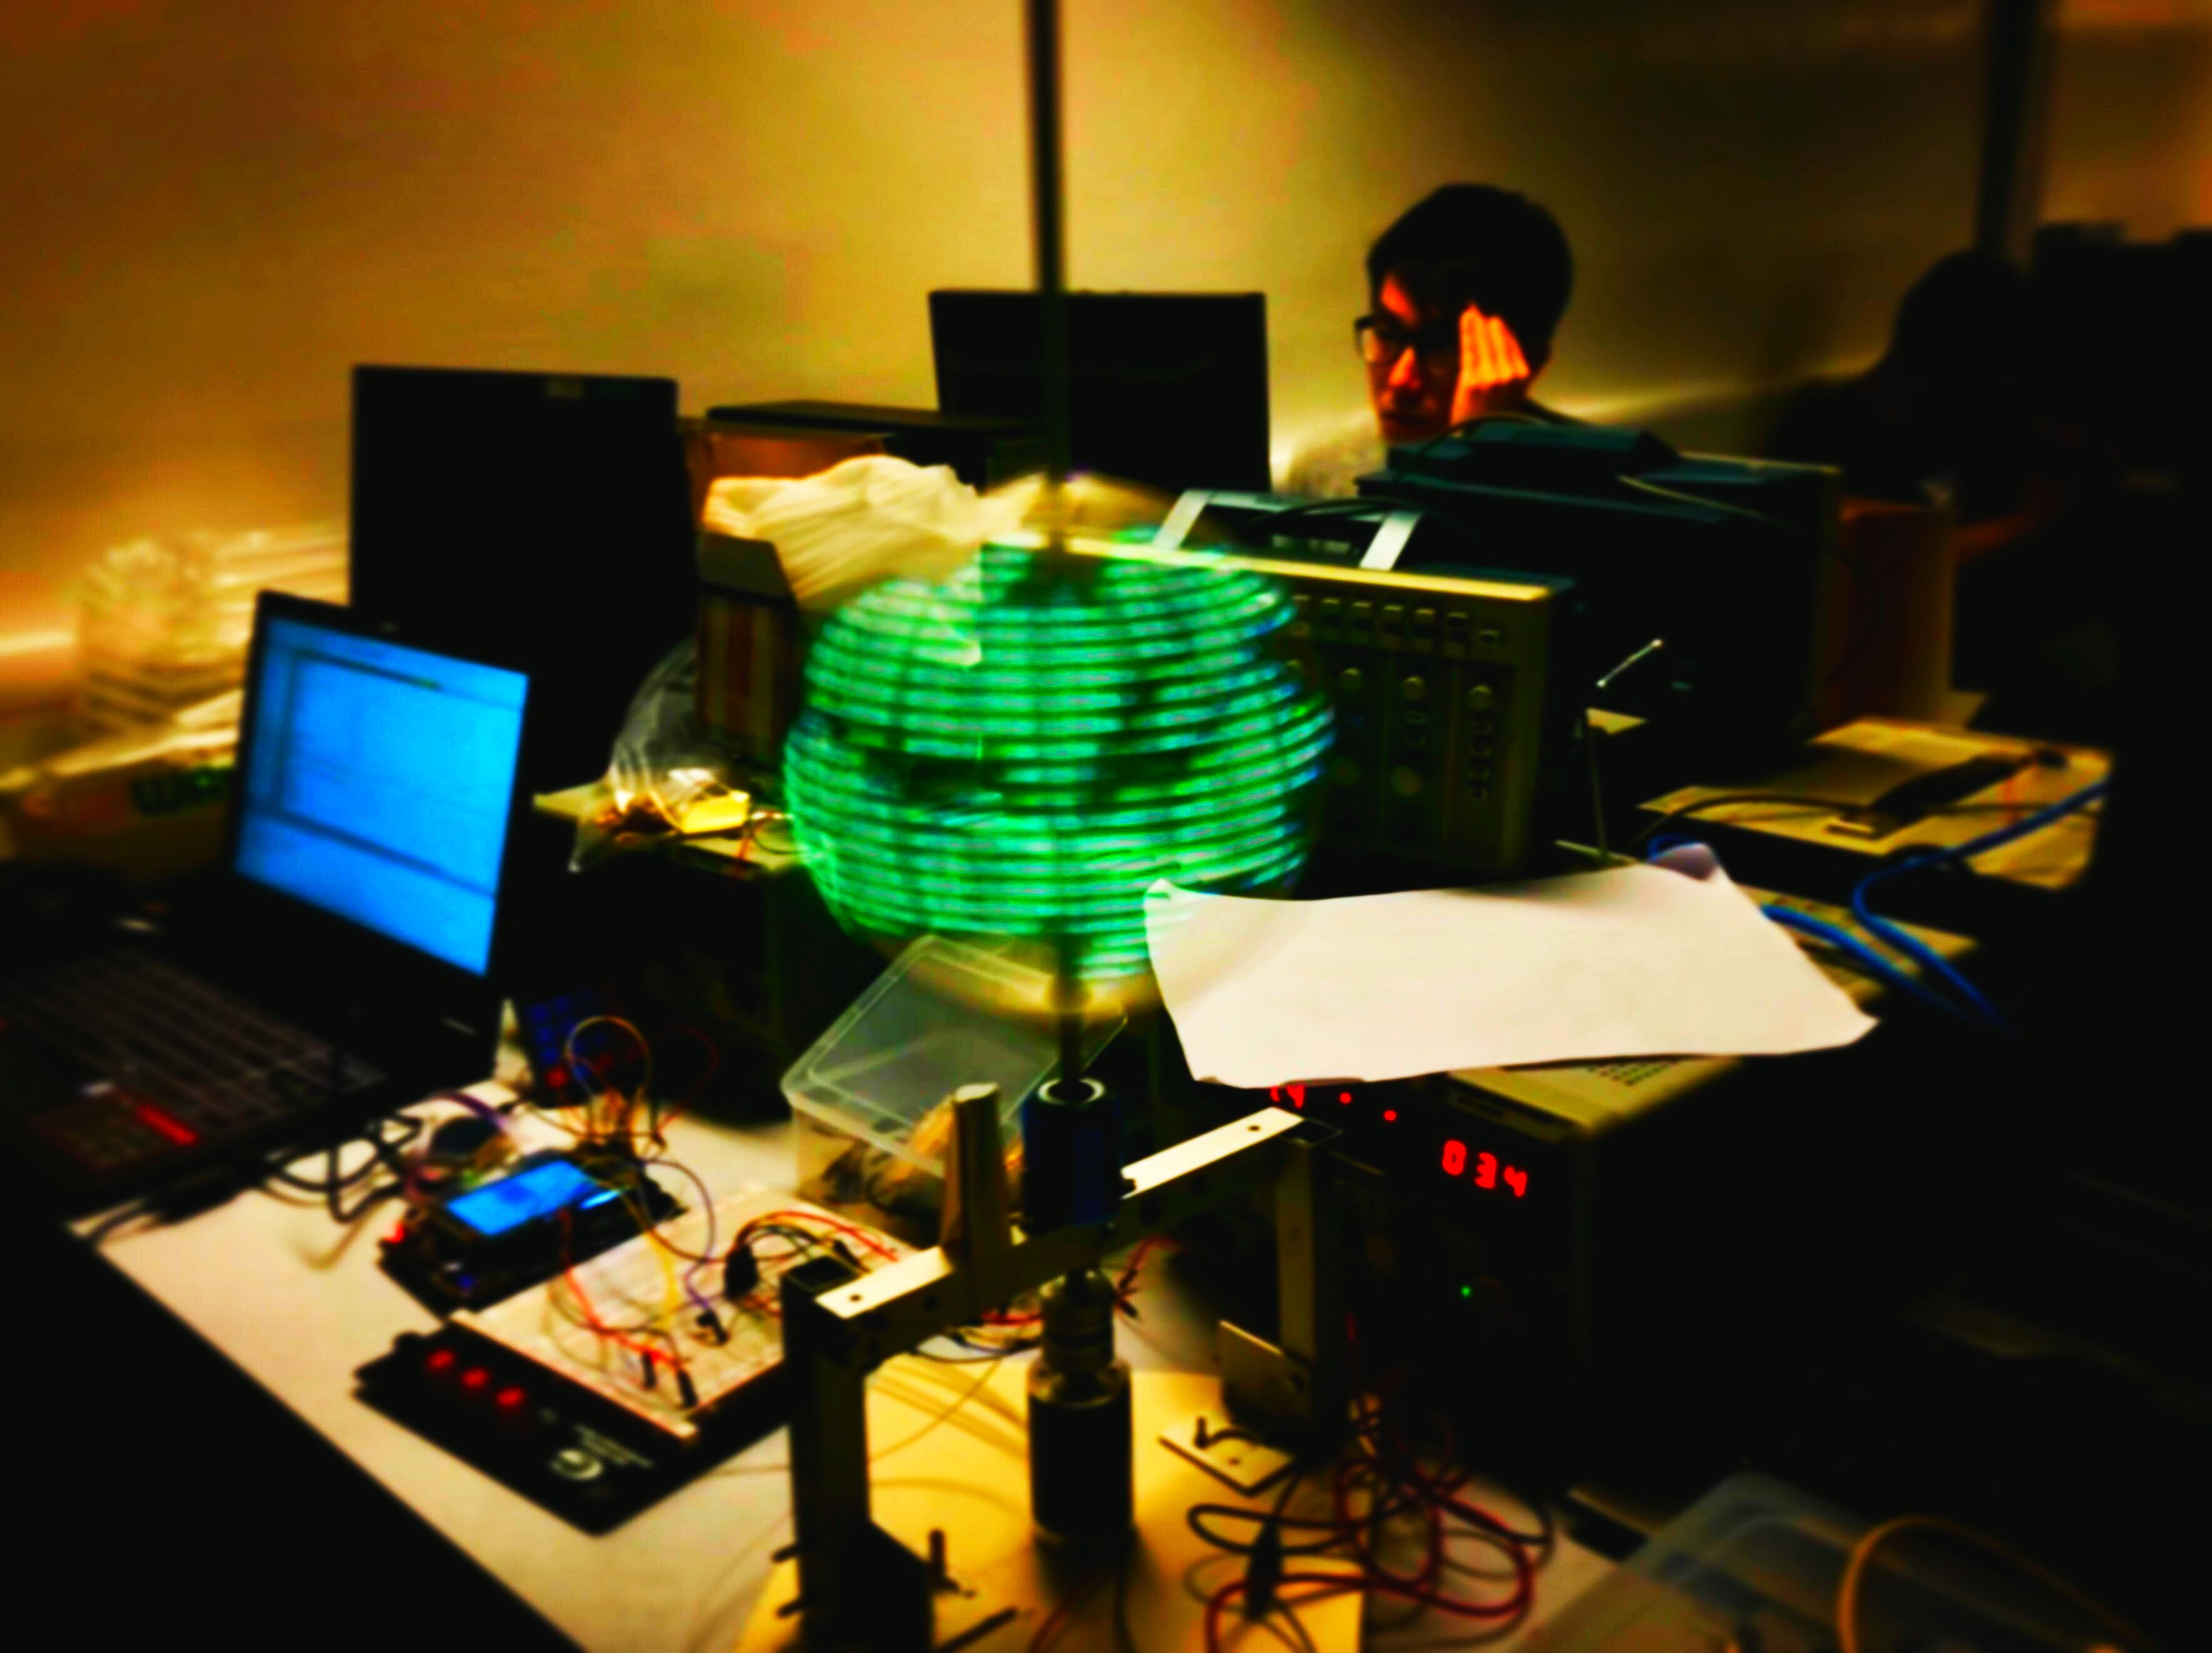

Please list the functions of your project in point form

- Detect the frequency of rotation via Hall Effect Sensor
- Self-correct the display delays between each pixel according to the spinning frequency.
- Displays input characters and numbers.
- Uses SPI communication to refresh APA102c LED strips.
- Display input images (BMP) from the SD card to the LED display.
- A custom made layered animation system to display multiple animations together.
- Read input buttons via button matrix and output according MIDI signal to the PC using USB.
- Adjust modes of the button matrix(4x4 with 4 modes) to display different midi signals per mode.
- Assigning different animations on each button press.

