Table of Content

Task1: Analyse the problem faced by the Company 1

Task2: Discussion 1

A) Discuss how you can/should re-identify the cycle of BI analysis 1

Analysis 1

Insight 1

Decision 2

Evaluation 2

b) Discuss what type of analysis techniques (descriptive, predictive, and prescriptive) you will propose to address the problem? 2

References 4

# Task1: Analyse the problem faced by the Company

From the case study given, the problem that Domino Pizza facing are unsecure of the domino system. Then the legitimate coupon codes ended up selling on online shopping like Shopee. Also, the Domino Pizza should have detected that unauthorized voucher are been used but they still allow the voucher code can be use in their system. It’s frightening that the restaurant does not have a high secure system to protect the corporation and the customer profit.

Second Domino do not take any immediate action on the fundamental logic flaw in their online ordering system that has been exploited long time ago. Customer get a huge discount on their order by tricking the system with the voucher and customizing the pizza with extra ingredients by not charging any extra prices.

# Task2: Discussion

## A) Discuss how you can/should re-identify the cycle of BI analysis

The cycle of business intelligence analysis consists of four processes which are analysis, insight, decision and evaluation.

### Analysis

According to the case study, the problem of Domino facing the arise of unauthorised coupon and system bug.

Due to these issues, the critical problem that might bring to Domino is the loss of revenue. If Domino do not address the problem, in the end will keep losing money and “bankrupt”.

### Insight

The root cause of arise of unauthorised coupon sold on third party platform such as Shopee. When the customer buys the pizza with the coupon, Domino never check the coupon whether is authorised or have been used before and letting the coupon works during customer purchased. Domino do not fix and change the system which are having a bug that customer can customized the pizza with additional ingredients without paying the extra cost. No matter how customer adding extra ingredients, the system still will remain the same price as before.

### Decision

Firstly, Domino should appeal customer not to buy any voucher from third party platform and have to keep track on any suspicious seller that are try to sell unauthorised voucher based on the experience. While Domino produce the new coupon, they have to check the coupon code are stored in database. Other than that, Domino have to fix the bug of the ordering system by make sure the system works normally on charging the cost of adding or customizing the ingredients of the pizza.

### Evaluation

Domino should be able to reduce the fraud on their online ordering system and keep their revenue back to the normal level.

## b) Discuss what type of analysis techniques (descriptive, predictive, and prescriptive) you will propose to address the problem?

Predictive analytics refers using historical data, machine learning, and artificial intelligence to predict what will happened in the future. The historical data is fed into a mathematical model that consider key trends and pattern in data. Then applied to current data to predict what will happened next [1], [3].

In this case study, using the data mining technique and the supervised machine learning. Supervised machine learning is the process of algorithm learning from the training dataset can be thought of as a teacher supervising the learning process [2]-[4]. Grouping this supervised learning problem into two which are classification and regression. Classification are the machine is trained to classify something into some class [4].

Example classifying whether the voucher is authorised or has been use in early. Machine should check the voucher code is match with that store in the database. If the code is same with database, it authorised; if difference, the code is unauthorised. Classifying whether the voucher code is been used in early before? If a voucher code has been using by person A, the machine should detect when it has been used again or another person.

Second is regression. Regression is used to predict a range of numeric values. In domino system, we can use regression to predict the customized pizza behavioural and the cost. Example, an aloha chicken pizza cost RM32.00. If customer customized the pizza by adding more ingredients, the cost should be around RM35.00 above and RM50 below. The system will detect the abnormal if the price out of range.

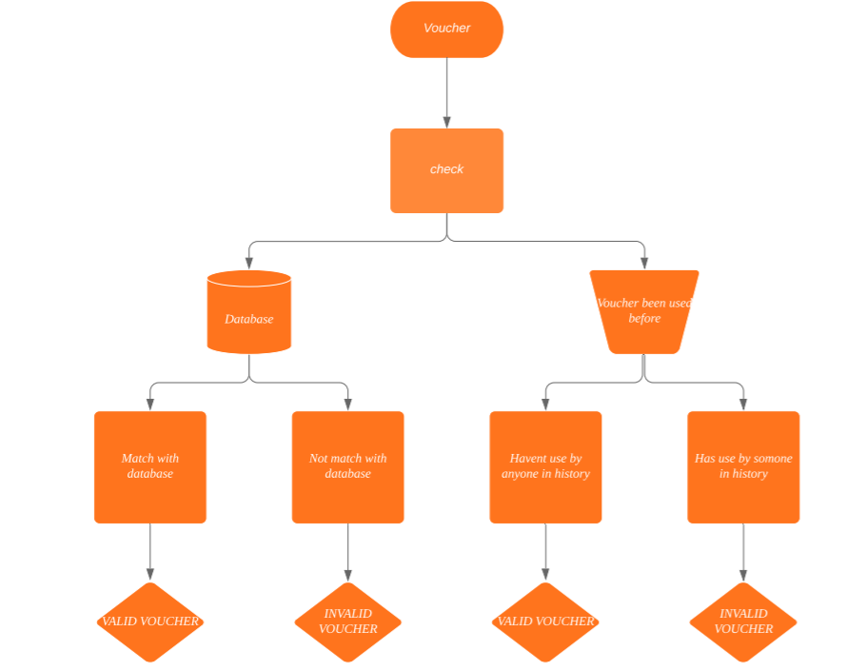Diagram 1: the flow chart of the voucher checking process

# References

[1] Halo. (2019). Descriptive, Predictive, And Prescriptive Analytics Explained. Accessed on: November. 30, 2019. [Online].Available: <https://halobi.com/blog/descriptive-predictive-and-prescriptive-analytics-explained/>

[2] Jason.Brownlee.  (2019, August 12). Supervised and Unsupervised Machine Learning Algorithms

. Accessed on: December,1, 2019. [Online]. Available: <https://machinelearningmastery.com/supervised-and-unsupervised-machine-learning-algorithms/>

[3] Sriram Parthasarathy. (2017, November 7). What is predictive analytics. Accessed on: November,30,2019. [Online]. Available: <https://www.logianalytics.com/predictive-analytics/what-is-/predictive-analytics/>

[4] [Giuseppe Bonaccorso](https://www.google.com/search?sa=X&rlz=1C1CHBF_enMY754MY754&biw=1242&bih=577&sxsrf=ACYBGNTE3QxGLfjlvjzKiobuWKOgHXRifA:1575530226499&q=Giuseppe+Bonaccorso&stick=H4sIAAAAAAAAAOPgE-LVT9c3NExLMijJTUkxUIJwk8rTyg1M4g21ZLKTrfST8vOz9cuLMktKUvPiy_OLsq0SS0sy8osWsQq7Z5YWpxYUpCo45eclJifnFxXnAwAotZSlVAAAAA&ved=2ahUKEwiX0O67-53mAhW6_XMBHbruCr4QmxMoATAZegQIDhAK), Machine Learning Algorithms, 2nd ed. Livery Street, Birmingham, United kingdom: Packt Publishing Ltd, 2017, ch. 1, pp. 14-15.