# 一 新建opencv的项目

在项目属性下, VC++ 目录.

“包含目录”

|  |
| --- |
| G:\tools\openCV-3.3\opencv\build\include\opencv2  G:\tools\openCV-3.3\opencv\build\include\opencv  G:\tools\openCV-3.3\opencv\build\include |

“库目录”

|  |
| --- |
| G:\tools\openCV-3.3\opencv\build\x64\vc14\lib |

具体的库目录下内容:

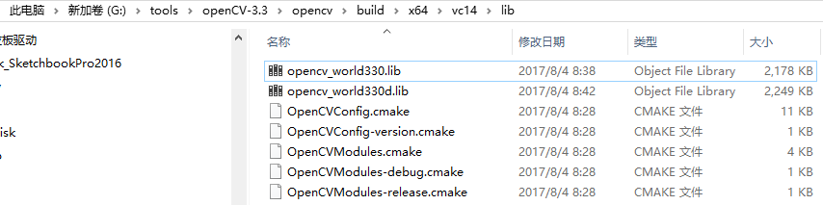

在”链接器” , “输入”, “附件依赖库”中

|  |
| --- |
| opencv_world330d.lib |

尽量只填一个,避免系统默认找第一个.