Promotions Configuration and Management

Platform Group

Exported on Feb 1, 2022 5:29 PM

Table of Contents

1 Access Promotions Object and Tab 4

2 Configuring Promotion 5

3 Managing a Promotion 9

3.1 Edit a Promotion 9

3.2 Deactivate a Promotion 9

3.3 Clone a Promotion 10

4 Promotion Calendar 11

Promotions play a significant role in increasing product sales. Promotions can be a part of a larger campaign to spread awareness about a new product or can be a part of a targeted objective. In Instore, Promotions are allocated to the accounts to let the sales representatives know about them while interacting with the customer.

* Access Promotions Object and Tab
* Configuring Promotion
* Managing a Promotion
  + Edit a Promotion
  + Deactivate a Promotion
  + Clone a Promotion
* Promotion Calendar

|  |
| --- |
| The information present here assumes that you already have the **Promotions Managed Package** installed in your Salesforce account. Check [Promotions Managed Package Details](https://pitcher-ag.atlassian.net/wiki/spaces/PG/pages/245235813/Promotions+Managed+Package+Details) for more details. |

# Access Promotions Object and Tab

To access the object:

1. Log in to Salesforce.
2. In the **App Launcher**, click **Promotions** to navigate to the **Promotions** tab.

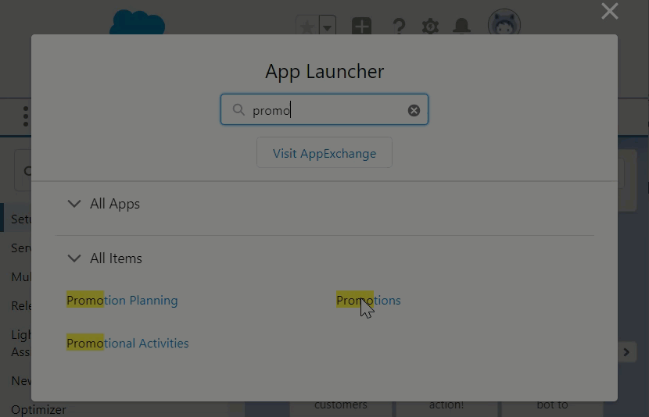

Figure 1 Accessing the Promotions Object

# Configuring Promotion

To create a promotion:

1. In the **Promotions** tab, click **New**.

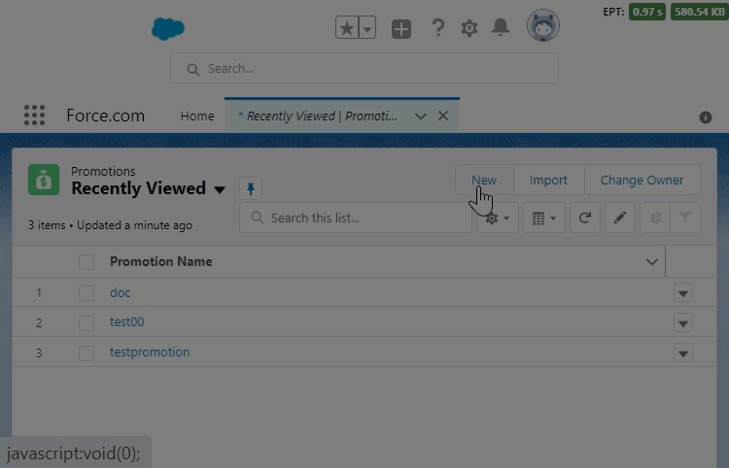

Figure 2 The New Promotion button

1. In the **New Promotion** dialog that appears, set the following fields to define the meta-details of a new promotion object:

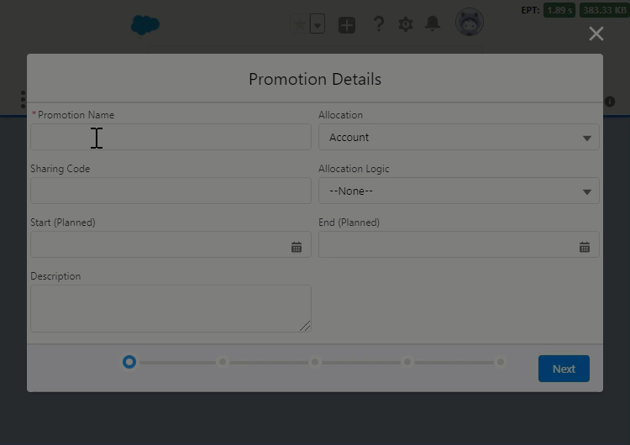

Figure 3 Configuring Promotion Details

* + **Promotion Name** - The name of the Promotion.
  + **Allocation** - This field is set to Account by default since you're going to be allocating the promotion to accounts in the next step.
  + **Sharing Code** - Enter a code to map a sharing rule to define the visibility of the promotion.
  + **Allocation Logic** - Choose AND or OR logical operator depending on the need.
  + **Start (Planned)** - Choose the start date of the promotion.
  + **End (Planned)** - Choose the end date of the promotion.
  + **Description** - Enter text to describe the promotion.

1. Click **Next** to move to the **Product Selection** page and select the products you would like to promote.

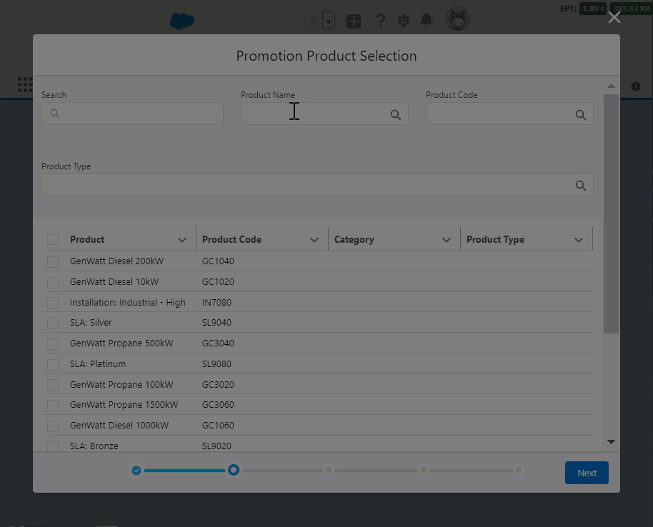

Figure 4 Selecting Products for Promotion

On this page, you can:

* + Select multiple products one by one using the checkboxes in the grid.
  + Define if the product is Included or Excluded.
  + Define validity period - Start and End date (The end date can be set to blank).
  + Filter products by:
    - **Product Type**
    - **Brand**
    - **Category**
  + Search products by:
    - **Product Name**
    - **Product Code**
  + The page appears in a grid format with the following columns:
    - **Product Name**
    - **Product Code**
    - **Product Type**
    - **Brand**
    - **Category**

1. Click **Next** to see the detailed grid view of all the selected products.
   * The grid includes the following columns:
     + **Product Name**
     + **Product Code**
     + **Price**
     + **Sequence**
   * On this page, you can:
     + **Delete product lines**
     + **Update Start and End date**
     + **Update Rules**
2. Click **Next** to allocate the Promotion to the accounts based on the following criteria:
   * **Individual Accounts** - You can add one or more accounts to include or exclude from the promotion.

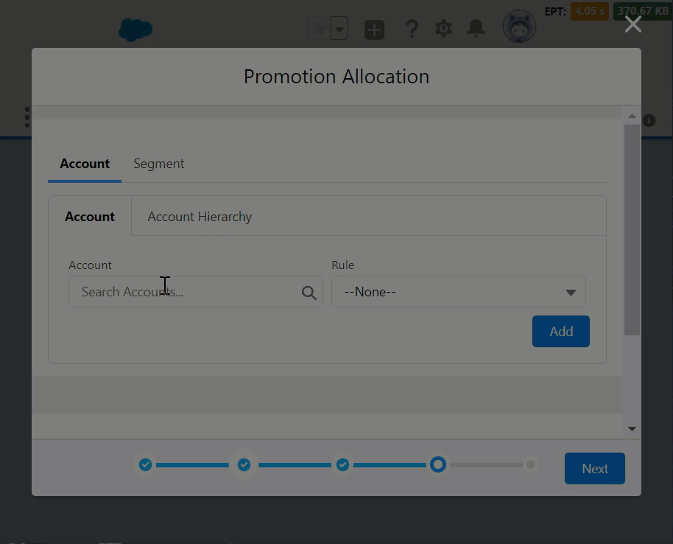

Figure 5 Allocating to accounts individually

* + **Account Hierarchy** - Allocation based on a family of account (parent-child relationship). You can turn on the Inheritance and add one or more parent accounts to include or exclude from the promotion.

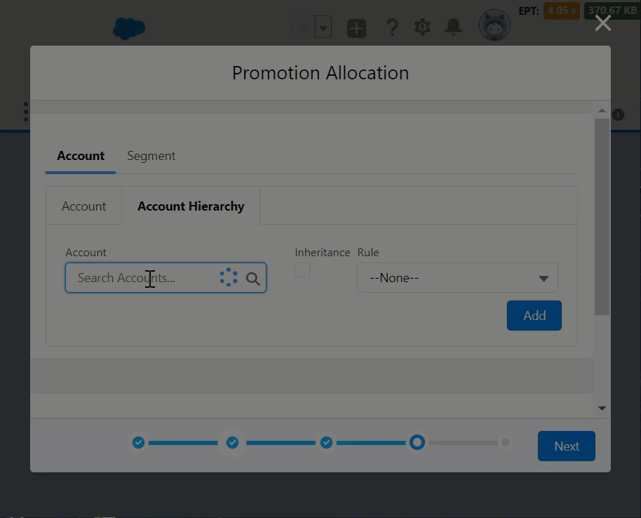

Figure 6 Allocation based on hierarchy

* + **Segment** - Allocation based on a filtered group of accounts. You can filter a group (segment) of accounts to promote based on one or more account attributes or tags.

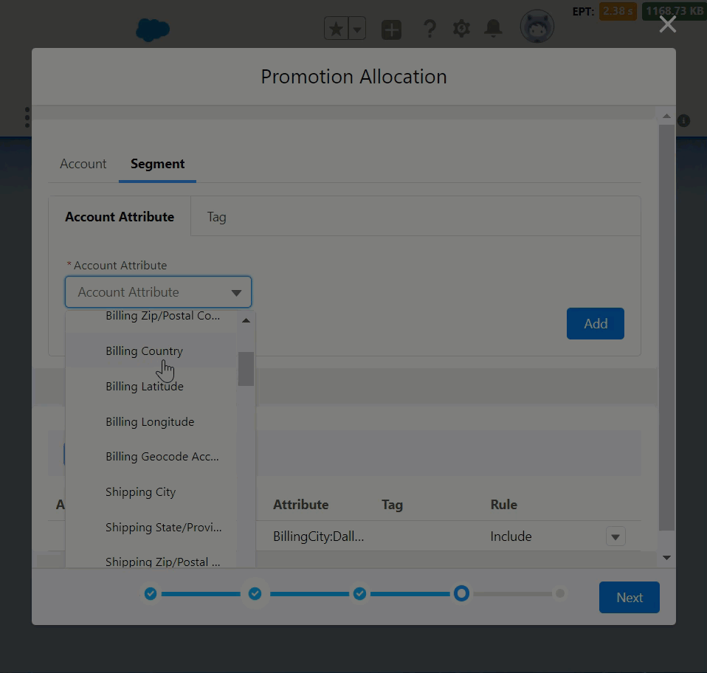

Figure 7 Allocating to a group of accounts

1. Click **Next** and choose an action based on need:
   * For new promotions, choose either:

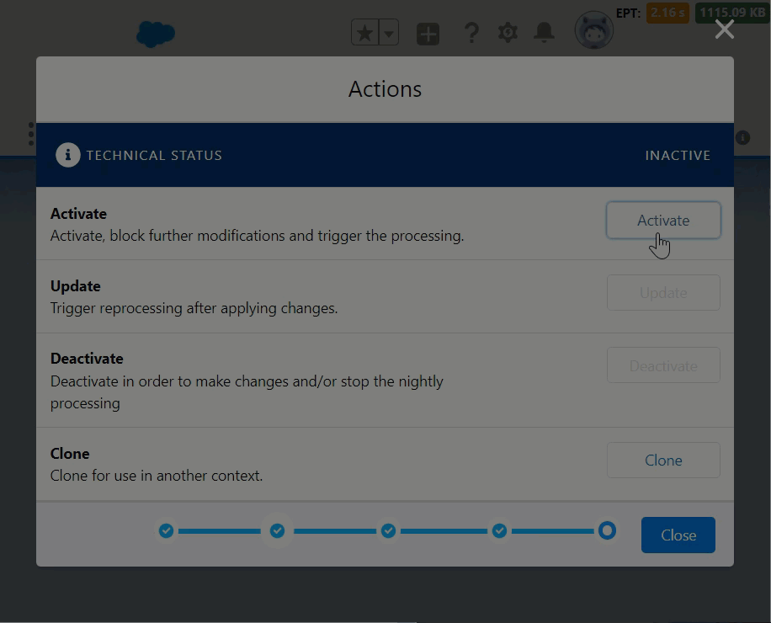

Figure 8 Activating the new Promotion

* + - **Activate** - Publishes the new Promotion.
    - **Clone** - Clones an existing Promotion. This option is disabled for new Promotions.
  + While editing existing promotions, you choose to either:

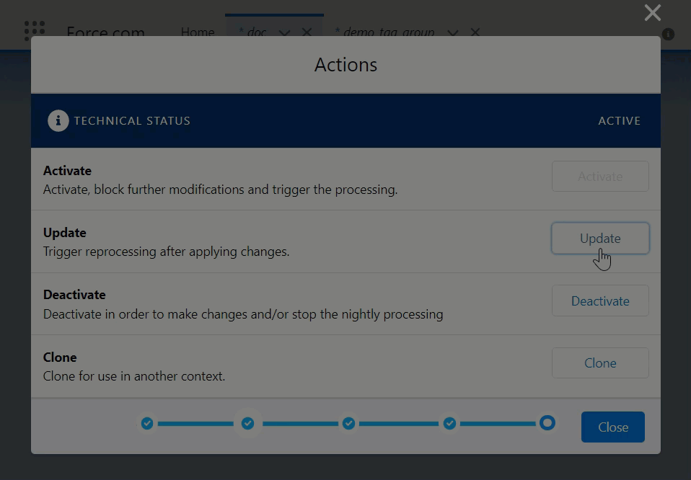

Figure 9 Updating changes in a Promotion

* + - **Deactivate** - Deactivates existing Promotion.
    - **Update** - Save changes to existing Promotion.

1. You can also just click **Close** to save and leave the new promotion in the **Draft** state.

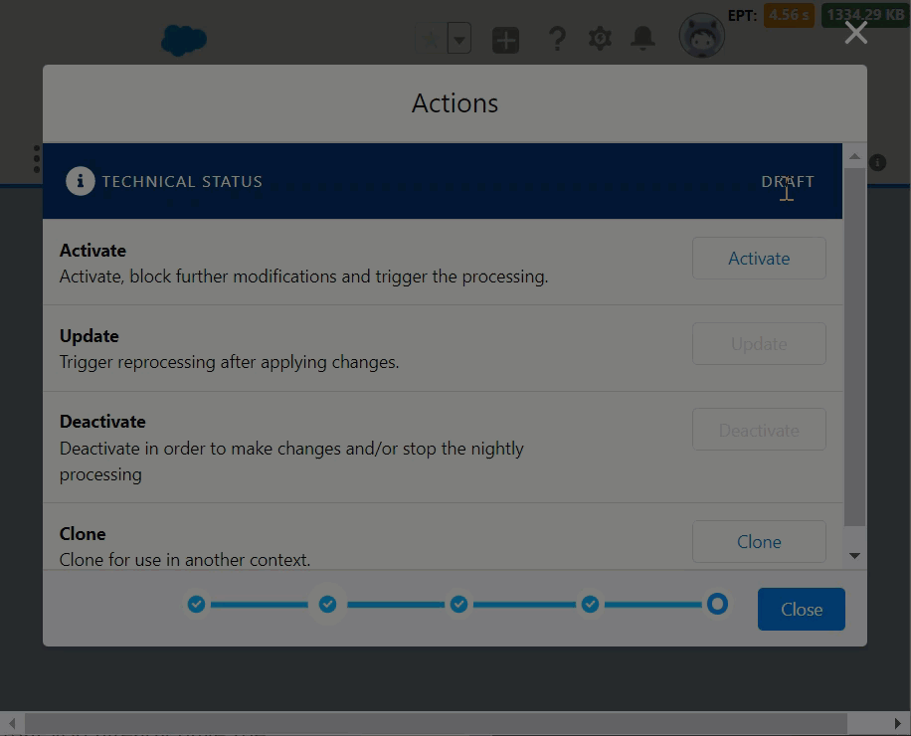

Figure 10 Saving Promotion as Draft

# Managing a Promotion

You can edit, deactivate or clone an existing promotion depending on the need.

## Edit a Promotion

To edit an existing promotion object:

1. In the **Promotions** tab, click any promotion.
2. On the Promotion page, click **Edit**.
3. In the **Promotion** dialog that appears, make changes to the details as needed and click **Next** until you reach the last page on the dialog.
4. Click **Update** to save the changes and then click **Close**.

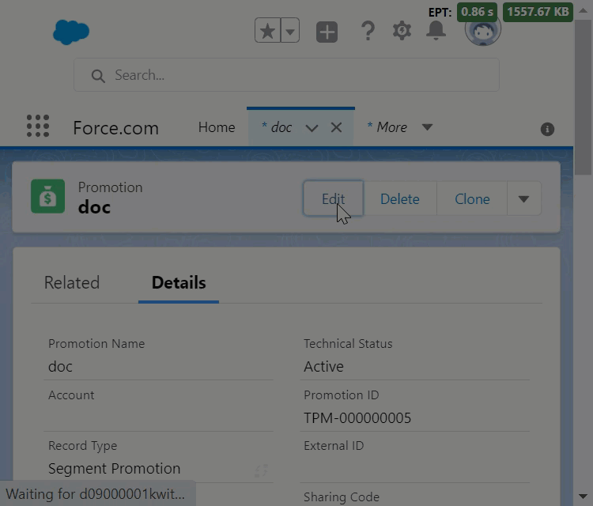

Figure 11 Editing a Promotion

## Deactivate a Promotion

To deactivate an existing promotion object:

1. In the **Promotions** tab, click any promotion.
2. On the Promotion page, click **Edit**.
3. In the **Promotion** dialog that appears, click **Next** until you reach the last page on the dialog.
4. Click **Deactivate** and then click **Close**.

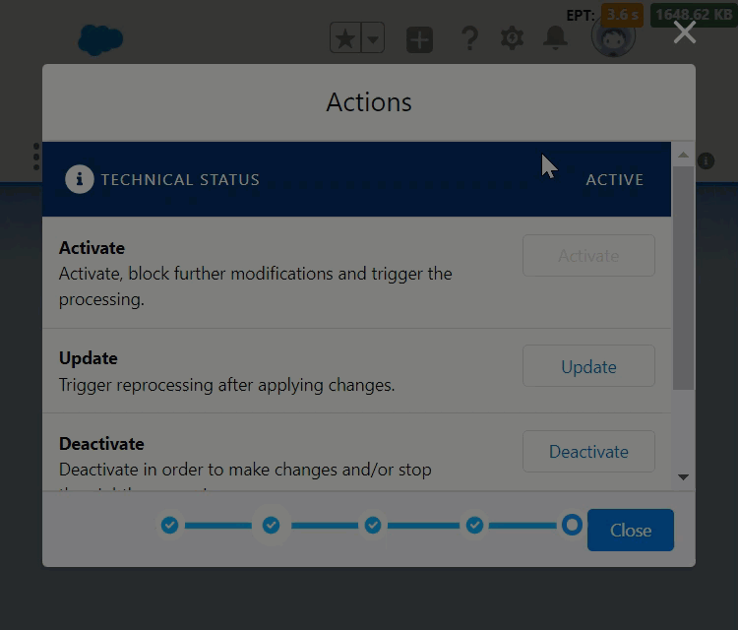

Figure 12 Deactivating a Promotion

## Clone a Promotion

To clone an existing promotion object:

1. In the **Promotions** tab, click any promotion.
2. On the Promotion page, click **Clone**.
3. In the **Promotion Details** dialog that appears, leave the configuration as it is or make changes to the details as needed.
4. Click **Save** to create the clone record.

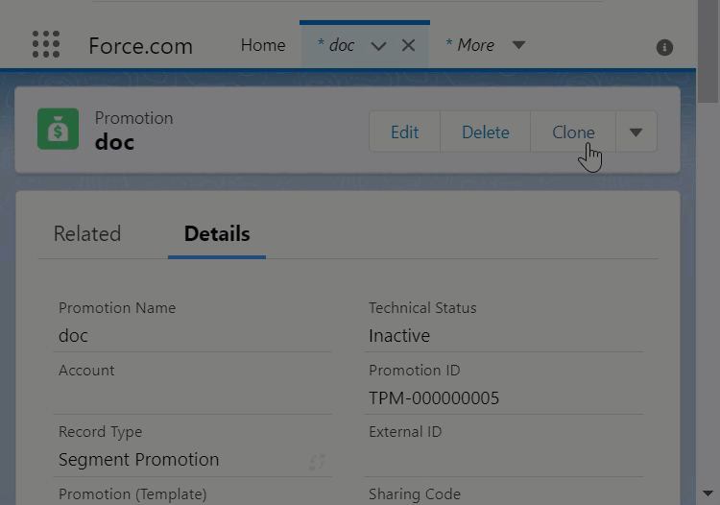

Figure 13 Cloning a Promotion

# Promotion Calendar

A Promotion Calendar shows you a calendar view of all scheduled promotions.

You can access the calendar from the **Promotions Planning** page.

In the calendar, you can:

* Click any scheduled promotion to view its details
* Add a new Promotion
* Search for any promotion.
* Switch between the Week, Month, and Year view of the calendar based on the need.

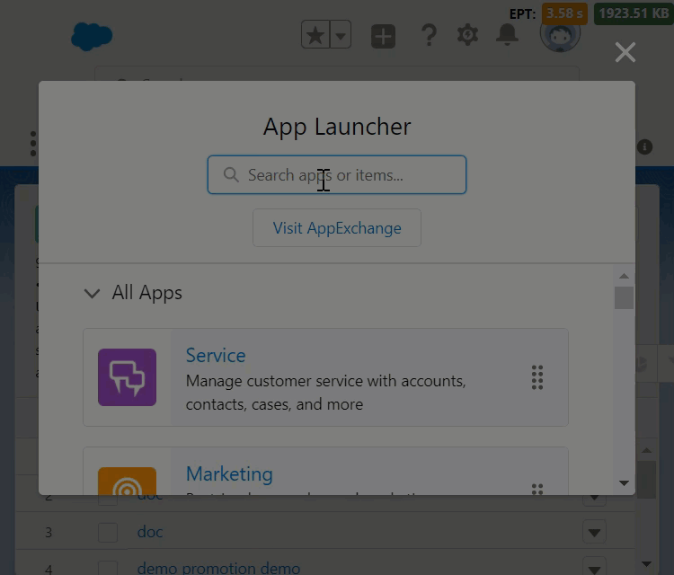

Figure 14 The Promotions Calendar