Products and Assortments Configuration and Management

Platform Group

Exported on Feb 1, 2022 5:25 PM

Table of Contents

1 Products 4

1.1 Access Products Object and Tab 4

1.2 Create a Product 4

1.3 Edit a Product 5

1.4 Delete a Product 5

1.5 Clone a Product 5

2 Product Assortment 7

2.1 Access Assortment Object and Tab 7

2.2 Configuring Product Assortment 7

2.3 Managing an Assortment 10

2.3.1 Edit an Assortment 11

2.3.2 Deactivate an Assortment 11

2.3.3 Clone an Assortment 11

* Products
  + Access Products Object and Tab
  + Create a Product
  + Edit a Product
  + Delete a Product
  + Clone a Product
* Product Assortment
  + Access Assortment Object and Tab
  + Configuring Product Assortment
  + Managing an Assortment
    - Edit an Assortment
    - Deactivate an Assortment
    - Clone an Assortment

|  |
| --- |
| The information present here assumes that you already have the **Products Managed Package** installed in your Salesforce account. Check [Products Managed Package Details](https://pitcher-ag.atlassian.net/wiki/spaces/PG/pages/245006343/Products+Managed+Package+Details) for more details. |

# Products

A Product is a standard Salesforce object that represents a service or an item that the company sells to its customers. In the Instore application, a product is usually created to represent a service or an individual product that is later grouped along with other products in an assortment and allocated to customer accounts to let the sales representatives know about them while interacting with the customer.

## Access Products Object and Tab

To access the object:

1. Log in to Salesforce.
2. In the **App Launcher**, click **Products** to navigate to the **Products** tab.

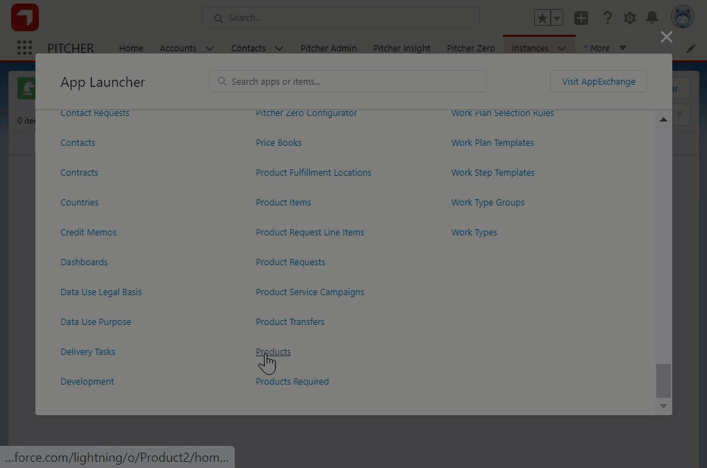

Figure 1 Accessing the Products Object and Tab

The **Products** tab contains a grid layout that contains a list of all Products. You can click on any of them to view the Product details.

## Create a Product

To create a Product:

1. In the **Products** tab, click **New**.
2. In the **New Product** dialog that appears, set the following fields and click **Save** to create the Product:

|  |  |
| --- | --- |
| **Field Name** | **Description** |
| Product Name | The name of the Product. |
| Product Code | A unique identifier of the Product. |
| Active | Determines the state of the Product post its creation. |
| Product Family | The Product Family it belongs to (if applicable). |
| Product Description | Text that describes the Product. |

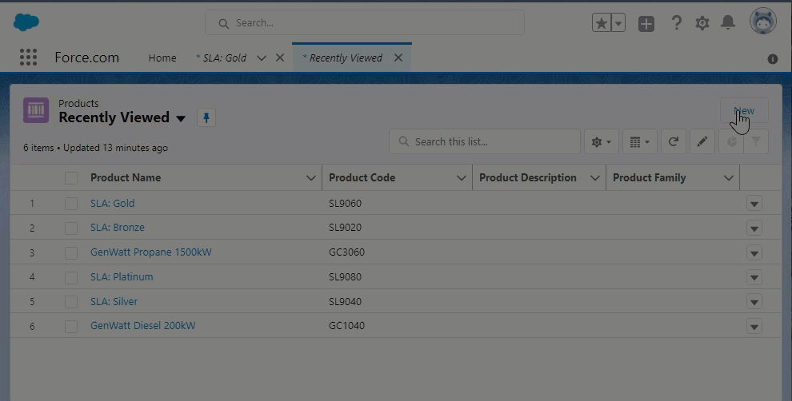

Figure 2 Creating a Product

## Edit a Product

To edit a Product:

1. In the **Products** tab, click the product you wish to edit.
2. On the **Product Details** page, click **Edit**.
3. Do the required changes and click **Save**.

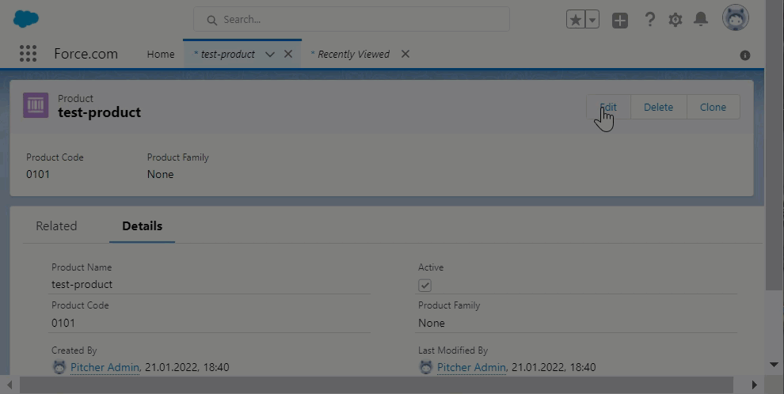

Figure 3 Editing a Product

## Delete a Product

To delete a Product:

1. In the **Products** tab, click the product you wish to delete.
2. Click **Delete**.
3. Confirm to delete.

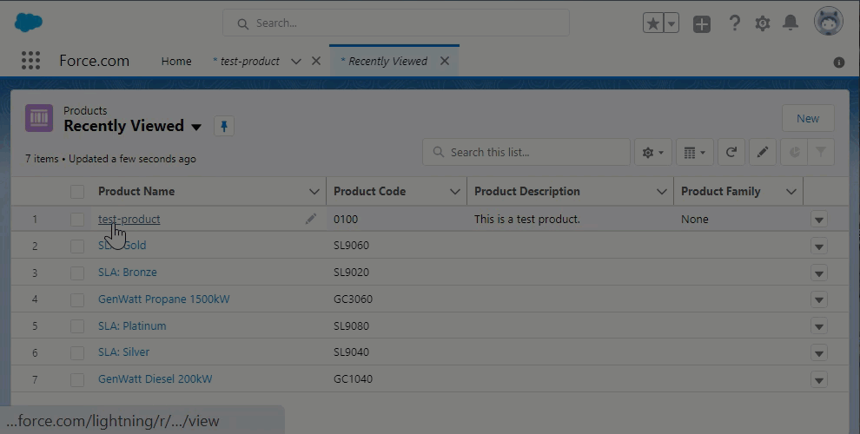

Figure 4 Deleting a Product

## Clone a Product

To clone an existing product object:

1. In the **Products** tab, click any product.
2. On the Product page, click **Clone**.
3. In the **New** **Product** dialog that appears, leave the configuration as it is or make changes to the details as needed.
4. Click **Save** to create the clone record.

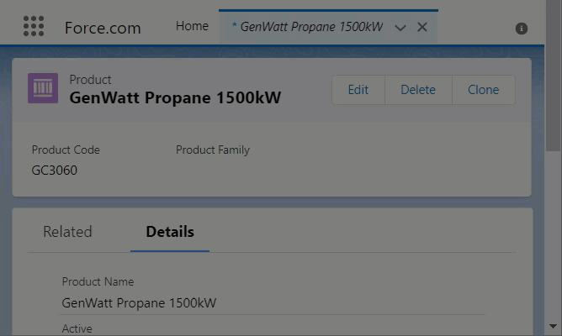

Figure 5 Cloning a Product

# Product Assortment

In Instore, a product assortment represents a number of products that are grouped together and allocated to customer accounts based on different criteria.

## Access Assortment Object and Tab

To access the object:

1. Log in to Salesforce.
2. In the **App Launcher**, click **Assortments** to navigate to the **Assortments** tab.

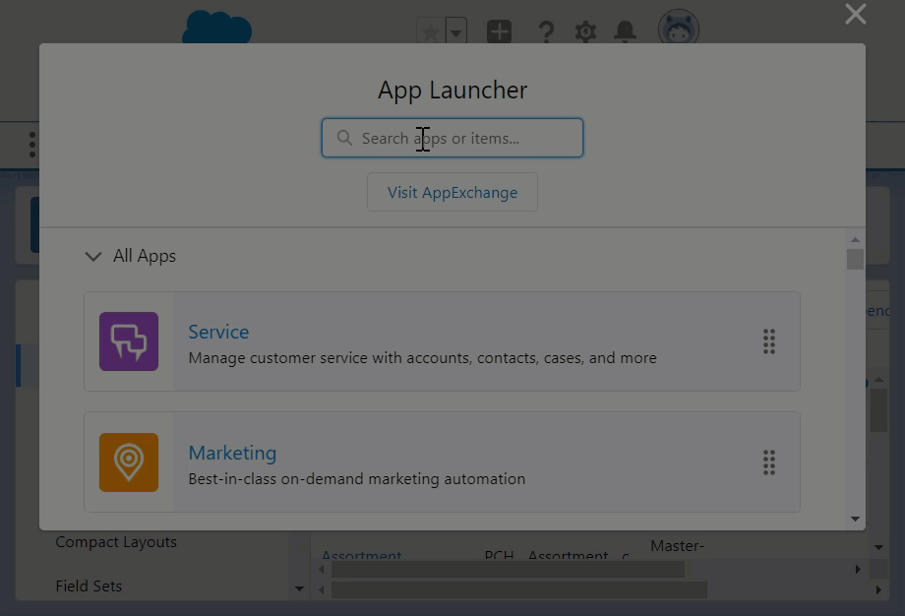

Figure 6 Accessing the Assortment Object

## Configuring Product Assortment

To create an assortment:

1. In the **Assortments** tab, click **New**.

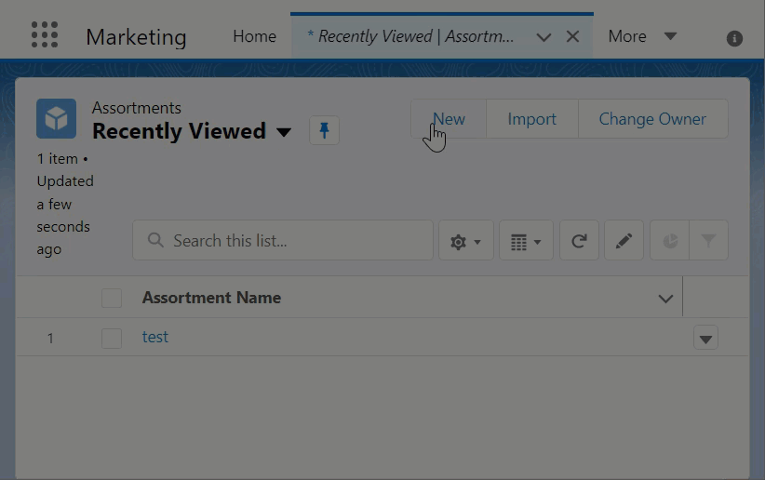

Figure 7 The New Assortment button

1. In the **Assortment Details** dialog that appears, set the following fields to define the meta-details of a new assortment object:

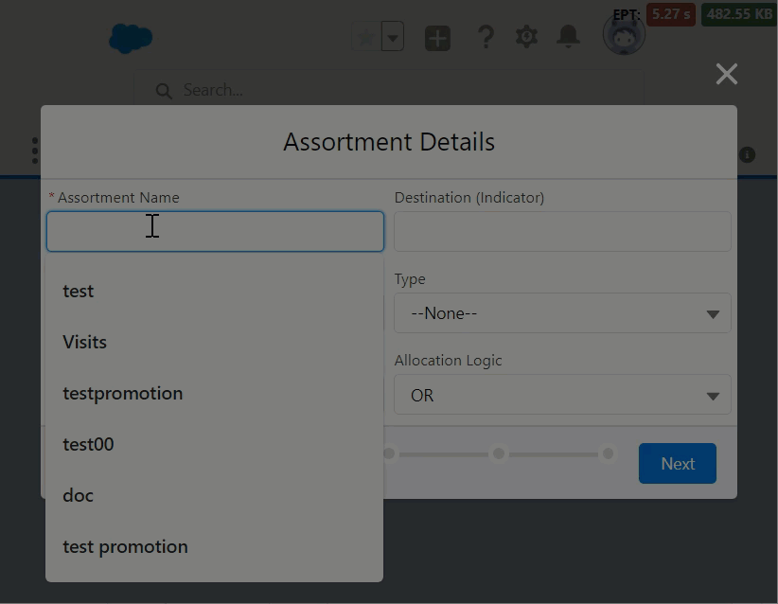

Figure 8 Configuring Assortment details

* + **Assortment Name** - The name of the Assortment.
  + **Destination (Indicator)** -
  + **Allocation** - This field is set to Account by default since you're going to be allocating the assortment to accounts in the next step.
  + **Type** - Select **Product Assortment** from the dropdown.
  + **Sharing Code** - Enter a code to map a sharing rule to define the visibility of the assortment.
  + **Allocation Logic** - Choose AND or OR logical operator depending on the need.

1. Click **Next** to move to the **Product Selection** page and select the products you would like to add to the assortment.

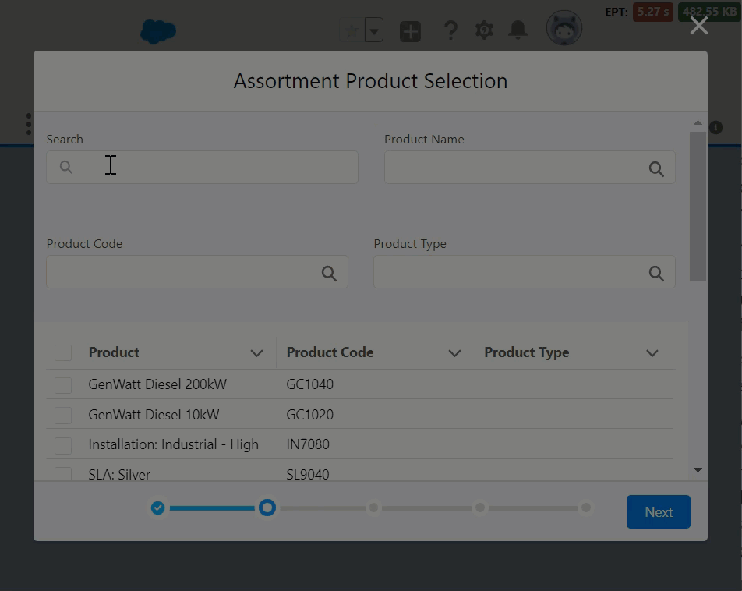

Figure 9 Selecting Products for Assortment

On this page, you can:

* + Select multiple products one by one using the checkboxes in the grid.
  + Search products
  + Filter products by:
    - **Product Type**
    - **Product Name**
    - **Product Code**
  + The page appears in a grid format with the following columns:
    - **Product Name**
    - **Product Code**
    - **Product Type**

1. Click **Next** to see the detailed grid view of all the selected products on the **Assortment Selection Details** page.

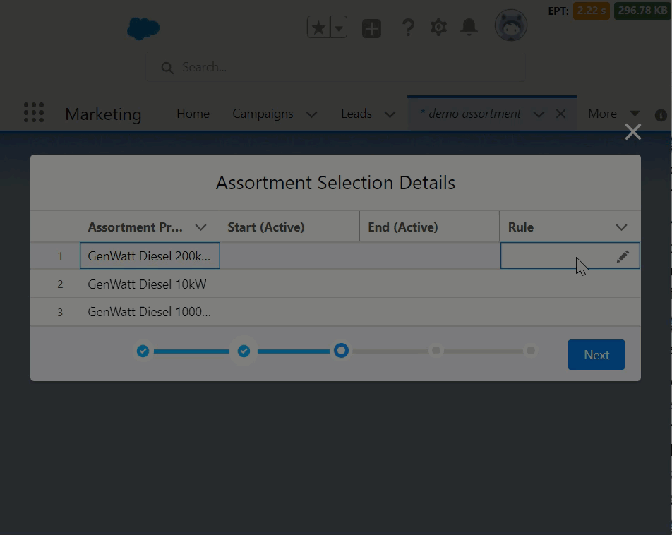

Figure 10 Defining Rules and Validity

On this page, you can:

* + Define if the product is to Include or Exclude in the Assortment.
  + Define the validity period of the Product to be part of the Assortment using the Start and End dates. The end date can be left blank if required.

1. Click **Next** to allocate the Assortment to the accounts based on the following criteria:
   * **Individual Accounts** - You can add one or more accounts to include or exclude from the assortment allocation.

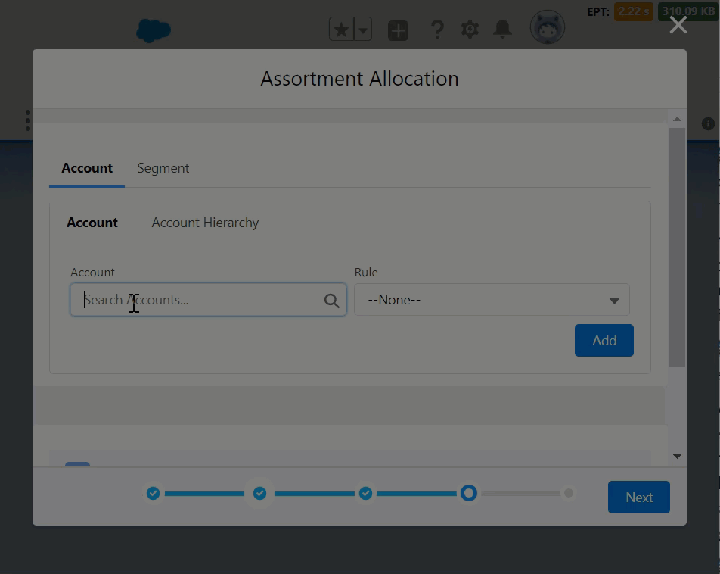

Figure 11 Allocating to accounts individually

* + **Account Hierarchy** - Allocation based on a family of account (parent-child relationship). You can turn on the Inheritance and add one or more parent accounts to include or exclude from the assortment allocation.

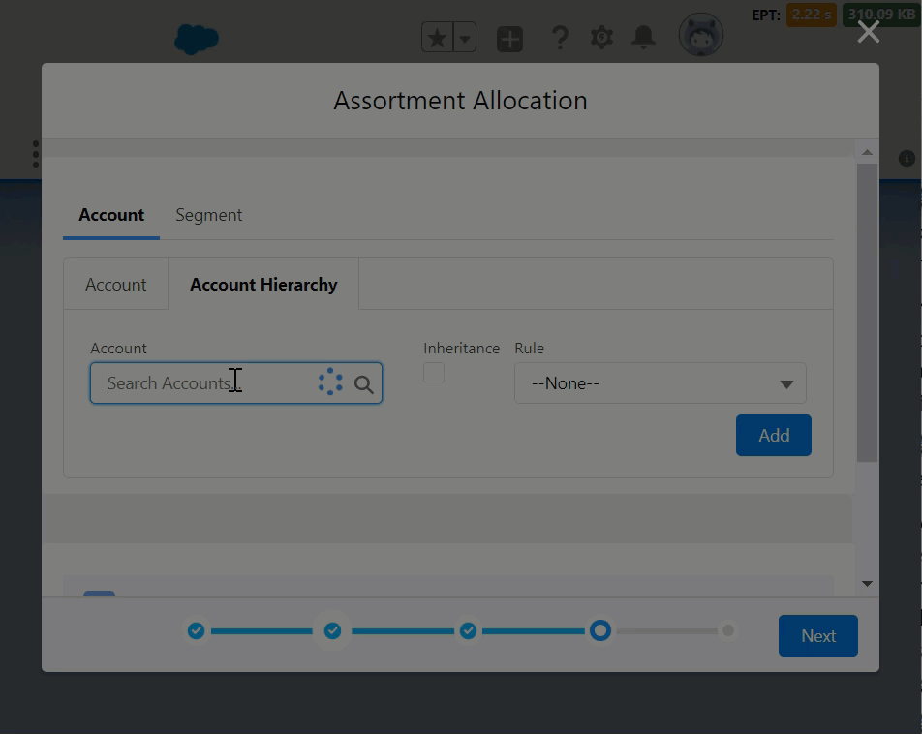

Figure 12 Allocation based on hierarchy

* + **Segment** - Allocation based on a filtered group of accounts. You can filter a group (segment) of accounts based on one or more account attributes or tags.

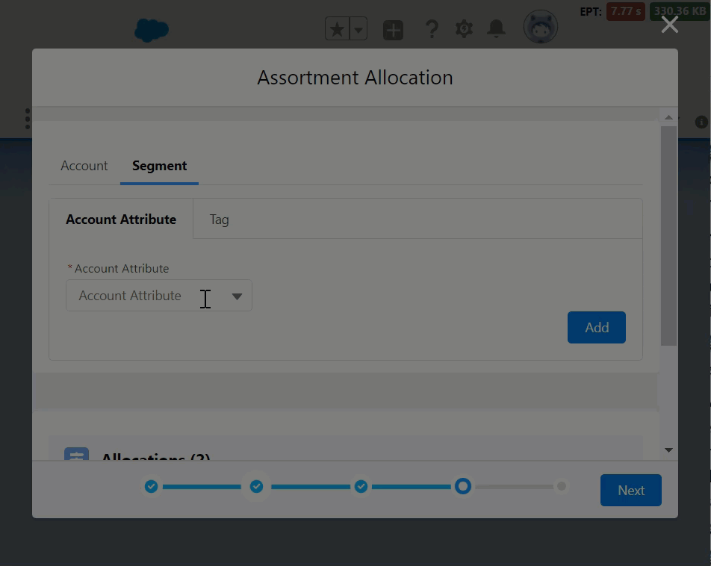

Figure 13 Allocating to a group of accounts

1. Click **Next** and choose an action based on need:
   * For new assortments, choose either:

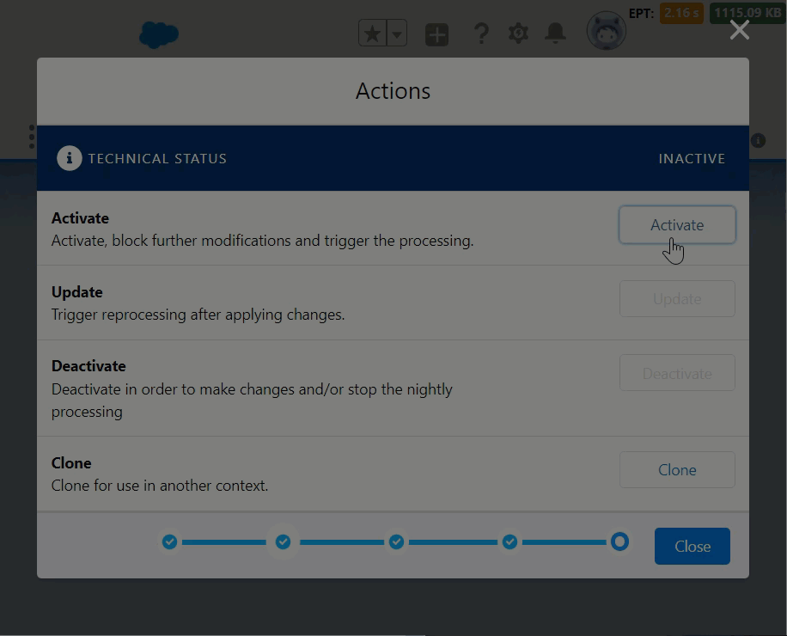

Figure 14 Activating the new Assortment

* + - **Activate** - Publishes the new Assortment.
    - **Clone** - Clones an existing Assortment.
  + While editing existing assortments, you choose to either:

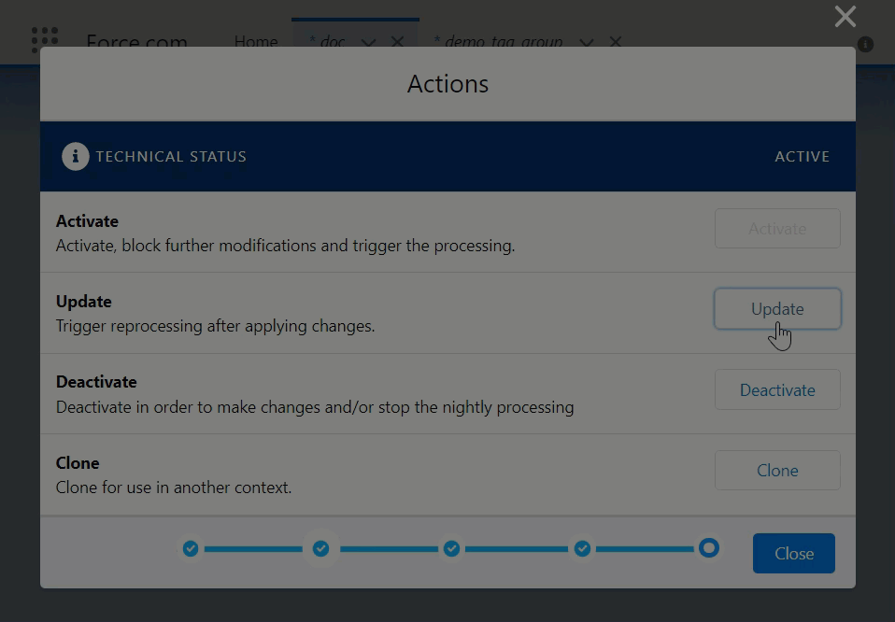

Figure 15 Updating changes in an Assortment

* + - **Deactivate** - Deactivates existing Assortment.
    - **Update** - Save changes to existing Assortment.

1. You can also just click **Close** to save and leave the new assortment in the **Draft** state.

## Managing an Assortment

You can edit, deactivate or clone an existing assortment depending on the need.

### Edit an Assortment

To edit an existing assortment object:

1. In the **Assortment** tab, click any assortment.
2. On the Assortment page, click **Edit**.
3. In the **Assortment Details** dialog that appears, make changes to the details as needed and click **Next** until you reach the last page on the dialog.
4. Click **Update** to save the changes and then click **Close**.

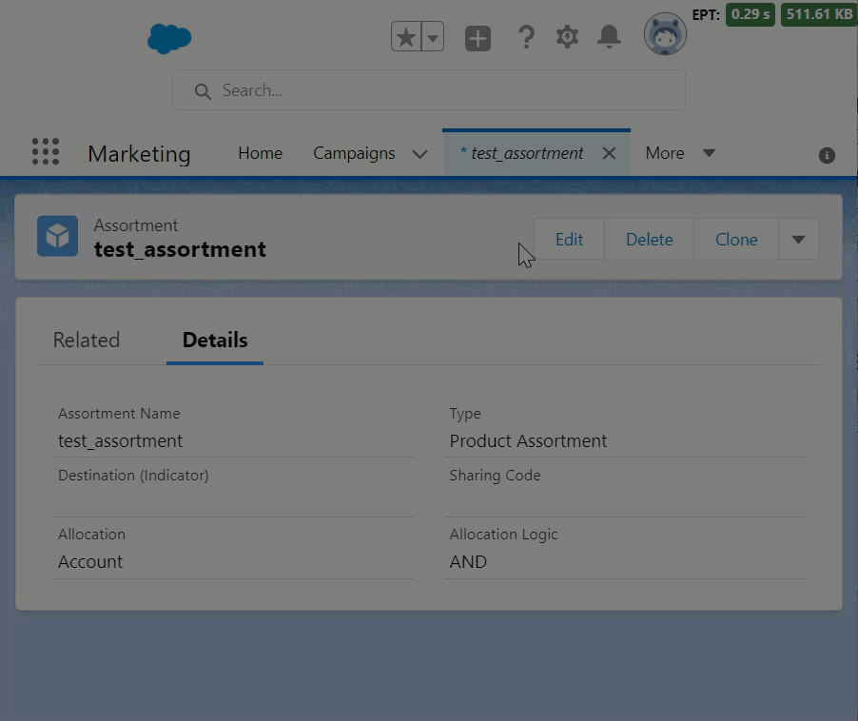

Figure 16 Editing an Assortment

### Deactivate an Assortment

To deactivate an existing assortment object:

1. In the **Assortments** tab, click any assortment.
2. On the Assortment page, click **Edit**.
3. In the **Assortment Details** dialog that appears, click **Next** until you reach the last page on the dialog.
4. Click **Deactivate** and then click **Close**.

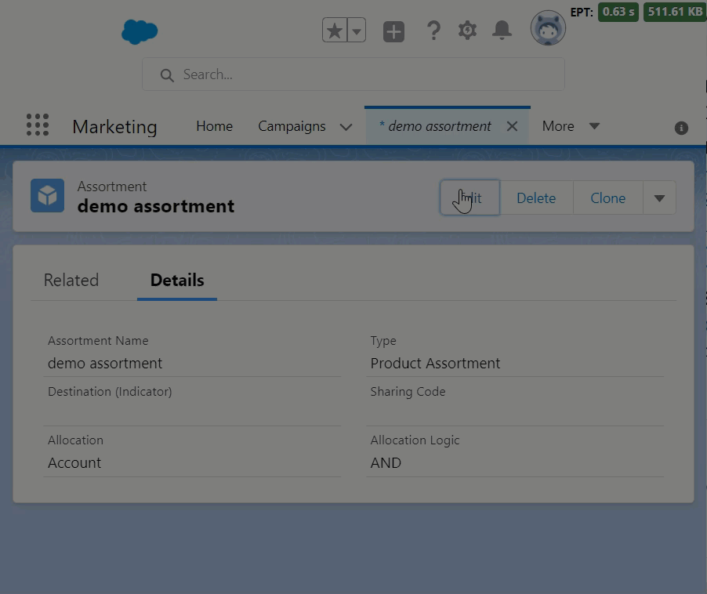

### Clone an Assortment

To clone an existing Assortment object:

1. In the **Assortments** tab, click any assortment.
2. On the Assortment page, click **Clone**.
3. In the **Assortment Details** dialog that appears, leave the configuration as it is or make changes to the details as needed.
4. Click **Save**.

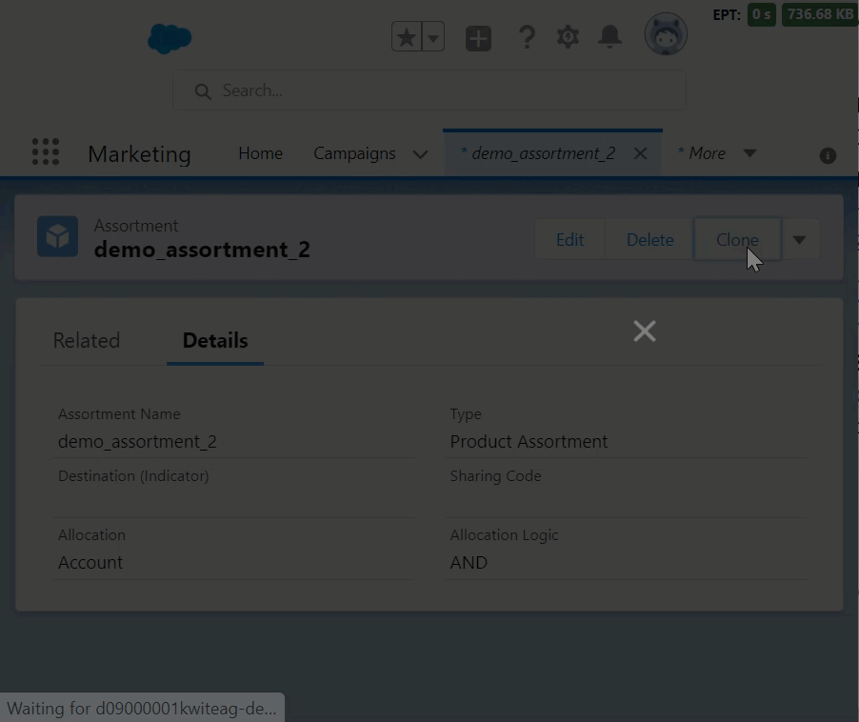

Figure 17 Cloning an Assortment