***ista|*NET**

**Billing Management**

**Guide**

**This Guide is intended for internal use only.**

**Contents**

Billing Management 3

Bill Group Management 3

Consumption Management 5

Invoice Generation Administration 5

Selecting a Bill Group 5

Locking the Invoice Batch 6

Processing Validation Exceptions 11

Generating the Invoices in a Batch 11

Invoice QA Process 11

Batch Print Administration 11

# Billing Management

One of the primary functions within ***ista***|NET is Customer Billing. This User Guide provides the means for understanding how to use the tools available for managing the Billing and Invoicing Administration processes.

This Guide is organized by the five major business processes involved in Billing Management:

1. Bill Group Management
2. Consumption Management
3. Invoice Generation Administration (pre-invoice process)
4. Invoice QA (post-invoice process)
5. Invoice Print Administration

## Bill Group Management

Bill Groups are an ista internal tool used to manage the billing process. Customers are assigned to Bill Groups via the Bill Group Setup page, which is accessed from the link located on the Administration Menu page.

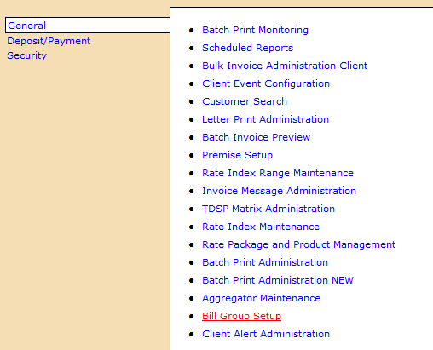

To add a Bill Group, click on the Add link **[A]**. Enter a Bill Group number in the Bill Group Field, Enter a Description, and Enter Notes to further explain the description. Click on the Add Bill Group button when finished.

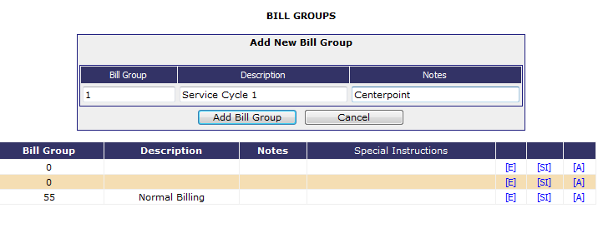

To edit an existing Bill Group, Click on the Edit link **[E]**. Enter a Description and add Notes to further explain the description. Click on the **[Save]** button when finished.

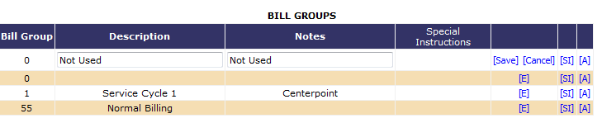

To add Special Instructions to an existing Bill Group, Click on the Special Instructions link **[SI]**. Select the appropriate Special Instructions. Click on the **Update** button when finished.

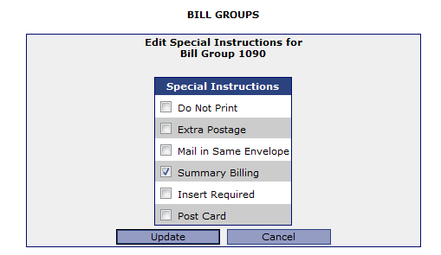

## Consumption Management

Since billing occurs monthly, consumption and 810s/820s, where appropriate, are received it is necessary to monitor for customers who do not receive consumption on a timely basis. The primary tool for monitoring consumption is the Current Consumption Audit Report.

## Invoice Generation Administration

The Invoice Administration process includes three Steps:

1. Selecting a Bill Group
2. Locking the Invoice Batch
3. Validating the Batch

#### Quick Links Page

**Purpose of each field from the Quick Links Page (left-hand side):**

|  |  |
| --- | --- |
| **[Locks]** | Shows the list of Bill Groups that are currently locked |
| **[Batches]** | Shows the list of Batches that have been generated during the past 7 days (default). |
| **[Meter Data]** | Shows the Rate Details, Premise Information, and Meter Data. |
| **[Configuration]** | Allow users to configure invoice validation parameters, invoice thresholds, and administer Bill Groups. |
| **[Estimates]** |  |
| **BG** | Bill Group that the Customer belongs to |
| **Total Customers** | Total number of customers in that Bill Group |
| **Billable Customers** | Number of Customers with unbilled consumption and are ready for billing |

### Selecting a Bill Group

All Customers are assigned to Bill Groups, which is a number assigned at enrollment by ***ista***|NET for the purposes of managing the billing of customers with similar billing rules. The Invoice Administration page organizes invoice batches by Bill Group. To start the billing process, select a Bill Group from the list located on the Left-hand side of the page.

### Locking the Invoice Batch

Choose a batch and lock it, which automatically puts it into the validation queue. The Validation service picks up the batch in about 5 minutes and validates it.

**[Locks]**

Shows the list of Bill Groups that are currently locked.

**Purpose of selection criteria from the Locks page (right-hand side):**

|  |  |
| --- | --- |
| **User** | User that currently has the Bill Group locked |
| **CSP** | Customer Service Provider of the Batches |
| **Bill Group** | Bill Groups locked |
| **Day of Month** | ? |
| **Validated Customers** | Number of customers in the batch and number that have gone through the validation process |
| **Status** | Current Status of the locked batch |

**[Batches]**

Shows the list of Batches that have been generated during the past 7 days (default). Changing the date range produces results for the period selected.

**Purpose of each field from the Batch List (right-hand side):**

|  |  |
| --- | --- |
| **Batch** | Billing Batch generated during period selected |
| **Bill Group** | Bill Group number of the Batch |
| **Description** |  |
| **Customers** | Number of Customers in the batch and number within the batch that were billed |
| **Status** | Status of the Batch |

**Purpose of selection criteria from the Batch List (right-hand side):**

|  |  |
| --- | --- |
| **User** | Select Batches that a particular User generated |
| **Status** | Select Batches by a particular Status |
| **Date From** | Select Batches that were generated no earlier than date |
| **Date To** | Select Batches that were generated no later than date |

**[Meter Data]**

Shows the Rate Details, Premise Information, and Meter Data.

**Purpose of selection criteria from the Meter Data Screen (right-hand side):**

|  |  |
| --- | --- |
| **Account No** | Allows user to search on Customer Number |
| **Customer Name** | Allows user to search on Customer Name |
| **ESI ID** | Allows user to search on complete ESI ID |
| **ESI ID Fragment** | Allows user to search on portion of the ESI ID |

**Purpose of each field from the Meter Data Screen (right-hand side):**

|  |  |
| --- | --- |
| **Bill Group** | Bill Group number of the Batch |
| **Production Cycle** | Meter Read cycle assigned by the TDSP/LDC. |
| **Customer Type** | Customer Type assigned |
| **TDSP Template** | Matrix of TDSP Charges being withheld or passed through to the Customer during billing. |
| **Division** | Client Division assigned to the customer. |
| **Taxable** | Y/N indicator for whether or not the customer is tax exempt. N = Tax Exempt, Y = Taxable |
| **Late Fees** | Y/N indicator for whether or not the customer is subject to late Fees. N = not subject to late fees, Y = subject to late fees. |
| **Rate Code** | Rate Code that is currently being billed. Indicates various charge types and method of billing. |

**[Configuration]**

Allow users to configure invoice validation parameters, invoice thresholds, and administer Bill Groups.

**Purpose of selection criteria from the Invoice Configuration screen (right-hand side):**

|  |  |
| --- | --- |
| **Invoice Validations** | Configure pre-invoice validations. These can be global or client specific and configured per customer type, rate type, and/or LDC. |
| **Invoice Thresholds** | Configure minimum and maximum values on consumption periods, amounts, and percent variances. If a threshold is exceeded, pre-invoice validation alerts are raised and customers must be cleared before invoicing can occur. |
| **Bill Group Administration** | Configure the bill groups that will be automated for invoicing. Customers in these selected bill groups will be invoiced when consumption arrives and they validate successfully. |

**[Estimates]**

.

**Purpose of selection criteria from the Batch List (right-hand side):**

|  |  |
| --- | --- |
|  |  |
|  |  |
|  |  |
|  |  |

**Purpose of each field from the Batch List (right-hand side):**

|  |  |
| --- | --- |
|  |  |
|  |  |
|  |  |
|  |  |
|  |  |

**Purpose of each field from the Customer List (right-hand side):**

|  |  |
| --- | --- |
| List (Icon) | Returns results after selecting certain criteria |
| Lock Batch (Icon) | Locks the Customers selected into a Billing Batch protect them from being used by another person |
| Bill Group Transfer (Icon) | Transference of customers to a different Bill Group |
| CSP (Field) | List of Customer Service Providers contained within the system |
| Date To (Field) | Unbilled Consumption Service Period Date To |
| Production Cycle (Field) | TDSP/LDC Meter Read Cycle |
| Filter (Field) | Additional Filter |
| 867 Transaction Date (Field) | Allows user to enter a specific meter read transaction date (service period end date?) |
| Bill Group (for transfer) (Field) | Field to enter the Bill Group that the customers selected are being moved to |
| Show Customers without Consumption (Check Box) | Check if you only want a listing of customers without consumption (what criteria are used in this report?) |
| Customers with Unbilled Consumption (Table) | Initial list comes from all customers in the Bill Group. Changing search criteria provides results from all the search criteria selected |

|  |  |
| --- | --- |
| **Invoice Validations** | Configure pre-invoice validations. These can be global or client specific and configured per customer type, rate type, and/or LDC. See table below for examples |

|  |  |  |  |  |  |  |  |  |  |  |  |
| --- | --- | --- | --- | --- | --- | --- | --- | --- | --- | --- | --- |
| Validation Type | CSP | Customer Type | Rate Type | Billing Type | Market | LDC | Bill Group | Priority | Min | Max | Amount |
| [Consumption Cancel Without Rebill](http://uat.csr.tenbilling.com/Administration/Invoice/ValidationDetail.aspx?ClientID=19&CSPID=1&CVTID=6) |  |  |  | 4 |  |  |  |  |  |  |  |
| [Consumption Cancel Without Rebill](http://uat.csr.tenbilling.com/Administration/Invoice/ValidationDetail.aspx?ClientID=19&CSPID=1&CVTID=5) |  |  |  | 3 |  |  |  |  |  |  |  |
| [Consumption Cancel Without Rebill](http://uat.csr.tenbilling.com/Administration/Invoice/ValidationDetail.aspx?ClientID=19&CSPID=1&CVTID=4) |  |  |  | 2 |  |  |  |  |  |  |  |
| [Consumption Invoiced](http://uat.csr.tenbilling.com/Administration/Invoice/ValidationDetail.aspx?ClientID=19&CSPID=1&CVTID=20) |  |  |  |  |  |  |  |  |  |  |  |
| [Consumption Type](http://uat.csr.tenbilling.com/Administration/Invoice/ValidationDetail.aspx?ClientID=19&CSPID=1&CVTID=13) |  |  |  |  |  |  |  |  |  |  |  |
| [Invalid Consumption Unit](http://uat.csr.tenbilling.com/Administration/Invoice/ValidationDetail.aspx?ClientID=19&CSPID=1&CVTID=8) |  |  |  |  |  |  |  |  |  |  |  |
| [Invalid Load Profile](http://uat.csr.tenbilling.com/Administration/Invoice/ValidationDetail.aspx?ClientID=19&CSPID=1&CVTID=7) |  |  |  |  |  |  |  |  |  |  |  |
| [Mismatch Service Dates](http://uat.csr.tenbilling.com/Administration/Invoice/ValidationDetail.aspx?ClientID=19&CSPID=1&CVTID=11) |  |  |  |  |  |  |  |  |  |  |  |
| [Missing Consumption Sub Customer](http://uat.csr.tenbilling.com/Administration/Invoice/ValidationDetail.aspx?ClientID=19&CSPID=1&CVTID=3) |  |  |  |  |  |  |  |  |  |  |  |
| [Missing Geocode](http://uat.csr.tenbilling.com/Administration/Invoice/ValidationDetail.aspx?ClientID=19&CSPID=1&CVTID=19) |  |  |  |  |  |  |  |  |  |  |  |
| [Missing Rate](http://uat.csr.tenbilling.com/Administration/Invoice/ValidationDetail.aspx?ClientID=19&CSPID=1&CVTID=12) |  |  |  |  |  |  |  |  |  |  |  |
| [Missing Rate BOC](http://uat.csr.tenbilling.com/Administration/Invoice/ValidationDetail.aspx?ClientID=19&CSPID=1&CVTID=2) |  |  | Variable Price Calculation |  |  |  |  |  |  |  |  |
| [Missing Rate Contract Volumes](http://uat.csr.tenbilling.com/Administration/Invoice/ValidationDetail.aspx?ClientID=19&CSPID=1&CVTID=21) |  |  |  |  |  |  |  |  |  |  |  |
| [Missing Rate Variable](http://uat.csr.tenbilling.com/Administration/Invoice/ValidationDetail.aspx?ClientID=19&CSPID=1&CVTID=1) |  |  | Index Price Calculation |  |  |  |  |  |  |  |  |
| [Missing TDSP Charges](http://uat.csr.tenbilling.com/Administration/Invoice/ValidationDetail.aspx?ClientID=19&CSPID=1&CVTID=9) |  |  |  |  |  |  |  |  |  |  |  |
| [Multiple Consumption Charges](http://uat.csr.tenbilling.com/Administration/Invoice/ValidationDetail.aspx?ClientID=19&CSPID=1&CVTID=14) |  |  |  |  |  |  |  |  |  |  |  |
| [Multiple TDSP Charges](http://uat.csr.tenbilling.com/Administration/Invoice/ValidationDetail.aspx?ClientID=19&CSPID=1&CVTID=10) |  |  |  |  |  |  |  |  |  |  |  |
| [Threshold: Cons Estimate](http://uat.csr.tenbilling.com/Administration/Invoice/ValidationDetail.aspx?ClientID=19&CSPID=1&CVTID=15) |  |  |  |  |  |  |  |  |  |  |  |
| [Threshold: Cons Period](http://uat.csr.tenbilling.com/Administration/Invoice/ValidationDetail.aspx?ClientID=19&CSPID=1&CVTID=16) |  |  |  |  |  |  |  |  |  |  |  |
| [Threshold: Cons Range](http://uat.csr.tenbilling.com/Administration/Invoice/ValidationDetail.aspx?ClientID=19&CSPID=1&CVTID=17) |  |  |  |  |  |  |  |  |  |  |  |
| [Threshold: Cons Variance](http://uat.csr.tenbilling.com/Administration/Invoice/ValidationDetail.aspx?ClientID=19&CSPID=1&CVTID=18) |  |  |  |  |  |  |  |  |  |  |  |

|  |  |
| --- | --- |
| **Invoice Thresholds** | Configure minimum and maximum values on consumption periods, amounts, and percent variances. If a threshold is exceeded, pre-invoice validation alerts are raised and customers must be cleared before invoicing can occur. |

|  |  |  |  |  |
| --- | --- | --- | --- | --- |
| Category | Description | [Minimum](javascript:__doPostBack('ctl00$cphContent$dgThresholds$ctl01$ctl00','')) | [Maximum](javascript:__doPostBack('ctl00$cphContent$dgThresholds$ctl01$ctl01','')) |  |
| CSA | Threshold: Consumption Period | 15.00 | 40.00 | [[E]](javascript:__doPostBack('ctl00$cphContent$dgThresholds$ctl02$lbtnEdit','')) |
| EMA | Threshold: Consumption Period | 15.00 | 40.00 | [[E]](javascript:__doPostBack('ctl00$cphContent$dgThresholds$ctl03$lbtnEdit','')) |
| CAA | Threshold: Consumption Period | 15.00 | 40.00 | [[E]](javascript:__doPostBack('ctl00$cphContent$dgThresholds$ctl04$lbtnEdit','')) |
| CSA | Threshold: Consumption Range | 1.00 | 25000.00 | [[E]](javascript:__doPostBack('ctl00$cphContent$dgThresholds$ctl05$lbtnEdit','')) |
| EMA | Threshold: Consumption Range | 1.00 | 25000.00 | [[E]](javascript:__doPostBack('ctl00$cphContent$dgThresholds$ctl06$lbtnEdit','')) |
| CAA | Threshold: Consumption Range | 1.00 | 25000.00 | [[E]](javascript:__doPostBack('ctl00$cphContent$dgThresholds$ctl07$lbtnEdit','')) |
| CSA | Threshold: Consumption Variance | 3.00 | 3.00 | [[E]](javascript:__doPostBack('ctl00$cphContent$dgThresholds$ctl08$lbtnEdit','')) |
| EMA | Threshold: Consumption Variance | 0.90 | 3.00 | [[E]](javascript:__doPostBack('ctl00$cphContent$dgThresholds$ctl09$lbtnEdit','')) |
| CAA | Threshold: Consumption Variance | 3.00 | 3.00 | [[E]](javascript:__doPostBack('ctl00$cphContent$dgThresholds$ctl10$lbtnEdit','')) |
|  | Threshold: Consumption Estimate | 0.00 | 1.00 | [[E]](javascript:__doPostBack('ctl00$cphContent$dgThresholds$ctl11$lbtnEdit','')) |
| NA | Threshold: Consumption Period | 15.00 | 100.00 | [[E]](javascript:__doPostBack('ctl00$cphContent$dgThresholds$ctl12$lbtnEdit','')) |
| NA | Threshold: Consumption Variance | 5.00 | 5.00 | [[E]](javascript:__doPostBack('ctl00$cphContent$dgThresholds$ctl13$lbtnEdit','')) |
|  | Threshold: Consumption Parital Period | 0.00 | 0.00 | [[E]](javascript:__doPostBack('ctl00$cphContent$dgThresholds$ctl14$lbtnEdit','')) |

|  |  |
| --- | --- |
| **Bill Group Administration** | Configure the bill groups that will be automated for invoicing. Customers in these selected bill groups will be invoiced when consumption arrives and they validate successfully. |

|  |  |  |  |  |
| --- | --- | --- | --- | --- |
| Bill Group | Description | Special Instructions | Customers | Invoice Automated |
| [0001](http://uat.csr.tenbilling.com/Administration/Invoice/BillCycleDetail.aspx?ClientID=19&CSPID=1&BillCycleID=3) | RGE - Bill Ready |  | 121365 | False |
| [0002](http://uat.csr.tenbilling.com/Administration/Invoice/BillCycleDetail.aspx?ClientID=19&CSPID=1&BillCycleID=4) | RGE - Dual |  | 7980 | True |
| [0003](http://uat.csr.tenbilling.com/Administration/Invoice/BillCycleDetail.aspx?ClientID=19&CSPID=1&BillCycleID=5) | RGE Problems |  | 0 | False |
| [0004](http://uat.csr.tenbilling.com/Administration/Invoice/BillCycleDetail.aspx?ClientID=19&CSPID=1&BillCycleID=310) | Dobson Cellular |  | 0 | False |
| [0011](http://uat.csr.tenbilling.com/Administration/Invoice/BillCycleDetail.aspx?ClientID=19&CSPID=1&BillCycleID=373) | Collections - Bill Option Issues |  | 0 | False |
| [0021](http://uat.csr.tenbilling.com/Administration/Invoice/BillCycleDetail.aspx?ClientID=19&CSPID=1&BillCycleID=8) | Multi-LDC Accts: RGE and NYSEG |  | 14 | False |
| [0022](http://uat.csr.tenbilling.com/Administration/Invoice/BillCycleDetail.aspx?ClientID=19&CSPID=1&BillCycleID=9) | Multi-LDC Accts: NYSEG and Corning |  | 18 | False |
| [0023](http://uat.csr.tenbilling.com/Administration/Invoice/BillCycleDetail.aspx?ClientID=19&CSPID=1&BillCycleID=10) | Special Handle Accounts |  | 1 | False |
| [0024](http://uat.csr.tenbilling.com/Administration/Invoice/BillCycleDetail.aspx?ClientID=19&CSPID=1&BillCycleID=11) | Multi-LDC Accts: RGE and Nat. Grid |  | 207 | False |
| [0031](http://uat.csr.tenbilling.com/Administration/Invoice/BillCycleDetail.aspx?ClientID=19&CSPID=1&BillCycleID=12) | NYSEG - Bill Ready |  | 409 | False |
| [0032](http://uat.csr.tenbilling.com/Administration/Invoice/BillCycleDetail.aspx?ClientID=19&CSPID=1&BillCycleID=13) | NYSEG - Dual |  | 507 | True |

.

### Processing Validation Exceptions

To accept a customer’s validation error and allow it to be invoiced in the Batch, put a check in the Clear check box located on the right and select the Clear Button.

To exclude the customer’s account from the Batch, select the **[E]** Exclude icon on the left.

To correct the error, select the [MD] Icon on the left to open up the Meter Data on this ESI ID and edit appropriate data accordingly. Re-validate the customer until the validation is complete.

### Generating the Invoices in a Batch

To invoice the Batch, select the Invoice button at the top of the page. This action will place the batch in the Invoice Queue for the Service to pick it up within 5 minutes and process.

### Invoice QA Process

To Review the customer list within a Batch that has completed, select the **[Batches]** Icon and then select the specific Batch number from the list.

### Batch Print Administration

To release an Invoice Batch to the Print Queue, select the radio button for Print and select the Process Print Batch.

To remove an Invoice Batch from the Print Queue, select the radio button for Remove and select the Process Print Batch.

To take no action (default) on an Invoice Batch, be sure that the radio button for No Action is selected.