DAY 5 | Linux Administration - Advanced Tasks

Task 1: Compress and Decompress Files Using tar
Objective:
Understand how to archive, compress, and extract files using the tar utility.
Purpose:
To efficiently back up, transfer, and store multiple files or directories as a single archive.
Implementation:
1. Create an archive: tar -cvf archive.tar folder/
2. Extract an archive: tar -xvf archive.tar
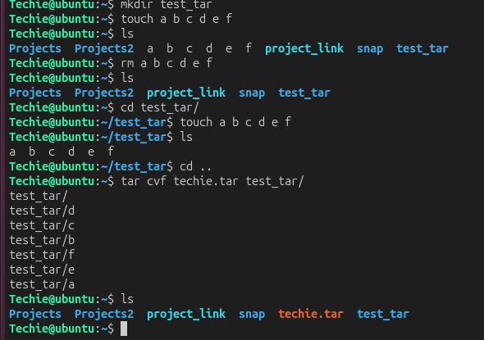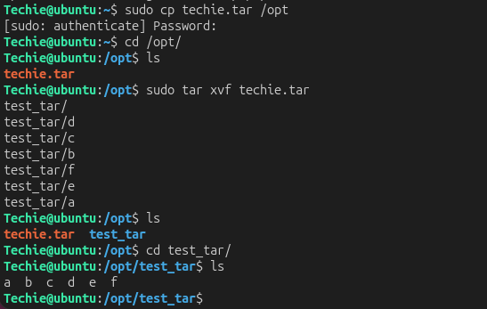
Conclusion:
Successfully creates, compresses, lists, and extracts archive files.

Task 2: Monitor System Resources with top or htop
Objective:
Learn to monitor CPU, memory, processes, and system performance in real time.
Purpose:
To identify performance bottlenecks and troubleshoot system resource usage.
Implementation:
1. Run top
2. Install htop: sudo apt install htop -y
3. Launch htop
4. Sort processes by CPU or memory usage.
5. Exit using q (top) or F10 (htop). 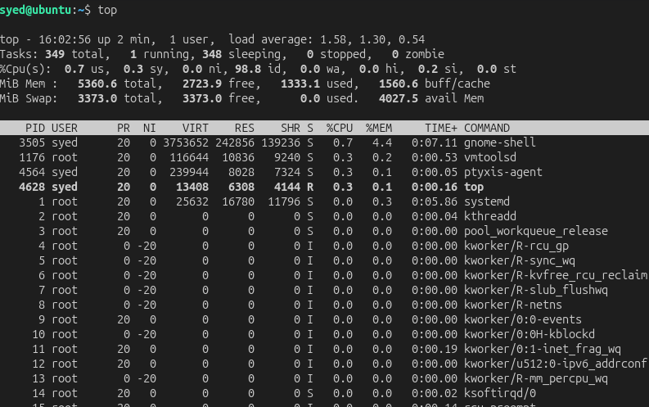 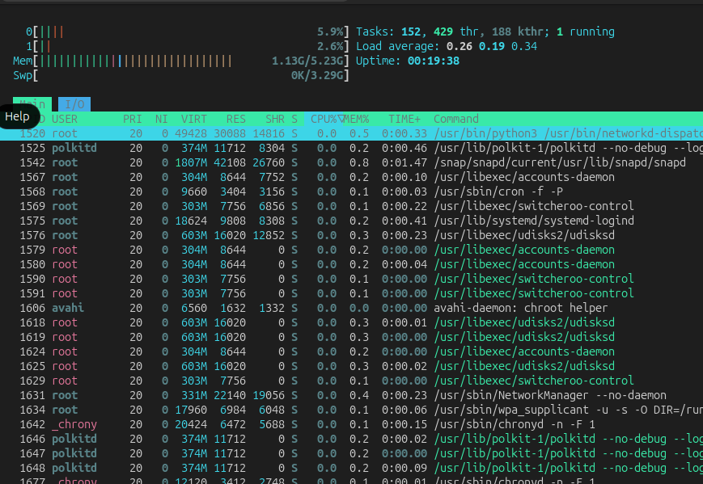
Conclusion:
Real-time system performance can be monitored effectively.

Task 3: Create and Manage User Groups
Objective:
Learn to create groups and manage user memberships.
Purpose:
To simplify permission management for multiple users.
Implementation:
1. Create group: sudo groupadd developers
2. Add user: sudo usermod -aG developers Techie
3. Verify: groups Techie
4. Delete group: sudo groupdel developers
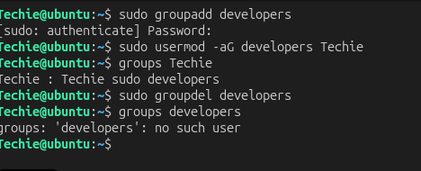
Conclusion:
Users are successfully assigned to and managed through groups.

Task 4: Set Up SSH Passwordless Authentication
Objective:
Configure SSH key-based authentication.
Purpose:
To improve security and automate remote logins.
Implementation 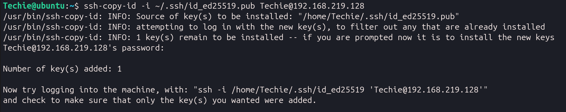 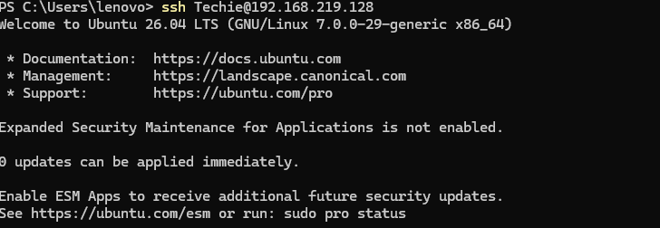

Conclusion:
SSH login is possible without entering a password.

Task 5: Monitor Log Files
Objective:
Learn to monitor and search log files.
Purpose:
To troubleshoot applications and system issues.
Implementation:
1. View live logs: tail -f /var/log/syslog
2. Search logs: grep ERROR app.log
3. Search recursively: grep -R ERROR /var/log/
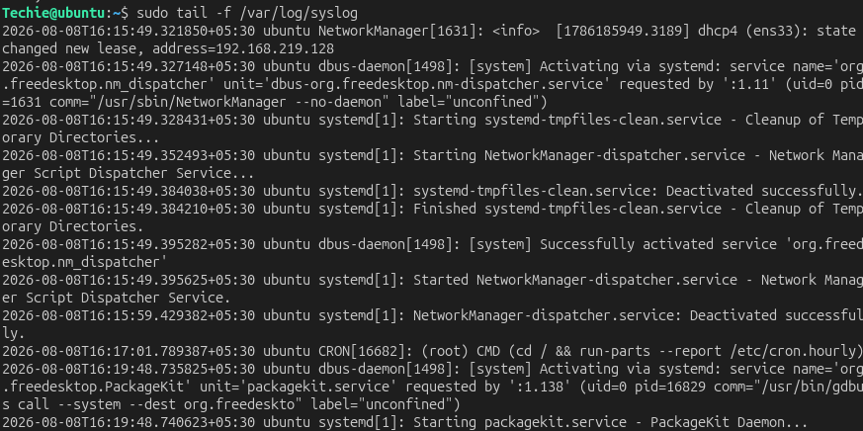
Conclusion:
Relevant log entries can be viewed and analyzed quickly.

Task 6: Set Up a Web Server (Nginx)
Objective:
Install and configure a web server.
Purpose:
To host websites and web applications.
Implementation:
sudo apt install nginx -y
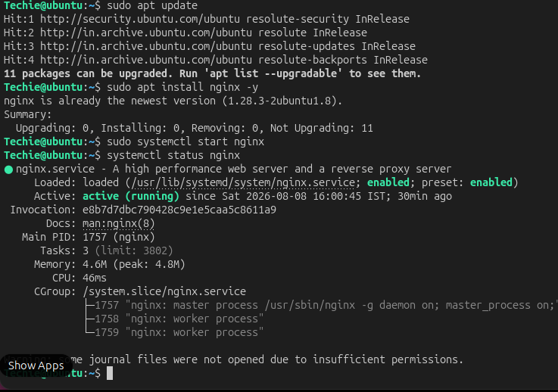
Conclusion:
Nginx is installed and serving web content.

Task 7: Configure and Secure MySQL
Objective:
Install and secure a MySQL database server.
Purpose:
To protect databases from unauthorized access.
Implementation:
1. sudo apt install mysql-server -y
2. sudo mysql_secure_installation
3. sudo systemctl status mysql
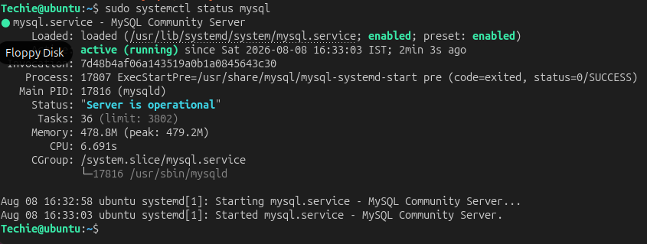
Conclusion:
MySQL is installed and secured.

Task 8: Set Up Apache Tomcatclear
Objective:
Install and configure Apache Tomcat.
Purpose:
To deploy Java web applications.
Implementation:
1. Install Java
2. Download Tomcat
3. Extract Tomcat
4. Start startup.sh
Conclusion:
Tomcat is ready to host Java applications.

Task 9: Create a systemd Service for Tomcat
Objective:
Manage Tomcat as a Linux service.
Purpose:
To start, stop, restart, and enable Tomcat using systemctl.
Implementation:
1. Create /etc/systemd/system/tomcat.service
2. sudo systemctl daemon-reload
3. sudo systemctl enable tomcat
4. sudo systemctl start tomcat
5. sudo systemctl status tomcat
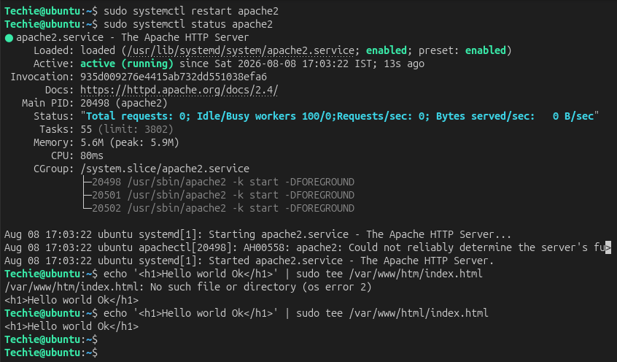

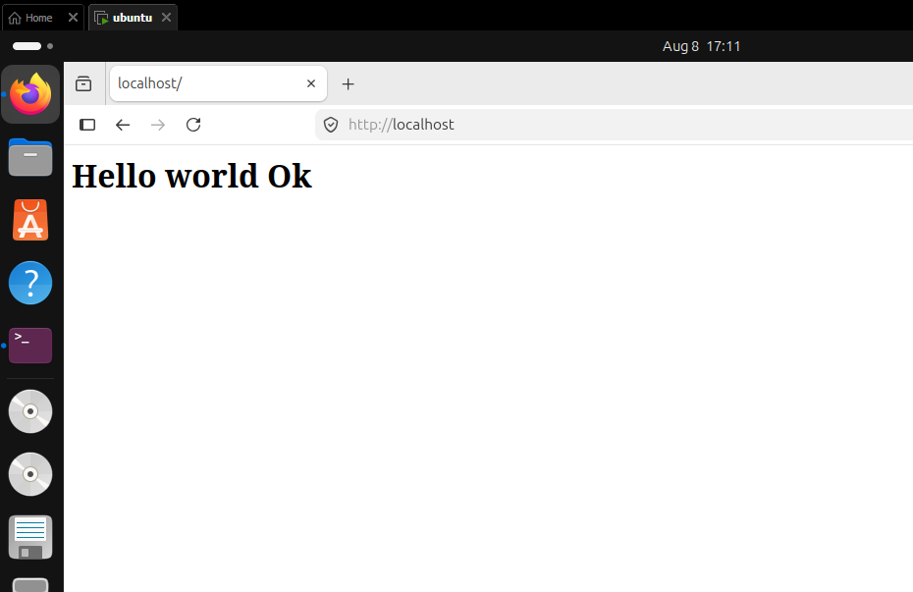
Conclusion:
Tomcat is managed using systemctl.

Task 10: Print Specific Columns
Objective:
Extract selected columns from delimited files.
Purpose:
To process structured data efficiently.
Implementation:
1. awk -F, '{print $1,$3}' Techiedata.csv
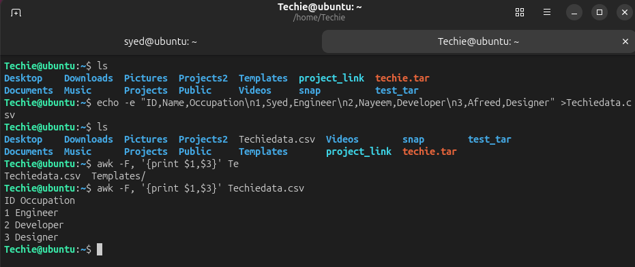
Conclusion:
Required columns are displayed.

Task 11: Filter Lines (AWK)
Objective:
Filter records matching a condition.
Purpose:
To locate relevant information quickly.
Implementation:
1. awk '/ERROR/' projectfile.txt
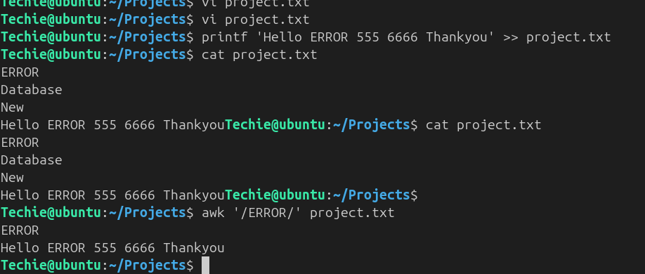
Conclusion:
Only matching records are displayed.

Task 12: Calculate Statistics (AWK)
Objective:
Calculate totals and averages.
Purpose:
To generate reports from numeric data.
Implementation:
1. awk '{sum+=$2} END {print sum,sum/NR}' statistic.txt
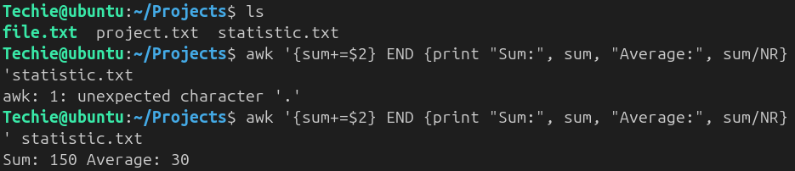
Conclusion:
Sum and average are calculated.

Task 13: String Manipulation (AWK)
Objective:
Modify and extract text.
Purpose:
To reformat and process strings.
Implementation:
1. awk '{print toupper($1), substr($2,1,3)}' linux.txt
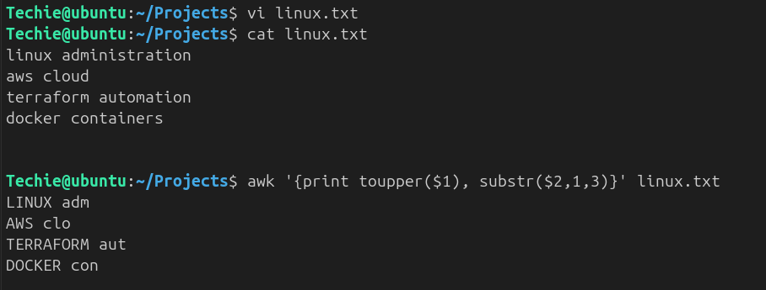
Conclusion:
Strings are transformed as required.

Task 14: Count Pattern Occurrences
Objective:
Count matching text patterns.
Purpose:
To analyze logs and datasets.
Implementation:
1. grep -c 'ERROR' app.log
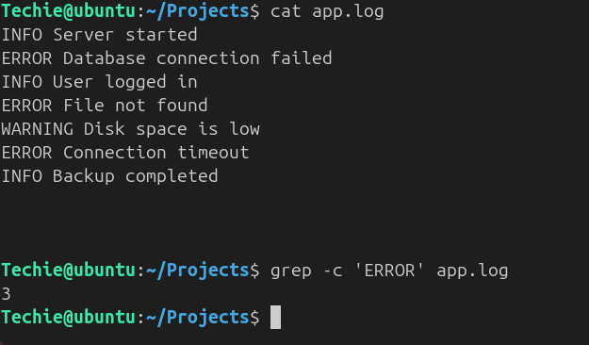
Conclusion:
Pattern frequency is displayed.

Task 15: Sort Lines by Column
Objective:
Sort data using specific fields.
Purpose:
To organize information for reporting.
Implementation:
1. sort -k2n patter.txt
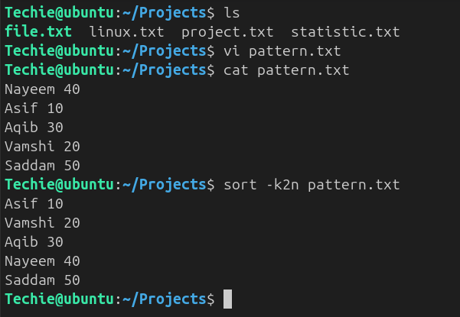
Conclusion:
Records are sorted correctly.

Task 16: Merge Multiple Files
Objective:
Combine related files.
Purpose:
To merge datasets using common fields.
Implementation:
1. join file1 file2
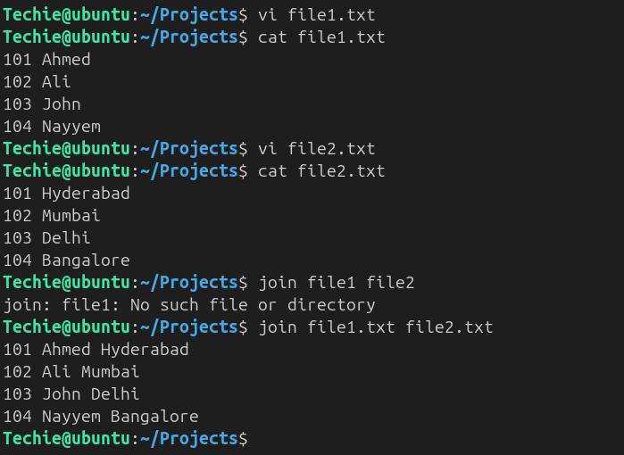
Conclusion:
Matching records are merged.

Task 17: Search and Replace (sed)
Objective:
Replace text in files.
Purpose:
To automate bulk text modifications.
Implementation:
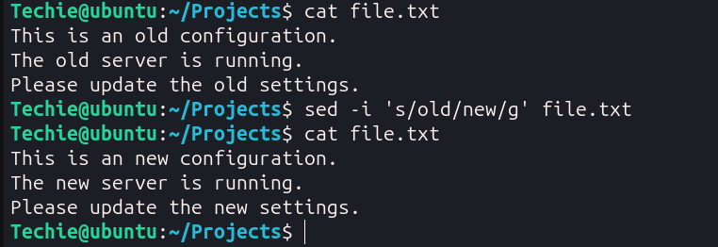
1. sed -i 's/old/new/g' file.txt
Conclusion:
Specified text is replaced.

Task 18: Delete Specific Lines (sed)
Objective:
Remove unwanted lines.
Purpose:
To clean configuration and log files.
Implementation:
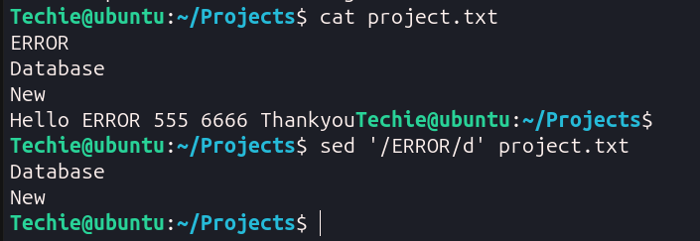
Conclusion:
Matching lines are removed.

Task 19: Append or Insert Text (sed)
Objective:
Insert text before or after patterns.
Purpose:
To automate configuration updates.
Implementation:
1. sed '/pattern/a New Line' file.txt
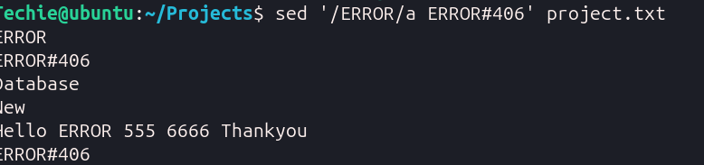
Conclusion:
Text is inserted successfully.

Task 20: Print Specific Lines (sed)
Objective:
Display selected line numbers.
Purpose:
To inspect particular sections of a file.
Implementation:
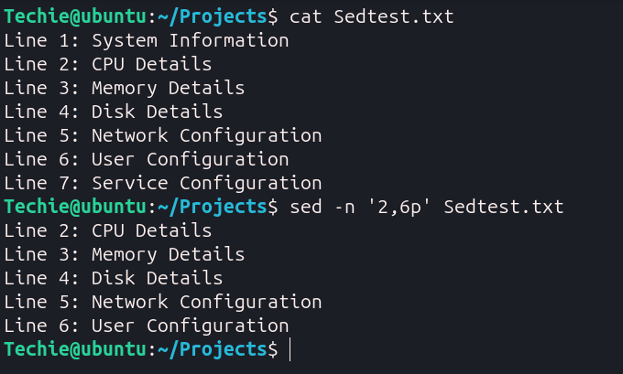
Conclusion:
Only the specified lines are displayed.

Task 21: Copy File from Linux to Windows
Objective:
Transfer files securely between systems.
Purpose:
To move files between Linux and Windows machines.
Implementation:
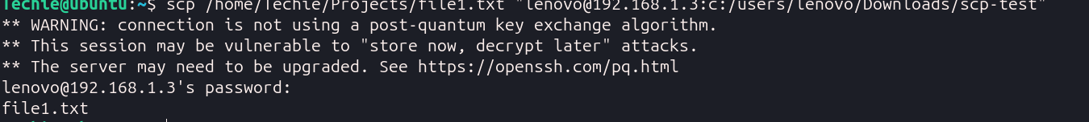
Conclusion:
File is copied successfully.

