PROPOSAL · 16 SEPTEMBER 2026
AI Website Generator
A small business answers a few questions. A finished, live website comes out the other side — in under a minute.
~2¢ per site · <60s to a live site · 6 weeks to a paying pilot
What we are building
A questionnaire, not a website builder  No dragging, no templates to browse, no blank canvas. Eight questions. | Powered by the Claude API  It reads the answers and decides the layout, the structure and every word of the copy.
Published automatically  The finished site goes live at their own address the moment they finish. | Costs pennies to run  About two cents to generate, one cent a month to host. Profitable from customer one.
How the generation works
STEP 01  They answer  Eight questions, four to a screen. Under two minutes. | → | STEP 02  Claude decides  Picks the sections, the order, the colours — and writes every word. | → | STEP 03  We assemble  Our renderer builds the page from tested components. It cannot come out broken. | → | STEP 04  It goes live  Published instantly at theirname.oursite.com, ready to share.
What the customer sees
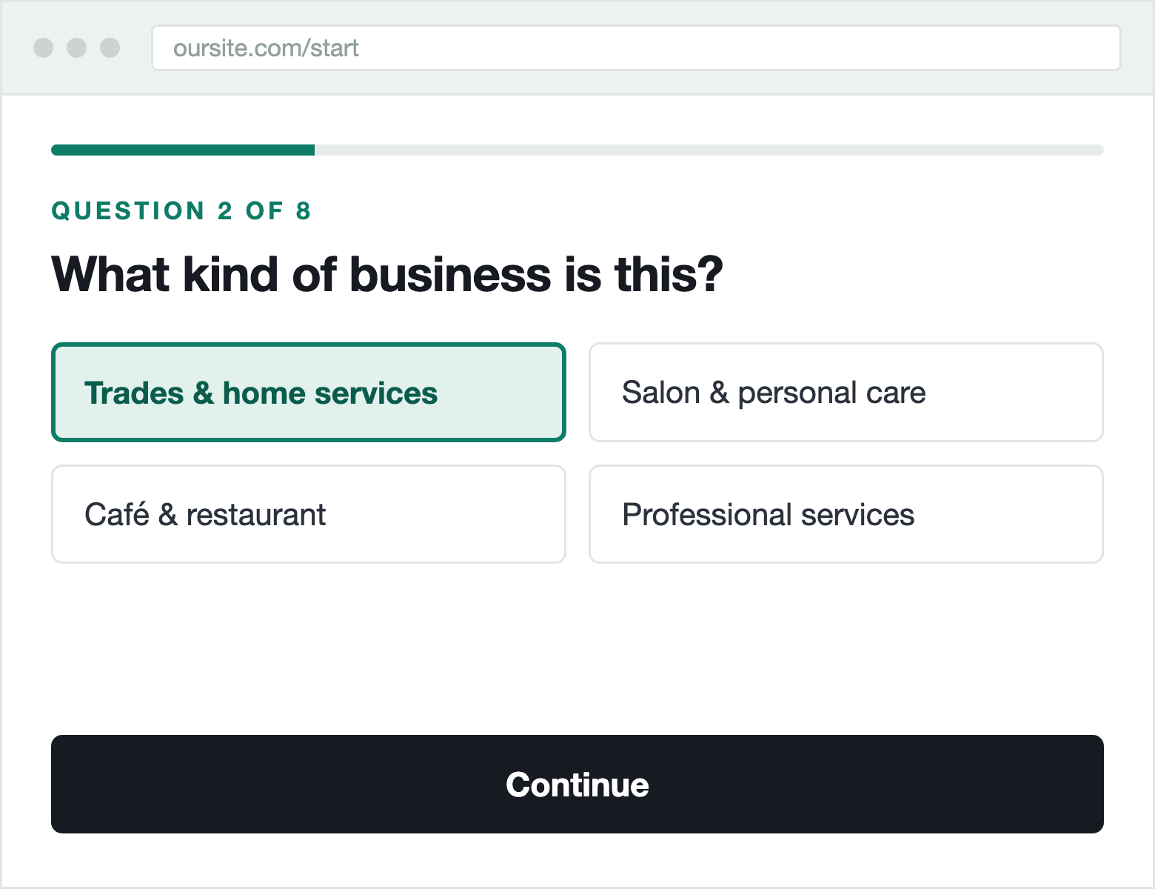 | 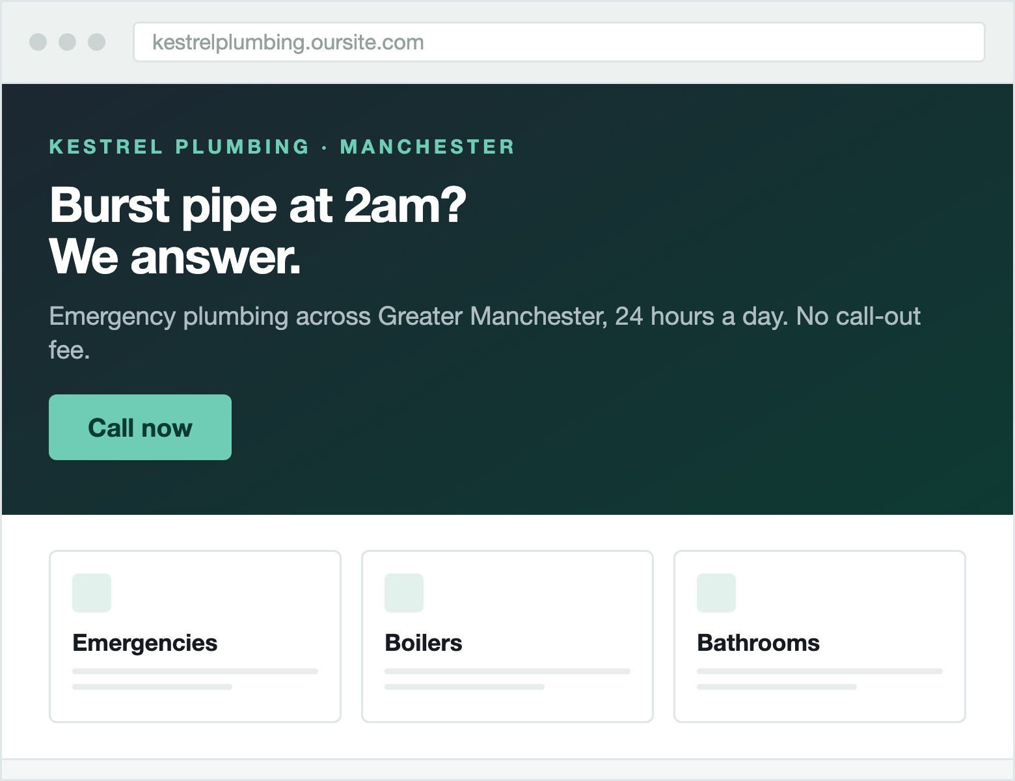
The questionnaire — four options, one tap | The site it generates — live in seconds

The eight questions we ask
01 | What is your business called?  Becomes the title, the logo wordmark and the web address. | 02 | What kind of business is this?  Decides the layout, the section order and the imagery.
03 | Your top three to five services  The main content of the page. Typed by the owner, never invented. | 04 | Where are you based?  Contact details, map, and local phrasing in the copy.
05 | What makes you different?  Becomes the headline. The single most important answer. | 06 | What should visitors do?  Sets the main button: call, book, get a quote, order or visit.
07 | How should it sound?  Sets the writing tone, the colours and the typography. | 08 | How can customers reach you?  Contact section, click-to-call and enquiry form.

Nice to add Optional — every one of these visibly improves the result
+ A logo — or we design a clean wordmark for them | + Brand colours — with a “choose for me” default
+ Photos of the premises, the team or finished work | + Years in business — and whether it is one person or a team
+ Opening hours — or “by appointment only” | + Prices — shown, or replaced with “get a quote”
+ Real customer reviews, pasted or pulled from Google | + Social links — Instagram, Facebook, TikTok

And one free-text box: “Pretend you’re texting a friend who’s building this site for you. What do you tell them so they don’t mess it up?” — worded this way because it gets a real answer instead of “make it nice”.
Then, once they have seen their site
Pick a different headline  Three written options, shown live on their own page. | Pick a different look  Three complete visual treatments, one click apart.
Swap any photo, add an FAQ  Or reorder and hide sections they do not want. | Connect their own domain  The natural moment a free customer becomes a paying one.
Six weeks to a paying pilot
Week 1  Live address  Hosting, log-in and a real page served over HTTPS. | Week 2  Three looks  The visual themes and the first page sections. | Week 3  Design frozen  Every section built and hardened against odd content. | Week 4  Claude connected  Answers in, finished site out, with a spending cap. | Week 5  Strangers welcome  The live questionnaire, working end to end. | Week 6  Pilot opens  Ten real businesses, then we fix what they find.

At the end of week six: ten to twenty-five small businesses paying for real, good-looking, mobile-correct websites that our software generated and serves for them. Three engineers estimated this independently and landed within four hours of each other, at about 238 hours — six weeks at forty.
Costs verified against current Claude API and hosting pricing, September 2026. Mockups are illustrative of the intended output.

