Interviewee: 21 year old woman

City of primary residence: Lansdale, PA

1. How familiar are you with your local recycling regulations in your primary residence area?
   1. Not very familiar – “we had a pamphlet on what to throw out and what to not throw out. I read the pamphlet but that was like six years ago”
2. How accessible do you think information regarding how to recycle is
   1. “Really accessible” because people want to save the earth
3. Do you recycle regularly? Why or why not
   1. “Yes because I don’t want to be like one of those cranky old men who don’t want to recycle”
4. If yes, do you think you recycle properly
   1. “I want to say yes”
5. If yes, how did you learn how to properly recycle
   1. “My dad yelled at me – and I think that’s something we learned in third grade; that’s something we learned in elementary school”
6. How much do you separate your waste? (all in the trash; trash and recycling; trash and multiple separate recycling; trash, recycling, compost)
   1. However much they ask me to separate it (at home can/bottles/recycling)
7. When you spend time away from your primary residence do you still recycle? Why or why not
   1. Apartment – yes
   2. Vacation – “it depends on where I go, obviously most places want to recycle but some hotels don’t give two cans to separate it”
8. Do you know where your primary residence’s local waste drop-off center is located
   1. “Absoultely not”
9. Do you know when trash collection days are at your primary residence
   1. “Yes because I have to take the trash out”
10. When you are choosing what politicans to vote for/support do you take into account their stance on environmental issues
    1. “I mean yeah; global warming, climate change”
11. If you are unsure whether an item can be recycled, do you recycle the item or throw it in the trash?
    1. I look for the triangle and then I guess
12. Do you recognize these symbols?

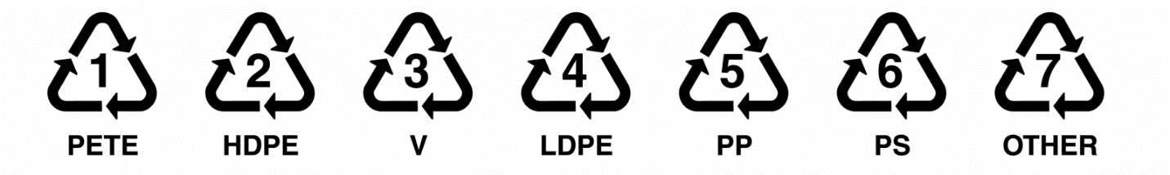

* 1. Yes

1. If yes, do you know what they mean? If so, what do they mean?
   1. “noooo”
2. Are you aware that these symbols do not necessarily mean the object can be recycled in your area?
   1. No