Interviewee: 21 year old woman

City of primary residence: Lansdale, PA

1. How familiar are you with your local recycling regulations in your primary residence area?
   1. “None. I just know what everyone has told me but I havent looked up and read it myself but I know it has to be cleaned like you wash it out and everything and you have to put them in the right places and that’s it”
2. How accessible do you think information regarding how to recycle is
   1. “Probably accessible cause you can just look it up”
3. Do you recycle regularly? Why or why not
   1. “Yess cause I feel bad if I don’t and I think about all the animals that might eat the plastic and die – I think about it all the time and if im actually helping [by recycling]”
4. If yes, do you think you recycle properly
   1. No but tries to
5. If yes, how did you learn how to properly recycle
   1. Just from other people telling me and school (elementary school they had to learn a recycle song)
6. How much do you separate your waste? (all in the trash; trash and recycling; trash and multiple separate recycling; trash, recycling, compost)
   1. Just a trash bin and a recycle bin (all recycle stuff in the one recycle bin)
7. When you spend time away from your primary residence do you still recycle? Why or why not
   1. “I try to like when I go on vacation I take everything and I bring it to a separate – I went to a hotel and they didn’t have any recycling bins in the rooms so I brought it all to their dining area to throw away properly”
8. Do you know where your primary residence’s local waste drop-off center is located
   1. No
9. Do you know when trash collection days are at your primary residence
   1. no
10. When you are choosing what politicans to vote for/support do you take into account their stance on environmental issues
    1. “Yeess – that’s like the most important thing; that and reproductive rights”
11. If you are unsure whether an item can be recycled, do you throw it in the trash or guess which recycling bin to throw it in?
    1. I guess which bin – theres sometimes when I try to throw it out
12. Do you recognize these symbols?

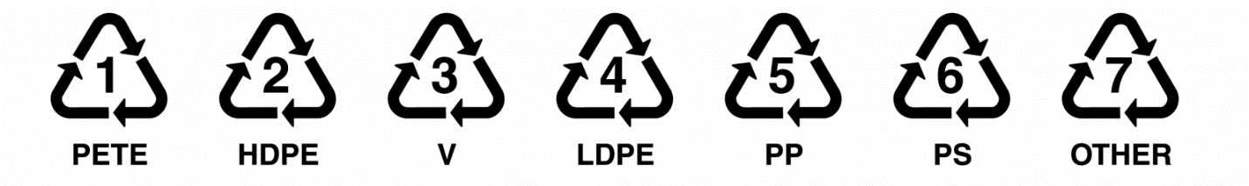

* 1. Yes

1. If yes, do you know what they mean? If so, what do they mean?
   1. “I think number 4 can be recycled” – “I usually look it up when im curious about it”
2. Are you aware that these symbols do not necessarily mean the object can be recycled in your area?
   1. Yes