Interviewee: 53 year old man

City of primary residence: Olney, MD

1. How familiar are you with your local recycling regulations in your primary residence area?
   1. Average knowledge of it – “I’ve googled it a bunch of times depending on what I want to recycle”
2. How accessible do you think information regarding how to recycle is
   1. “Very accessible – you just google montgomery county recycling and theres a ton of information. So around here its very easy. For Grammy on the other hand, it would be very difficult because they don’t have it set up there the way we do here
3. Do you recycle regularly? Why or why not
   1. Yes to “save the planet”, “reduce waste going into landfills – save the environment”
4. If yes, do you think you recycle properly
   1. Yes
5. If yes, how did you learn how to properly recycle
   1. “By googling the montgomery county recycling information. When we moved here they provided the recycling canisters” and they usually gave literature with it that told us what we can and cannot recycle and told us where to take other types of things to recycle them
6. How much do you separate your waste? (all in the trash; trash and recycling; trash and multiple separate recycling; trash, recycling, compost)
   1. 3 bins: Trash; paper; glass/aluminum/plastic
7. When you spend time away from your primary residence do you still recycle? Why or why not
   1. “I try to. I always look for recycling bins”; sometimes bring stuff home to properly recycle it rather than throwing it in the garbage
8. Do you know where your primary residence’s local waste drop-off center is located
   1. Yes I know where it is
9. Do you know when trash collection days are at your primary residence
   1. Yes
10. When you are choosing what politicans to vote for/support do you take into account their stance on environmental issues
    1. Idk – yeah sort of have that as a consideration
11. If you are unsure whether an item can be recycled, do you throw it in the trash or guess which recycling bin to throw it in?
    1. Depends on what it is but probably both – sometimes I throw it in the trash and sometimes I take my best guess – someone there will figure it out if it should be recycled or not
12. Do you recognize these symbols?

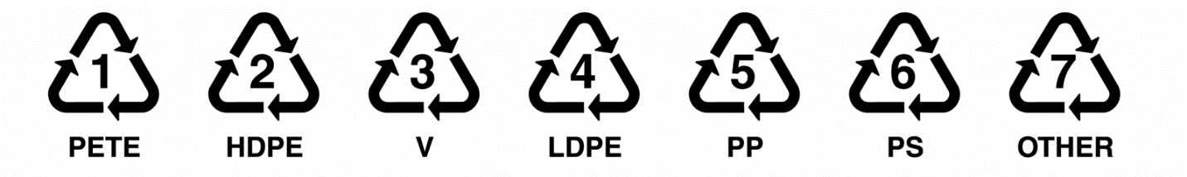

* 1. I recognize them but I do not know what they mean theres too many of them to remember what they all mean

1. If yes, do you know what they mean? If so, what do they mean?
   1. Don’t know what any of them mean – assume if it has a symbol like that it can be recycled
2. Are you aware that these symbols do not necessarily mean the object can be recycled in your area?
   1. Aware that not every one of them can be recycled – “but generally somewhere they can be recycled”