# Visualising Data

The second workshop covers techniques for drawing a number of useful graphics. Visualising variables provide an important “first look” at your data. The topics include:

1. Producing a pie chart
2. Producing a bar chart
3. Producing a grouped bar chart
4. Producing a stacked bar chart
5. Producing a histogram
6. How to save SPSS graphs as a format of graphic files

In this workshop, we will use the dataset you created last week. Or you can download “Workshop2 Data File” on the iLearn and open it in the SPSS. Then, you are ready to start.

## Producing a Pie Chart

A pie chart is a circular graph with slices that represent the proportion of the total contained within each category. We can use pie charts to visualise nominal as well as ordinal variables.

To produce a pie chart, go to **Analyze > Descriptive Statistics > Frequencies**.

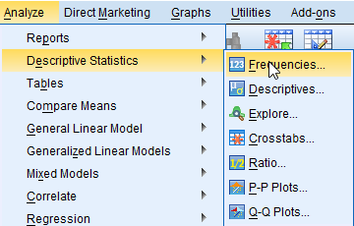

<Figure 2.1>

In the popped-up box, **select a variable** for which you want to produce a pie chart and then **click the arrow**. In this example, I will produce a pie chart of *gender*.

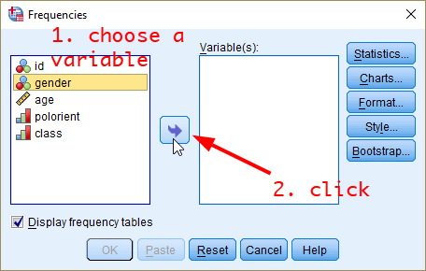

<Figure 2.2>

Now, you will see the selected variable in the pane of Variable(s). **Click *Charts***.

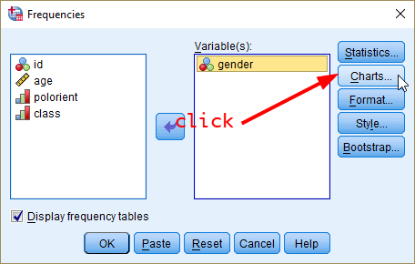

<Figure 2.3>

In the popped-up box, select “Pie charts” as Chart Type and “Frequencies” as Chart Values. Then click *Continue*.

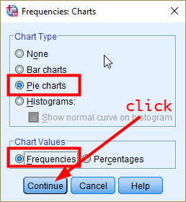

<Figure 2.4>

You will be back to the previous Frequencies box. **Click *OK***.

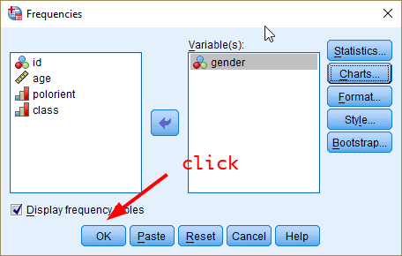

<Figure 2.5>

In the output window, you will see the frequency table and pie chart of gender.

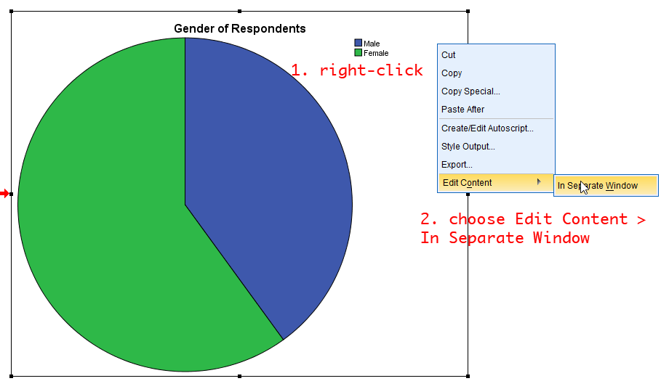

<Figure 2.6>

However, this pie chart does not provide information on the number (frequency) of males and females. Let’s add this information to the chart. At any place in the pie chart, **right-click and then choose Edit Content > In Separate Window**.

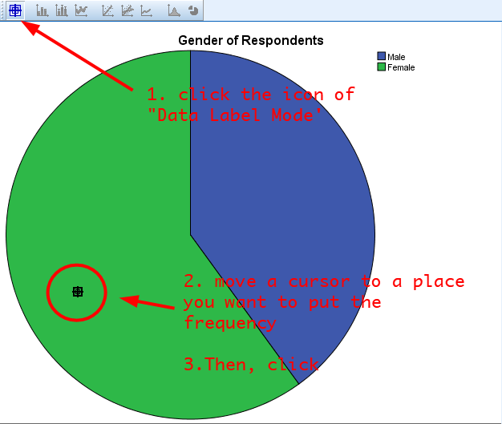

<Figure 2.7>

In the popped-up window, **click the icon of *Data Label Mode*** *(see <Figure 2.7>)*. Then, **move your mouse cursor to a place where you want to put the number. And click**. You need to click on both green (female) and blue (male) areas. Then, you will see the frequency of male and female category.

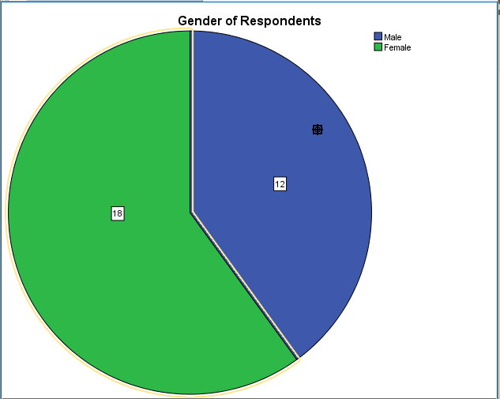

<Figure 2.8>

In <Figure 2.8>, the size of numbers is too small. Let’s edit the font size for better readability. **Click the icon of *Data Label Mode* again to turn off the data label mode and to go back to edit mode**. You will see a popped-up window called *properties*. Close that.

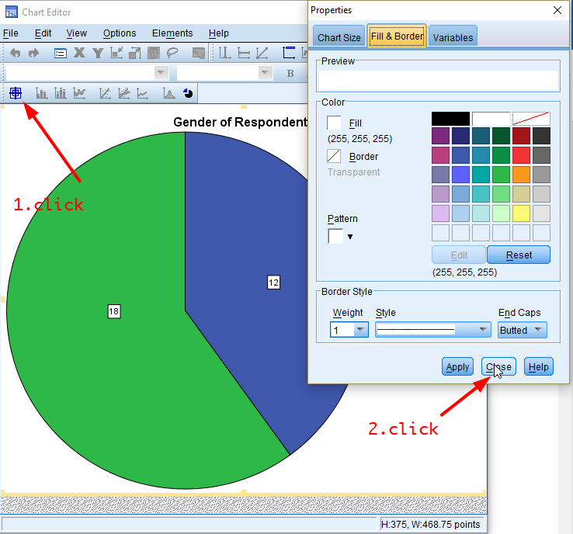

<Figure 2.9>

Then, **click any number of frequencies**. You will see the toolbar of font type and font size activated (see Figure 2.10). There you can change the size of font as well as the type. **Let’s choose 12 as font size.** Then **close the *Chart Editor* by clicking X**.

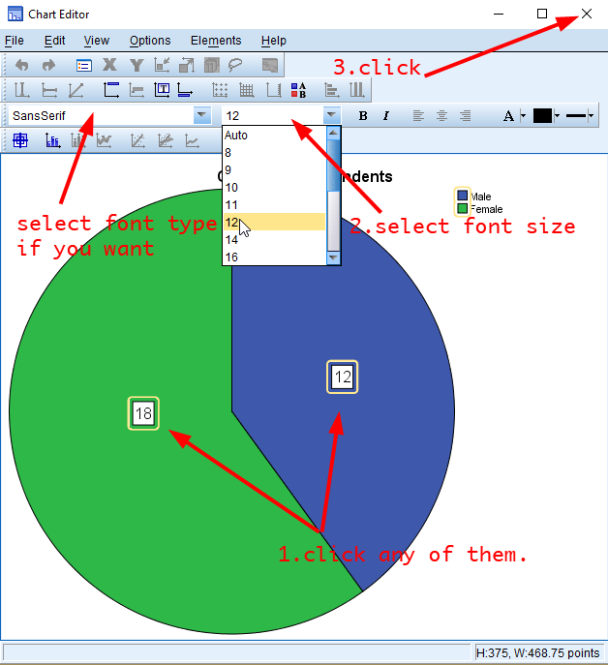

<Figure 2.10>

Note) In <Figure 2.4>, if you select “Percentages” as Chart Values (see <Figure 2.11>), the pie chart will show the percentage of each category of gender (see <Figure 2.12>).

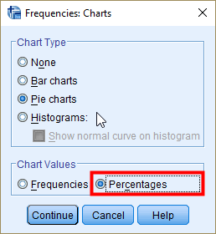

<Figure 2.11>

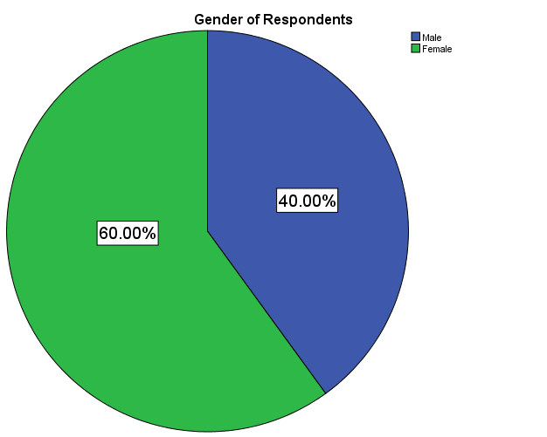

<Figure 2.12>

## Producing a Bar Chart

A bar chart (also called bar graph) is a graphical display of data using bars of different heights. We can use bar charts to visualise nominal as well as ordinal variables.

### Bar charts with a Y-axis representing the frequency

The *Frequencies* command will produce a bar chart as well. Go to **Analyze > Descriptive Statistics > Frequencies**.



<Figure 2.13>

In the popped-up box, **select a variable** for which you want to produce a bar graph and then **click the arrow**. In this example, I will produce a bar graph of *gender*.



<Figure 2.14>

Now, you will see the selected variable in the pane of Variable(s). **Click *Charts***.



<Figure 2.15>

In the popped-up box, select “Bar charts” as Chart Type and “Frequencies” as Chart Values. Then click *Continue*.

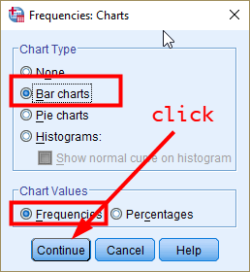

<Figure 2.16>

You will be back to the previous Frequencies box. **Click *OK***.



<Figure 2.17>

In the output window, you will see the frequency table and bar chart of gender.

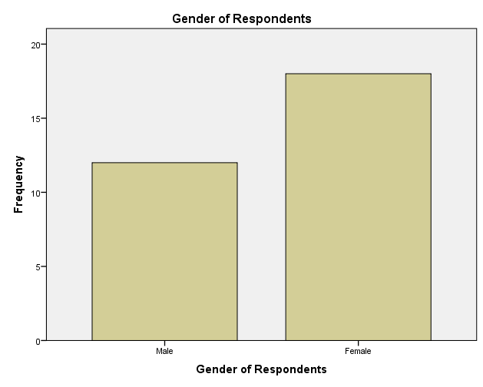

<Figure 2.18>

The bar chart consists of a Y-axis, representing the frequency, and an X-axis, representing each category of *gender*.

### Bar charts with a Y-axis representing the percentage

Sometimes it is useful to compare the percentages of each category in a bar chart instead of frequencies. Let’s make **A bar chart with a Y-axis representing the percentage**. Follow the same steps from <Figure 2.1> to <Figure 2.3>. Then, **select “Percentages” as Chart Values**. Then, **click *Continue***.

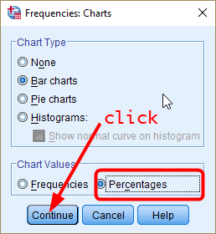

<Figure 2.19>

In the box of Frequencies, click OK (see <Figure 2.15>). You will see the bar chart with a Y-axis representing the frequency of each gender category.

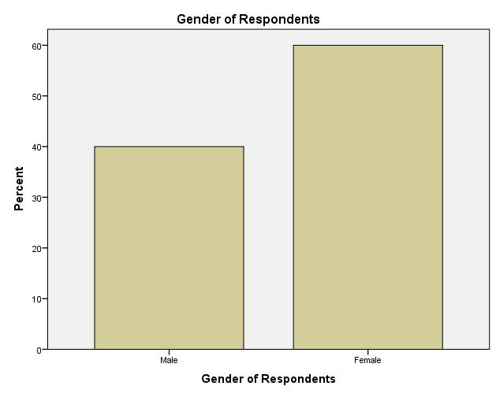

<Figure 2.20>

## Producing a grouped bar chart

Suppose you want to compare the frequency of a variable by subgroups. For example, you may be interested in knowing how the distribution of political orientation differs by gender. Bar charts can be used for this more complex comparison of data by grouping or stacking bar charts. Let’s examine grouped bar chart first. A grouped bar graph produces bars for every combination of categories (gender X political orientation) and then group those bars by subgroups (gender), typically uing colored bars to represent a particular grouping.

To produce this grouped bar chart, **go to Graphs>Legacy Dialogs > Bar**.

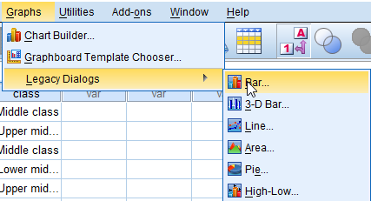

<Figure 2.21>

In the popped-up window, choose “Clustered” as a type of bar charts and “Summaries for groups of cases” in *Data in Chart Are*. Then, click *Define*.

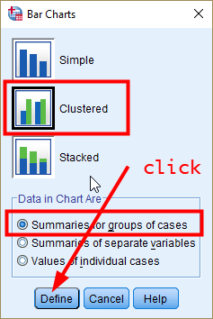

<Figure 2.22>

In the popped-up window, 1) **choose a variable for which a bar is produced** (in our example, it is political orientation) in the pane of variables, and then **click the arrow in *Category Axis***; 2) **choose a group variable by which bars are compared** (in our example, it is gender), and then **click the arrow in *Define Clusters by***; 3) **choose “% of cases” in *Bars Represent*** *(comparing the percentages makes more sense because the number of males and females is different)* and then the bars will represent the percentages(If you choose “N of cases”, the bar will represent the frequency); 4) **click *OK***.

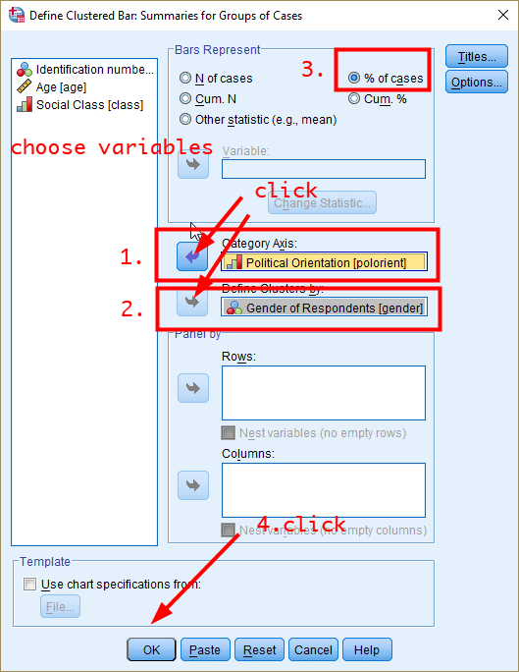

<Figure 2.23>

In the output window, you will see <Figure 2.24>.

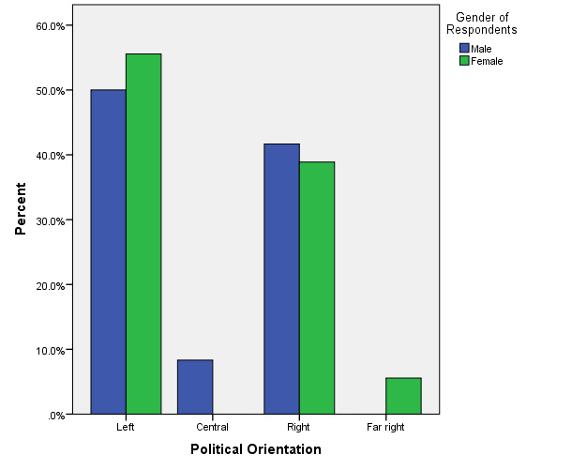

<Figure 2.24>

You can add the percentages to this chart by following the same steps as you did for the pie chart.

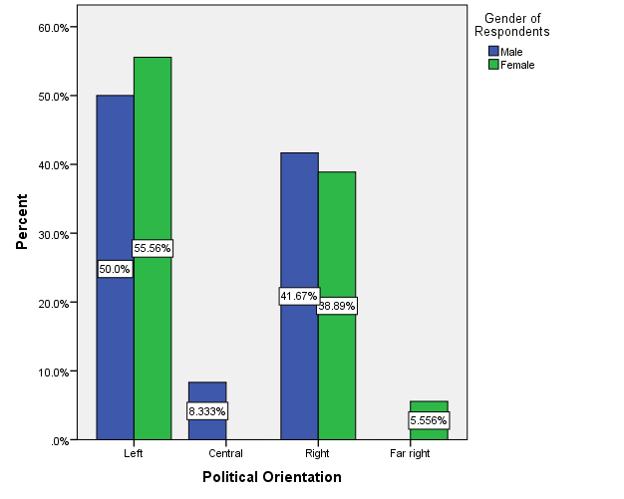

<Figure 2.25>

## Producing a stacked bar chart

A stacked bar chart provides an alternative way to compare the frequency of a variable by subgroups. In a stacked bar chart, parts of the data are stacked: each bar displays a total amount, broken down into sub-amounts.

We will again compare the distribution of political orientation by gender.

To produce it, Go to **Graphs > Chart Builder**.

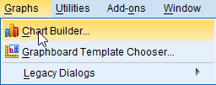

<Figure 2.26>

In the popped-up window, **tick the box of *Don’t show this dialogue again* and click *OK*.**

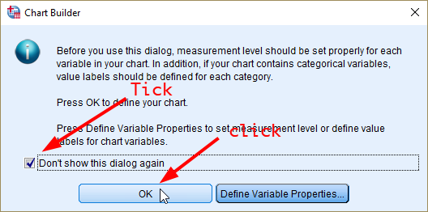

<Figure 2.27>

In the window of Chart Builder, click the icon of stacked bar chart. **Drag and drop it to the upper white pane** (see <Figure 2.28>).

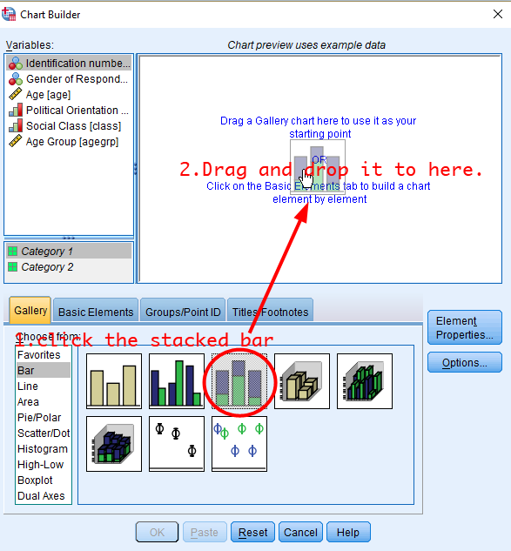

<Figure 2.28>

Then, **drag and drop gender to X-axis and political orientation to Stack: set color**. **After that, click *Element Properties***

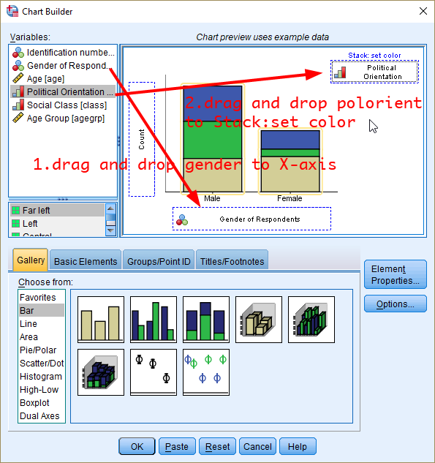

3. Click *Element Properties*

<Figure 2.29>

Next, in the window of Element Properties, let’s edit properties of Bar1 by **selecting “Percentage(?)” in *Statistic***. Then, **click *Apply***.

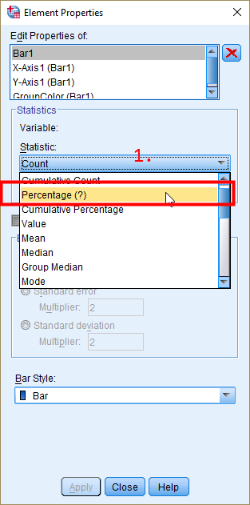

<Figure 2.30>

You will see *Set Parameters* activated (see Figure 2.31). Let’s open that box and **select “Total for Each X-Axis Category” as *Denominator for Computing Percentage***. This is to calculate percentages within subgroups by choosing the total counts of subgroup as denominator (instead of the total counts of your sample, or grand total). This way, each group has 100% as total percentage so meaningful comparison can be made. **Click *Continue***. Then **click *Apply*** at the bottom.

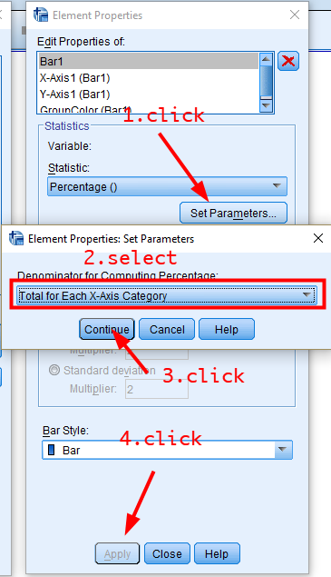

<Figure 2.31>

Lastly, click OK to finish the Chart Builder.

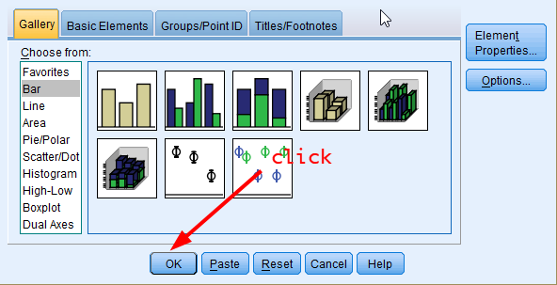

<Figure 2.32>

In the output window, you should see a stacked bar chart of political orientation by gender while both males and females have 100% as their total percentages.

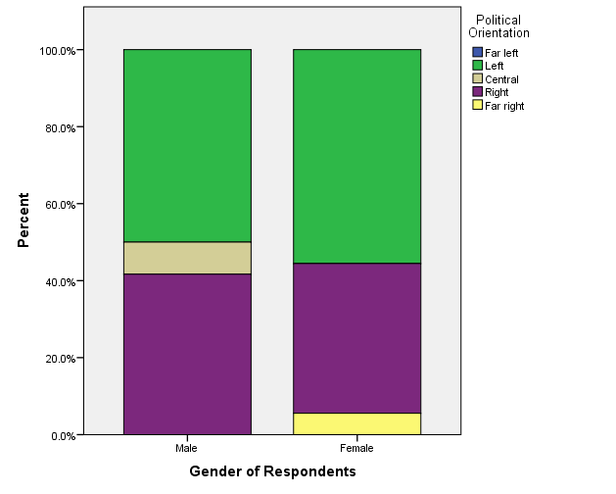

<Figure 2.33>

## Producing a histogram

So far, we create graphs for categorical variables (nominal and ordinal). Can we visualise continuous variables? Yes, the histogram displays well a graphic representation of the distribution of a single continuous variable. It is a kind of bar chart that can be used with continuous variables. The difference is that in a histogram, the bars touch with each other. The widths of the bars represent the widths of the intervals, and the height of each bar represents the frequency of each interval.

We will produce a histogram of age. To create it, **go to Graphs > Legacy Dialogs > Histogram**.

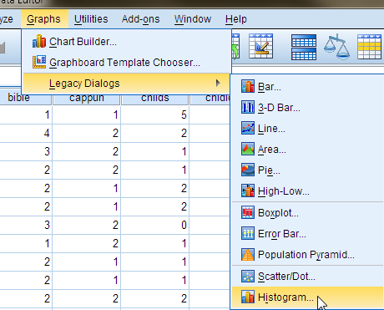

<Figure 2.34>

In the popped-up box, choose a variable you want to plot (in our case, it is age) and then move it to a pane labelled Variable by clicking the arrow next to Variable. Then, click OK.

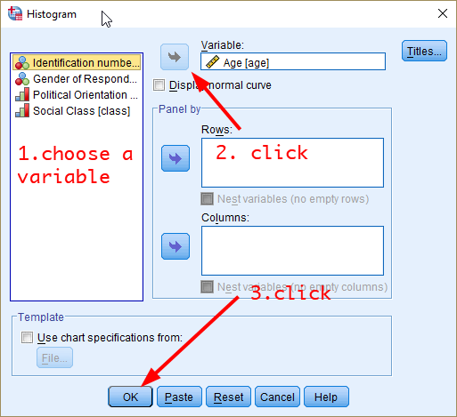

<Figure 2.35>

You will see the histogram of age in the output window (see <Figure 2.28>).

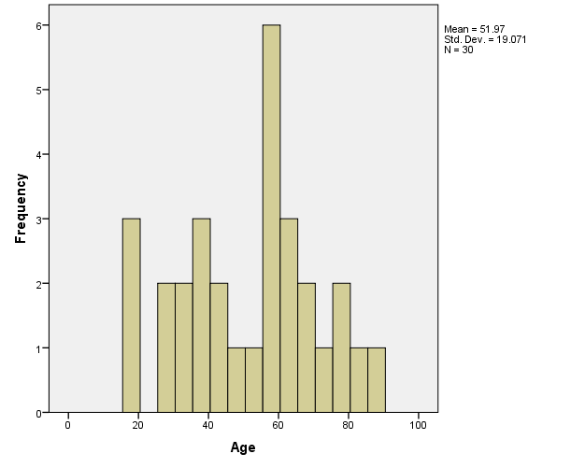

<Figure 2.36>

## How to save SPSS graphs as a format of graphic files

Saving SPSS graphs as a format of graphic files (such as png or jpeg) is a convenient way to keep your graphic outcomes. And then you can import our graphic files into Word, PowerPoint, or iLearn.

First, choose the chart you want to save in the output window. Then, right-click on the chart and select “Export”.

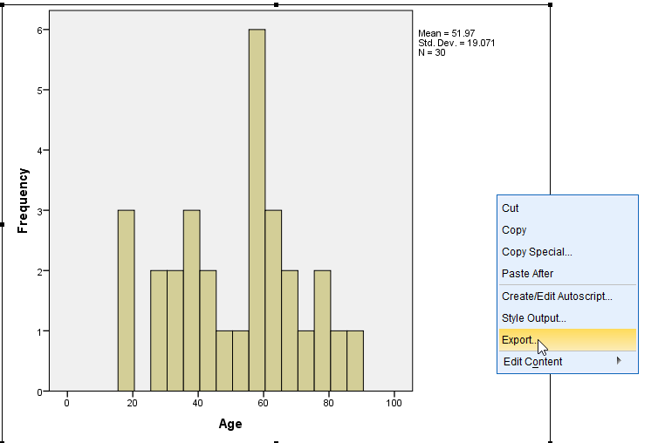

<Figure 2.37>

In the popped-up window, **choose “Selected” in *Object to Export***, “**None (Graphics only)” as *Document Type***, **“PNG file (*.png)” as *Graphics Type***. Of course, you can choose any other graphic formats. Then, **click *Browse* and** you specify the folder where the graphic file will be saved.

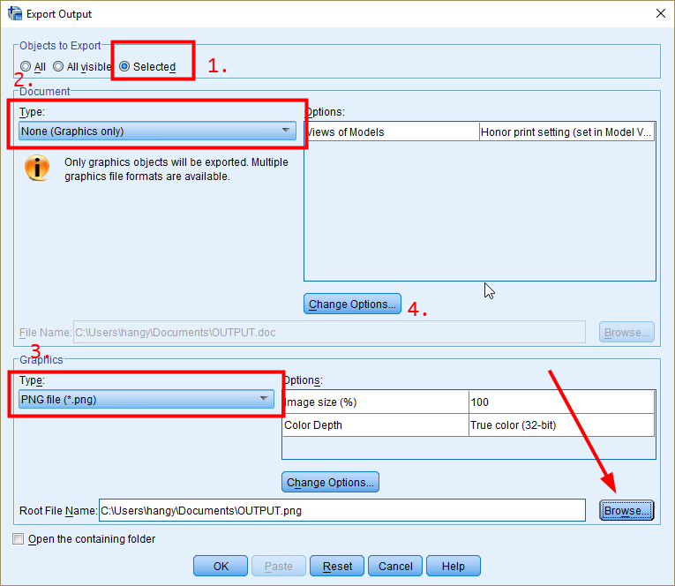

<Figure 2.38>

In the popped-up window, **click a small reverse triangle in the pane of *Look in***. Then, **choose Desktop (it is your desktop (wallpaper))**. **Type file names** and **click *Save***.

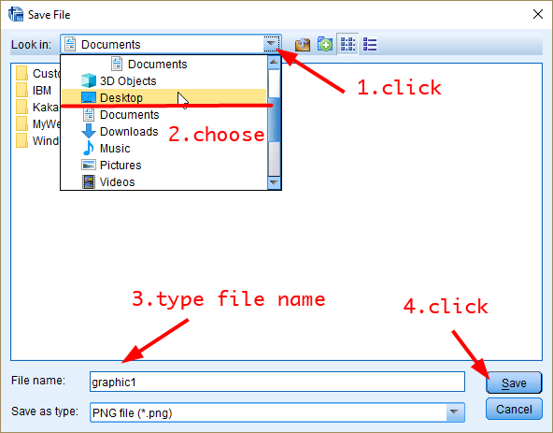

<Figure 2.39>

You will be back to the previous window. Then **click *OK* at the bottom**.

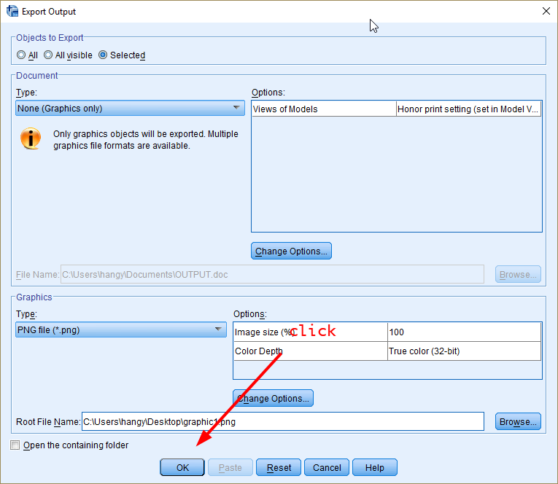

<Figure 2.40>

You will see the saved file on your desktop. Use this file to submit your results to iLearn.

Workshop 2 Activities

Download “Workshop2 Exercise File” on the iLearn. This dataset includes five variables: *id*, *gender*, *degree*(education), *childnum*(number of children) and age. *Gender* has two categories: 0 equals to male(M), and 1 equals to female(F). *Degree* has four categories:1 equals to “Less than High School”, 2 equals to “High School”, 3 equals to “Bachelor Degree”, and 4 equals to “Graduate Degree”.

1. Make a relevant chart for degree. And explain why this type of charts is relevant.
2. Compare the distribution of degree by gender using a grouped bar chart or stacked bar chart. Check whether there are gender differences in the level of education and justify your conclusion.
3. Make a relevant chart for *childnum*. And explain why this type of charts is relevant.

***NOTE) External students should post their answers to these three questions on the iLearn. These activities will contribute to your workshop participation marks.***