Deaths by Intentional Self-harm in the State of Texas in 2013

The dataset focuses on death rates for Texas between the years of 2012 and 2016 by county specifically, on deaths that were deemed “International self-harm.” Some of the included causes of death were suicide by different means of self-poisoning, self-harm by drowning, etc. The dataset does not specifically focus on self-harm as counselors conceptualize the behavior. This difference in conceptualization raises awareness for how the behavior can perceived differently at a societal level. The dataset includes the urbanization status of each county within Texas for the year 2013. The counties were also broken up into regions within Texas. Adding these variables to the death rates in 2013 in Texas will potentially provide information that may confirm previous notions about self-harm. Firstly, what is the correlation relationship between deaths and urbanization status of county. Secondly, what is the correlation relationship between deaths and region of Texas. Due to suicide being the most commonly used name for this classification of deaths, the paper will focus on prevention efforts in Texas.

Texas has a total of 254 counties, however after merging all variables needed there were 83 counties included. The decrease in number may be due to lack of demographic information on death rates in the remaining 171 counties within Texas. To provide descriptive statistics on the rates of deaths due to intentional self-harm in Texas, observations yielding ‘Na’ were removed resulting in 59 counties. Table 1. describes the total deaths by means of intentional self-harm for the state of Texas in 2013. In Texas there were a total of 2,310 deaths with the average being 39 among the included counties that reported deaths of suicide. Another factor to consider, is these rates may not include deaths that were demeaned “accidents” regardless of overlap in description by means, for example, poisoning.

|  |  |  |  |  |  |  |  |
| --- | --- | --- | --- | --- | --- | --- | --- |
| Table 1. Descriptive Statistics of Deaths by Intentional Self-harm in counties within Texas in 2013 | | | | | | | |
|  | | | | | | | |
| Variable | Observations | Mean | Median | S.D. | Min. | Max. | Variance |
| Deaths | 59 | 39 | 20 | 51 | 10 | 306 | 2,625 |
| Note: Not all counties within Texas are included. | | | |  |  |  |  |

Typically, stigma surrounding intentional self-harm, which generally means suicide for governmental purposes, males complete more often than women. In Table 2. we can see that more observations in the sample were male possibly relating to the aforementioned stigma. However, the average deaths were close in number meaning that within Texas counties gender may not meet the stigma.

|  |  |  |  |  |  |  |
| --- | --- | --- | --- | --- | --- | --- |
| Table 2. Descriptive Statistics of Deaths by Intentional Self-harm in counties within Texas in 2013 by Gender | | | | | | |
|  | | | | | | |
| Variable | Counties that reported deaths by intentional self-harm | Mean | Median | S.D. | Min. | Max. |
| Male | 48 | 40 | 19 | 56 | 10 | 306 |
| Female | 11 | 36 | 28 | 27 | 11 | 103 |
| Note: Not all counties had information listed for both genders. | | | | |  |  |

The lifestyle in urban versus rural areas can potentially impact depression leading to death by intentional self-harm. A concern when merging the datasets was the category deemed “rural” was no longer available. This may be due to the lack of information from these specific counties. The other added factor is the merging based on urbanization of a county is specific to the year 2013. In that year, counties that are identified as rural did not have any deaths to report.

Table 3. outlines the descriptions of urbanization status for the counties of Texas. Also, when removing observations of ‘NAs’ the category of ‘Nonmetro not adjacent to metro area’ was removed. The two descriptive variables left were Metro and Nonmetro adjacent to a metro area.

|  |  |  |  |  |  |  |  |  |
| --- | --- | --- | --- | --- | --- | --- | --- | --- |
| Table 3. Urbanization Descriptions | | | | | | | | |
|  | | | | | | | | |
| Code | Description |  |  |  |  |  |  |  |
| 1 | Metro - Counties in metro areas of 1 million population or more | | | | |  |  |  |
| 2 | Metro - Counties in metro areas of 250,000 to 1 million population | | | | | |  |  |
| 3 | Metro - Counties in metro areas of fewer than 250,000 population | | | | | |  |  |
| 4 | Nonmetro - Urban population of 20,000 or more, adjacent to a metro area | | | | | |  |  |
| 5 | Nonmetro - Urban population of 20,000 or more, not adjacent to a metro area | | | | | | |  |
| 6 | Nonmetro - Urban population of 2,500 to 19,999, adjacent to a metro area | | | | | |  |  |
| 7 | Nonmetro - Urban population of 2,500 to 19,999, not adjacent to a metro area | | | | | |  |  |
| 8 | Nonmetro - Completely rural or less than 2,500 urban population, adjacent to a metro area | | | | | | |  |
| 9 | Nonmetro - Completely rural or less than 2,500 urban population, not adjacent to a metro area | | | | | | | |
| Source: United States Department of Agriculture Economic Research Service | | | | | | | | |

Table 4. were the remaining variable’s descriptive statistics for the deaths caused by intentional self-harm for Texas counties meeting the description of Metro and Nonmetro urbanization status in the year 2013. It is difficult to infer differences within the averages of deaths between these variables due the drastic difference in observations.

|  |  |  |  |  |  |  |  |  |
| --- | --- | --- | --- | --- | --- | --- | --- | --- |
| Table 4. Descriptive Statistics of Deaths by Intentional Self-harm in counties within Texas in 2013 by Urbanization Status | | | | | | | | |
|  |  |  |  |  |  |  |  |  |
| Variable | | Observations | Mean | Median | S.D. | Min. | Max. |  |
| Metro Counties | | 56 | 41 | 21 | 52 | 10 | 306 |  |
| Nonmetro counties (Adjacent to a Metro Area) | | 3 | 11 | 11 | 1 | 10 | 12 |  |
| Note: Two categories of status are not included. | | | | | | | | |

In the attempt to gain a better understanding of suicide death rates, regions of Texas were also considered. Possibly having significant differences could raise awareness of areas most affected and understanding of differences among regions could provide clinicians the opportunity to focus mental health services within those areas in the state of Texas.

Figure 1. taken from Texas Department of Health Care

Figure 1.

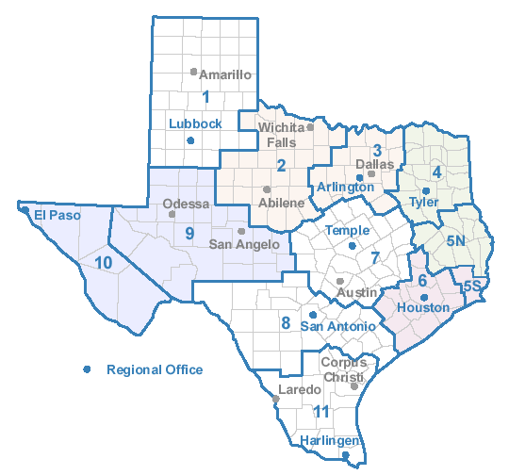

services provided the mapping for how Texas Regions were

included in the dataset. Table 5. provides descriptive statistics

of the deaths in counties based on these regions. The table

shows a majority of the observations are focused in the North

Texas region while West Texas was very limited. This could

possibly be due the fact that commonly when thinking of Texas demographics

North Texas has some of the larger cities compared to West Texas. Typically, this region does not have large populations except when considering the city of El Paso falls into this region.

|  |  |  |  |  |  |  |  |  |
| --- | --- | --- | --- | --- | --- | --- | --- | --- |
| Table 5. Descriptive Statistics of Deaths by Intentional Self-harm in counties within Texas in 2013 by Region of Texas | | | | | | | | |
|  |  |  |  |  |  |  |  |  |
| Variable | | Observations | Mean | Median | S.D. | Min. | Max. |  |
| North Texas | | 25 | 36 | 17 | 1 | 10 | 188 |  |
| West Texas |  | 5 | 26 | 18 | 20 | 15 | 62 |  |
| Central Texas | | 10 | 30 | 20 | 28 | 10 | 101 |  |
| South Texas |  | 8 | 41 | 32 | 42 | 12 | 141 |  |
| East Texas |  | 11 | 59 | 28 | 86 | 10 | 306 |  |
| Note: Regions are as described by Researcher groupings. | | | | | | | | |
| Source: Texas Department for Health Care Services (mapping). | | | | | | | | |

The data is not normally distributed; therefore, the correlational method used was Spearman and not Pearson. In addition, there was no significant correlation (p>.001) between the rate of deaths and the regions within Texas or urbanization status of county. Both findings indicate that there is no significant relationship between the variables (region and urbanization) and deaths rates in Texas thus we reject the null hypothesis. These findings could be reflected by the structure of the data being categorical; a county is either metro or nonmetro and resides in one region amongst the five. To increase findings from the data, a t-test and ANOVA will be conducted.