Objective
My project aimed to forecast water scarcity for Lake Travis in Austin, TX using a cleaned and merged dataset from multiple sources. Due to climate change, water availability has become an increasingly severe issue. Thus, the ultimate goal of this project was to investigate how machine learning can be employed in the context of water monitoring and to potentially inform policy. I selected a target variable (water_level) and built a predictive model using past features such as population, precipitation, PDSI and other environmental and socio-economic indicators.

Data Cleaning & Feature Engineering
I collected data for the regional population, water usage across sectors, the weather, the Palmer Drought Severity Index, and the Standardized Precipitation Index. To ensure easy aggregation after cleaning, I created year and month columns in all datasets and used interpolation to scale data as necessary. Some of the specific cleaning tasks I carried out include:

Population
Scaling was needed to translate the yearly census into monthly data, so I used linear interpolation.

Water Usage
This dataset had years that were missing. To handle this, I created a graph of water use features against time and recognized that there were small fluctuations over time, but the data lacked an obvious trend, so I used the mean to fill missing entries. To transform the data to a monthly scale, I researched estimates of the percentage of water use that occurs during each month, then scaled the yearly values using those approximations.

Standard Precipitation Index
The SPI dataset had missing data for all months of 2025. The SPI varied over time, so I used the monthly averages of 2023 and 2024 to fill the gaps in 2025.

Feature Engineering
The following interaction terms were created to try to uncover underlying interactions between features:
- Population * Groundwater
- Population * Surface Water
- Precipitation * Irrigation Surface Water
- Days since precipitation * Irrigation Groundwater
- Year * PDSI
- Year * SPI

Exploratory Data Analysis

After aggregating the datasets, the shape of the resulting dataset was (936, 66). To analyze feature correlations with the target variable, I created a bar plot and wrote a loop to obtain a list of features where the magnitude of the correlation exceeds 0.15. After this step, there were 19 features that remained.
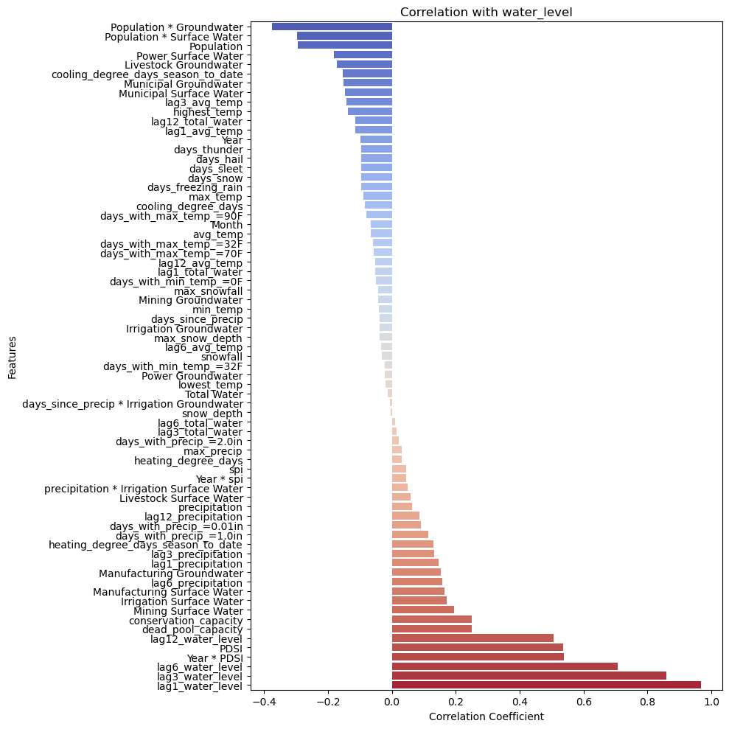
Figure 1 : Barplot of All Feature Correlations

As expected, some of the most correlated features were the lagged columns of the target. I also expected the PDSI and population to have a moderate correlation with water level. Some of the engineered features I created proved to have the strongest correlation with water level. Although some of their component features, such as municipal surface water, do not have the strongest correlation with water level alone, when paired with population, municipal water level is a strong predictor.

Because meat production requires a substantial amount of water, another feature that would have been valuable to employ in the model is the number of cows slaughtered per year in Central Texas. However, I could only find data for the years 2019-2024 for this feature, so using it in the model was not realistic.
Next, I visualized the relationship of these 19 features with respect to time and water level.
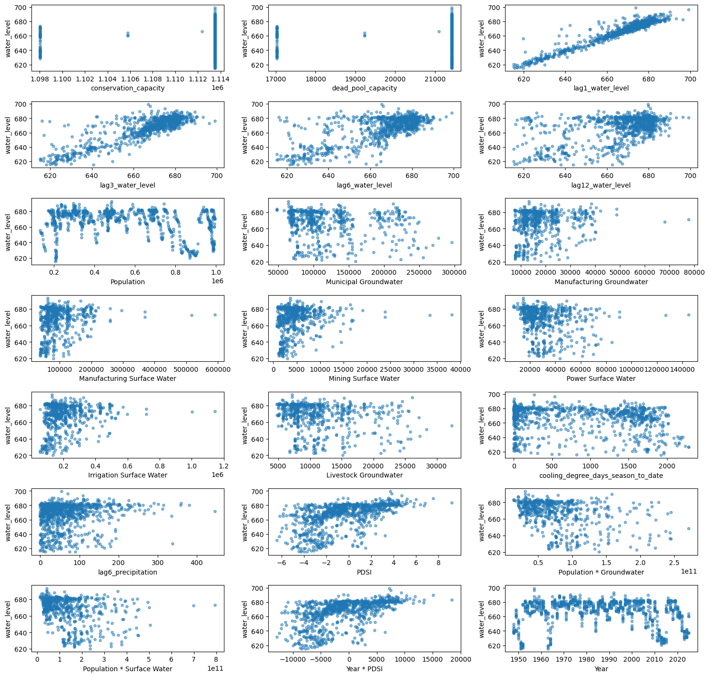
Figure 2 : Scatterplots (Feature vs Water Level)

I observed the scatterplots involving the lagged water level, the PDSI, the mining surface water, and the manufacturing surface water all show slight positive correlations. In terms of the population scatterplot, the nonlinear relation is potentially due to the monthly fluctuations in population. This scatterplot also illustrates that the correlation between water level and population is irrelevant because there is a nonlinear relationship. Additionally, in the top left graph, the water level within a single year forms a vertical line because the water level varies by month.

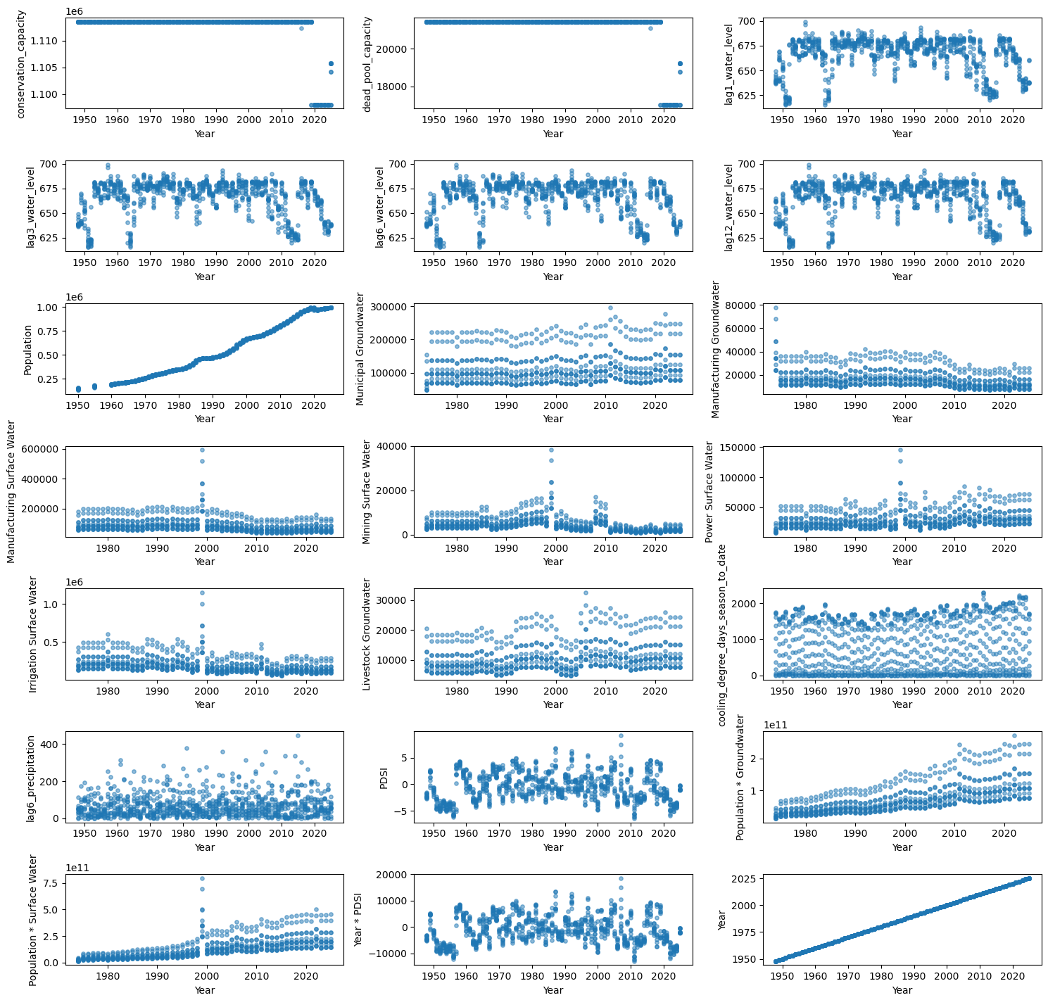
Figure 3 : Scatterplots (Year vs Feature)

Some features, including manufacturing surface water, mining surface water, power surface water, and irrigation surface water, have outliers around the year 2000. At first it seemed like the data may have been incorrectly entered, but the scale is also different for all three features, so the data entry was likely intentional and not simply copy pasted into each column. During this time, Texas was experiencing a significant drought and water use is reported as very high, so the data is likely reflective of reality. I did not remove these outliers for that reason.

Feature Selection
Many features are non-linear, so correlation is not a viable metric for performing feature selection. Instead, I selected features using Recursive Feature Elimination after having trained the model. More details are provided below.

Model Building
XG Boost is appropriate for forecasting future water levels because:
- It handles nonlinear relationships.
- It is robust to missing data: The wateruse columns had missing values throughout the 1950s-1970s, but other features had complete data during this time period. I opted to use the longer period of time because the model performed better on unseen data when exposed to a longer duration of time.
- It provides insight about feature importance: This information can be used for improved features selection later.

The model was trained using a 80/20 train test split, so the first 80% of the data was used as training data. Because XG Boost doesn’t require scaling, the data was left unscaled. To determine the optimal parameters, I employed three fold cross validation and used GridSearchCV to iterate over the following parameter combinations:
param_grid = {
‘n_estimators’ : [100, 200],
‘max_depth’: [3, 4],
‘learning_rate’: [0.05, 0.1],
}
The parameter set with the best score was [200, 3, 0.1], so it was used to fit the model. After fitting the model, RFE was used to obtain the strongest 20 predictors, then the model was retrained using GridSearchCV on these 20 features. The features that were ultimately used in the model were year, cooling_degree_days, days_with_precip_=0.01in, days_with_max_temp_=90F, days_thunder, highest_temp, heating_degree_days_season_to_date, precipitation, max_temp, lag1_avg_temp, lag12_avg_temp, lag1_precipitation, lag3_precipitation, lag12_precipitation, PDSI, spi, year * PDSI, lag1_water_level, lag3_water_level, and lag6_water_level.

Forecasting: Test Set with Actual Lag Data Available
During the first series of testing, I generated predictions on the test set where the model had access to all columns available, including the lag columns. This trial had a holdout mean absolute error of 2.44 and a relative MAE of 0.37%. Thus, the model is generating very accurate predictions on unseen data because the target feature is highly correlated with the lagged water level columns.

Figure : Test Set Predictions (Lag Available)

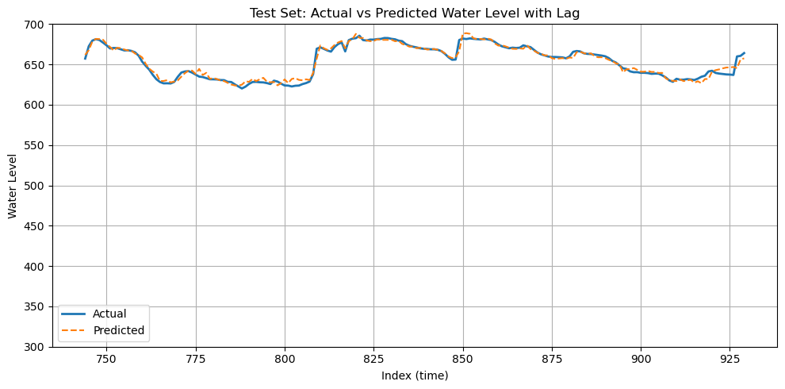
Forecasting: Test Set without Lag Data Available
In the next trial, I reinitialized the XGBoost model, then set the lag columns entries equal to NaN for all indices that appear in the test set. I generated predictions by writing a for loop that iterates over all the indices where the water level is NaN and obtains all existing lag values, fills missing lag column entries that there is existing data for from prior prediction loop, and predicts the next row of water_level. In this way, the for loop uses forward fill to propagate the missing entries for the lag water level columns and generate predictions for all rows in the test set. The predictions were then compared to the actual values:
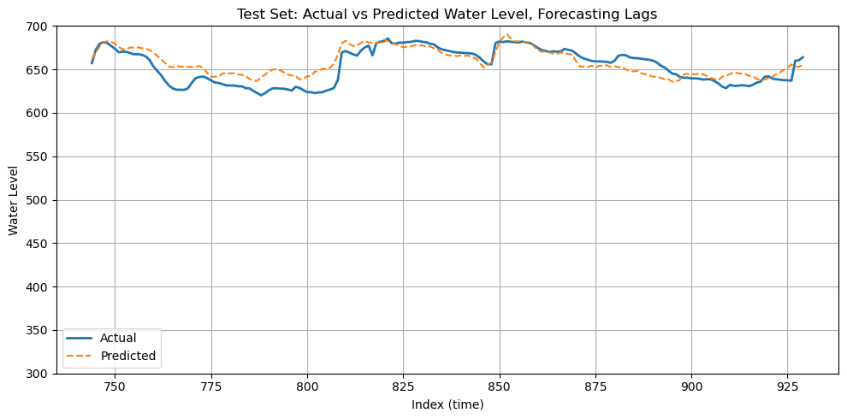

Figure 4 : Test Set Predictions (Lag Forecasting)

The holdout MAE was 8.69 and the relative MAE was 1.33%. The error increased, though the model was still able to accurately replicate the general curvature of the line corresponding to the actual water level. The relative MAE is calculated as
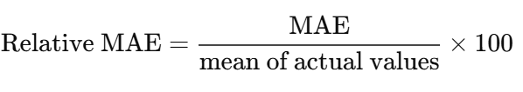
So a relative MAE of 0.37% means that, on average, the model's predictions were off by just 0.37% of the actual water level value when the model was supplied with the true lagged water levels. Likewise, 1.33% indicates high accuracy when the lagged water levels were predicted and forward filled.

Forecasting: Future Data
The last date that true values were available for the target was June 2025. The model was used to generate predictions of Lake Travis’ water levels in July, August, and September. Here were the following results:
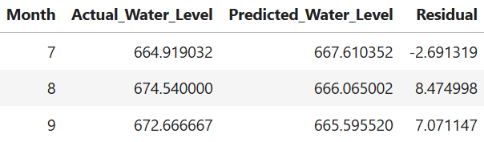
The predictions for future, unseen data had an MAE of 6.079, which is slightly higher than the performance on the training data and slightly lower compared to the test data. However, looking at the predictions, it is evident that they are relatively constant, suggesting that predictions are not deviating much from the average water level, which suggests that the model is underfitting. Rephrased, the model is currently struggling to capture variation in the data. Alternative methods for forecasting and feature determination need to be explored. This leads into the challenges section.

Challenges

2025 Prediction
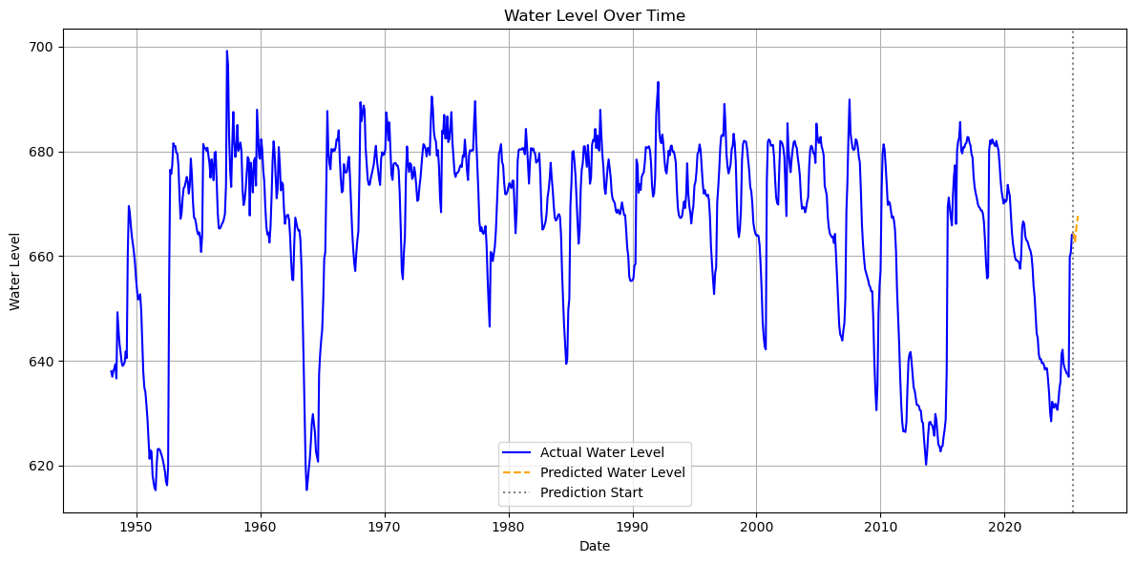
It is difficult to forecast data for climate systems because to generate future forecasts, you need future data for all features being employed in the model. I used population projections for future population data. For the weather related features, I used averages across the entire dataset, or the average of the most recent 10 years depending on whether there is a noticeable change in the feature over time. However, this approach doesn’t reflect the nuances of climate systems. Additionally, future predictions are challenging because weather predictions can only be made a couple of months into the future before the estimations become unreliable. However, this project would have the most impact if predictions could be made at least a couple of years out so that there is time for policymakers to evaluate how we can best prepare for upcoming forecasts. Based on the visual in Figure 6, the future water level estimations follow the trend of the most recent data. The predictions suggest that water levels in Lake Travis will rise slightly through the end of 2025.

Figure 6 : Actual Historical Data and Forecast of 06/2025 Through End of Year

Tools Used
- Python
- Pandas
- NumPy
- Matplotlib
- Seaborn
- Sqlite3
- Scikit-learn
- SQL
- GitHub
- Jupyter Notebook
- Visual Studio Code

