entity project documentation

2017-07-14



Contents

1 Revision History 3

2 Scope 4

2.1 The Legacy System 4

2.2 Goals of the Project 4

3 Functional Requirements 4

4 System Update 4

4.1 Entities list 4

4.1.1 3D Drawings 4

4.1.2 2D Drawings 4

4.1.3 Not Accepted Entities 4

4.2 Tests 4

4.2.1 3D Drawings 4

4.2.2 2D Drawings 4

4.3 Outstanding Tests 4

5 User Documentation and Training 4

6 Saving Files 4

7 Anticipated Changes 4

# Revision History

|  |  |  |  |
| --- | --- | --- | --- |
| **Revision Number** | **Revision Date** | **Description of Changes** | **Changes By** |
| 6 | 14-July-17 | Embedded VBA code into the Excel file, and removed step 4 and 6 from training portion as it was no longer needed. | Asher Dhillon |
| 5 | 14-Jun-17 | Added where to save Log_Files.txt and Catalog_Results.xlsx. | Sydney Lieng |
| 4 | 11-May-17 | Update User Documentation and Training to clarify steps. | Sydney Lieng |
| 3 | 29-Mar-17 | Update checkEntities to add more information into Log_File.txt. Created easier process for Entity_Template.xlsx. | Sydney Lieng |
| 2 | 03-Mar-17 | Update checkEntities. Creates Log_File.txt | Sydney Lieng |
| 1 | 19-Dec-16 | Creation of documentation and update project system. | Sydney Lieng |
| 0 | 01-Aug-14 | Creation of project | Maya Zhang |

# Scope

## The Legacy System

In previous years, 2020 has been testing the entities in our drawings. 2020’s tool either removes or converts unsupported entities when processes our graphics. To mitigate the risk of specifiers finding incomplete symbols and for Teknion to own their data, we developed our own entity checker.

The Entity Project is a system that ensures that 2D/3D drawings contain the correct entities. This is an automated process in which utilizes AutoCAD’s scripting capabilities. The project was first presented using the ScriptPro, a program that read lines of commands and executed it in sequence. The program was able to open drawings in AutoCAD, check the entities and save the drawings in its corresponding folder. However, ScriptPro was created to close/reopen AutoCAD session after a certain amount of drawings, which created a long runtime.

The LISP and Script are available at: *M:\Students\05_Maya*.

The ScriptPro utility is available at *M:\Students\05_Maya\ScriptPro 2.0\bin\ScriptPro.exe*.

## Goals of the Project

The goal of the Entity Project is to create an automated system that will be able to check a catalogs worth of drawings with a faster runtime. The system must be able to recognize the type of drawing (either 2D or 3D) and be robust when checking its entities.

# Functional Requirements

The Entity Project must be able to:

1. Open drawings
2. Determine whether the drawing is 2D or 3D
3. Check the drawing’s entities in its entirety
   1. In 3D drawings, only entities from list **4.1.1**
   2. In 2D drawings, only entities from list **4.1.2**
   3. Both 3D/2D do not include any entities from list **4.1.3**
   4. No entities are found on the ‘0’ layer
4. Save drawings in its corresponding folder
5. Continue this process until all drawings are checked
6. Create a Log File that includes the following:
   1. Start Date/Time
   2. End Date/Time
   3. Duration
   4. Number of Drawings Processed
   5. Number of Errors

# System Update

The current system uses a script that is dragged-and-dropped into AutoCAD directly. It uses of an Excel file called, Entity_Template.xlsx, to create a script that will run through all drawings in one AutoCAD session. The following table outlines the runtime difference between the previous and old system:

|  |  |
| --- | --- |
| **System** | **# of Drawings / Hour** |
| ScriptPro (Legacy System) | ~375 |
| Drag-and-Drop | ~1000 |

The current system is approximately three times faster than the old.

## Entities list

### 3D Drawings

1. 3D Solids

### 2D Drawings

1. Line
2. Arc
3. Point
4. Circle
5. Polyline
6. Spline
7. Text

### Not Accepted Entities

1. 3 Point Angular Dimension
2. 3D Polyline
3. Aligned Constraint Parameter
4. Aligned Dimension
5. Angular Constraint Parameter
6. Angular Dimension
7. Arc Length Dimension
8. Array
9. Attribute
10. Attribute Definition
11. Block Reference
12. Diameter Constraint Parameter
13. Diametric Dimension
14. External Reference
15. Hatch
16. Helix
17. Horizontal Constraint Parameter
18. Jogged Dimension
19. Leader
20. Mesh
21. MLine
22. MText
23. Multileader
24. Ordinate Dimension
25. Polyface Mesh
26. Position Maker
27. Radial Dimension
28. Radius Constraint Parameter
29. Region
30. Rotated Dimension
31. Section Object
32. Surface
33. Table
34. Vertical Constraint Parameter
35. Viewport

## Tests

### 3D Drawings

|  |  |  |  |
| --- | --- | --- | --- |
| **Test Number** | **Description of Test** | **Expected Output** | **Actual Output** |
| 1 | Only 3D Solids | Checked | Checked |
| 2 | Only 3D Solids on different 3D layers | Checked | Checked |
| 3 | Non – 3D Solids | Errors | Errors |
| 4 | Non – 3D Solids on different 3D layers | Errors | Errors |
| 5 | 3D Solids and Non – 3D Solids | Errors | Errors |
| 6 | 3D Solids and Non – 3D Solids on different 3D layers | Errors | Errors |
| 7 | Only Block Reference | Errors | Errors |
| 8 | Only Block Reference on different 3D layers | Errors | Errors |
| 9 | 3D Solids and Block Reference | Errors | Errors |
| 10 | 3D Solids and Block Reference on different 3D layers | Errors | Errors |
| 11 | Only Region | Errors | Errors |
| 12 | Only Region on different 3D layers | Errors | Errors |
| 13 | 3D Solids and Region | Errors | Errors |
| 14 | 3D Solids and Region on different 3D layers | Errors | Errors |
| 15 | Only Surface | Errors | Errors |
| 16 | Only Surface on different 3D layers | Errors | Errors |
| 17 | 3D Solids and Surface | Errors | Errors |
| 18 | 3D Solids and Surface on different 3D layers | Errors | Errors |
| 19 | Only Polyface Mesh | Errors | Errors |
| 20 | Only Polyface Mesh on different 3D layers | Errors | Errors |
| 21 | 3D Solids and Polyface Mesh | Errors | Errors |
| 22 | 3D Solids and Polyface Mesh on different 3D layers | Errors | Errors |

### 2D Drawings

|  |  |  |  |
| --- | --- | --- | --- |
| **Test Number** | **Description of Test** | **Expected Output** | **Actual Output** |
| 23 | Only Lines | Checked | Checked |
| 24 | Only Lines on different 2D layers | Checked | Checked |
| 25 | Only Arc | Checked | Checked |
| 26 | Only Arc on different 2D layers | Checked | Checked |
| 27 | Only Point | Checked | Checked |
| 28 | Only Point on different 2D layers | Checked | Checked |
| 29 | Only Circle | Checked | Checked |
| 30 | Only Circle on different 2D layers | Checked | Checked |
| 31 | Only Polyline | Checked | Checked |
| 32 | Only Polyline on different 2D layers | Checked | Checked |
| 33 | Only Splines | Checked | Checked |
| 34 | Only Splines on different 2D layers | Checked | Checked |
| 35 | Only Text | Checked | Checked |
| 36 | Only Text on different 2D layers | Checked | Checked |
| 37 | All accepted entities in 2D drawings | Checked | Checked |
| 38 | Only Attributes | Errors | Errors |
| 39 | Only Attributes on different 2D layers | Errors | Errors |
| 40 | Attributes and 2D entities | Errors | Errors |
| 41 | Attributes and 2D entities on different 2D layers | Errors | Errors |
| 42 | Only 3D Solids | Errors | Errors |
| 43 | Only 3D Solids on different 2D layers | Errors | Errors |
| 44 | 3D Solids and 2D entities | Errors | Errors |
| 45 | 3D Solids and 2D entities on different 3D layers | Errors | Errors |
| 46 | Only Polyface Mesh | Errors | Errors |
| 47 | Only Polyface Mesh on different 2D layers | Errors | Errors |
| 48 | Polyface Mesh and 2D Entities | Errors | Errors |
| 49 | Polyface Mesh and 2D Entities on different 3D layers | Errors | Errors |

## Outstanding Tests

|  |  |
| --- | --- |
| **Test Number** | **Description of Test** |
| 50 | Test on small, medium and large catalogs and review runtime |

# User Documentation and Training

1. Move all drawings into a folder on your Local Drive.
2. Create folders **in the drawing folder** called Errors and Checked. Create an empty text file called “Log_File”. Using the “create_dwg_list.bat” file, make a list file called “list”.

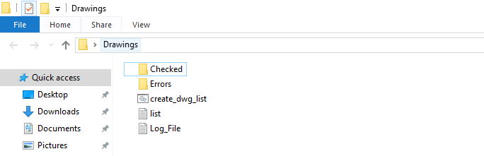

1. Using Entity_Template.xlsx file, fill out the highlighted section with Drawing Location, Drawing Name and location of checkEntities.lsp.

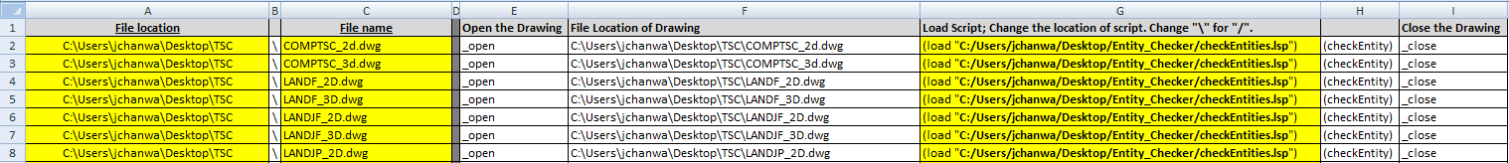

1. Run **NEW** VBA Code in “Developer” tab in Excel.

Change the destination of the Entity Checker. SCR and the location of the checkEntities.lsp script.

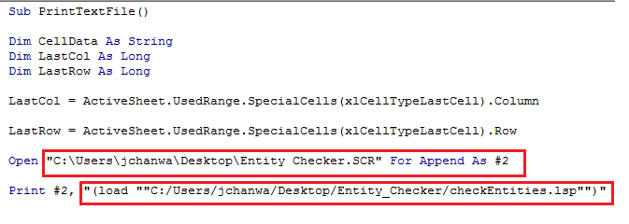

1. Open the LISP script called checkEntities.

Search for “**DESTINATION**” and replace with **your** **drawing folder location**.

DON’T FORGET TO SAVE.

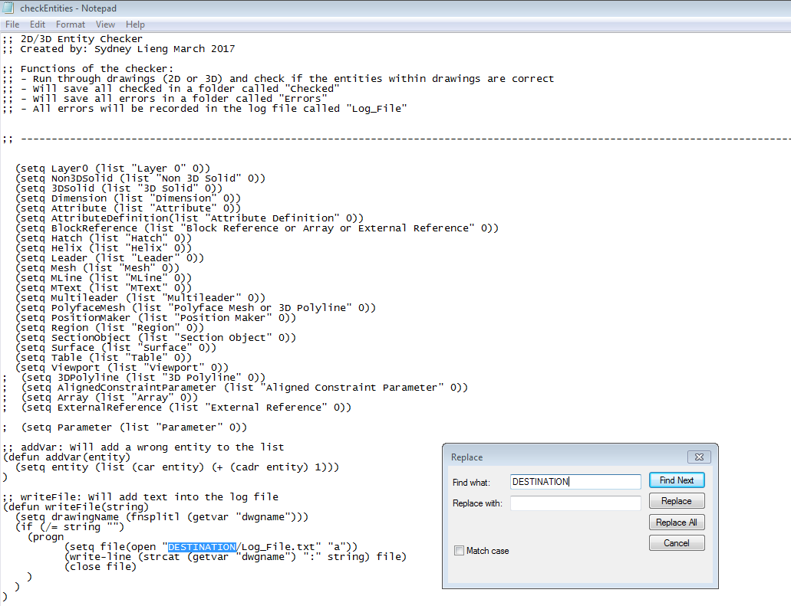

1. Drag-and-Drop the Entity Checker script into AutoCAD

# Saving Files

The Entity Checker is run per Launch. It will be saved in the corresponding launch folder; includes the Log_Files.txt and Catalog_Results.xlsx.

M:\Students\**\*launch_folder\*\**Entity_Checker

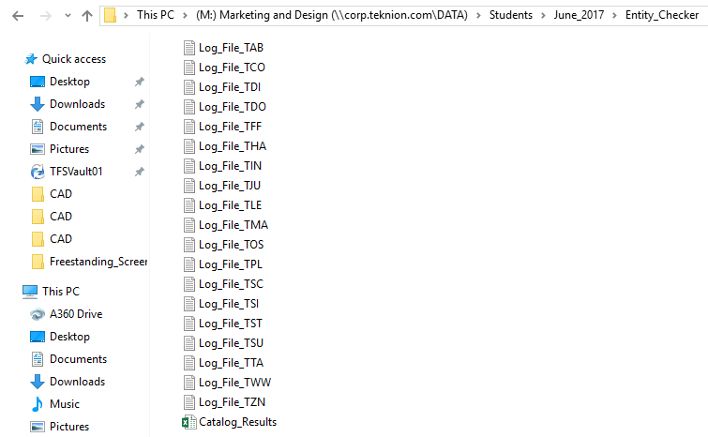

# Anticipated Changes

To further the Entity Project, the following will be added to its functionality:

1. Find room for improvement in runtime without changing accuracy of the checker.