Jenkins

To implement continuous delivery pipeline with Jenkins on the project version 2, there is first some installation to make. Indeed we are working on a maven project with a git repository. So maven and git must be install on the pc in order for Jenkins to be able to use it later.

Then, while creating a freestyle project on Jenkins, what we want to do is to link it to our git repository. To help we install the GitHub Integration plugin on Jenkins.

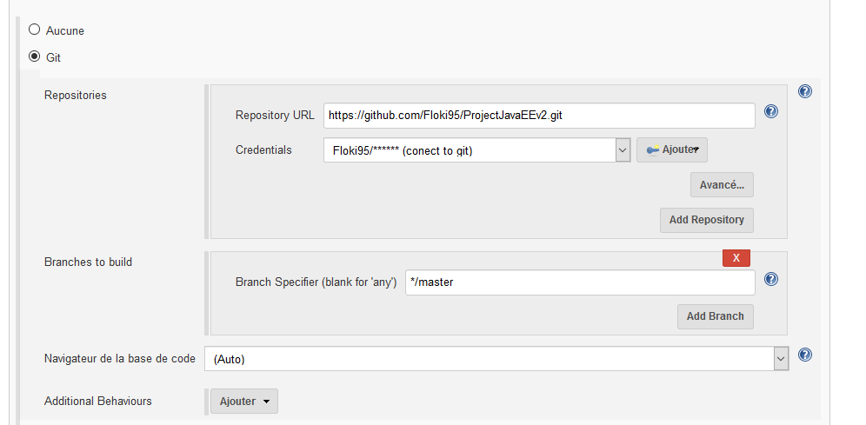

Then in the build part we can define the operations that Jenkins will do on the project when building. Here there is just a “clean install” for the demo. But here we can define all sort of test.

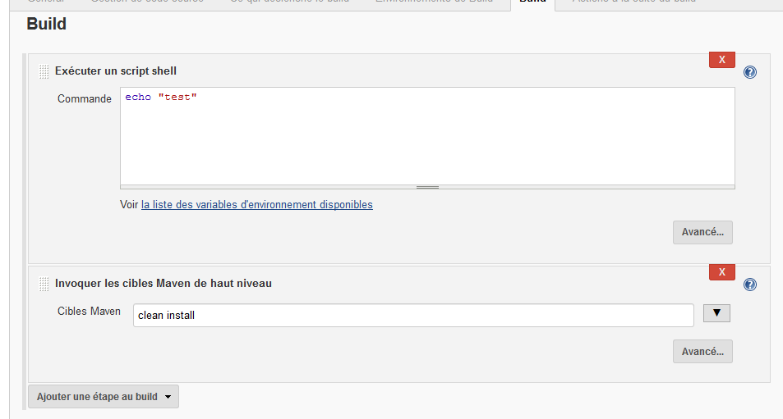

The next step is to do a webhook so every time a commit is pushed on the git repository the build will be triggered automatically.

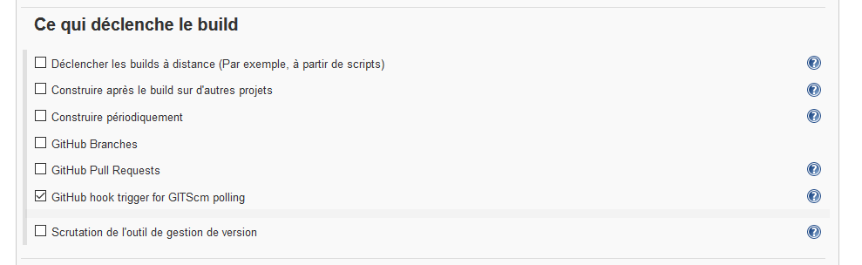

On github, under the repository settings and webhook section we can add a webhook simply by typing the payload url (the “localhost” must be replace by the pc ip address in Jenkins settings, to be accessible from outside, and so from github). We can notice at the bottom the history of all the delivery made from this webhook.

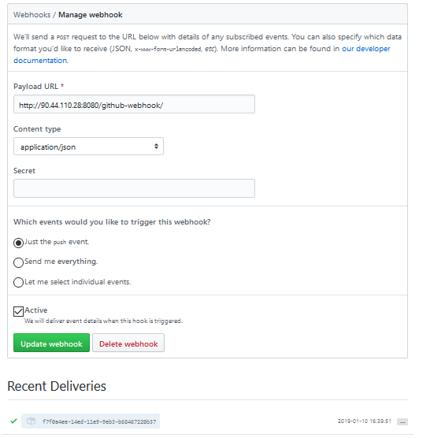

We can access information by clicking on the project name.

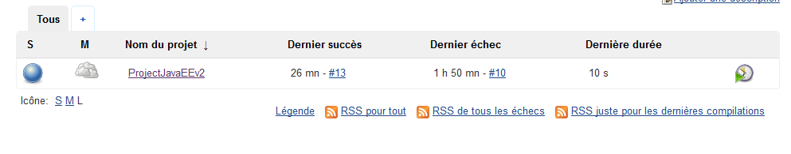

Then watch the build history.

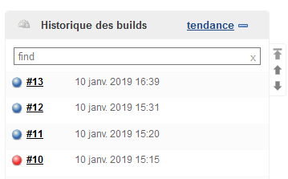

Here is a build triggered by a commit of an update of the README file, from github.

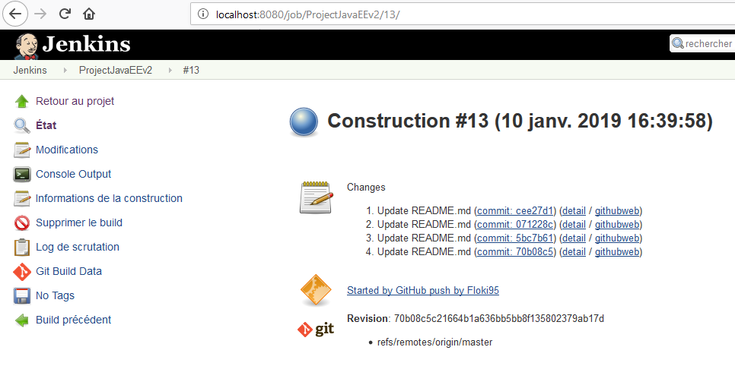

With the following console output, the “clean install” succeed.

