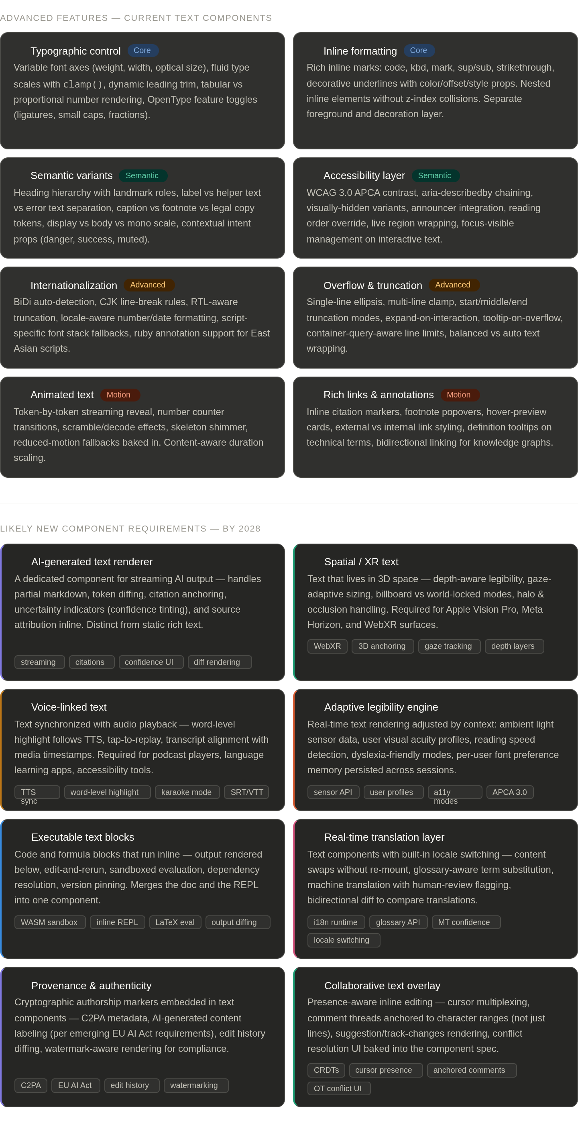


Here's a comprehensive breakdown of both topics — current advanced features and near-future component requirements.
Advanced text component features in modern design systems today cover five main areas: rich formatting, semantic semantics, accessibility, adaptive rendering, and interactivity. Then looking toward 2028, several forces — AI integration, spatial computing, multimodal interfaces — are driving new requirements. Let me visualize both.Here's a breakdown of the key themes:
Today's advanced features cluster into four capability layers. The typographic layer — variable fonts, fluid scales, OpenType features — has matured dramatically in the past three years and is now table stakes for serious systems. Above that sits the semantic layer: clearly typed roles (label, helper, error, caption) with matching ARIA contracts rather than just visual styling. The third layer covers global scale — BiDi, CJK, RTL-aware truncation — which many teams still treat as an afterthought but is increasingly a day-one requirement. The fourth is the motion layer: streaming text reveal and number transitions are no longer "nice to have" given how much AI-generated content surfaces in UIs.
By 2028, the forces shaping new requirements are:
AI integration is the biggest driver. A dedicated streaming/AI renderer component — one that handles partial markdown, confidence indicators, and citation anchoring natively — will be as standard as a button is today. The pattern already exists in Claude, Gemini, and Copilot UIs but isn't formalized as a reusable spec yet.
Spatial computing will demand text components that understand depth, gaze, and occlusion — something completely absent from today's web-centric specs. Apple Vision Pro and WebXR deployments are pushing this faster than most teams expected.
Regulatory pressure (EU AI Act, C2PA standards) will require provenance and authenticity markers baked into content components, not bolted on as an afterthought.
Executable text is underrated on this list — the line between documentation and runtime is already dissolving in tools like Observable, Notion, and Jupyter. By 2028 it will be a common expectation in productivity and developer surfaces.

