1. **To check data is already present in data base if not present add data if present print in backend already exists in database?**

**Step 1 : RPA Service**

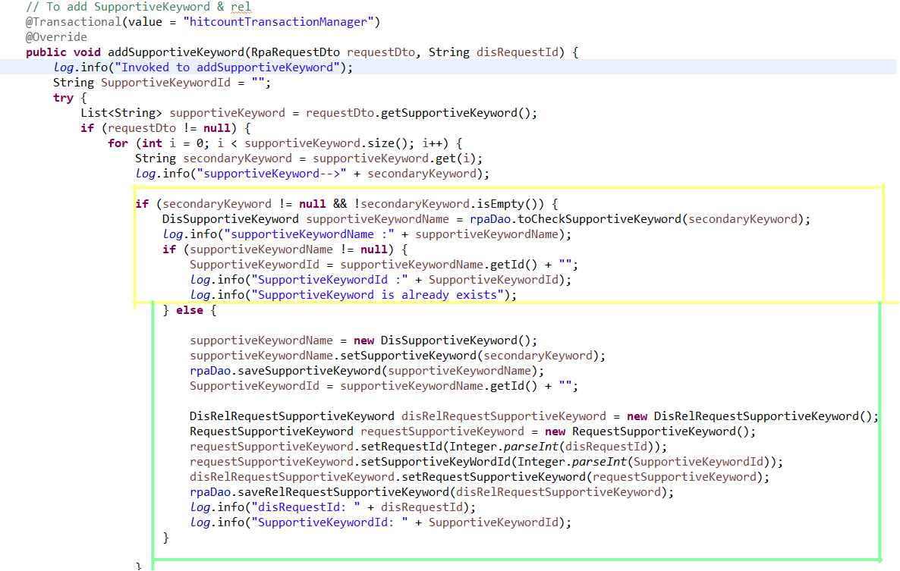

**Step 2 : RPA DAO (Repository)**

1. Graphical user interface, text, application

   Description automatically generated**How to create @EmbeddedId , @ Embeddable & how give vales or data in order to into database ?**

**Step 1**

**Step 2 :   
  
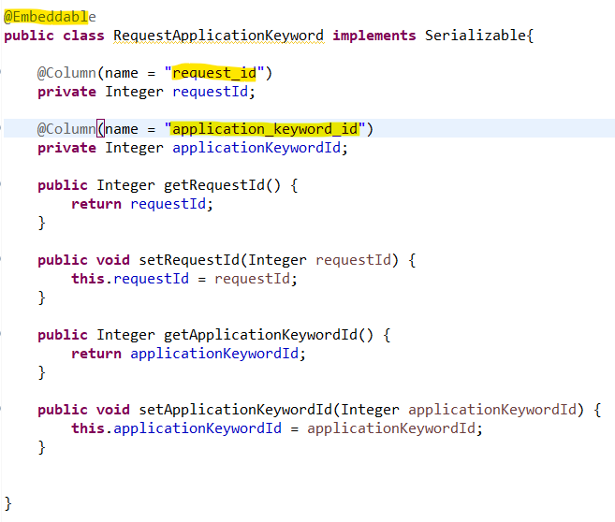**

**Step 3 : to give values**

**  
3) How create log file connection in app.property.files ?**

1. **How to use track (Errors) logs in each class ?**

**4) How to send response in form of JSON Object?**

**Step 1 : create one response Dto --> create one object variable --> set the value & return the object**

**Step 2 : to return response in controller layer**

**Step 3 : Service layer**

**public** Boolean addSupportiveKeyword(RpaRequestDto requestDto, String disRequestId);

**Step 4 : ServiceImpl layer**

1. Graphical user interface, text, application, Word

   Description automatically generatedTimeline

   Description automatically generated**How to make fields (ProjectId and FunctionalKeyword) mandatory in back end and return status as true?**

**JASON STRUCTURE**

ProjectId & Functional Kw are mandatory

1. **Positions, Roles & Responsibilities?**

**Project Manager: Project Manager plays the leadership role by leading the planning for the execution of the project**

**Product Manager :**

**Business Analyst:**

**Scrum Master:**

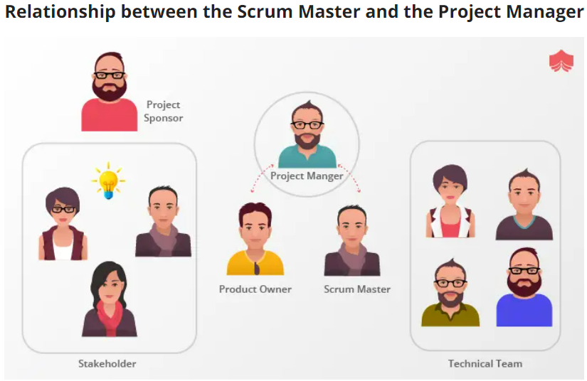

1. **How to create a Exception class without using try & catch ? BY using throw keyword?**

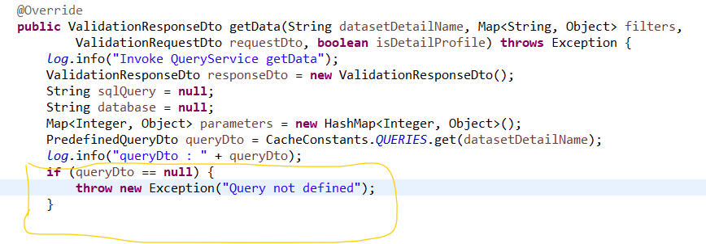

1. **To check whether Id’s (Topic Id & Subtopic Id) is already present in data base if not present add data if present print in backend already exists in database? Aws:- Step 1**

**Step 2 : how to write query and interact with database and fetch the results ().**

**  
10) How to convert GSON (java ) to JSON or GSON (java ) from JSON ?**

**(Present in Usecase update method)**

**Ans : Link :** [**https://mkyong.com/java/how-do-convert-java-object-to-from-json-format-gson-api/**](https://mkyong.com/java/how-do-convert-java-object-to-from-json-format-gson-api/)

**11) How to get single data (only one data) and multiple data from DB?**

**Ans: For single data use ---> List<Object> (present in MappingchachingDaoImpl)**

[List<Object> queryDetails = **null**;

Integer i=(Integer)queryDetails.get(0);]

**For multiple data use--->List<Object[]> > (present in MappingchachingDaoImpl)**

**12) In order to escape single quotes from the string coming from frontend?**

**Ans: (Present in company add Details** **method)**

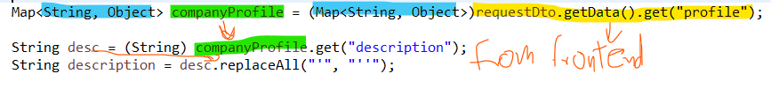

DO check technologycontentvalidationservicimpl add technology flow for how to iterate the objects without using for loop

need to use same in marketsizecontentvalidationservicimpl add marketsize

**13.To iterate Map , hasMap ect which consist of key value pair use below formap ?**

**Ans:**

**13.a. To iterate List of array objects,string ,integer use below foreach ?**

**13.b. To get only single record from first object by using list<object> ?**

**very imp can alter to get single rec from 2nd object. To get all records**

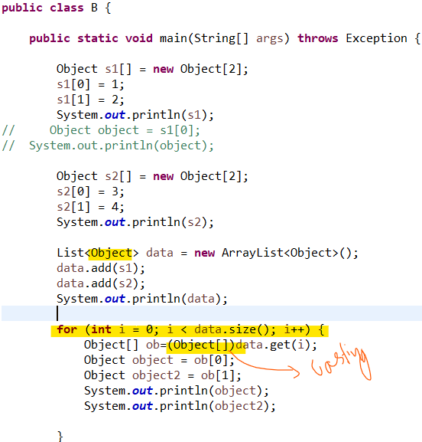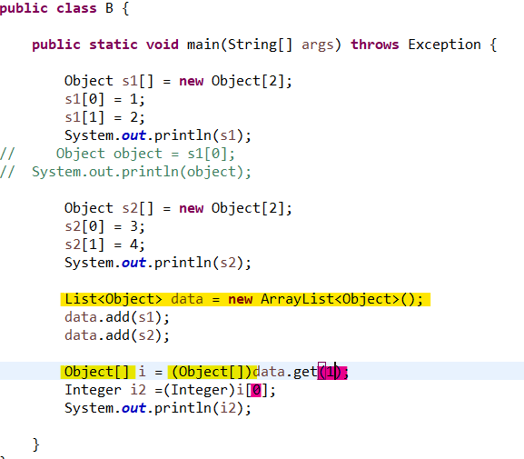

**14. To convert Gson to Json & vice versa ?**

**15. To give response like below ?**

**1. 2.**

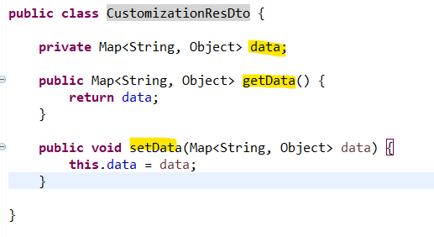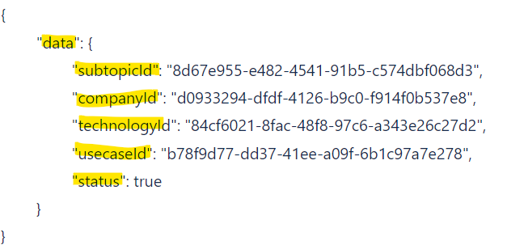  
  
**3.**

**15. Link regarding Hibernate session, Criteria Queries for CURD operation? (Hebernate -session factory without SpringBoot)**

**v.Imp**

<https://www.tutorialspoint.com/hibernate/hibernate_criteria_queries.htm>

**a.**

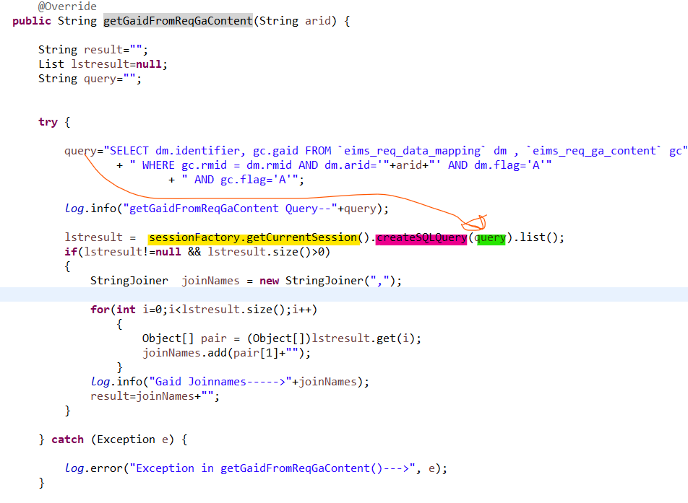**b.**

**16.How to round-off number? Eg : 1) if 0.5 or more to 1. 2) 1.5 or more to 2 3)2.5 or more to 3 ?**

**Ans:** Math.round(**double** or **float**);-->Applicable only on **double** or **float**

eg :

**double** d=2.0; **float** f =2.0f;

Math.*round*(d); Math.*round*(f);

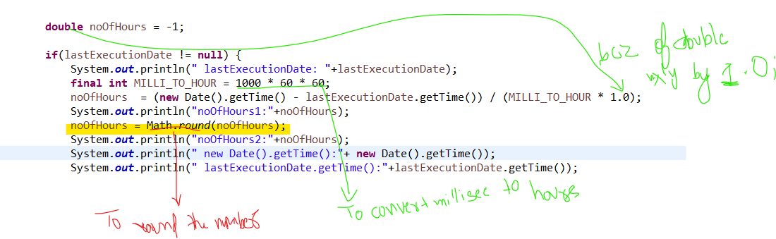

**17.JDBC Connection ?**

**Ans :** **public** **class** DBConnection {

String url = "jdbc:postgresql://3.7.66.156/";

String driver = "org.postgresql.Driver";

**private** Connection common;

**private** Connection hitCount;

**private** Connection marketSize;

**public** Connection getCommonDbConnection() **throws** Exception {

**this**.common = prepareConnection("usr_common", "d@t@g#n#r@t!on@123", "dis_common");

**return** **this**.common;

}

**public** Connection getHitcountConnection() **throws** Exception {

**this**.hitCount = prepareConnection("usr_hitcount", "d@t@g#n#r@t!on@123", "dis_hitcount");

**return** **this**.hitCount;

}

**public** Connection getMarketSizeDbConnection() **throws** Exception {

**this**.marketSize = prepareConnection("usr_marketsize", "d@t@g#n#r@t!on@123", "dis_marketsize");

**return** **this**.marketSize;

}

**public** **void** closeCommonDbConnection(){

**try** {

**if**(**this**.common != **null** && !**this**.common.isClosed()) {

**this**.common.close();

}

}**catch**(Exception e) {

e.printStackTrace();

}

}

**public** **void** closeHitcountConnection(){

**try** {

**if**(**this**.hitCount != **null** && !**this**.hitCount.isClosed()) {

**this**.hitCount.close();

}

}**catch**(Exception e) {

e.printStackTrace();

}

}

**public** **void** closeMarketSizeDbConnection(){

**try** {

**if**(**this**.marketSize != **null** && !**this**.marketSize.isClosed()) {

**this**.marketSize.close();

}

}**catch**(Exception e) {

e.printStackTrace();

}

}

**public** **void** closeAllDbConnection(){

closeCommonDbConnection();

closeHitcountConnection();

closeMarketSizeDbConnection();

}

**private** Connection prepareConnection(String userName, String password, String dbName) {

**try** {

Class.*forName*(driver).newInstance();

Connection conn = DriverManager.*getConnection*((**new** StringBuilder(String.*valueOf*(url))).append(dbName).toString(), userName, password);

conn.setAutoCommit(**false**);

**return** conn;

}**catch**(Exception e) {

e.printStackTrace();

}

**return** **null**;

}

@Override

**protected** **void** finalize() **throws** Throwable {

closeAllDbConnection();

**super**.finalize();

}

}

18.