# Lab 01: Project Proposal

**Objectives**

• Discuss the Project & learn how to write project Proposal.

**Outline**

• Project Proposal.

**Introduction**

The most important thing about a software engineering proposal is that the **proposal is about the problem domain**, **not** about programming. The proposal should clearly describe the motivation for the proposed work and the proposed solution along with its expected business value. The proposal should **not** contain any technical jargon. There are three key components of a software engineering proposal:

DIAGNOSE PROBLEM   ==>   PRESCRIBE TREATMENT   ==>   DESCRIBE PLAN OF WORK

In this lab, students will create a project proposal according to the project they have selected. On the template that is provided to the students.

Appendix A includes Project Proposal Template.

**Exercises**

• Form groups of 4 or 5 students (with one of them as a leader and identify their roles).

• Brainstorm and list 5 suitable project titles.

• Choose one of the projects from your list.

• Try to write (a hypothetical) project definition for it.

**Example:**

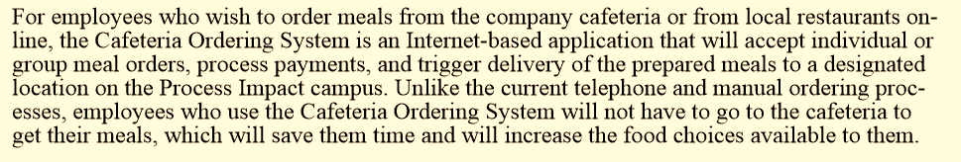

• Present it to the instructor/class.

• Submit project proposal in the next class along with group name, members name, leader name and their roles.