**Task1: The FCFS source code given above assumes that the arrival times for processes are provided in ascending order of time. Modify the code in C language for random process arrival times.**

**Input:**

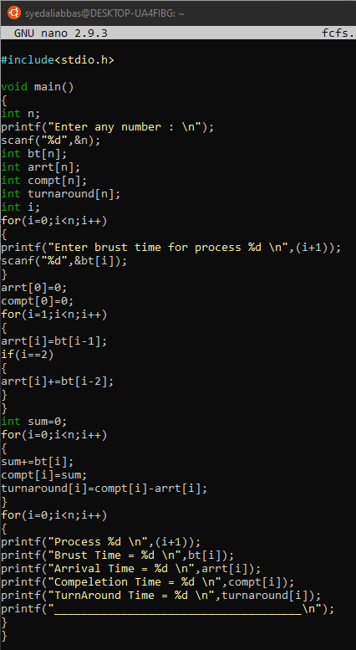

**Output:**

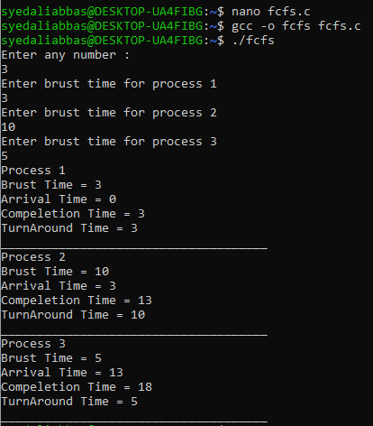

**Task2: The FCFS source code given above assumes that the arrival times for processes are provided in ascending order of time. Modify the code in C language for random process arrival times.**

Task3. Implement Round Robin Algorithm in C language.

**Input:**

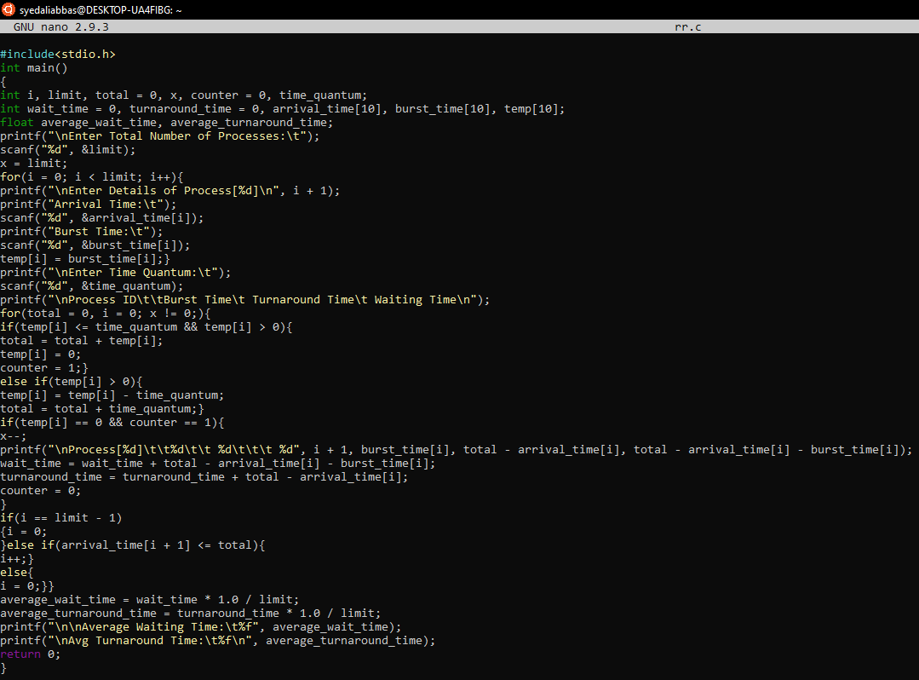

**Output:**

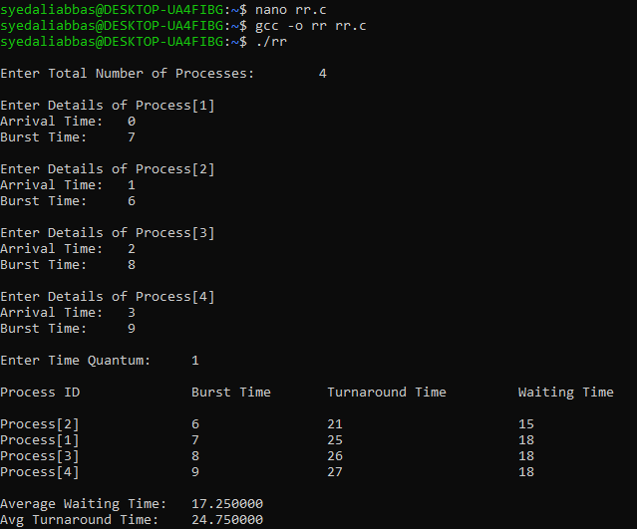

1. Implement SPN algorithm in C.