**Question 1**: Practice all the Linux commands discussed in this lab while taking assistance using the **man** command. Write the complete syntax used for utilizing the **cp**, **mv** and **rm** commands in Linux shell.

|  |  |
| --- | --- |
| cp | Copy file or directory |
| mv | Move file or directory |
| rm | Remove file or directory |

**Question 2**: Write a shell script to display your address over multiple lines.

**Code:**

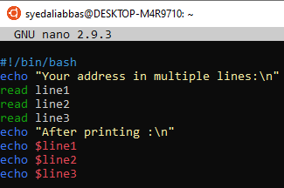

**Output:**

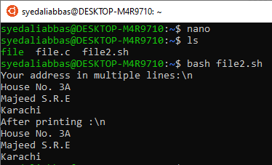

**Question 3**: Write a shell script that would traverse among any three directories that are placed under the /home directory. While moving from one directory to another, the script should display the name of the current working directory and list the content within that directory, including the hidden files.

**Output:**

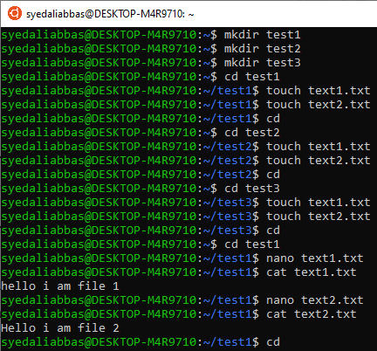

**Question 4**: Write the C programs provided in this lab and generate their outputs over Linux environment (provide snapshot).

**Code:**

#include <stdio.h>

int main()

{

int x, n = 10, z;

x = n++;

z = ++n;

printf("The value of x = %d\n", x);

printf("The value of z = %d\n", z);

return 0;

}

**Output:**

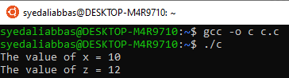

**Code:**

#include <stdio.h>

#define LIMIT 50

int main()

{

int age;

printf("Hello, please enter your age!\n");

scanf("%d", &age);

if(age < LIMIT)

{

printf("Your age is %d.\n", age);

printf("Still young!!\n");

}

else if(age == LIMIT)

{

printf("Your age is %d.\n", age);

printf("Almost there.\n");}

else{printf("Your age is %d.\n", age);

printf("You are a senior!\n");

}

return 0;

}

**Output:**

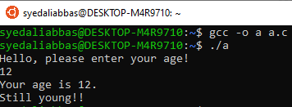

**Question 5:** Write a C program on the Linux environment that takes your marks as an input and display your grades accordingly to that followed at Bahria University. Limit your program to a maximum of five subjects. Use the suitable logical operator(s), i.e. and (&&), or (||), not (!), if required.

**Code:**

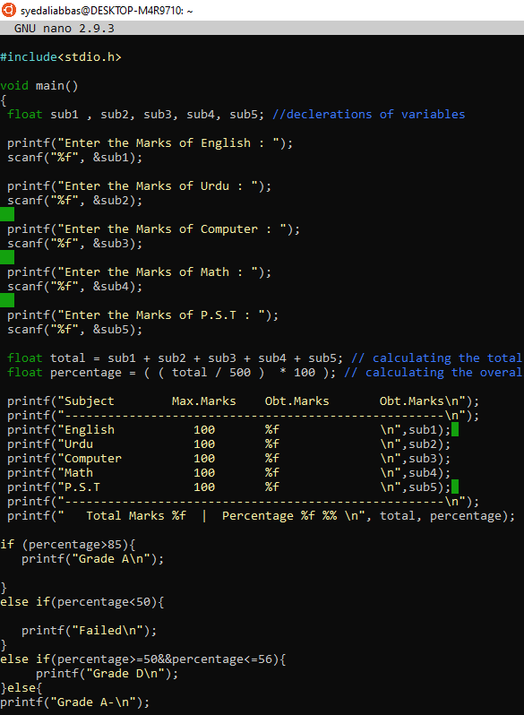

**Output:**

