**Task1: Write what you have learned in few lines on each of the three programs that were using the fork() system call.**

**Explanation:**

1. Fork() method is used to know about the parent and child process of current process. Fork() returns **0** if it is in a child class otherwise if it is in parent process it will return its child process’s **id**. If there is no child of the current process, it will return **-1**.
2. Suppose there are three process A, B and C. Process A is parent of process B and B is the parent of C.

Now, if we use fork in process A, it will return id of process B. Similarly, in process B, the id of C will be returned. In C, zero will be returned.

1. Another use of fork() is the running of statements, following the fork, multiple times. It works as the power of 2. One fork will run the statement twice. Two forks will run the statements 4 times, as 2 raises to the power 2. Similarly, if we want to run a statement 16 times, we will use fork 4 times.

**Task 2**: Write a C program that uses ***fork()*** system call to print a single line eight times without using ***for*** loop and repeated ***printf*** command.

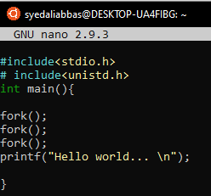

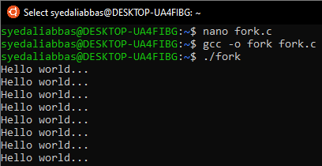

**Task 3**: Code the C program given below and explain what it does along with providing a snapshot of the output. Investigate and write about the usage of ***execlp()*** system call.

**Explanation:**

The execlp() family of commands can be used to execute an application from a process. The system call execlp() replaces the executing process by a new process image which executes the application specified as its parameter. Arguments can also be specified.

In simple words execlp() is a function that takes single or multiple strings and a Null pointer as parameter. First string defines the path of an executable file that we want to be executed and then the next strings are the commands that we want to run.

**Execlp(“Path/Directory”, ”Command1”,...,NULL)**

The given program first runs the else statement and because of fork it runs second time and till that time it moves in child class and the pid will have 0 value in it. The else if statement becomes true so it reaches execlp(). Execlp() is moving to path ‘/bin/ls’ and executing the command ‘ls’ which is listing all the files.

**Input:**

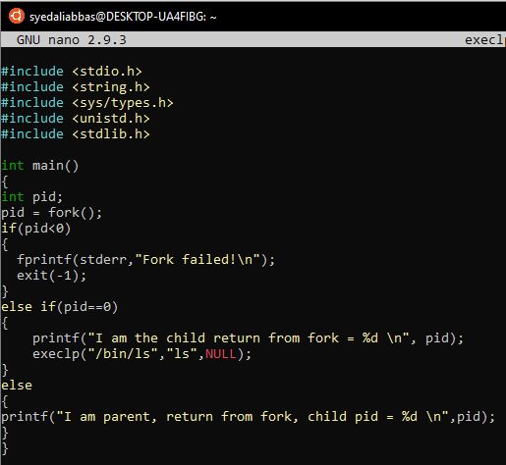

**Output:**

