**Assignment #6 (Midterm Exam – Part I)**

**PART 1:**

1-**Tradional Enterprise Data** will be captured from UPC scanners and ERP Softwares and will be integrated into the database to Ensures a single consistent version of enterprise data for sharing throughout the enterprise.

Example of such data include: Item Information such as (ID=1123=Diary), Item Description(Descr=Milk Carton) and other corresponding information’s. Human Resource information for example Job_ID(1080B),Job_ID_Descr(Business Analyist).Dept_ID(1001),Dept_ID_Desc(Accounts) and many others.

2-**Loyalty or Bonus Card Data:** Help us collect different customer data such as shopping habits, product descriptions, department preferences , brand preference, prices paid for product, buying frequency and type of items bought from specific stores. By combining such data with application we can create a clearer picture of when , where and how the people do there shopping.

3-**Customer Smartphone :** information is also important, we can see from which location more customers are ordering and see a demographic demand of our product with respect to geo-locationa and other relevant details, timing, product details, customer info (ages, gender etc.).

4- **Social media Logins by customers:** user logging in from social media platform will provide us in-depth customer details e.g. there name, age location and buying behavior. Most customer find it suitable to login via already being used platform rather than creating a retail site account. So this will help gathering more data.

5-**Online Contact**: via emails, inquires, cookies etc. Emails are really important they can be use for marketing and promotional purpose and see how the user is responding to different campaigns which will help the company decide which direction to take.(through emails, cookies, complaints, inquiries etc).Cookies provide with user and locational data etc.

6- **Purchasing Details/History:** such as purchasing history, quantity and return. Will given in-depth information about different products.

7- **RFID chips:** Helps in automated data collection of products and users. Can be use for product tracking also.

8 -**Virtual store:** it allows us to track the user navigation through our store. Helps in identifying buying behavior.

9-**CCTV Footage:** shop traffic at different times of the day/week/months/holidays etc.

10**-Inventory Stock:** help us see the demand of different products.

11 **Other Sources** :also include weather monitoring system, location of small sector retailers, register and non-register customers. etc.

**PART 2:**

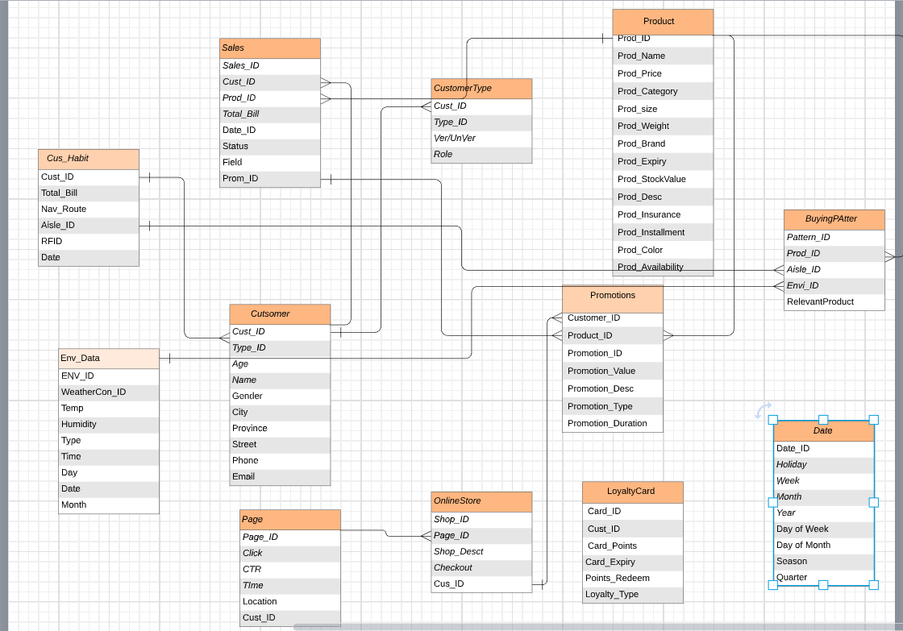

**PART 3:**

**(a)**

|  |  |  |  |  |  |  |  |  |  |  |  |  |  |
| --- | --- | --- | --- | --- | --- | --- | --- | --- | --- | --- | --- | --- | --- |
| Dimensions→  Procedures↓ | Time/  Date | Customer | Product | Employee | Dealer | Ware  house | Store | Promotion | Sales | Website | Social  media | Shelf | Payment |
| Purchasing |  |  |  |  |  |  |  |  |  |  |  |  |  |
| Sales |  |  |  |  |  |  |  |  |  |  |  |  |  |
| Marketing |  |  |  | \ |  |  |  |  |  |  |  |  |  |

**(b)**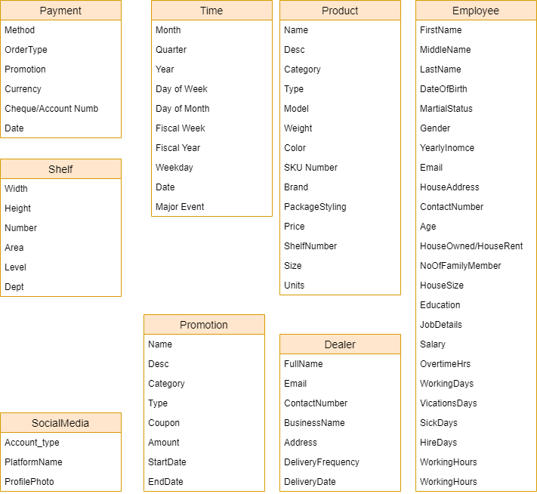

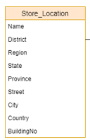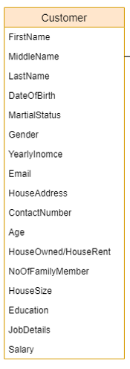

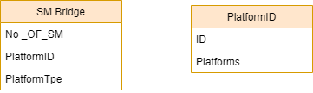**(c)**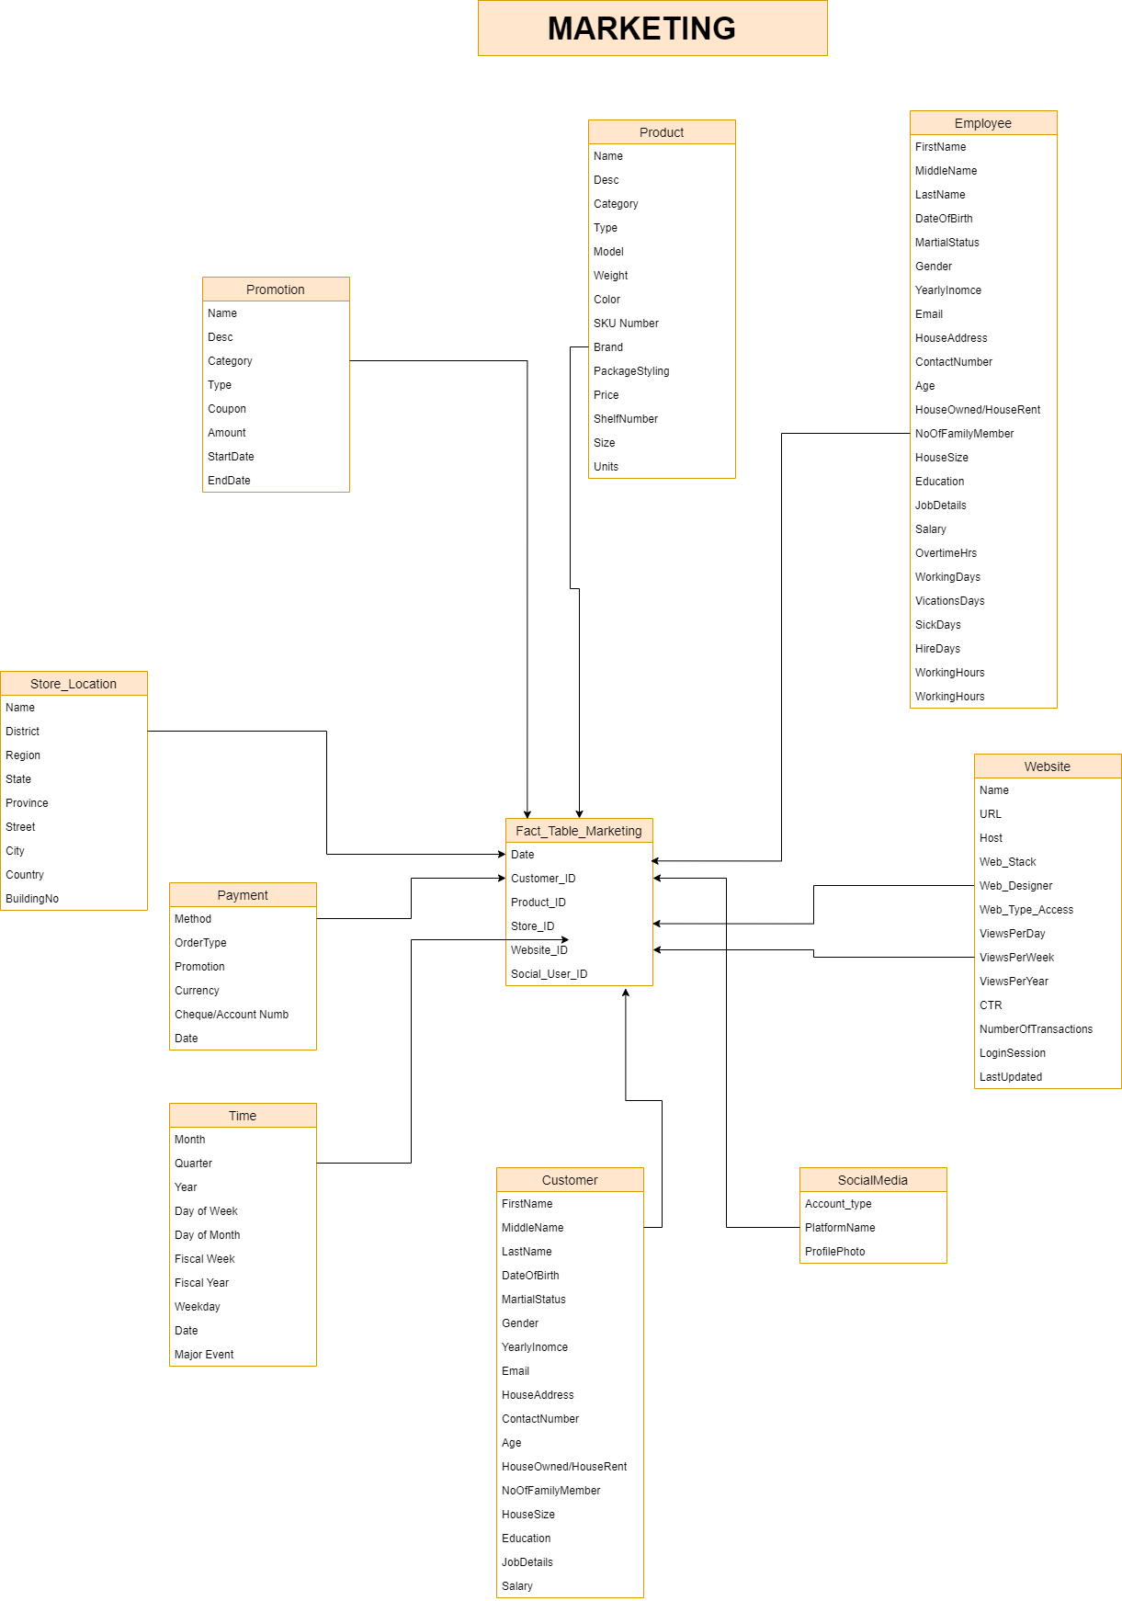

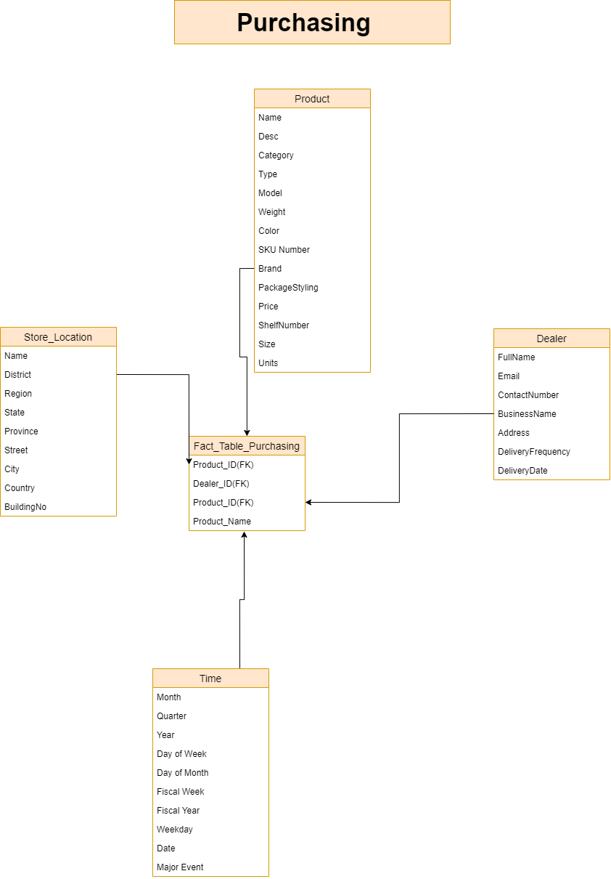

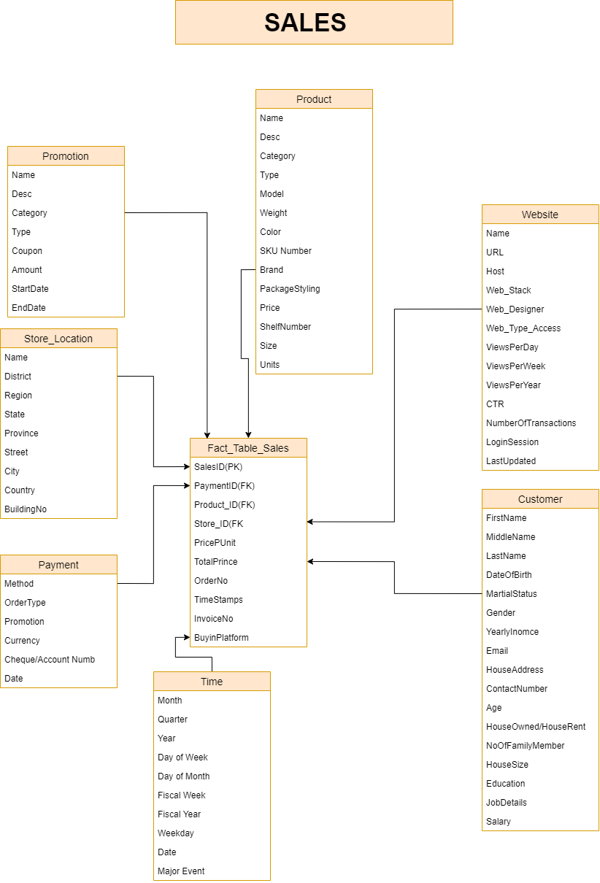

**(D)**

|  |  |  |  |
| --- | --- | --- | --- |
| Fact table name | Fact granularity | Fact table type | Brief justification |
| Fact_Marketing | Product_ID | Transactional | We can check for each product if it has any promotion going on or not and we can check the placement of these products in various stores. And then see the impact of these on sales. |
| Fact_Sales | Store_ID | Transactional | We check purchases by store.Then for each store we can further check frequency and amount of product purchased. |
| Fact_Purchasing | Dealer_ID | Transactional | We check from which dealers are stores getting the most product. This way we can work with them to set up promotional offers |

**(E)**

|  |  |  |
| --- | --- | --- |
| Dimension table name | Dimension table name | Attribute hierarchies |
| Store | There are multiple stores across different location. We need to keep track of the sales pattern in each location to get an understanding of what needs to be focused on different stores. | Country → province → city→ region → district → zip→code → street |
| Product | Products have multiple divisions.Products->Category->Brands and so on.This allows us to have an indepth analysis of different product sales. | 1. Product → weight → size → size range 2. Product name → package type → package styling 3. Product line→ product category → product type→ product brand → model number → product name |
| Customer | We need which customer visit which store. What they bought. How frequently did they bought? In order to determine buying patterns of our customers. As the whole basis is to increase customer sales. We need to have indepth detail of customer. Were they live what they earn ,other details and so on. | 1. Customer→ name → birthdate→age → gender → phone→ email → address 2. Customer→ name →age→education level→ yearly income→ address→ home value→own or rent→ vehicles owned 3. Customer → name → age → gender→ marital status→ no of children→ no of people in house |
| Employee | Keeping tracks of employees gives us accountability’s which stores reviews are better. Which is selling more. What is lacking which departmental employees are not working up to mark or are exceptional. To keep track of al of this wee need a employee table. | 1. Employee → hire date→ salary month → salary date→ last paid → salary 2. Employee → working days → working hours → overtime hours → sick/leave hours → vacation hours 3. Employee name→ age → gender → marital status 4. Employee → department → title → salary |
| Time | To track the day to day and weekly/Yearly sales.See which day sold more and why? For example holiday seasons | 1. Fiscal year → fiscal quarter → fiscal month → fiscal date 2. Day of year → day of month → day of week 3. Year → quarter → month → date → hour |
| Website | Website data are really useful. It gives us track of each customer. What they bought, from where they bought it. Did they buy any of out recommended items? What is the rate of conversion of sales? Etc. All these queries can be solved by website data | 1. Website-Number of clicks to order-number of transactions completed 2. Website -views per month-views per week=views per day-views per hour 3. Website-most clicked category-most clicked product-no of add to cart clicks 4. Website - website host-website designer-site last updated-ease of access-variety of info desc |
| Social Media | Different social media accounts help us keep track of customers and provide relevant data as well | 1. Platform-views per month-views per week-views per day 2. Platform-Number of clicks to order-number of transactions completed |
|  |  |  |

**(F)**

|  |  |  |
| --- | --- | --- |
| Design feature | Brief description | Brief justification |
| Fact less fact table | Used to know the cost of every product sold in each marketing schema. | FFT is used to directly link marketing to products with Prod_ID to find all the products in fact table. |
| Bridge table | Social media bridge table used in marketing star schema | Each customer will be counted as one in this table even if they login with different social account. |

**(G)**

Problem: Bridging Issue in Website schema. Was solved by creating Social Media table. Our website would count single customer as one. Same goes with customers coming by stores.

Solution: create a bridge table, that counts the account person have. Link it with their other details to loyalty cards etc.

**5**

