**ASSINGMENT MID 2**

1. See FilePartA.
2. See FilePartB.
3. See File DataScraping.ipby.
4. See FolderPartD.

**E: & F:**

**ANALYSIS USING TABLUE**

Our relationship schema contains 5 Files.

1. Main File named Movies.csv
2. To break the many to many relationships between movies and Genre, Directors, Writers & Stars 4 separate file are created containing PID of Movies.csv as Foreign Key.

**ERD**

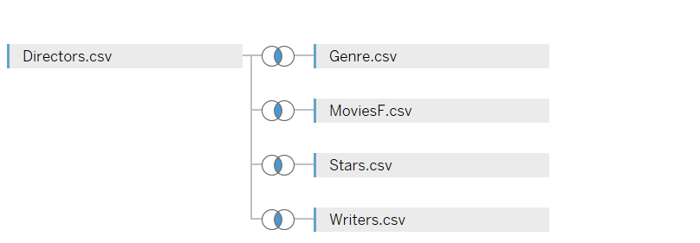

**Loading Data Set:**

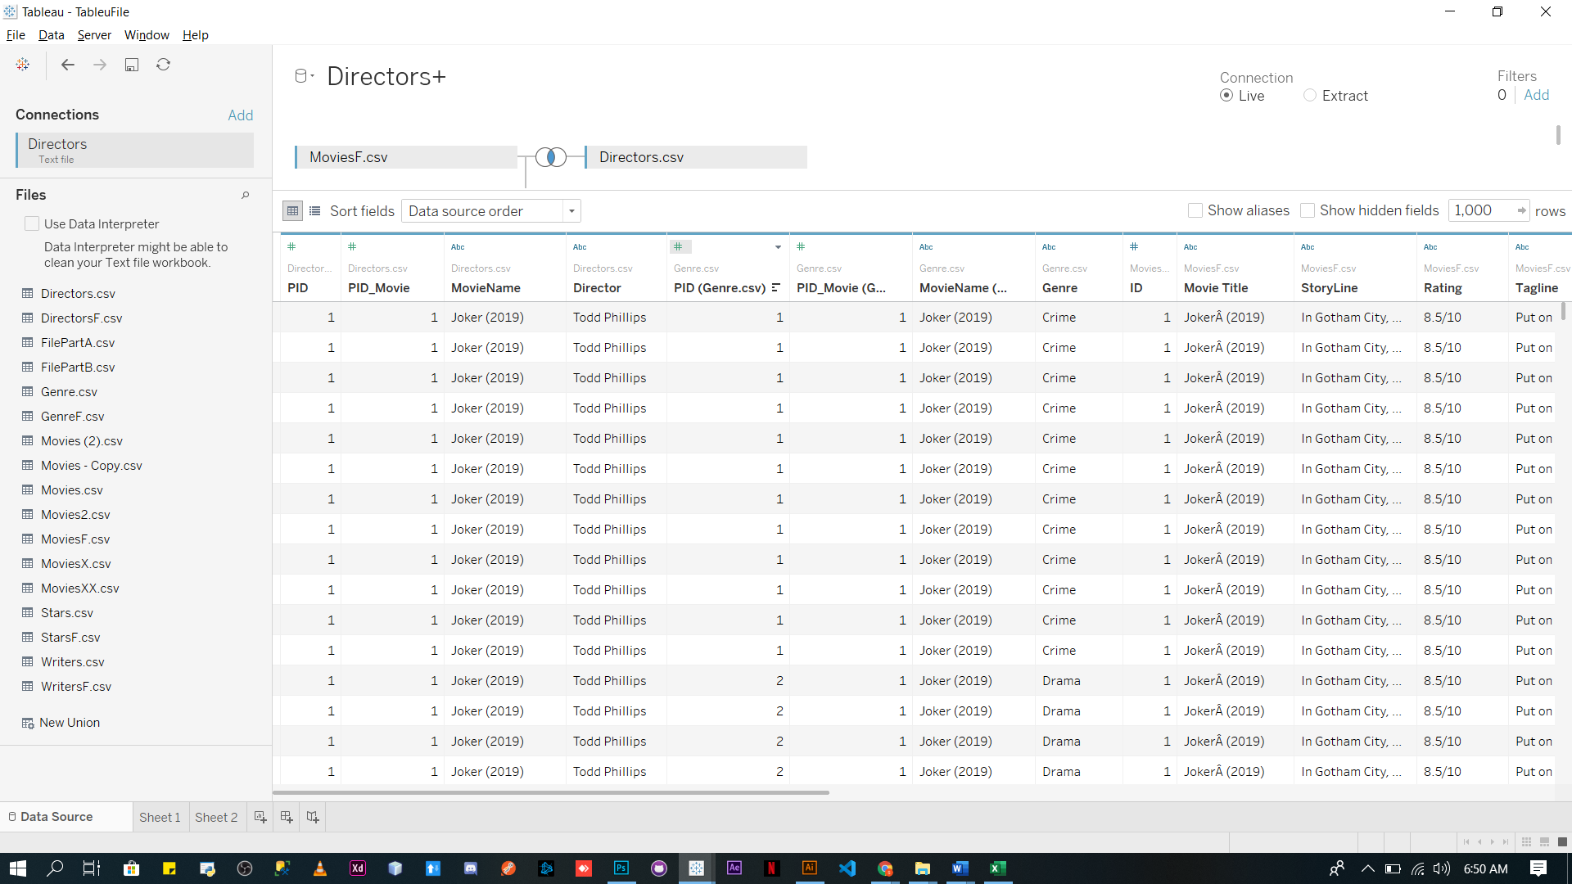

**Sentiment Analysis:**

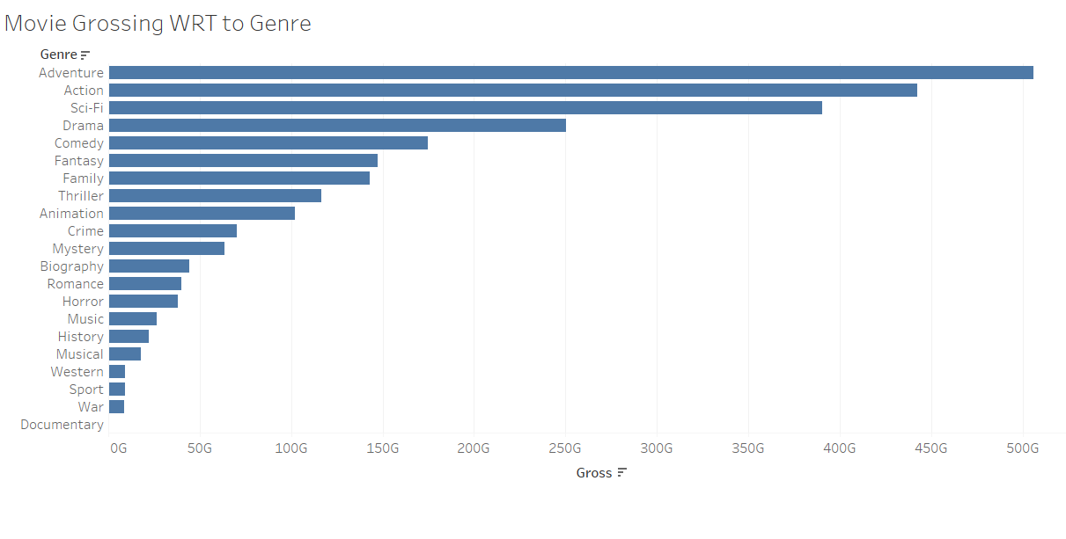

Action & Adventure Movies like Avengers Endgame, Stars Wars, Civil War make a huge chunk of profit in the past five years with Avengers Endgame being the highest grossing movie of all time. As a result, Adventure, Action Sci-Fi Sector had a lot of grossing.

Proof Given below: 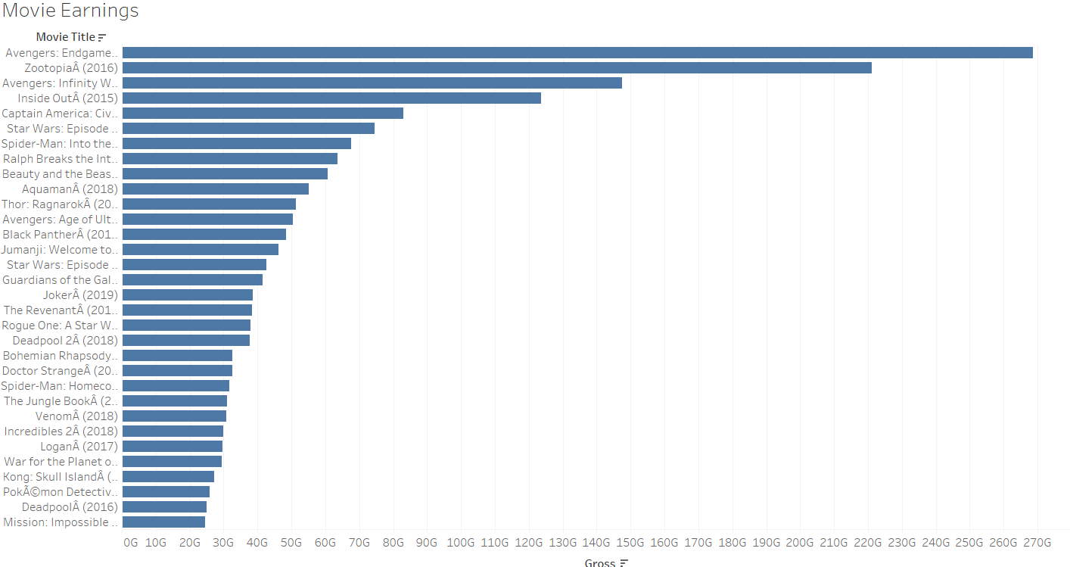

Russo brothers earned the most from there earning from the Avengers. 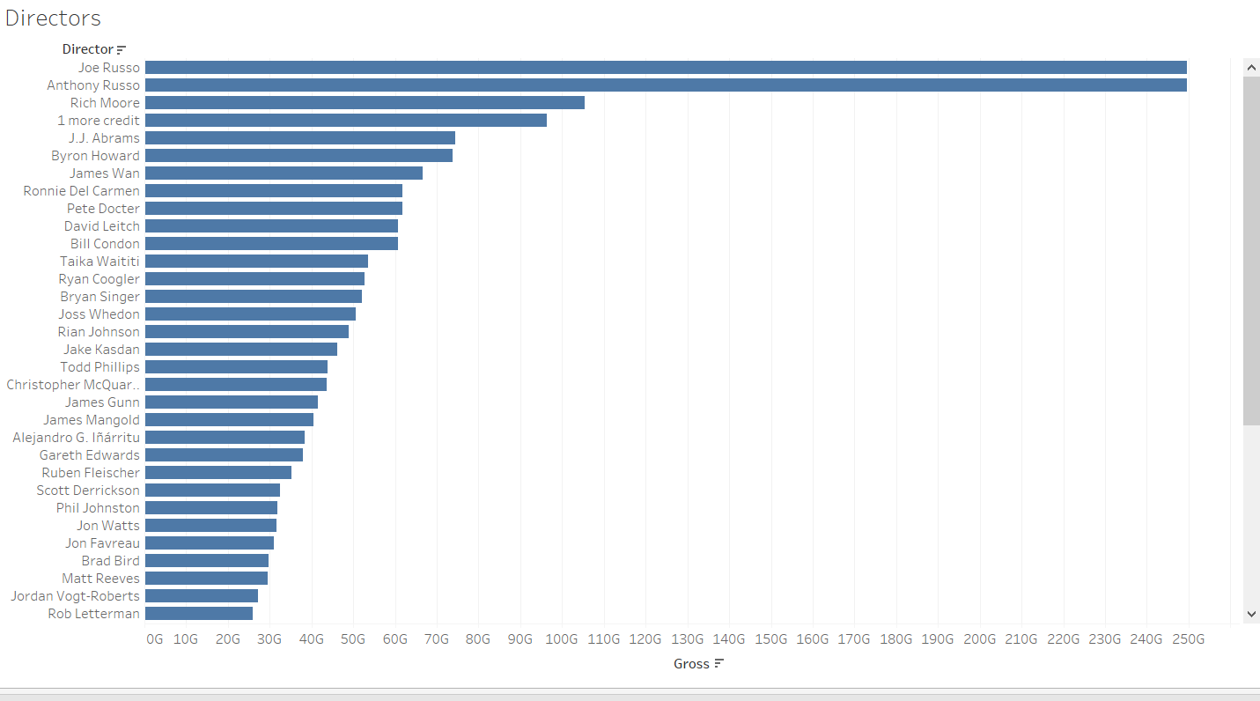

Rating matter to a certain extend in determingn the earning of the movies.As movies with lower rating have earned more than raitng with higher earnings.

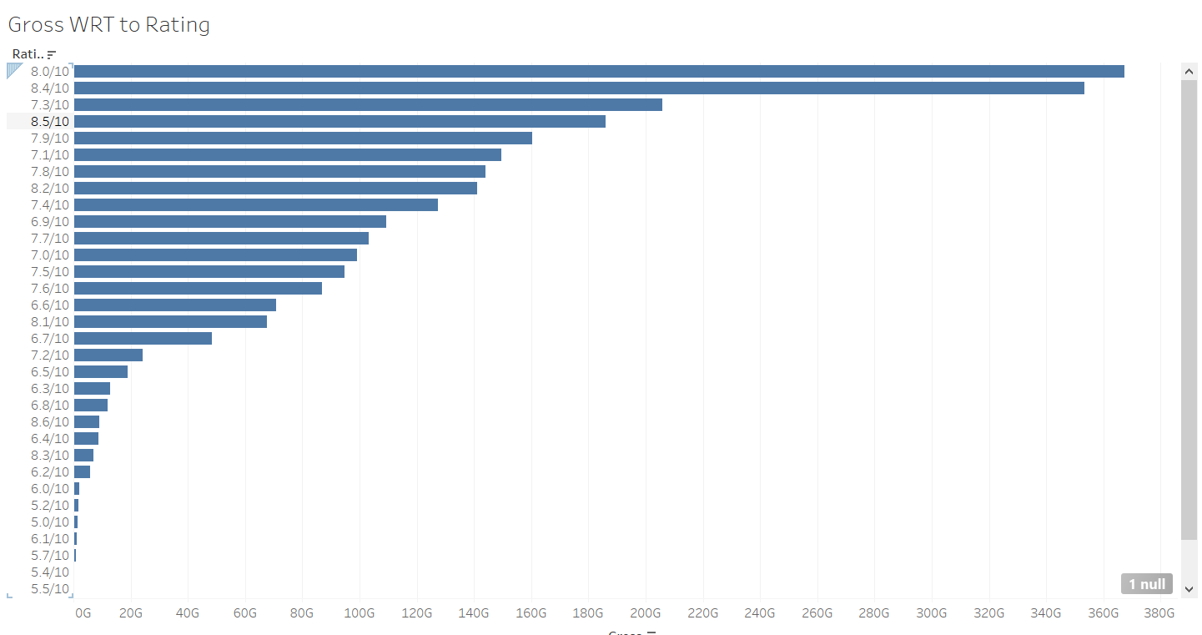

Most Amount of budget in the last 5 years has been spend on Sci-Fi,Adventure & Adventure Movies.

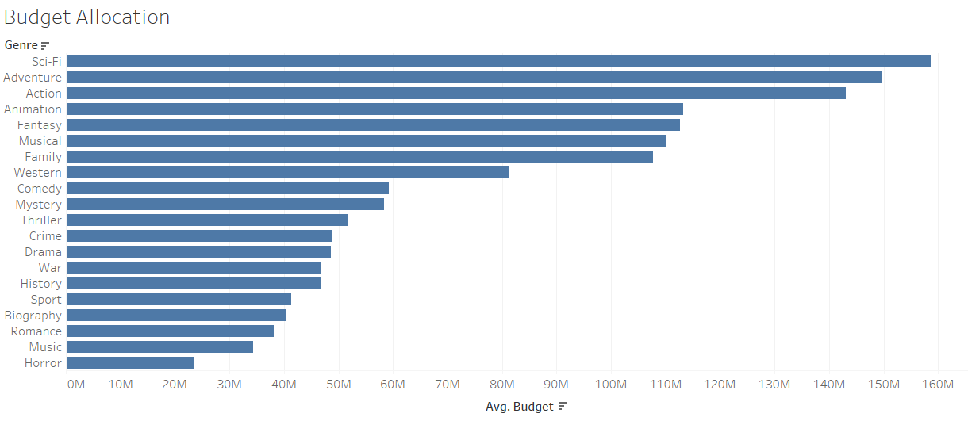

You can see below that directors which had the highest bugdet for movies also end up earning the highest.Rian Johson , Joe Russo And Anthony rusoo all have highest grosing movies.The highest overall budget use by a director was Rian Johson in Starwars and Knives Out.Althoug overall move budget was alloted to Rian Johsaon(Stars Wars Director) was more , Ruso Brother end up earning more via Success from Avenger Series.Giving high budget to director doesn’t always guarantee the success of a movie.

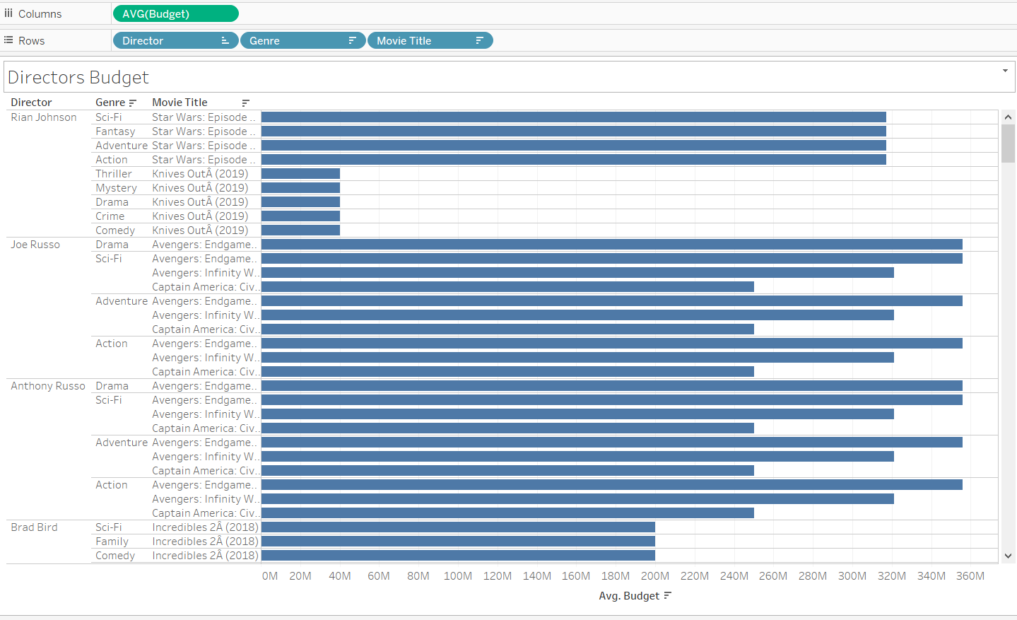

An obvious analysis was that since such movies gross so much. There actors must have had heavy earnings.:4 out of top 5 actors belong to Avengers. Other one belong to Star Wars.

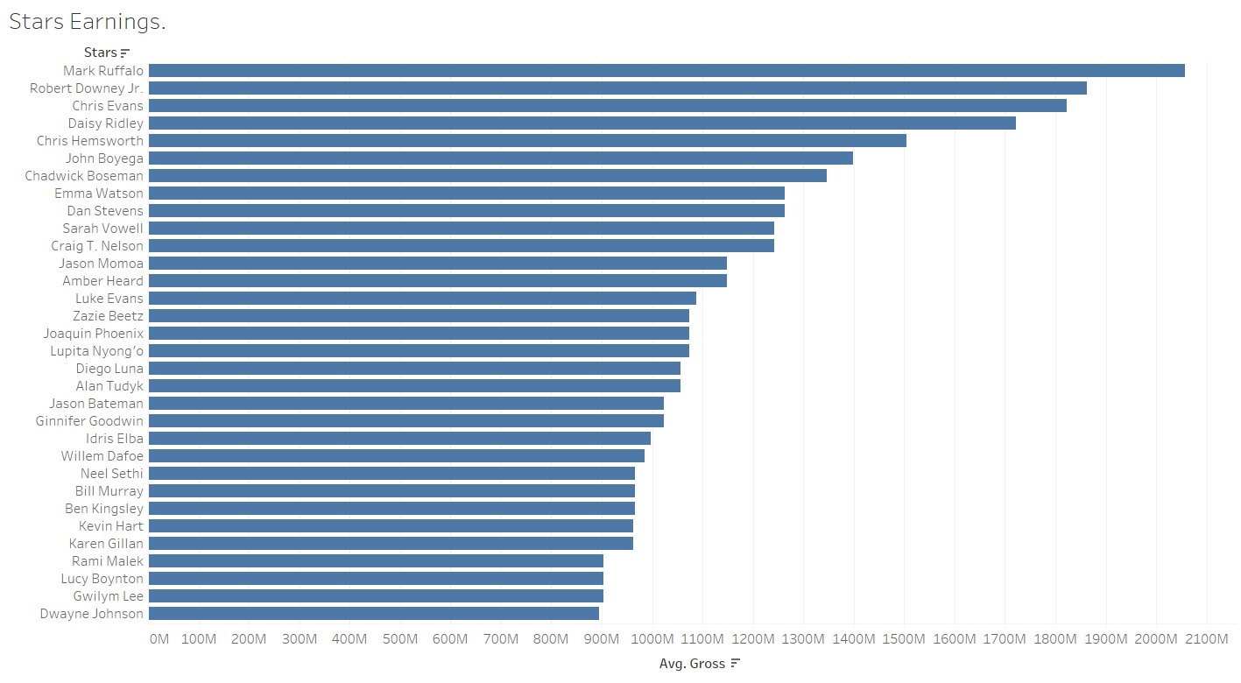

There are movies with lower budget that end up grossing more and Vice Versa.

Examples:

Joker gross a lot more than its allocated budget. Same is the case with Bohemian Rhapsody, & Jumanji. Sadly, a lot of movies were not able to gross more than there budget Jungle book, Aqua man etc.

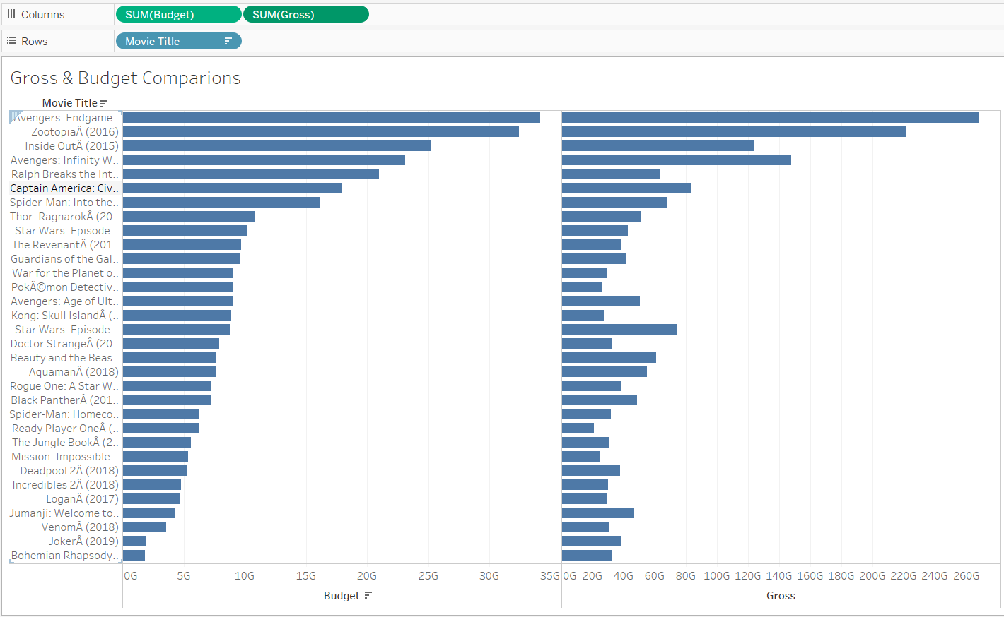

**Sentiment Analysis**

With the advancement in technologies being implemented in Sci Fi and Action Movies. There is a high demand of such movies by the consumer. And according to the trend being shown form the past 5 years it will continue to grow. However spending huge amount of budget on a movies does not always guarantee its success viewers want cool 3d graphics but at the end of the day they need a good plot as a result a lot of movies spend a lot more than it earned. With the animation being used there a increase in demand of animated movies such as frozen, Inside Out , Zootopia(earned more than avengers part 2).While Romantic, Horror, Musical (6th largest grossing amount was spent on this genre yet it came 4th last in grossing) Movies are not in as demand as they once were.