DHA Karachi Villas Logo Approval Options
Brand identity options prepared for client selection
This document brings together the shortlisted logo directions for DHA Karachi Villas. Please select one preferred main logo for final production.
Current Identity Refined
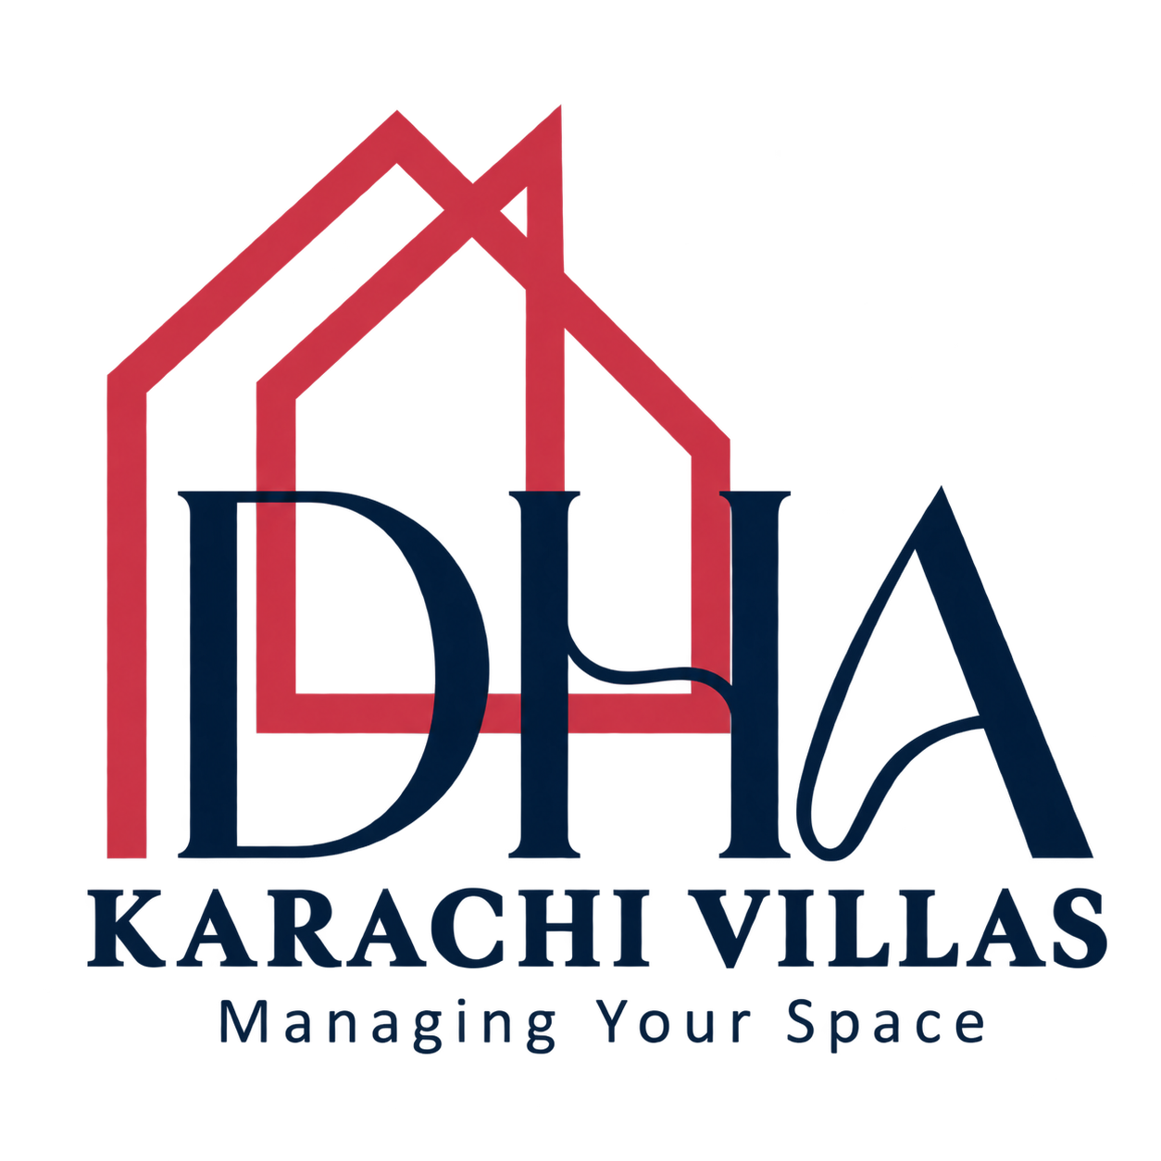
Thicker house outlines for stronger visibility in the website header and social media use.
The current refined logo is shown above. The following pages contain six alternative directions for comparison before final selection.

DV Monogram Concepts
Compact DV concepts designed for a premium modern brand and strong small-size performance.
01 DV Monogram Original
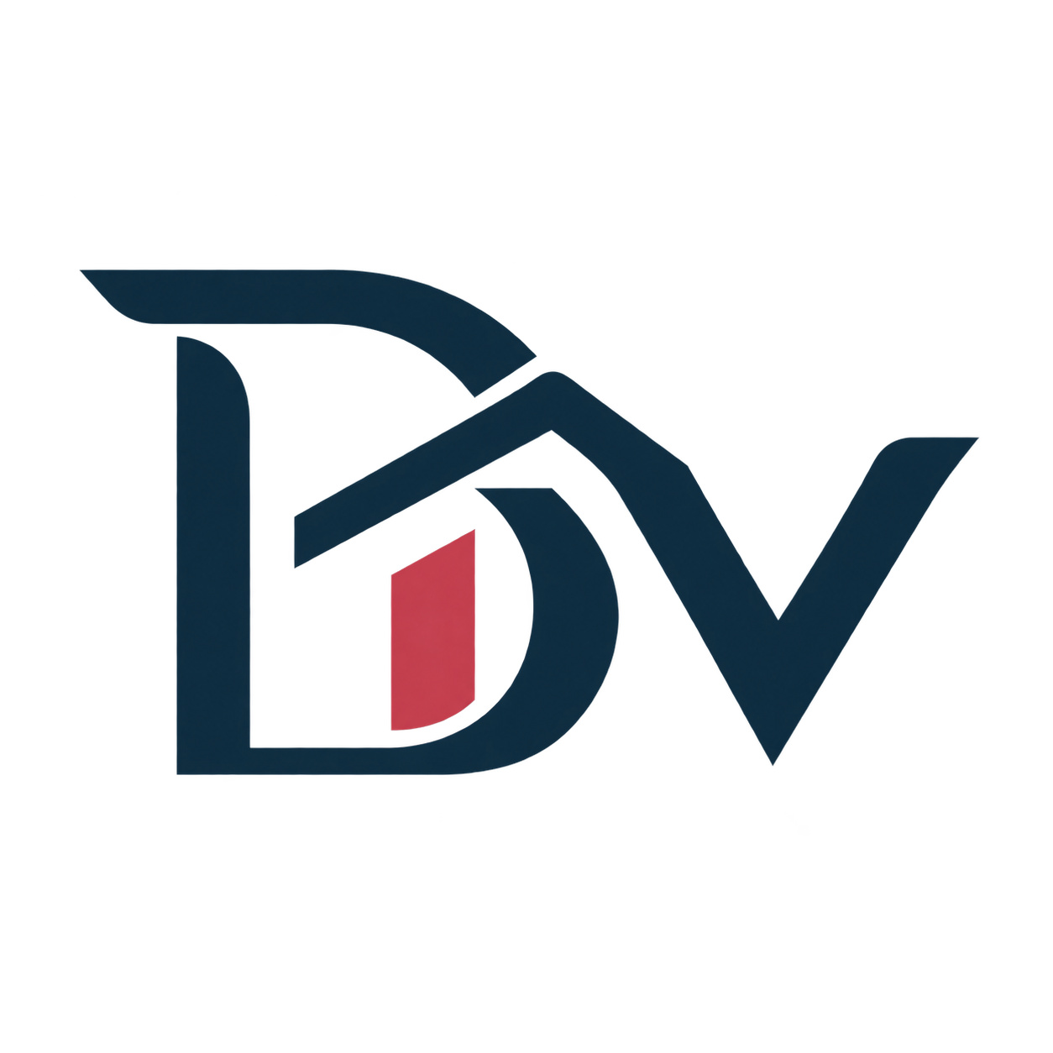
Clean DV lettermark with a modern villa roof accent.
02 DV Monogram Compact
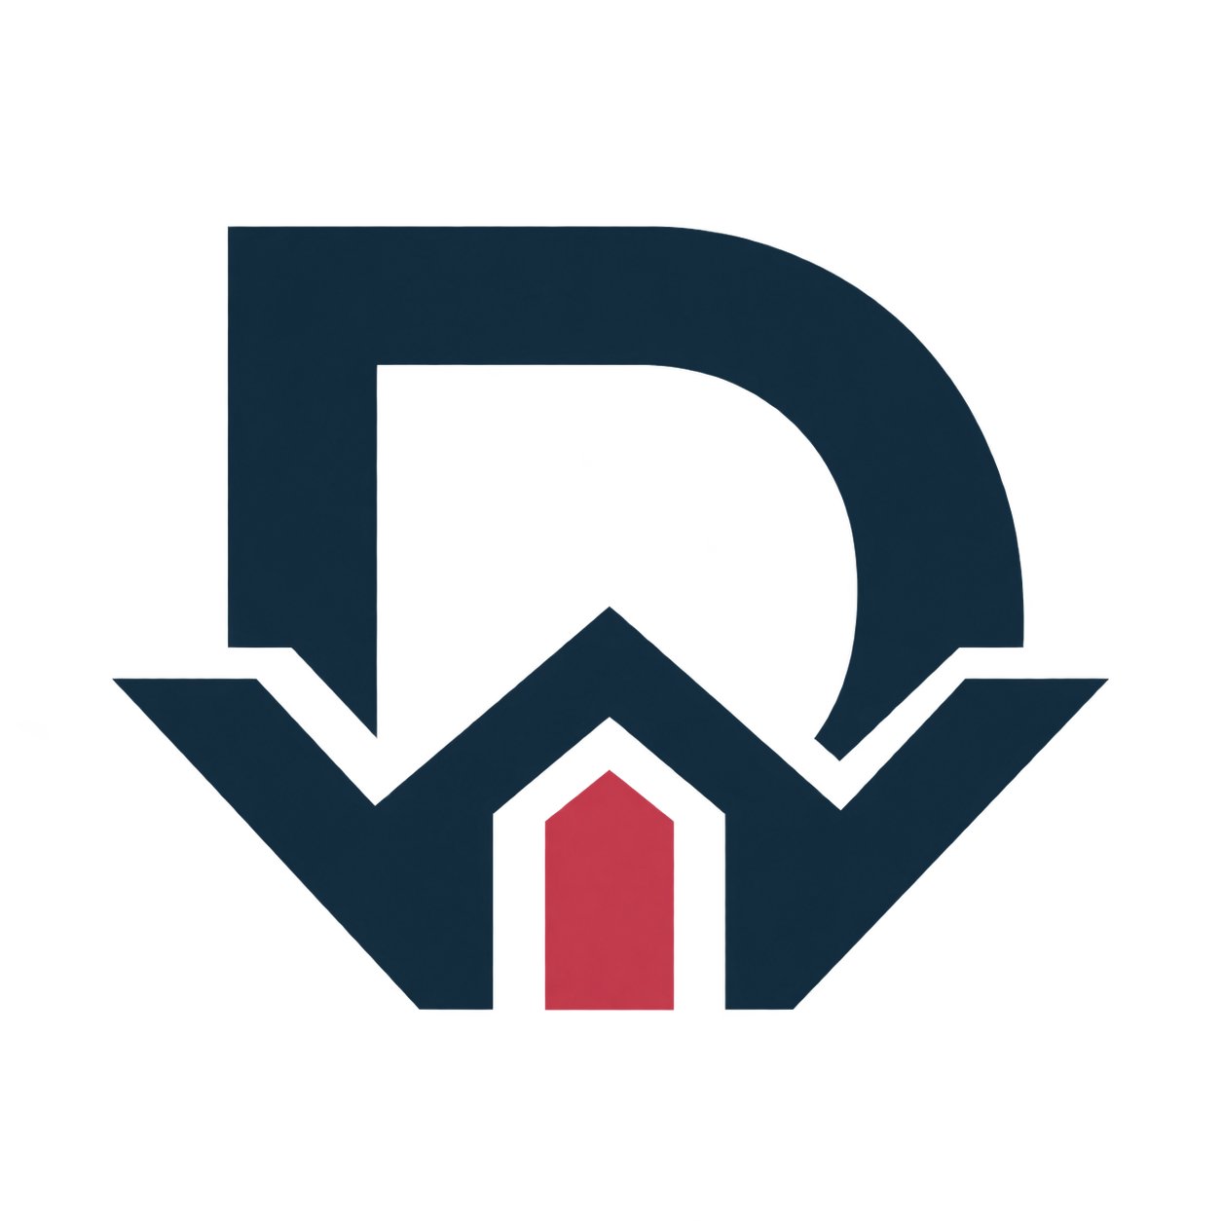
Compact roof-and-doorway variation designed to work well as a favicon and app icon.
03 DV Monogram Gateway
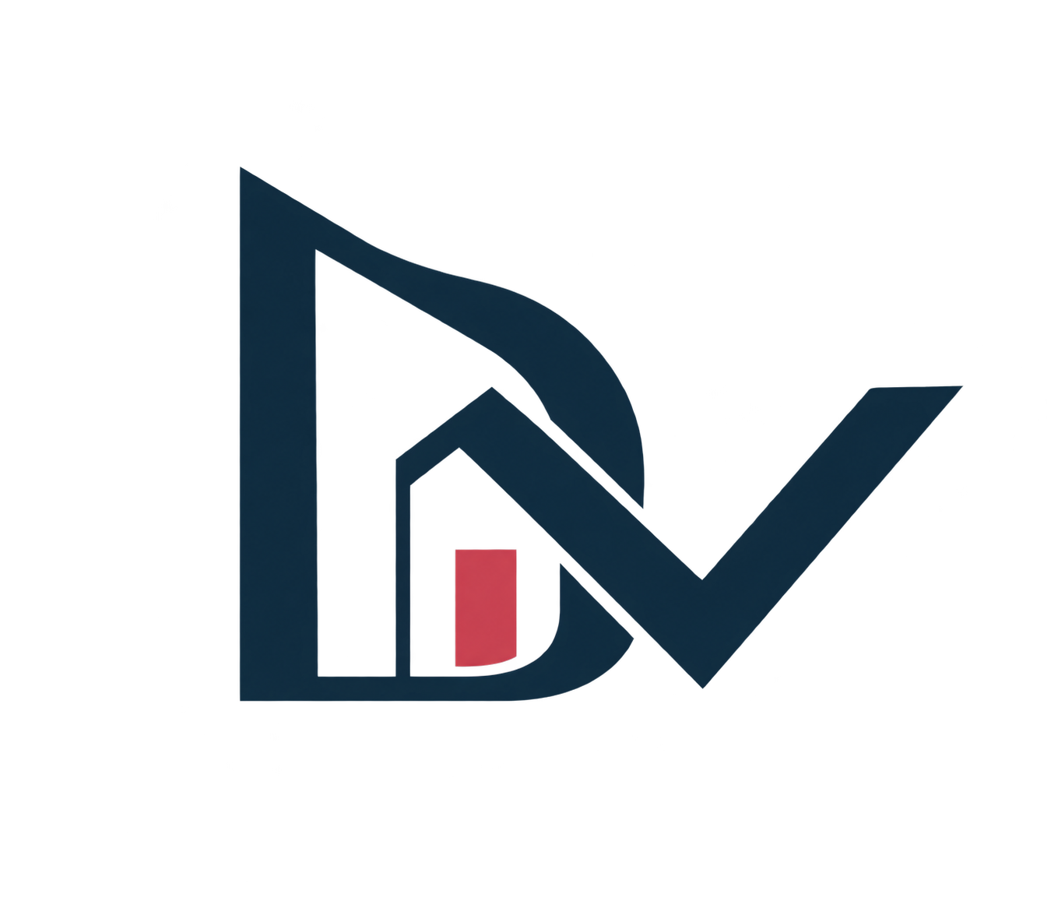
Bold interlocking DV mark with a premium architectural gateway feel.

Additional Architectural Concepts
Alternative logo directions that combine villa architecture with a distinct brand mark.
04 DV Monogram Ribbon
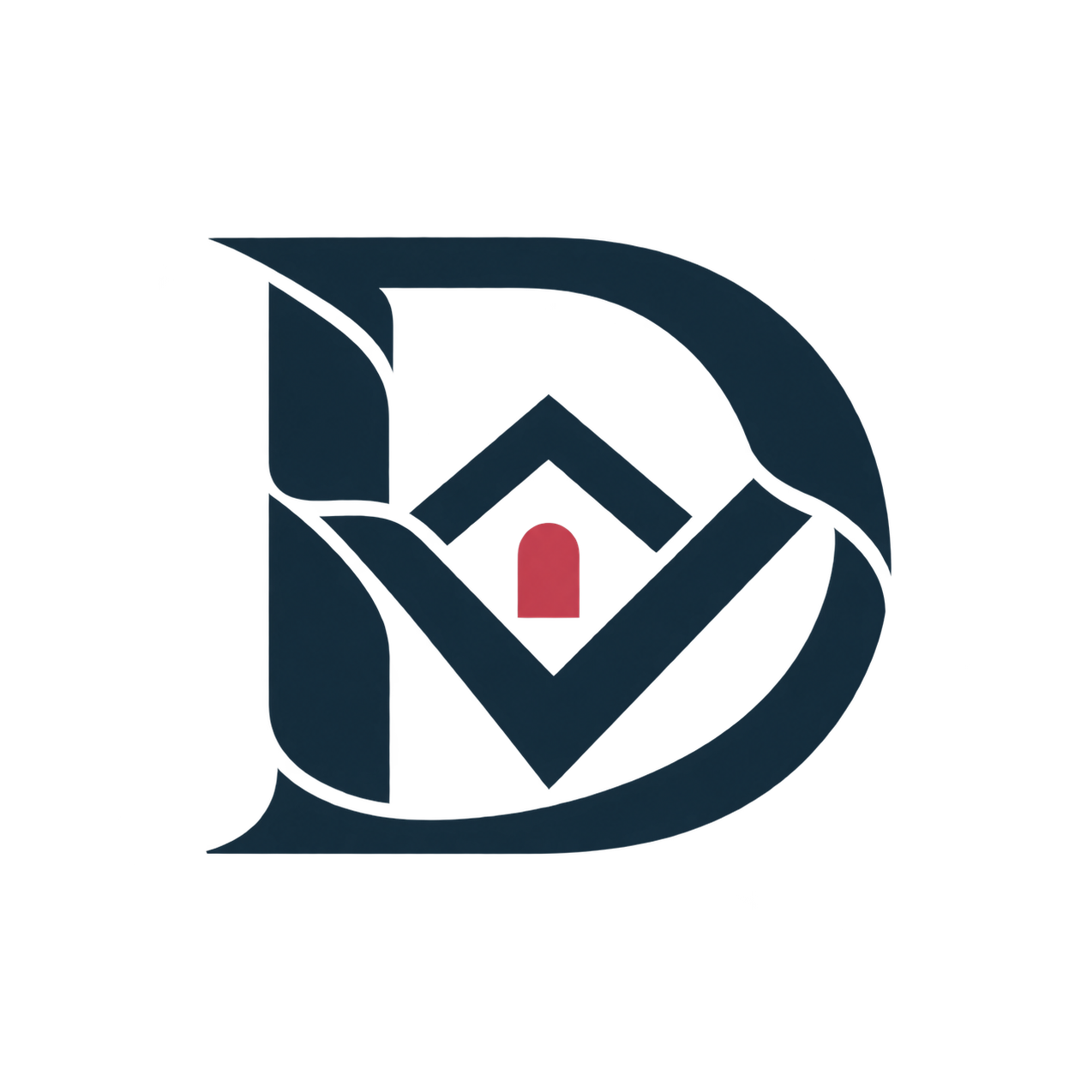
Softer, more editorial DV mark with a subtle doorway accent.
05 Villa Location Emblem

A villa and location-pin concept for a more descriptive real-estate mark.
06 Villa Gate Emblem
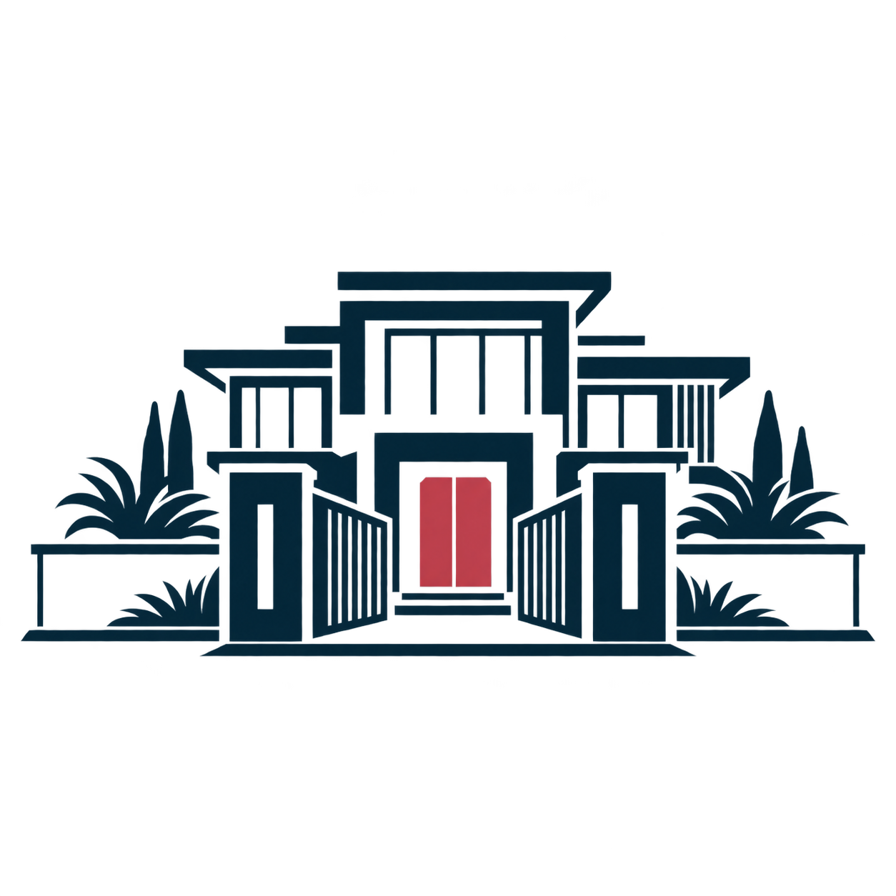
A strong residential gate and villa icon with a luxury property feel.

