***Paper 1 : Generating Personalized Job Role Recommendations for the IT Sector through Predictive Analytics and Personality Traits***

There are 5 common personality types : RIASEC R(Realistic)I(Investigative)A(Artistic)S(Social)E(Enterprising)C(Conventional)

Each of this personality type is dependent on one another. Hence they form a hexagonal model.

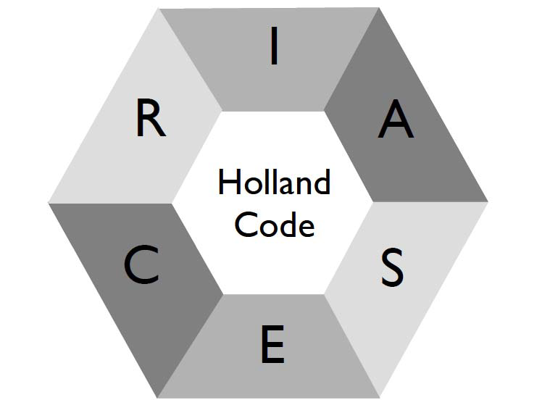

This leads to the Big 5 factor model where each personality types in detail abstracts to 5 different dimensions. They are Extraversion, Agreeableness, Conscientiousness, Neuroticism and Openness.

This paper focusses on a study where it tries to figure out the role of a specific job in the software industry needs what type of personality traits on the employee.It also has a recommendation system to the user what skills he needs to acquire to excel better on the job or even to nail the interview.

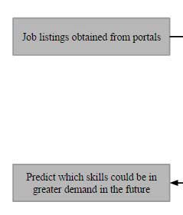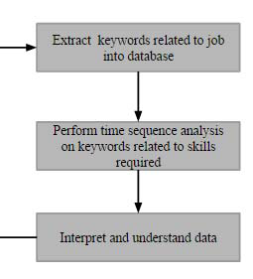

This is how their skills prediction module. The user will be tested for his Holland code and this would be used to match his skills with the relevant job openings.

***Paper 2 : ESCO: Boosting Job Matching in Europe with Semantic Interoperability***

There are lot of unfilled jobs in Healthcare , IT and other industries in Europe which remains to be the same way though the unemployment rate is high especially in a younger age group.

Their possible way of approaching this problem is that , making the unemployed people move across regions and also the how to help them focus on their career goals.

The use case discussed : a person who studied in france, living in estonia and looking for a suitable job in portugal should still be able to find one at ease. They aim to solve it with a technique called semantic interoperability.

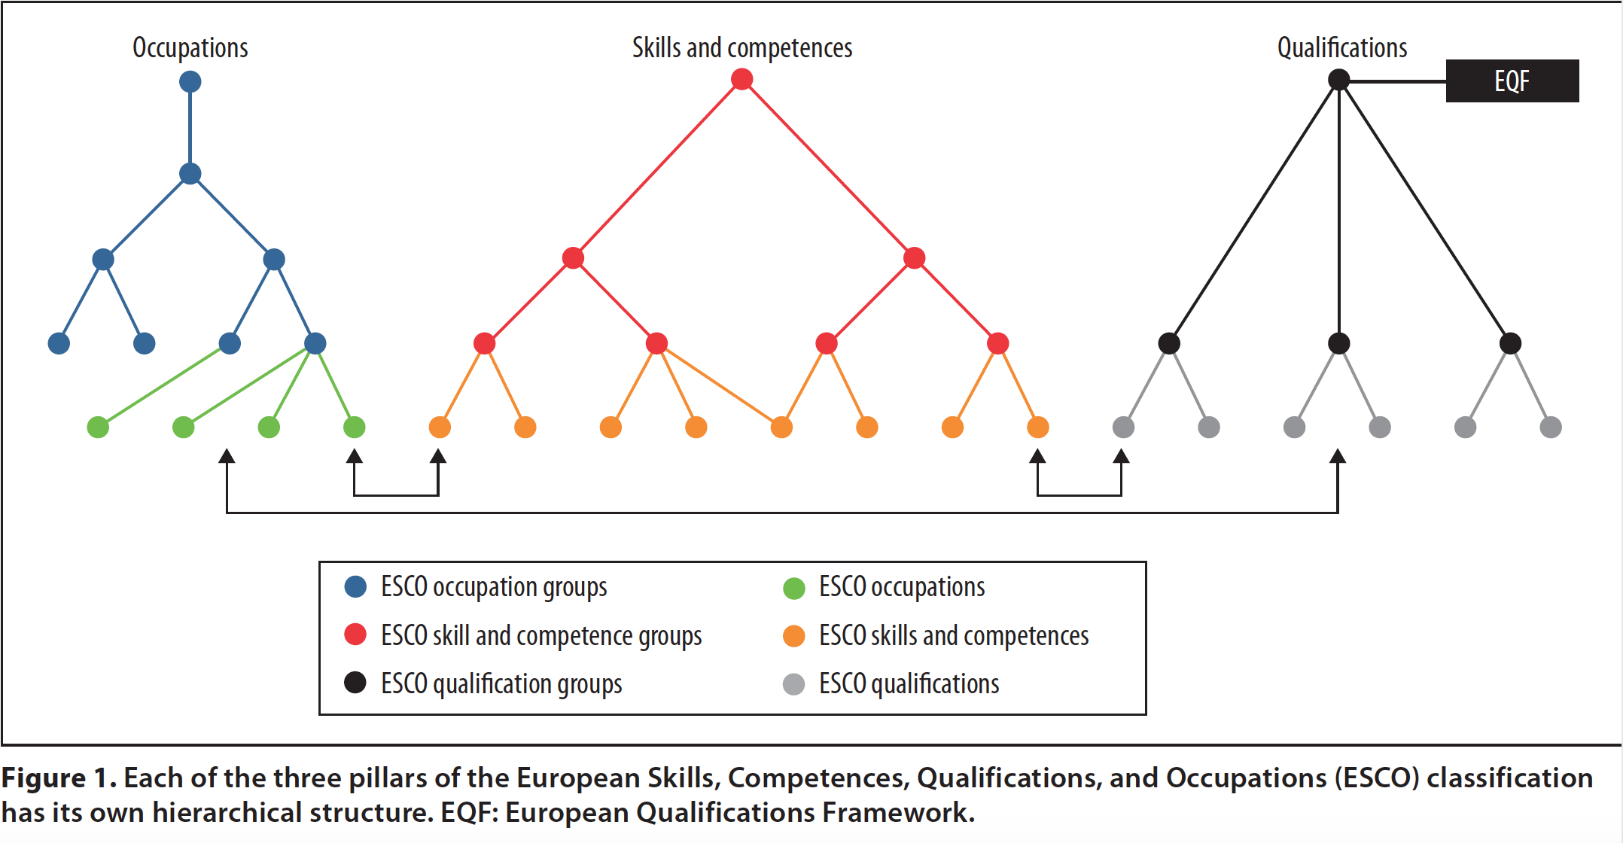

Their first release tried building this gap better . It works by connecting the information on job openings and qualifications with skills and the other capabilities of the employer along with the demands of the labor market.

The basic work of the algorithm is that it works by connecting the employees’ competencies with the employer needs to make the best match.

It crawls the job openings from the job portals like ONET online and then it looks at the user's’ library on its database and offers a machine readable translation between one classification to one another.For better understanding , take a look at the figure below .

