First required matlab/simulink model for inter turn faults detection, position and level estiamtion in stator windings of DFIG based wind turbine using unscented and extended kalman filters and and then set up a comparison to evaluate the performance of the UKF and EKF algorithms, considering computational complexity, accuracy, and speed of estimation. You need to use faulty state space model from reference paper but please keep in mind n the reference research paper author use different technique for faults detection.

In the documentation, I required mathematical equations means, algorithms of UKF and EKF, and mathematical equations of the DFIG faulty model. And a comparison of both filters shows how UKF performed better estimation and faults detection than EKF in the form of results and graphs. I need graphs in which clear Estimation difference is done by both filter and their comparison with real. And I also need a video of running model in which you have to teach me all running process of model.

**DFIG Healthy State Model:**

Fig of the equivalent circuit of healthy doubly fed induction generator (DFIG) in the abc frame.

Fig of the equivalent circuit of healthy DFIG in the dq-frame.

**DFIG Faulty State Model:**

Fig The short circuit turns ratio representation.

Fig of The equivalent circuit of the faulty state DFIG in the dq-frame.

**parameter Estimation Procedures:**

General DFIG state space model

**Extended Kalman filter mathematical equations algorithm:**

**Unscented Kalman filter mathematical equations algorithm:**

The Covariance Matrices Tuning

**simulation Results**

EKF VS. UKF Response at different percentages of inter-turn faults

Step 1: Table of Parameters of DFIG

**Results required after applying inter-turn faults as shown in research paper:**

**Graphs for Transient behaviors from normal conditions to a 1%, 5% etc inter-turn short circuit fault**

**Graphs for Stator current signature for inter-short circuit fault in phases ‘a’, ‘b’, and ‘c’ using UKF and EKF.**

**Graphs for the stator current residual signatures for different cases that fault occurs in phase ‘a’, ‘b’ and ‘c’**

**Graphs for Fault detection. Fault position location (fx), fault level ($μ$) estimation using EKF , UKF and their comparison**

**Graph for Fault estimation under varying speed operation with UKF, EKF**

**E.g: as shown in shared research paper**

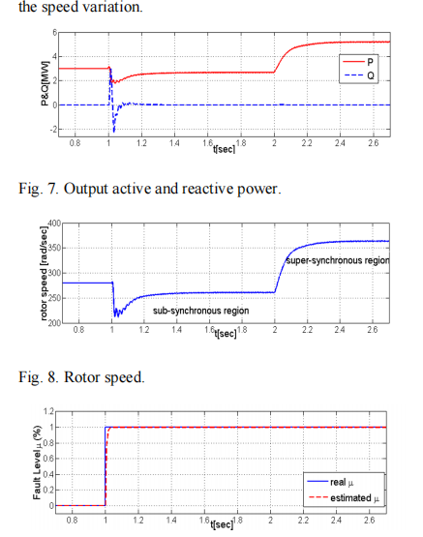

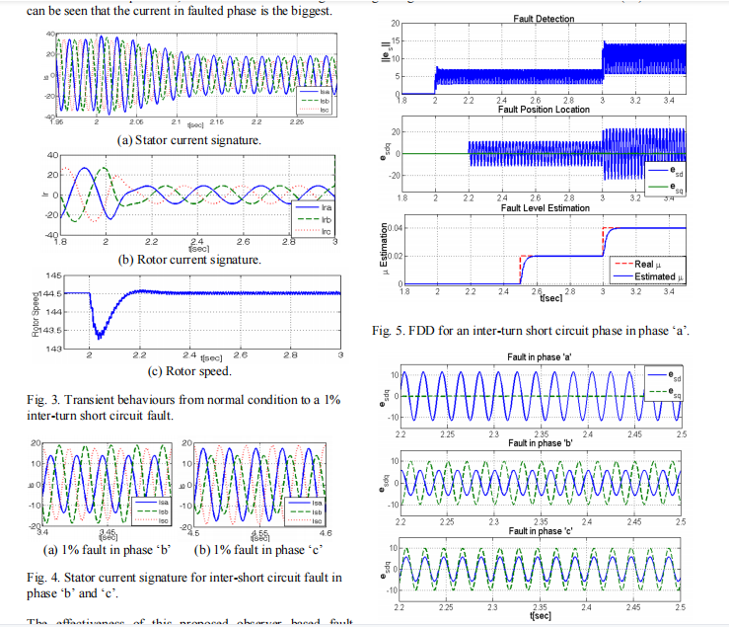

**Simulation Results with UKF Algorithm**

Graphs for active and reactive power with UKf

Graphs for Three Phase Stator Currents with UKF (Ia, Ib, Ic)

Graphs for Three Phase Rotor Current with UKF (Ia, Ib, Ic)

Graph for Rotor Speed with UKF

**Simulation Results with EKF Algorithm**

Graphs for active and reactive power with EKf

Graphs for Three Phase Stator Currents with EKF (Ia, Ib, Ic)

Graphs for Three Phase Rotor Current with EKF (Ia, Ib, Ic)

Graph for Rotor Speed with EKF

**Set up a comparison to evaluate the performance of the UKF and EKF algorithms, considering computational complexity, accuracy, and speed of estimation For example**

**Active Power Comparison:** The performance of the EKF and UKF estimators was compared for active power estimation. The rise time, peak time, and settling time are provided along with the mean squared error (MSE) for each estimator.

Results:

* Real: Rise Time = 0.0001 s, Peak Time = 0.0001 s
* UKF: Rise Time = 4.3988 s, Peak Time = 5.0001 s, Settling Time = 5.0001 s, MSE = 2.82665E-06
* EKF: Rise Time = 4.3957 s, Peak Time = 5.0001 s, Settling Time = 5.0001 s, MSE = 2.82725E-06

The EKF and UKF have very similar performance in terms of rise time, peak time, and settling time. The MSE values are also quite close, indicating that both estimators are equally effective in estimating active power.

**Reactive Power Comparison:** The performance of the EKF and UKF estimators was compared for reactive power estimation. The rise time, peak time, and settling time are provided along with the mean squared error (MSE) for each estimator.

Results:

* Real: Rise Time = 0.0001 s, Peak Time = 0.0998 s
* UKF: Rise Time = 0.0001 s, Peak Time = 0.1 s, Settling Time = 5.0001 s, MSE = 2.21929E-06
* EKF: Rise Time = 0.0001 s, Peak Time = 0.0998 s, Settling Time = 5.0001 s, MSE = 1.64177E-07

In terms of reactive power estimation, both EKF and UKF have similar rise times and peak times. However, the EKF has a significantly lower MSE than the UKF, indicating that it is more accurate in estimating reactive power.

**Rotor Speed Comparison:** The performance of the EKF and UKF estimators was compared for rotor speed estimation. The rise time, peak time, and settling time are provided along with the mean squared error (MSE) for each estimator.

Results:

* UKF: Rise Time = 0.9016 s, Peak Time = 3.652 s, Settling Time = 5.0001 s, MSE = 1.54678E-06
* EKF: Rise Time = 0.9015 s, Peak Time = 3.652 s, Settling Time = 5.0001 s, MSE = 1.54678E-06

The EKF and UKF exhibit nearly identical performance in terms of rotor speed estimation. Both the rise time, peak time, and settling time are the same, and their MSE values are equal.

**Performance Metrics:** In addition to the active power, reactive power, and rotor speed estimations, the computational time and RMSE values for different parameters were compared for both EKF and UKF.

EKF Performance:

* RMSE: Stator Current (Direct-axis) = 0.0017, Stator Current (Quadrature-axis) = 0.0118, Rotor Speed = 0.0004, Rotor Current (Direct-axis) = 0.0025
* Computational Time: 0.1829 seconds

**UKF Performance:**

* RMSE: Stator Current (Direct-axis) = 0.0017, Stator Current (Quadrature-axis) = 0.0117, Rotor Speed = 0.0015, Rotor Current (Direct-axis) = 0.0024
* Computational Time: 0.8754 seconds

The analysis of DFIG performance using EKF and UKF algorithms indicates that both techniques exhibit similar performance in terms of rise time, peak time, and settling time for active power and rotor speed estimation. However, the EKF shows a significantly lower MSE for reactive power estimation, making it a more accurate estimator for this parameter.

In terms of computational time, the EKF is faster than the UKF, with a computational time of 0.1829 seconds compared to 0.8754 seconds for the UKF. The RMSE values for various parameters are also similar for both algorithms, with the UKF showing slightly better performance in some cases.

**Comparison of Active Power**

Table: Active power of DFIG with EKF, UKF

|  |  |  |  |
| --- | --- | --- | --- |
| Parameters | Real | UKF | EKF |
| Rise Time(s) |  |  |  |
| Peak Time(s) |  |  |  |
| Settling Time (s) |  |  |  |
| Mean square error |  |  |  |

**Comparison of Reactive Power**

Table: Reactive power of DFIG with EKF, UKF

|  |  |  |  |
| --- | --- | --- | --- |
| Parameters | Real | UKF | EKF |
| Rise Time(s) |  |  |  |
| Peak Time(s) |  |  |  |
| Settling Time (s) |  |  |  |
| Mean square error |  |  |  |

**Comparison of Rotor Speed** Table Rotor Speed with EKF, UKF

|  |  |  |
| --- | --- | --- |
| Parameters | UKF | EKF |
| Rise Time(s) |  |  |
| Peak Time(s) |  |  |
| Settling Time (s) |  |  |
| Mean square error |  |  |