CPS 188 Term Project - Standardized Cover Page

**Team Leader**

Name: _______Amaan Asim____________               Section Number: _____

Email: amaan.asim @ ryerson.ca

**Team Members**

Name: ___Syed Maisam Abbas______                Section Number: _09__

Email: maisam.abbas @ ryerson.ca

Name: ____Mustafa Duale_______                Section Number: _____

Email: mustafa.duale @ ryerson.ca

We affirm that this project is original and is our own work.

Signatures:

______________________         __MAISAM__        ______________________

Introduction

In this report the temperatures of six different lakes were recorded throughout the year of 2020. These lakes include Lake Superior, Lake Huron, Lake Michigan, Lake Erie, Lake Superior, and St. Clair. This report analyzes the written C-program used to observe the temperatures of the lakes and provides a scientific analysis to support the results. All computations were done using the ‘C’ language throughout this assignment. The group members include Syed Maisam Abbas, Mustafa Duale, and Amaan Asim. Amaan Asim (the group leader) is responsible for questions one, two, and three. Additionally, the entire code was written by Amaan to keep a neat consistent, organized algorithm. Maisam is responsible for question four, five, and six. Mustafa is responsible for questions seven, eight, and nine. Finally, the final report was collaboratively written by Syed Maisam Abbas and Mustafa Duale.

Problems

Before proceeding to complete any problems or tasks given in the assignment, the provided document must be read as a file at the start of the code to analyze the data. To do so, the file was saved in the same platform as the .c file under the name of ‘in2020’ and ‘in2019’(for question 9). This file was opened in the program and the data was sorted into the appropriately defined arrays and variables using the while loop and the fscanf function.

Question 1 and 9

**Code:**

In this problem, the objective is to calculate the yearly average temperatures of all six lakes individually and collectively. To do so, the algorithm made use of equations, knowing that the average can be found using the equation:

This equation implies that the average is equal to the sum of all temperatures in the given year divided by the total number of days. The day count was scanned directly from the data file and the sum of the given temperatures was calculated using a while loop and the ‘+=’ function. This is a repetitive function (because of the loop) that continuously adds the specified data under the condition of the loop.

Once the averages of each individual lake were found, the average of the six lakes was found using a similar equation:

This equation implies that the average temperatures of the six lakes is found by summing all the given averages and then dividing by the total number of lakes (6). Finally, all results were printed using the printf function.

This algorithm was also used for question 9, however, with a different set of data and a separate file. To do so, the previous file was closed, and the new file was opened using the same steps described earlier.

**Analysis:**

As seen in the results, there is some differences in the average temperature for each lake. In general, the temperatures of all six lakes are higher in the year of 2020 as compared to the year 2019. This is to be expected scientifically speaking since the effects of global warming and climate change increase the global temperature of the atmosphere through the greenhouse effect. The greenhouse effect is a phenomenon that traps heat in the Earth’s atmosphere due to the over production of greenhouse gases such as carbon dioxide, methane, nitrous oxide, and water vapor.

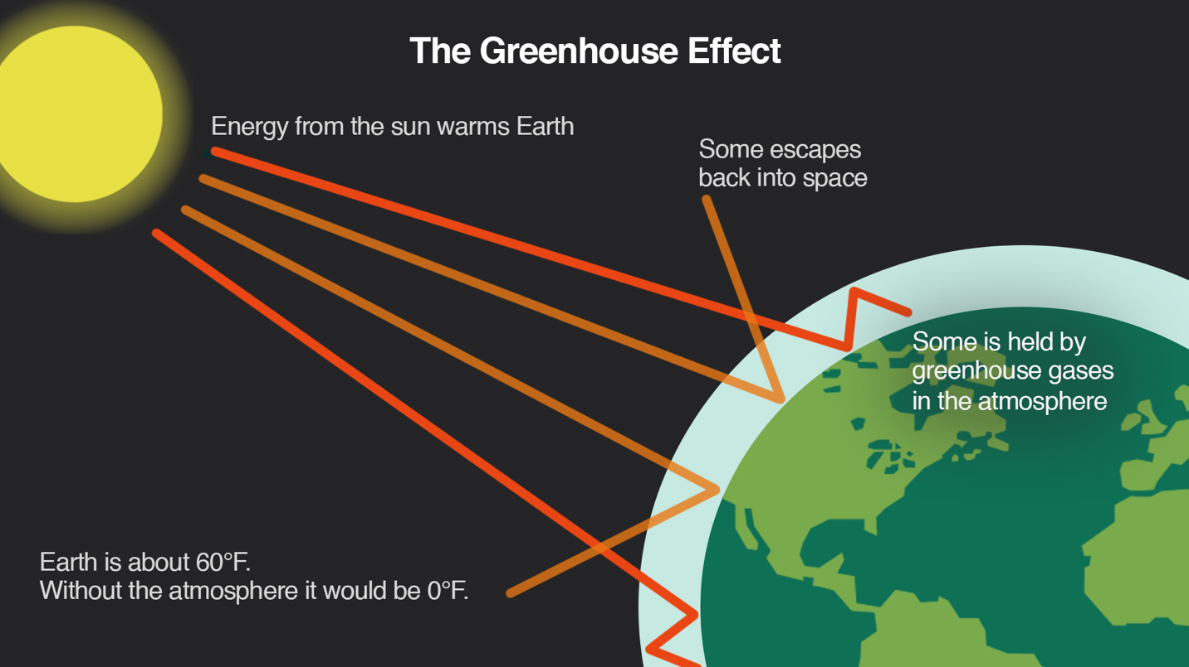

Image of the green house effect

Question 2

**Code:**

In the second problem, the task was to compare the temperatures of the lakes. This task is most suitable for ‘if statements’ since this programming function allows the user to compare multiple values and provides a set of conditions to be met. Firstly, the averages of all the lakes were transferred into an array. Next, a for loop was set under the condition of (i=0; i<6) to make a repetition of the algorithm to compare the six lakes simultaneously. The lake with the lowest average was defined as the coldest temperature lake and the lake with the highest average was defined as the warmest temperature lake. Next, to individually compare the average temperatures of the six lakes to the total average, a large sequence of nested if statements were used. These if statements individually compared the averages of all six lakes and specified which lakes had temperatures above/below the average value. Finally, to determine which lake should be specified in the printf function based on its average temperature, a set of if statements were used to compare the temperatures.

**Analysis:**

The results insist that the lake with the lowest temperature is Lake Superior and the lake with the highest temperature is Lake Erie. Additionally, the lakes below the average temperature include Lake Superior and Lake Huron. The lakes above the average temperature include Lake Michigan, Lake Erie, Lake Ontario, and Lake St. Clair. These results can be justified by analyzing a map consisting of these lakes.

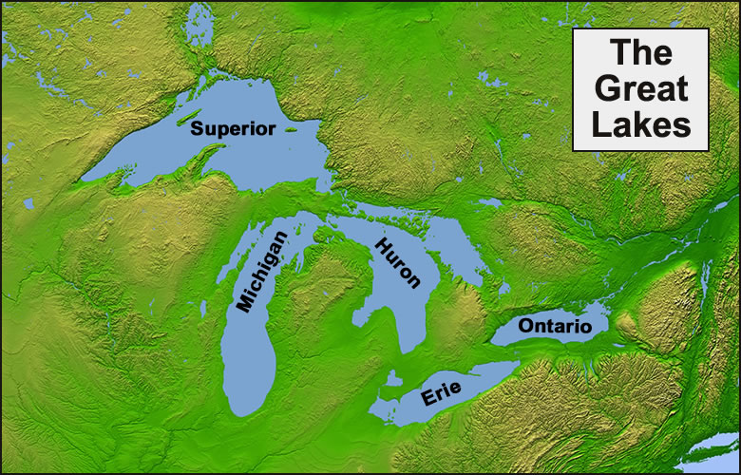

Image of the map of the five great lakes

This image shows the location of the five great lakes with Lake St. Clair located in between Lake Huron and Lake Erie. It is clearly observed that Lake Superior is located the furthest up north and Lake Erie is located furthest down south. The temperature of Earth is highest around Earth’s equator and lowest at the points furthest from the equator. This is because majority of the sun’s energy contacts the Earth along the equator. Since Lake Erie is closest to the equator, its temperature is the highest; and since Lake Superior is located furthest from the equator, its temperature is the lowest.

Question 3

**Code:**

The objective of this problem is to determine the coldest/warmest days of the lake in the year of 2020. The date should also be stated as a month and day. Since this problem seems to be a little more complex, the use of a function was initiated. The function was named ‘dayconversion2020’ as a function of the day number. Knowing that there are 30/31 days in a month, the function used if statements to count the number of days and compare the day number to the month. If the set of days were between a certain range, then it would be specified as the respectable month according to the day count. As the months went later into the year, the day number increased by adding the total days of the previous month (months). The day number was recorded by subtracting the total days in the previous month (months). This process was repeated for all 12 months in the year.

Next to determine the coldest day of the month the program used loops, arrays, and if statements. A for loop was initialized for all given lakes under the condition of (i=0; i<366) so that the process would be repeated for all days of the year. Using the arrays of the temperatures defined in an earlier question, the if statement compared the specified temperature of each lake individually. The minimum temperature of each month was recorded as the coldest day and the highest temperature of that month was recorded as the warmest day. The results were printed using a printf statement and the month-day was stated by calling the function made earlier.

**Analysis:**

The results of this question imply that the coldest temperatures are located near the months of January-March and the warmest temperatures are located near the months of July-August. These results are accurate because of the seasonal changes that occur throughout the year.

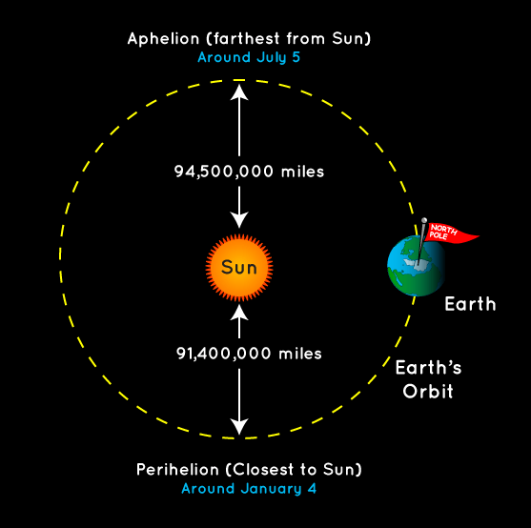

Image of the Earth’s orbit around the sun

The Earth’s rotation around the sun is not a perfect circular orbit, because of this, throughout the year (one full orbit) at some point the Earth is closest to the sun and at another point the Earth is furthest from the sun. Additionally, the temperature of Earth is proportional to the distance from the sun. As a result, when the Earth is closest to the sun (around January) the temperature begins to increase, and when the Earth is furthest from the sun (around July) the temperature begins to decrease. This phenomenon is what causes seasonal changes throughout the year.

Question 4

**Code:**

This problem asked the user to determine the overall warmest/coldest temperature (including all six lakes). The specified temperature and date also must be stated. To do so, this problem made use of arrays, loops, and if statements. First, the maximum/minimum temperatures of each month (determined from the previous problem) were put into arrays. Next a for loop under the condition of (i=0; i<6) was used so that the process would be repeated for all six lakes. Next, the if statements inside the loop compared the values of the highest temperature and lowest temperatures separately. Finally, the solution to the problem was printed using the printf statement.

**Analysis:**

The result of this question implies that the lowest temperature amongst all six lakes belongs to Lake St. Clair and the highest temperature belongs to Lake Erie. As mentioned previously, Lake Erie is closest to the equator, thus explaining its highest temperature. However, since Lake St. Clair is much smaller as compared to the five great lakes, its temperature is more flexible. Based on Charles’s law:

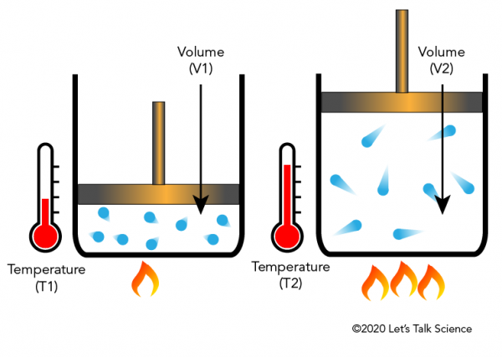

Image describing Charles’s law

This equation implies that the temperature is directly proportional to the volume. Thus, since Lake St. Clair has a significantly smaller volume as compared to the other lakes, its temperature will be lower.

Question 5 and 6

**Code:**

In this problem, the objective is to calculate the average summer/winter temperatures of the six lakes. This was done with the use of arrays, loops, and equations. Firstly, a for loop was initialized under the condition of the specified season (summer is i=171; i<265, winter is i=0; i<79 and i=354; i<366). Inside the loop the elements of each array under the specified set of days were summed using the equation ‘+=’. Each sum was recorded as a predefined variable. Next the sum was divided by the total number of days. Finally, the results were printed using a printf statement. This process was repeated for both winter and summer averages.

**Analysis:**

The results of questions 5 and 6 are not in the same order as the results of question 2. However, these results are reasonable because of the various properties of each lake. The temperature of each lake is proportional to the volume as discussed in the previous question. Since Lake St. Clair has the smallest volume, its temperature fluctuates as the seasons change. Additionally, the surroundings and location of each lake also have an effect of the temperature. The further north the lake is, the colder it will be and the further south the lake is, the warmer it will be. There are also other numerous factors such as wind currents, land masses, sunlight/solar radiation, heat transfer, climate change, etc. Therefore, the results of questions 5 and 6 and scientifically justified.

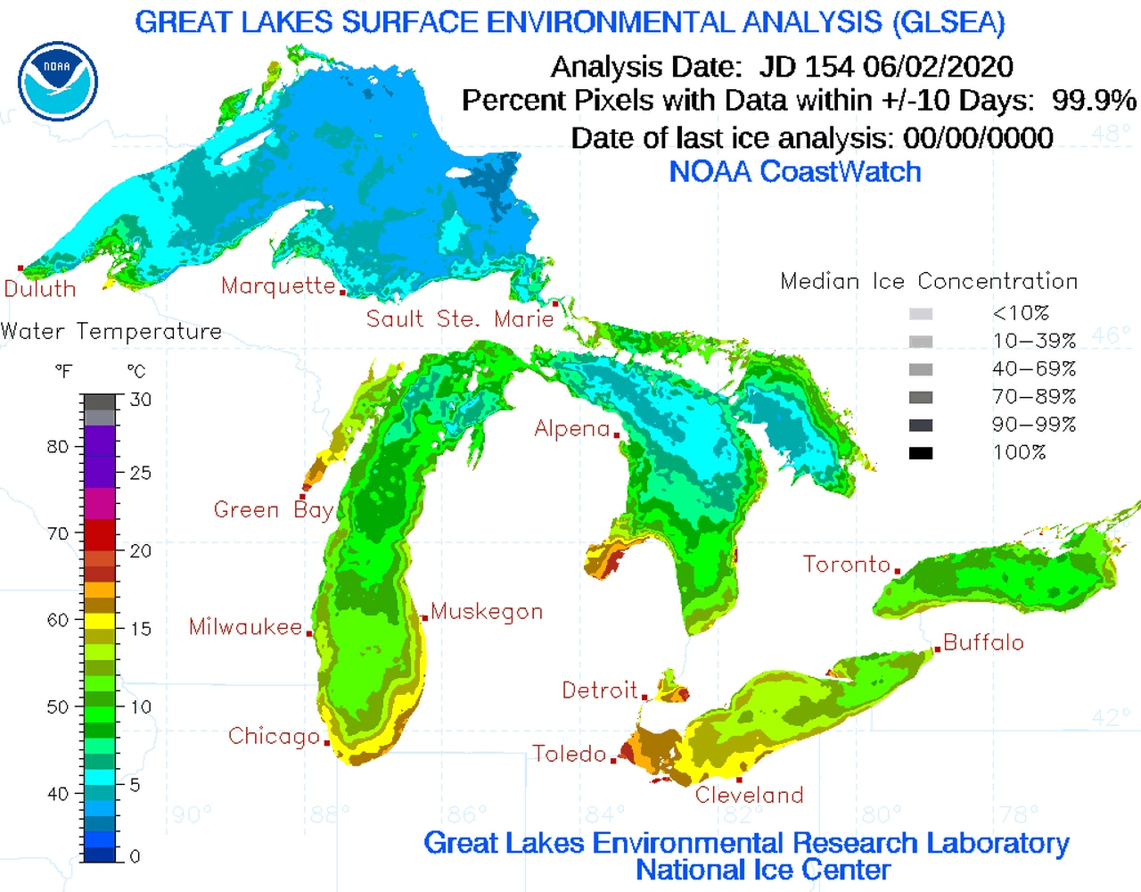

Image analyzing the temperatures of the five great lakes

Question 7 and 8

**Code:**

In this question, the objective is to determine how many days a human being can swim in the lakes (assuming the minimum temperature someone can swim in is 20 degrees) or how many days of the year the lakes are frozen (knowing that the freezing point of water is 0 degrees). At first glance, this problem suggests the use of comparison statements, which in C is best described as if statements. This problem also made use of loops and arrays. Firstly, a for loop was initialized under the condition of (i=0; i<366) so that the process would be repeated for all days in the year. Next, using the arrays defined in an earlier problem, each element was individually compared to 20 degrees or 0 degrees using if statements (lake[i] < 0 or lake[i] < 20). The numbers of days that met these conditions were recorded and the results were printed using the printf statement.

**Analysis:**

The results of question 7 provides the number of days where the lakes are comfortable and safe to swim in and question 8 suggest that the lakes are never frozen at any time throughout the year. Based on the results of the previous questions, it is already known that Lake Superior is the coldest lake on average and the coldest temperature recorded is 0.20 degrees which was the temperature of Lake St. Clair on January 22nd.

The results of question 7 are reasonable since the order of the days where someone can swim in the lake is similar to the order of the lakes temperatures. From previous results, it was observed that Lake Superior is the coldest lake on average and therefore has no days where someone can comfortably swim in the lake. Lake Erie was observed to be the highest temperature lake on average and therefore has the most days where someone can comfortably swim in the lake.

As for question 8, based on the physical properties of water (), the freezing point is experimentally determined to be 0 degrees Celsius. This is the case because at that certain temperature the water molecules begin to slow down and the particles being to form tight bonds with one another. Thus, the liquid beings to crystalize and therefore turning into its solid state. Since the temperature did not go below zero degrees at any point in time throughout the year for any of the six lakes, the results of question 8 are justified.

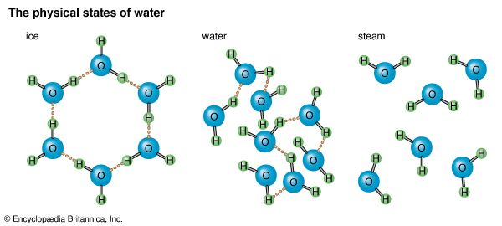

Image of the physical states of water

Conclusion

In conclusion, this assignment was very informative and helpful in understand the C-programming language. The usage of various algorithms and functions provided a diverse and broad understanding of the content of this course. In the future, it may be interesting to consider using arrays throughout question 1 and 2 similar to the algorithm followed throughout the other questions. Another aspect to consider is to also use string arrays throughout the code to provide a more efficient and faster response code. The use of string arrays would also reduce the size of the code by removing the need of multiple for loops. All in all, this assignment was an enjoyable project as it was informative, collaborative, and engaging to work on.

References

NASA. “What Is the Greenhouse Effect?” *Climate Change: Vital Signs of the Planet*, climate.nasa.gov/faq/19/what-is-the-greenhouse-effect/#:~:text=The%20greenhouse%20effect%20is%20the,it%20would%20be%20without%20them.‌

“Water Temperature.” *Environmental Measurement Systems*, www.fondriest.com/environmental-measurements/parameters/water-quality/water-temperature/#:~:text=Water%20temperature%20can%20be%20affected.

“The Greenhouse Effect.” *Climatecentral.org*, 9 Jan. 2019, medialibrary.climatecentral.org/resources/the-greenhouse-effect.

“Map of the Great Lakes.” *Geology.com*, geology.com/maps/lakes/great-lakes/.

‌

NASA. “What Causes the Seasons? | NASA Space Place – NASA Science for Kids.” *Nasa.gov*, 2016, spaceplace.nasa.gov/seasons/en/.

“Charles’ Law and Gay-Lussac’s Law.” *Let’s Talk Science*, 20 Jan. 2020, letstalkscience.ca/educational-resources/backgrounders/charles-law-and-gay-lussacs-law.

‌

“Great Lakes Water Temperatures Starting to Warm, but Lake Superior Still in 30s.” *Mlive*, 3 June 2020, www.mlive.com/weather/2020/06/great-lakes-water-temperatures-starting-to-warm-but-lake-superior-still-in-30s.html. Accessed 1 Apr. 2022.

‌ “Physical States of Water.” *Britannica Kids*, kids.britannica.com/kids/assembly/view/54121. Accessed 1 Apr. 2022.

Appendix

Introduction …………………………………………………………………….....2

Problems. ……………………………………………………………………….... 2

Question 1 and 9……………………………………………………………….2

Question 2…………………………………………………………………….4

Question 3…………………………………………………………………….6

Question 4…………………………………………………………………….7

Question 5 and 6…………………………………………………………….....9

Question 7 and 8………………………………………………………...…….10

Conclusion.. …………………………………………………………………….....12

References.. ……………………………………………………………………….13