5 Ways to Manage Your Kubernetes Resource Usage
https://www.replex.io/blog/5-ways-to-manage-your-kubernetes-resource-usage

Why you should care about Kubernetes resources
Containers and pods deploy on the underlying cloud on on-premise infrastructure, consuming resources in the process. As environments scale, resource usage increases and costs go up. Inefficiencies in the shape of over-capacity also creep in, driving costs up even more. Both IT managers and ops teams need to keep an eye on Kubernetes resource usage to ensure their production environments are cost-effective, optimized and run seamlessly.
What are Kubernetes resources?
There are two types of resources in Kubernetes; CPU and Memory. CPU can refer to 1 AWS vCPU, 1 Azure core or corresponding abstractions on other cloud providers or physical infrastructure.
For reference, an m5.xlarge AWS instance has four vCPUs. Kubernetes, however, doesn't stop there; vCPU's can be broken down further into discrete bits of compute called millicpu. Memory is measured in units of bytes. An m5.xlarge AWS instance has 16 GiB of memory.
Kubernetes resource usage
Kubernetes resource usage refers to the amount of resources that are consumed by a container or pod in a production Kubernetes environment.
One obvious reason for this is cost. Since Kubernetes resources are abstractions on the underlying compute infrastructure (AWS, Azure, bare-metal), usage translates into cost. Monitoring kubernetes resource usage for containers and pods is also important for cost allocation efforts.
Resource utilization
Resource usage is also an important indicator of how optimized your Kubernetes environment is. Ideally, ops teams would want to maximize the percentage of resources consumed by pods, of the total amount of resources available on the cluster.
An easy way of thinking about optimizing Kubernetes resource usage is in terms of cloud provider instances. Let's assume you have a fleet of containers leveraging an m5.xlarge instance on AWS. This particular AWS instance has four vCPUs, which translate into 4000 millicores or millicpu on Kubernetes. An optimized Kubernetes environment is one in which the average CPU usage of the containers running on this instance is close to 4000 millicores.
Resource contention and deficiency
Kubernetes, like all shared systems, also has an inherent risk of resource contention between containers or pods running on a single machine. By default (and rushed devs), containers are provisioned without any limits on the amount of resources they can consume.
Since there are no limits on resource consumption, containers can hog cluster resources, when they exceed their regular resource consumption patterns. This leads to resource deficiency with other pods/containers not having enough resources to run.
Pods can also fail to run because nodes on your cluster do not have enough resources to run them. Keeping track of resource usage on specific nodes or clusters and ensuring there are enough resources on individual nodes to support them is also important.
How do I manage my Kubernetes resources?
There are a number of Kubernetes features and open source tools that can help you manage and optimize resource usage.
1. Resource request vs limit
One handy way of managing Kubernetes resources is to use resource requests and limits. Resource requests and limits allow you to allocate discrete bits of compute and memory to each container.
Resource request are the amount of resources being requested for a container. Kubernetes will ensure that the requested amount of resources are reserved for that specific container. Resource limits, on the other hand are the maximum amount of resources that can be consumed by the container. Container level resource requests and limits add up to pod resource requests and limits.
Decisions about resource requests and limits are hard to make in the absence of any historical data about resource usage patterns of containers. Manual allocation of resource requests and limits can lead to bloated pods, using only a fraction of the total resources allocated.

Resource types
CPU and memory are each a resource type. A resource type has a base unit. CPU is specified in units of cores, and memory is specified in units of bytes. If you’re using Kubernetes v1.14 or newer, you can specify huge page resources. Huge pages are a Linux-specific feature where the node kernel allocates blocks of memory that are much larger than the default page size.
For example, on a system where the default page size is 4KiB, you could specify a limit, hugepages-2Mi: 80Mi. If the container tries allocating over 40 2MiB huge pages (a total of 80 MiB), that allocation fails.
Note: You cannot overcommit hugepages-* resources. This is different from the memory and cpu resources.
CPU and memory are collectively referred to as compute resources, or just resources. Compute resources are measurable quantities that can be requested, allocated, and consumed. They are distinct from API resources. API resources, such as Pods and Services are objects that can be read and modified through the Kubernetes API server.
Resource requests and limits of Pod and Container
Each Container of a Pod can specify one or more of the following:
- spec.containers[].resources.limits.cpu
- spec.containers[].resources.limits.memory
- spec.containers[].resources.limits.hugepages-<size>
- spec.containers[].resources.requests.cpu
- spec.containers[].resources.requests.memory
- spec.containers[].resources.requests.hugepages-<size>
Although requests and limits can only be specified on individual Containers, it is convenient to talk about Pod resource requests and limits. A Pod resource request/limit for a particular resource type is the sum of the resource requests/limits of that type for each Container in the Pod.

Meaning of CPU
Limits and requests for CPU resources are measured in cpu units. One cpu, in Kubernetes, is equivalent to:
- 1 AWS vCPU
- 1 GCP Core
- 1 Azure vCore
- 1 IBM vCPU
- 1 Hyperthread on a bare-metal Intel processor with Hyperthreading
Fractional requests are allowed.
A Container with spec.containers[].resources.requests.cpu of 0.5 is guaranteed half as much CPU as one that asks for 1 CPU. The expression 0.1 is equivalent to the expression 100m, which can be read as “one hundred millicpu”. Some people say “one hundred millicores”, and this is understood to mean the same thing. A request with a decimal point, like 0.1, is converted to 100m by the API, and precision finer than 1m is not allowed. For this reason, the form 100m might be preferred.
CPU is always requested as an absolute quantity, never as a relative quantity; 0.1 is the same amount of CPU on a single-core, dual-core, or 48-core machine.

Meaning of memory
Limits and requests for memory are measured in bytes. You can express memory as a plain integer or as a fixed-point integer using one of these suffixes: E, P, T, G, M, K. You can also use the power-of-two equivalents: Ei, Pi, Ti, Gi, Mi, Ki. For example, the following represent roughly the same value:
128974848, 129e6, 129M, 123Mi
Here’s an example. The following Pod has two Containers. Each Container has a request of 0.25 cpu and 64MiB (226 bytes) of memory. Each Container has a limit of 0.5 cpu and 128MiB of memory. You can say the Pod has a request of 0.5 cpu and 128 MiB of memory, and a limit of 1 cpu and 256MiB of memory.

apiVersion: v1
kind: Pod
metadata:
name: frontend
spec:
containers:
- name: db
image: mysql
env:
- name: MYSQL_ROOT_PASSWORD
value: "password"
resources:
requests:
memory: "64Mi"
cpu: "250m"
limits:
memory: "128Mi"
cpu: "500m"
- name: wp
image: wordpress
resources:
requests:
memory: "64Mi"
cpu: "250m"
limits:
memory: "128Mi"
cpu: "500m"

How Pods with resource requests are scheduled
When you create a Pod, the Kubernetes scheduler selects a node for the Pod to run on. Each node has a maximum capacity for each of the resource types: the amount of CPU and memory it can provide for Pods. The scheduler ensures that, for each resource type, the sum of the resource requests of the scheduled Containers is less than the capacity of the node. Note that although actual memory or CPU resource usage on nodes is very low, the scheduler still refuses to place a Pod on a node if the capacity check fails. This protects against a resource shortage on a node when resource usage later increases, for example, during a daily peak in request rate.

How Pods with resource limits are run
When the kubelet starts a Container of a Pod, it passes the CPU and memory limits to the container runtime.
When using Docker:
The spec.containers[].resources.requests.cpu is converted to its core value, which is potentially fractional, and multiplied by 1024. The greater of this number or 2 is used as the value of the --cpu-shares flag in the docker run command.
The spec.containers[].resources.limits.cpu is converted to its millicore value and multiplied by 100. The resulting value is the total amount of CPU time that a container can use every 100ms. A container cannot use more than its share of CPU time during this interval.
Note: The default quota period is 100ms. The minimum resolution of CPU quota is 1ms.
The spec.containers[].resources.limits.memory is converted to an integer, and used as the value of the --memory flag in the docker run command.
If a Container exceeds its memory limit, it might be terminated. If it is restartable, the kubelet will restart it, as with any other type of runtime failure.
If a Container exceeds its memory request, it is likely that its Pod will be evicted whenever the node runs out of memory.
A Container might or might not be allowed to exceed its CPU limit for extended periods of time. However, it will not be killed for excessive CPU usage.

2. Resource quotas and limit ranges for Namespaces
One way to avoid bloated pods with a larger resource footprint than required is to set resource requests and limits on a namespace level. Namespaces are virtual partitions of your Kubernetes clusters that are allocated to specific services and teams.
Resource quotas allow you to set resource requests and limits as a whole for all the containers inside that namespace.
You can also control the maximum amount of resources that can be allocated to individual containers inside a namespace, using Limit range.
Resource quotas and limit ranges ultimately run into the same problem; resources have to be allocated using a combination of guess work and approximations.
3. Cluster Autoscaler
The cluster autoscaler is an open source tool that can be used to resize individual clusters, based on resource requirements and usage. The cluster autoscaler adds nodes to a cluster whenever a pod fails to run on that cluster due to resource deficiencies. It can also remove nodes whenever they are underutilized.
4. Horizontal pod autoscaling
Horizontal pod autoscaling (HPA) is a Kubernetes feature which automatically adds or removes pod replicas from Kubernetes replication controllers, based on resource utilization metrics. These include replica sets, deployments and replication controller. HPA makes scaling decisions based on Kubernetes metrics like CPU as well as custom defined metrics.
5. Vertical pod autoscaling
Kubernetes also recently introduced vertical pod autoscaling (VPA). The vertical pod autoscaler (which is still in alpha) has two functions: automate the process of reserving pod resources and improving cluster resource utilization.
VPA monitors pod utilization and OOM (out of memory) events and comes up with recommended resource request amounts for individual pods. Recommended resource requests can then be applied to newly created pods.
Updates can also be applied to already existing pods, however, to do this they have to be terminated first. Pods can then be re-started with the updated resource requests. It is important to note that VPA only controls the resource requests and sets the limits to infinity.
https://www.replex.io/blog/kubernetes-in-production-the-ultimate-guide-to-monitoring-resource-metrics
Kubernetes in Production: The Ultimate Guide to Monitoring Resource Metrics with Prometheus

Why Monitor Kubernetes Resource Metrics in Production?
Every Kubernetes administrator has stumbled across the “Failed Scheduling No nodes are available that match all of the following predicates:: Insufficient memory” or “Failed Scheduling No nodes are available that match all of the following predicates:: Insufficient CPU” error message.
It is obvious that these errors are caused by insufficient CPU or memory resources. Such issues can be avoided by having a real-time view of resource usage and availability for individual nodes or pods.
Monitoring Kubernetes is also important in the context of resource usage, utilization and cost control. Kubernetes clusters have to be actively managed to ensure pods utilize underlying node resources efficiently. The same is true of resources allocated to individual containers or namespaces.
Below we will review some best practices for monitoring Kubernetes resource metrics in production. We will go through the entire process of setting up the tools required, choosing which metrics to monitor as well as deploying dashboards.

Which Resource Metrics Should I be Monitoring?
The Utilization Saturation and Errors (USE) Method gives us an idea of the performance metrics we should be tracking for Kubernetes in production. The USE method was developed by Brendann Egg to analyze the performance of any system in production. It recommends tracking utilization, saturation and errors for all resources.
We can start with OS and hardware metrics exposed by the underlying Linux kernels of the containers running inside Kubernetes clusters. However, tracking resource metrics for OS and hardware is not enough in the Kubernetes context. For these metrics to be meaningful we need to co-relate them to Kubernetes primitives.
Kubernetes introduces a number of abstractions that we need to consider when choosing which metrics to track in production. These are abstractions on both the hardware as well as software layer including nodes, pods, containers, namespaces and clusters.
The resource management model of Kubernetes also has to be considered. Kubernetes has two types of resources that can be consumed by containers: CPU and memory. Container resource consumption can be managed using resource requests and resource limits. Resource requests are the minimum amount of resources requested for containers, limits, on the other hand, are the maximum amount that can be consumed by containers.
Bringing all of these concepts together results in the following exhaustive list of resource metrics that we can monitor in production. The list takes into consideration both OS and hardware metrics as well as the specific hardware and software abstractions introduced by Kubernetes and the resource management model.
Below is the list with brief descriptions of each resource metric:
Resource Metric | Description
Kubernetes Container CPU and Memory Usage | Containers are the building blocks of containerized applications. Container CPU usage refers to the amount of CPU resources consumed by containers in production. Memory usage is the measure of memory resources consumed. CPU resources are measured in CPU cores while memory is measured in bytes
Kubernetes Pod CPU and Memory Usage | Pods are collections of containers and as such pod CPU usage is the sum of the CPU usage of all containers that belong to a pod. Similarly, pod memory usage is the total memory usage of all containers belonging to the pod
Kubernetes Node CPU and Memory Usage | Node CPU usage is the number of CPU cores being used on the node by all pods running on that node. Similarly node memory usage is the total memory usage of all pods
Kubernetes Namespace CPU and Memory Usage | Namespace resource usage is the sum of CPU or memory usage of all pods that belong to that namespace
Kubernetes Cluster CPU and Memory Usage | The sum of CPU or memory usage of all pods running on nodes belonging to the cluster gives us the CPU or memory usage for the entire cluster
Kubernetes Container CPU and Memory Requests | You can think of container resource requests as a soft limit on the amount of CPU or memory resources a container can consume in production
Kubernetes Pod CPU and Memory Requests | The sum of CPU or memory requests of all containers belonging to a pod
Kubernetes Node CPU and Memory Requests | Node CPU requests are a sum of the CPU requests for all pods running on that node. Similarly, node memory requests are a sum of memory requests of all pods
Kubernetes Namespace CPU and Memory Requests | The sum of CPU or memory requests of all pods belonging to a namespace
Kubernetes Cluster CPU and Memory Requests | Sum of CPU requests or memory requests for all pods running on nodes belonging to a cluster
Kubernetes Container CPU and Memory Limits | Container CPU limits are a hard limit on the amount of CPU a container can consume in production. Memory limits are the maximum amount of bytes that a container can consume in production
Kubernetes Pod CPU and Memory Limits | The sum of CPU or memory limits for all containers belonging to a pod
Kubernetes Node CPU and Memory Limits | Node CPU limits are the sum of CPU limits for all pods running on that specific node. Node memory limits on the other hand, are a sum of the memory limits of all pods
Kubernetes Namespace CPU and Memory Limits | Sum of CPU or memory limits of all pods belonging to a namespace
Kubernetes Cluster CPU and Memory Limits | Sum of CPU or memory limits for all pods running on nodes belonging to a cluster
Kubernetes Resource Capacity | In cloud environments, Kubernetes nodes usually refer to cloud provider instances. Node CPU capacity is the total number of CPU cores on the node. Node memory capacity is the total number of bytes available on the node. For example, an N1-standard-1 instance has 2 vCPUs and 3.75 GB of memory  Cluster CPU capacity is the sum of CPU capacities of all Kubernetes nodes that are part of the cluster. Cluster memory capacity is the sum of memory capacities of all nodes belonging to the cluster. For example a cluster with 4 N1-standard-1 instances has 8vCPUs and 15 GB of memory
Kubernetes CPU and Memory Request Commitment (Resource Requests vs Capacity) | CPU request commitment is the ratio of CPU requests for all pods running on a node to the total CPU available on that node. In the same way, memory commitment is the ratio of pod memory requests to the total memory capacity of that node. We can also calculate cluster level request commitment by comparing CPU/memory requests on a cluster level to total cluster capacity  Request commitments give us an idea of how much of the node or cluster is committed in terms of soft resource usage limits
Kubernetes CPU and Memory Limit Commitment (Resource Limits vs Capacity) | CPU limit commitment is the ratio of CPU limits for all pods running on a node to the total CPU available on that node. Similarly, memory commitment is the ratio of pod memory limits to the total memory capacity of that node. Cluster level limit commitments can be calculated by comparing total CPU/memory limits to cluster capacity  Limit commitments give us an idea of how much of the node or cluster is committed in terms of hard CPU and memory limits
Kubernetes Resource Utilization (Resource Usage vs Capacity) | With the emphasis on pay as you go billing models for cloud deployments, resource utilization is an important metric to monitor and has major implications for cost control  CPU utilization is the ratio of CPU resources being currently consumed by all pods running on a node to the total CPU available on that node. Memory utilization is the ratio of memory usage by all pods to the total memory capacity of that node  Cluster resource utilization will compare resource usage (both CPU and memory) for all pods with the total resource capacity of all nodes
Kubernetes Resource Saturation | Node CPU saturation is the measure of requests for CPU which cannot be fulfilled because of unavailability. Similarly, memory saturation on the node is a measure of the memory requests which cannot be met due to unavailability  Saturation on the cluster level can be calculated based on saturation numbers across all nodes.

Which Tools Can I Use to Monitor Kubernetes Metrics?
There are a number of tools that can be used to monitor Kubernetes in production. These include cAdvisor, Heapster, Prometheus, metrics-server and kube-state-metrics.
Monitoring Resource Metrics with Metrics-Server
Metrics-server allows us to query resource metrics using kubectl right from the command line. However, It gives us access to only some of the metrics outlined above.
Follow the steps below to install metrics-server in your kubernetes cluster.
git clone https://github.com/kubernetes-incubator/metrics-server
cd metrics-server/deploy
kubectl create -f 1.8+/
Once you do this, you will see an instance of the metrics-server running in the kube-system namespace
kubectl get pods -n kube-system
ubuntu@ip-172-31-4-214:~/kubernetes/metrics-server/deploy$ kubectl get pods -n kube-system
NAME READY STATUS RESTARTS AGE
coredns-bb49df795-87l5r 1/1 Running 4 6d9h
coredns-bb49df795-hqv9z 1/1 Running 4 6d9h
etcd-ip-172-31-4-214 1/1 Running 5 6d9h
kube-apiserver-ip-172-31-4-214 1/1 Running 5 6d9h
kube-controller-manager-ip-172-31-4-214 1/1 Running 5 6d9h
kube-flannel-ds-amd64-2nhqm 1/1 Running 6 6d9h
kube-flannel-ds-amd64-dldbz 1/1 Running 5 6d9h
kube-flannel-ds-amd64-zf4pr 1/1 Running 5 6d9h
kube-proxy-m7gqv 1/1 Running 4 6d9h
kube-proxy-w4m6g 1/1 Running 5 6d9h
kube-proxy-xllq6 1/1 Running 4 6d9h
kube-scheduler-ip-172-31-4-214 1/1 Running 5 6d9h
metrics-server-d7b78c5b5-c76zz 1/1 Running 0 79s
tiller-deploy-764b54d8d6-8s2t5 1/1 Running 1 23h
ubuntu@ip-172-31-4-214:~/kubernetes/metrics-server/deploy$

However, If you try to access the logs for the metrics-server using kubectl logs -n kube-system metrics-server-749b7b675d-xpkcj you might see the unable to fetch pod metrics for pod <namespace_name>/<pod_name> message.
You will also get the error message error: Metrics not available for pod <namespace_name>/<pod_name> if you query kubectl top pod from the command line.
To get around this edit the metrics-server deployment config
kubectl edit deploy -n kube-system metrics-server
and add the following under .spec.template.spec.containers
command:
- /metrics-server
- --kubelet-insecure-tls
https://stackoverflow.com/questions/54106725/docker-kubernetes-mac-autoscaler-unable-to-find-metrics
- Delete any previous instance of metrics-server from your Kubernetes instance with kubectl delete -n kube-system deployments.apps metrics-server
- Clone metrics-server with git clone https://github.com/kubernetes-incubator/metrics-server.git
- Edit the file deploy/1.8+/metrics-server-deployment.yaml to override the default command by adding a command section that didn't exist before. The new section will instruct metrics-server to allow for an insecure communications session (don't verify the certs involved). Do this only for Docker, and not for production deployments of metrics-server:
containers:
- name: metrics-server
image: k8s.gcr.io/metrics-server-amd64:v0.3.1
command:
- /metrics-server
- --kubelet-insecure-tls
- Add metrics-server to your Kubernetes instance with kubectl create -f deploy/1.8+(if errors with the .yaml, write this instead: kubectl apply -f deploy/1.8+)
- Remove and add the autoscaler to your deployment again. It should now show the current cpu usage.

Passing these flags should only be considered as a work-around for test clusters. In production Kubernetes environments you should consider setting up the node's serving certificates to list the internal IP as an alternate name.
Now we are ready to query resource metrics using kubectl from the command line. Let’s start with resource usage per pod.
Resource Metric: Kubernetes Pod Resource Usage
The following command will give us both the CPU usage as well as the memory usage for all pods in the default namespace.
kubectl top pod
To get the resource usage for pods in another namespace use
kubectl top pod --namespace=<namespace_name>
For example we can see the resource usage for all pods in kube-system namespace using:
kubectl top pod --namespace=kube-system
To see the CPU and memory usage for the individual containers of a pod use:
kubectl top pod <pod_name> --containers
kubectl top pod my-pod --containers
Resource Metric: Kubernetes Node Resource Usage
To get the CPU and memory usage for individual nodes use the following command
kubectl top node
We can also see the CPU and memory usage for individual nodes by specifying a node name:
kubectl top node <node_name>
kubectl top node nodes-c472
Monitoring Resource Metrics with Prometheus
Next we will look at Prometheus which has become something of a favourite among DevOps. We will install Prometheus using Helm and the Prometheus operator. The Prometheus operator is a Kubernetes specific project that makes it easy to set up and configure Prometheus for Kubernetes clusters.
Let’s first install Helm. To do that, head over here and download the latest version. I downloaded the helm-v2.11.0-linux-amd64.tar.gz version.
Next, unpack it:
tar -zxvf helm-v2.11.0-linux-amd64.tar.gz
Move it to your bin directory:
mv linux-amd64/helm /usr/local/bin/helm
Initialize helm and install tiller:
helm init
Create a service account:
kubectl create serviceaccount --namespace kube-system tiller
Bind the new service account to the cluster-admin role. This will give tiller admin access to the entire cluster:
kubectl create clusterrolebinding tiller-cluster-rule --clusterrole=cluster-admin --serviceaccount=kube-system:tiller
Deploy tiller and add the line serviceAccount: tiller to spec.template.spec:
kubectl patch deploy --namespace kube-system tiller-deploy -p '{"spec":{"template":{"spec":{"serviceAccount":"tiller"}}}}'
Now we are ready to install the Prometheus operator:
helm install --name prom-operator stable/prometheus-operator --namespace monitoring
This will create a separate namespace monitoring and will install the Prometheus operator in that namespace. It will also install Grafana, Kube-state-metrics and the Prometheus alert manager in the same namespace.
Once the Prometheus operator is installed we can forward the Prometheus server pod to a port on our local machine
kubectl port-forward -n monitoring prometheus-prom-operator-prometheus-o-prometheus-0 9090:9090
Access the Prometheus dashboard by navigating to http://localhost:9090
Need to enable tunnel as well to access it via a different server.
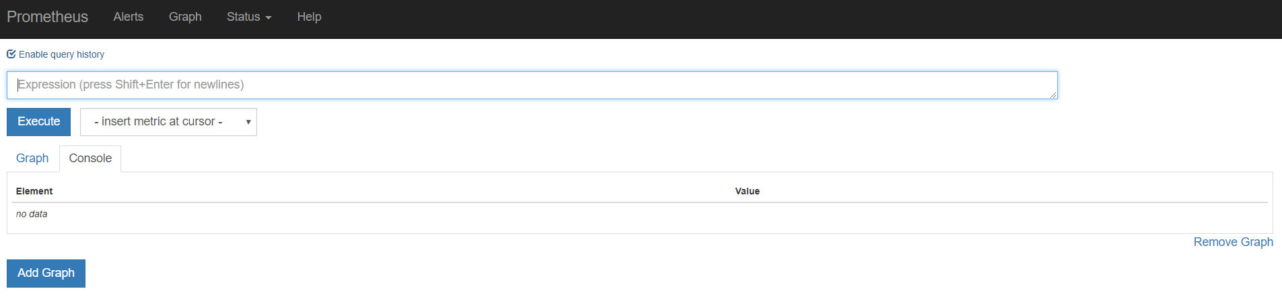
On the Prometheus dashboard, we can query metrics by typing them in the query field and pressing execute. Metrics can also be queried by choosing one from the drop down list shown below:
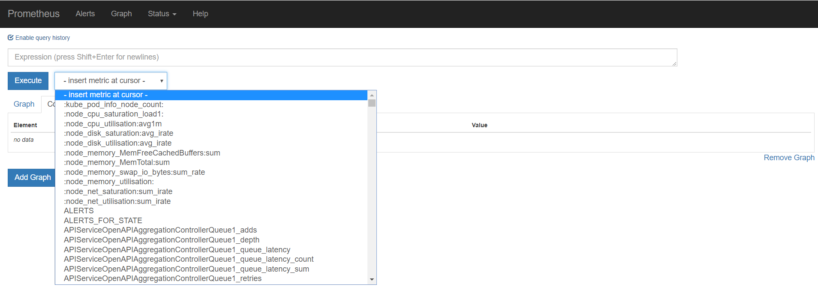
Now we are ready to start querying metrics. Below we will go through some of the resource metrics we identified earlier for containers, pods, namespaces, nodes and clusters. We will outline the metric name and the expression you can use in Prometheus to query it followed by a screenshot.
Resource Metric: Kubernetes CPU Usage
Expression:
sum(rate(container_cpu_usage_seconds_total{container_name!="POD",pod_name!=""}[5m]))
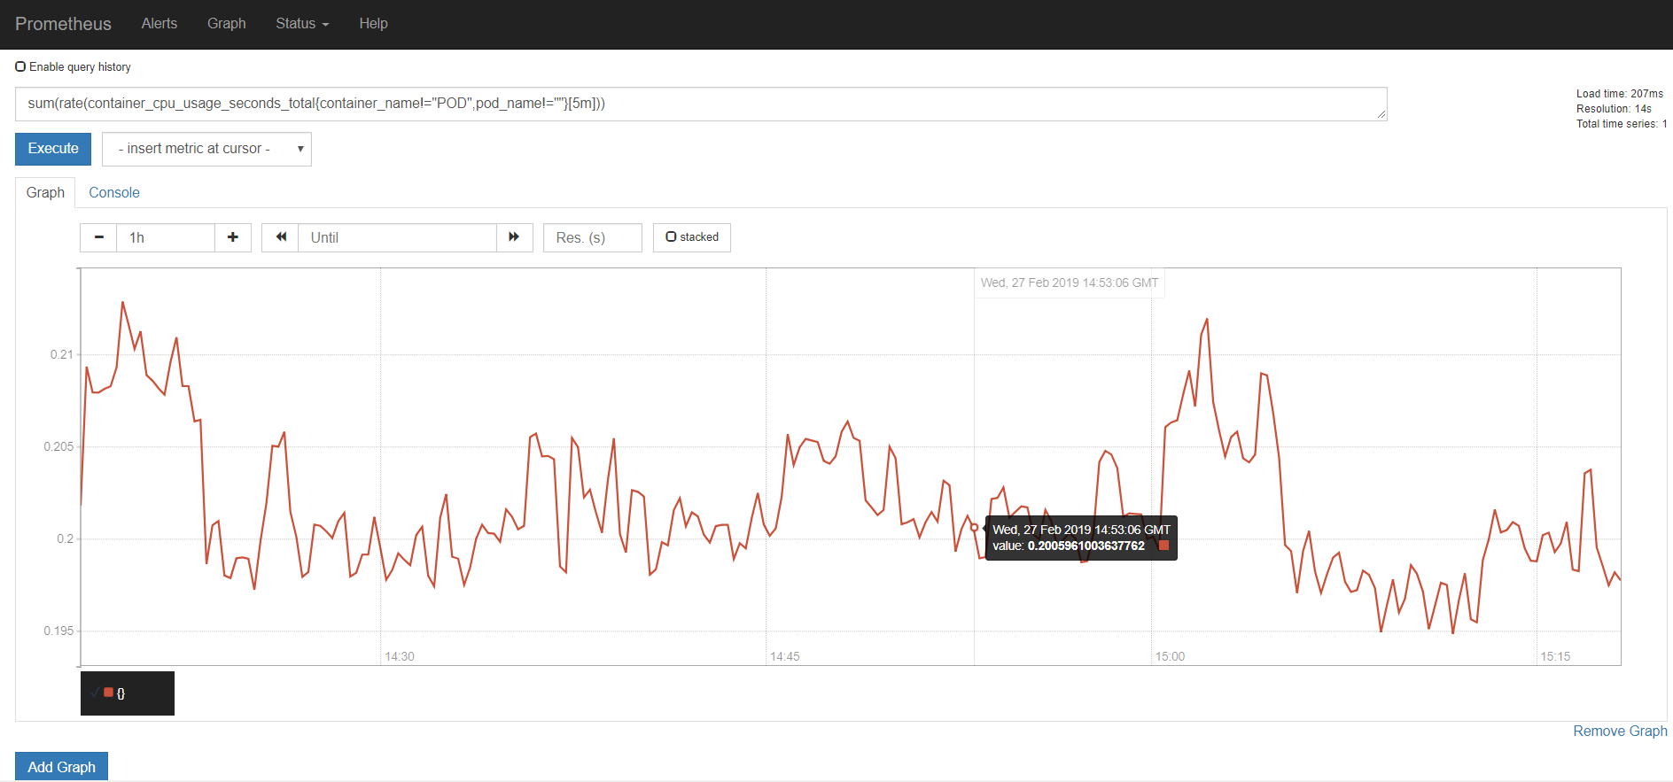
The screenshot above shows us the CPU usage for all pods belonging to the cluster.
Resource Metric: Kubernetes Container CPU usage
Expression:
rate(container_cpu_usage_seconds_total{container_name!="POD",pod_name!=""}[5m])
OR
sum(rate(container_cpu_usage_seconds_total{container_name!="POD",pod_name!=""}[5m])) by (container_name)
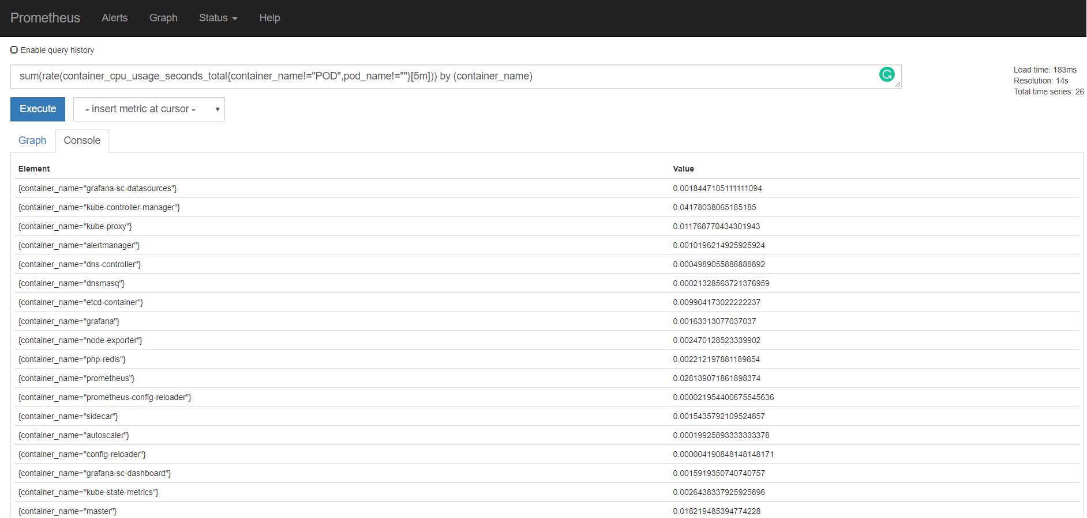
The first expression will show CPU usage for individual instances of each container. The second expression aggregates CPU usage for all containers with the same name.
Resource Metric: Kubernetes Pod CPU usage
Expression:
sum(rate(container_cpu_usage_seconds_total{container_name!="POD",pod_name!=""}[5m])) by (pod_name)
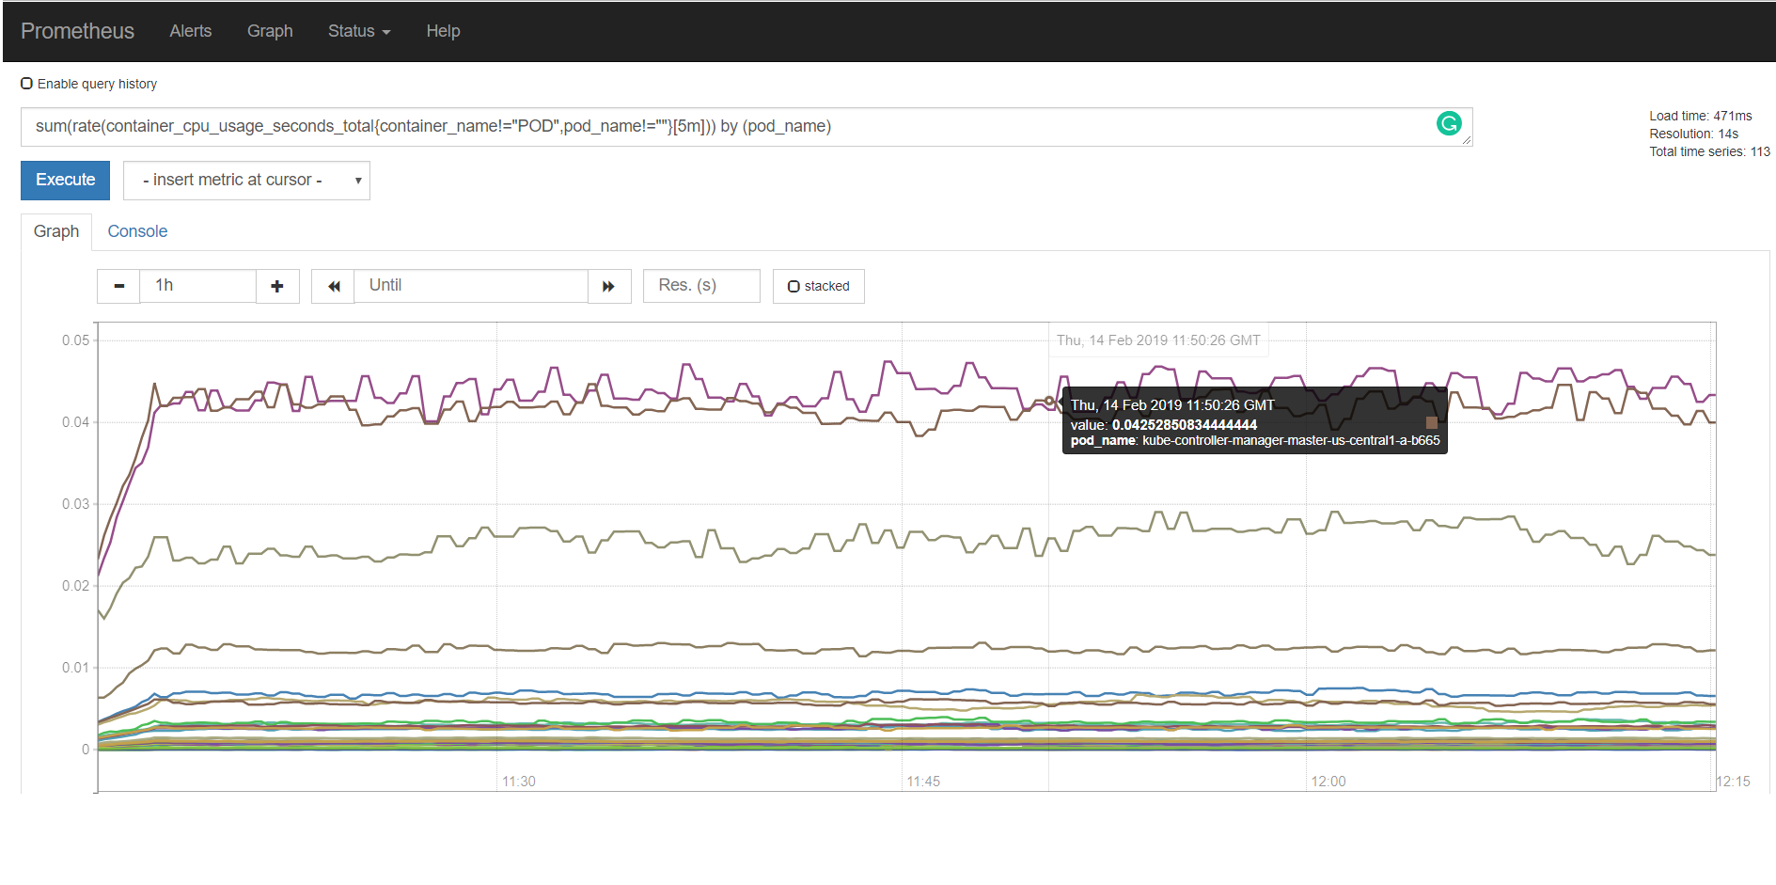The screenshot above shows the CPU usage for each individual pod. It is a sum of the CPU usage of each container belonging to the pod.
Resource Metric: Kubernetes Namespace CPU usage
Expression:
sum(rate(container_cpu_usage_seconds_total{container_name!="POD",namespace!=""}[5m])) by (namespace)
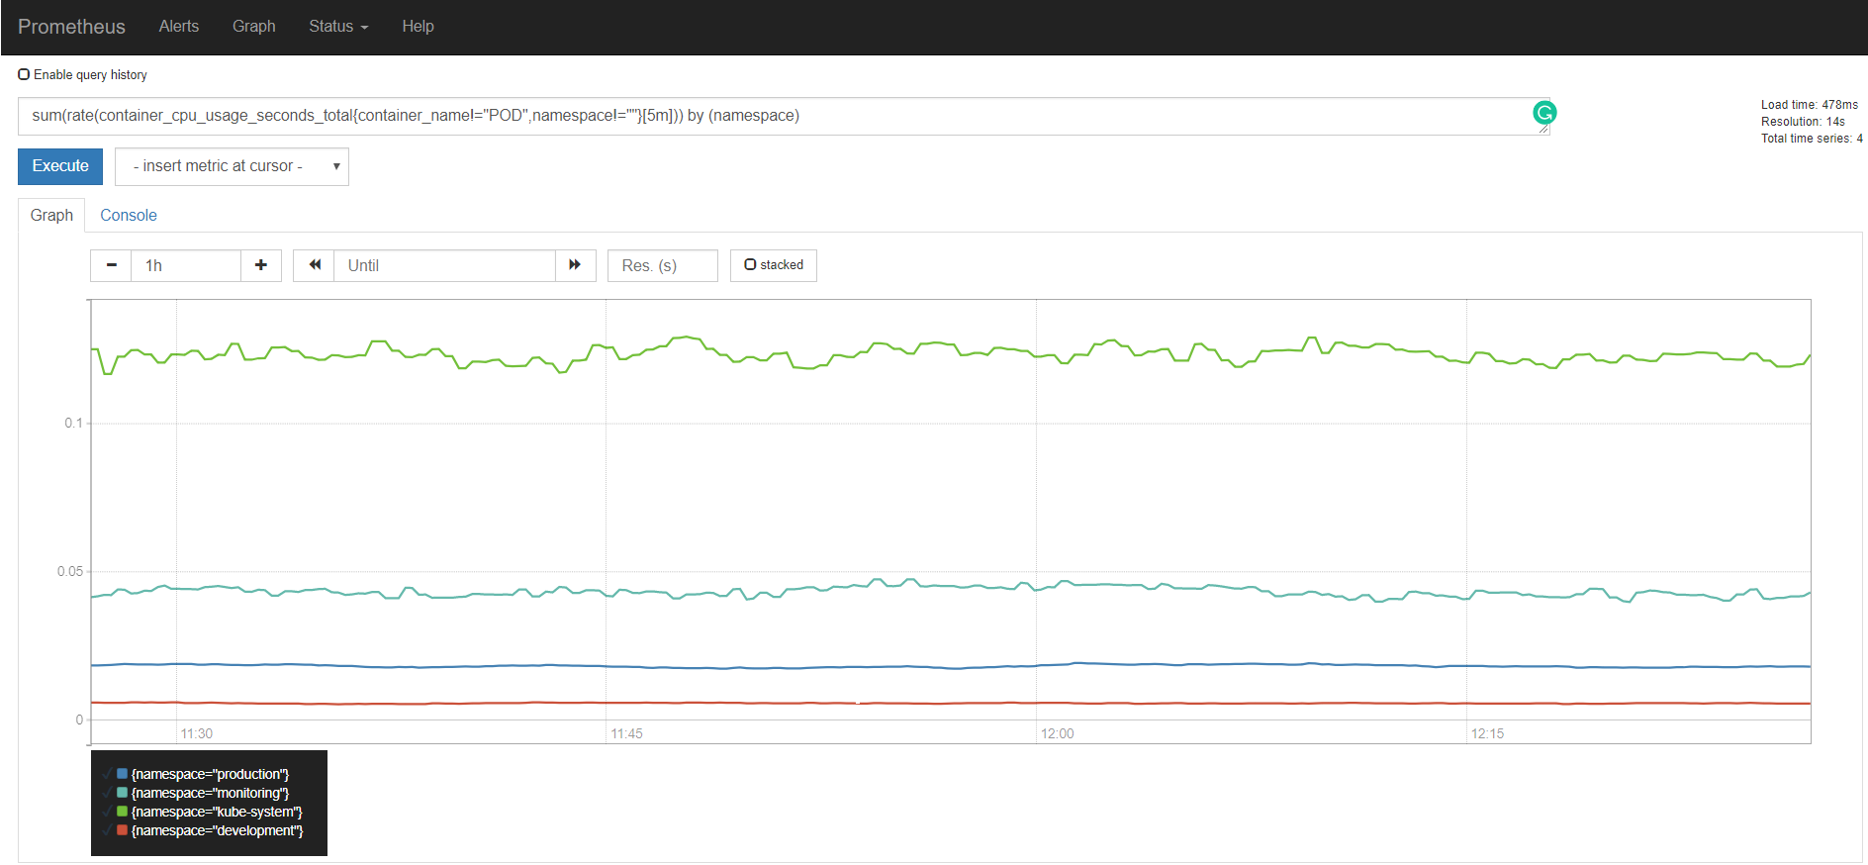
Resource Metric: Kubernetes CPU requests
Expression:
sum(kube_pod_container_resource_requests_cpu_cores)
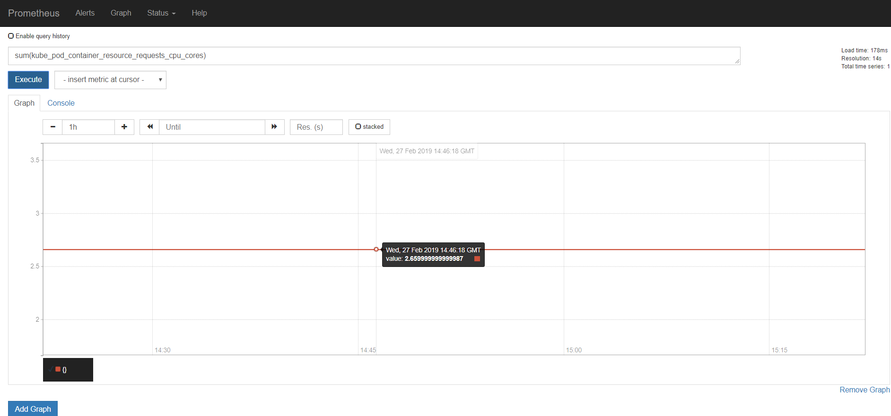
Resource Metric: Kubernetes Pod CPU requests
Expression:
sum(kube_pod_container_resource_requests_cpu_cores) by (pod)
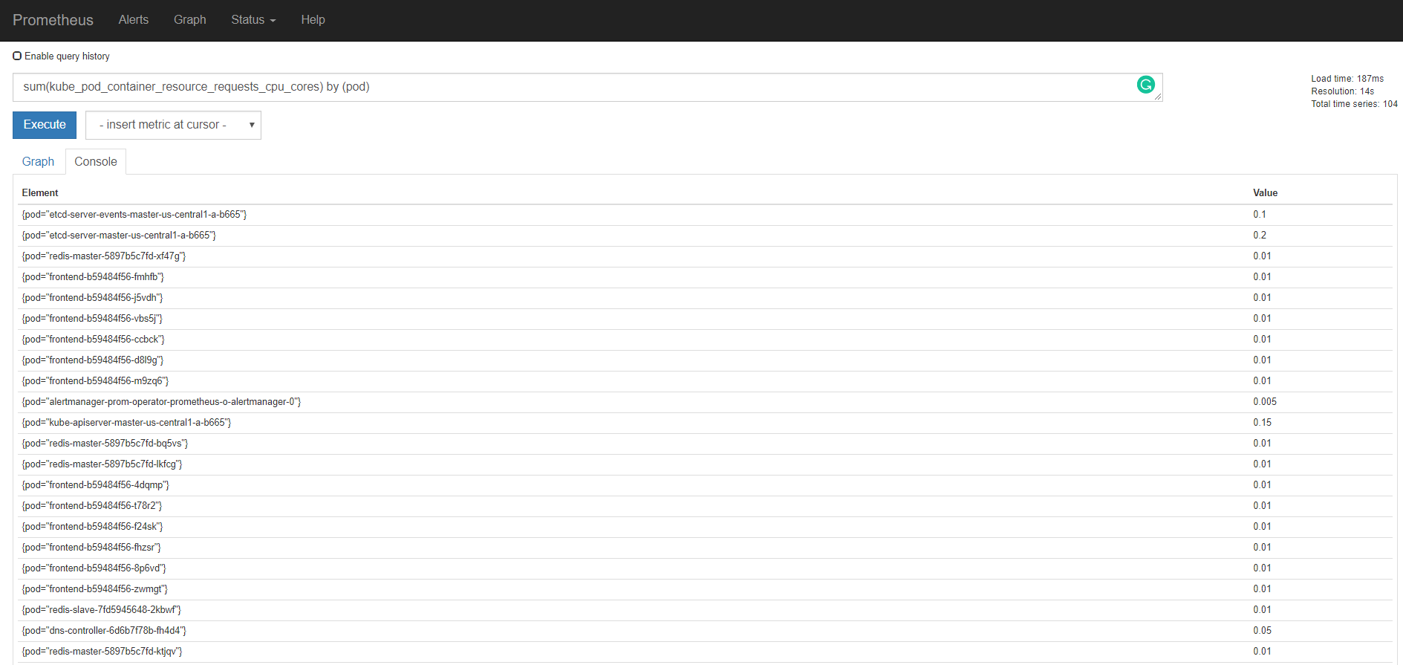
Resource Metric: Kubernetes Namespace CPU Requests
Expression:
sum(kube_pod_container_resource_requests_cpu_cores) by (namespace)
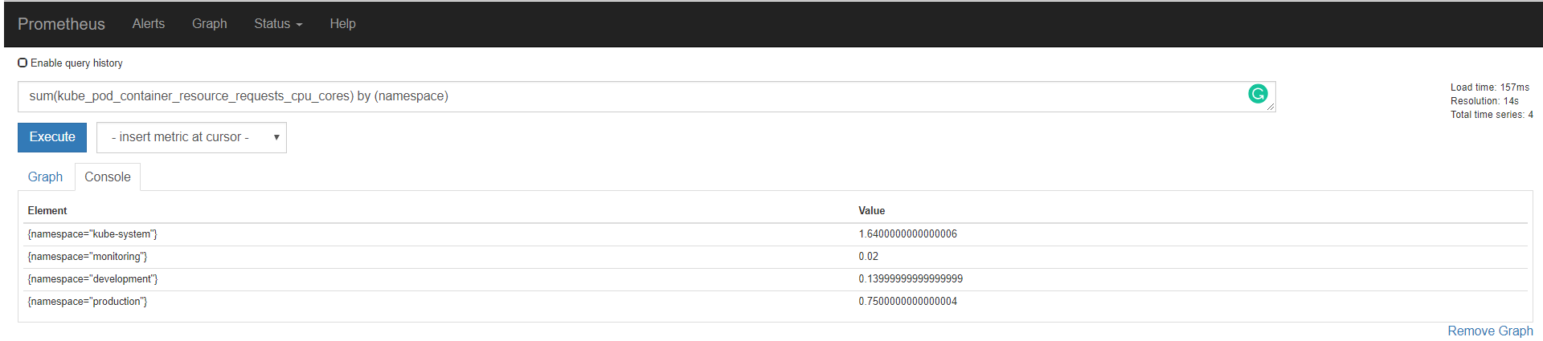
Resource Metric: Kubernetes CPU Limits
Expression:
sum(kube_pod_container_resource_limits_cpu_cores)
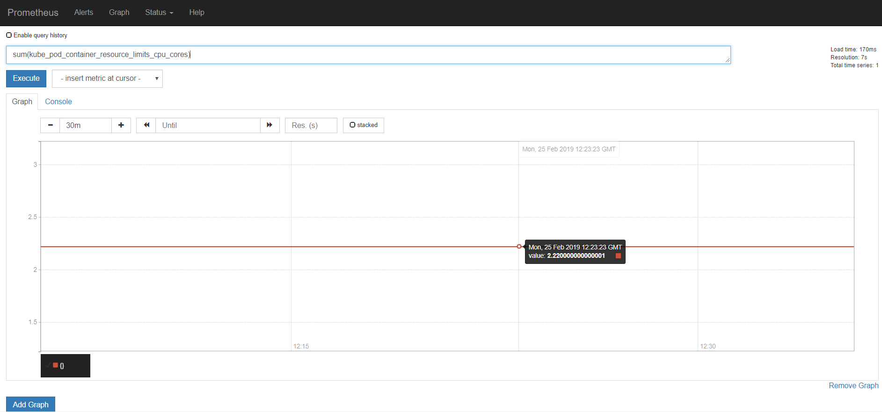
The screenshot above shows us the sum of CPU limits for all containers in the cluster.
Resource metric: Kubernetes Namespace CPU Limits
Expression:
sum(kube_pod_container_resource_limits_cpu_cores) by (namespace)
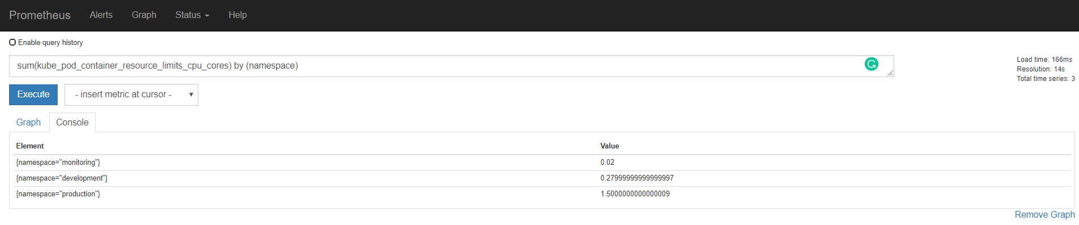
Resource Metric: Kubernetes CPU Request Commitment
Expression:
sum(kube_pod_container_resource_requests_cpu_cores) / sum(node:node_num_cpu:sum)*100
This will give us the CPU request commitment for the entire cluster.
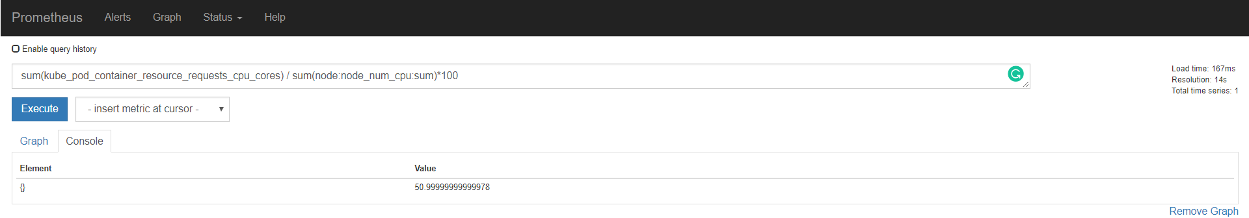
Resource Metric: Kubernetes Node CPU Request Commitment
Expression:
(sum(kube_pod_container_resource_requests_cpu_cores) by (node) / node:node_num_cpu:sum)*100
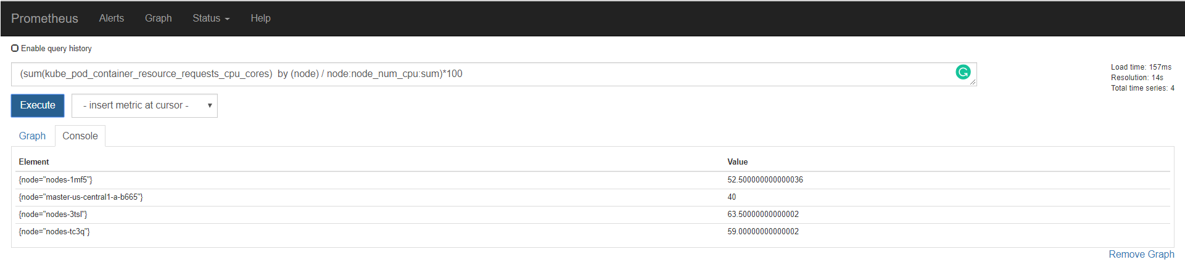
Resource Metric: Kubernetes CPU Saturation
Expression:
sum(node_load1) by (node) / count(node_cpu{mode="system"}) by (node)*100
This gives us the CPU saturation for the cluster.
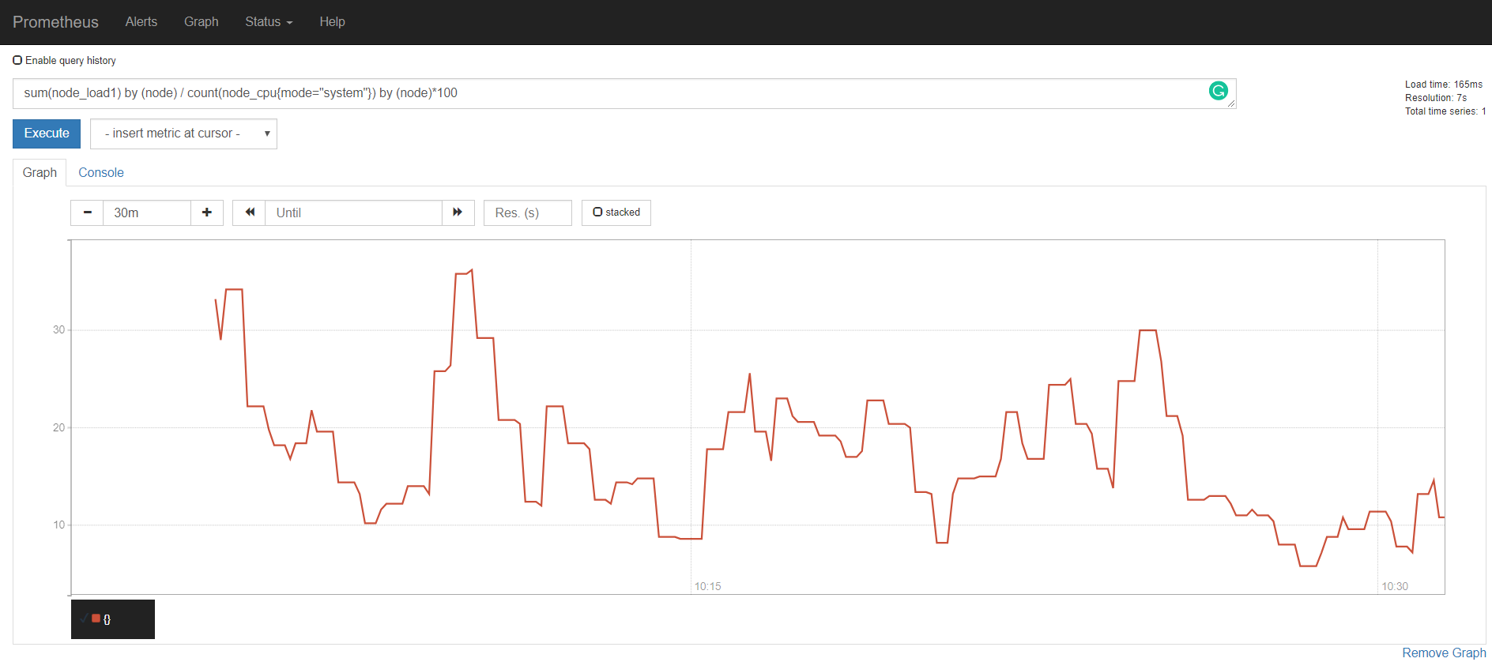
Resource Metric: Kubernetes Node CPU Saturation
Expression:
node:node_cpu_saturation_load1:
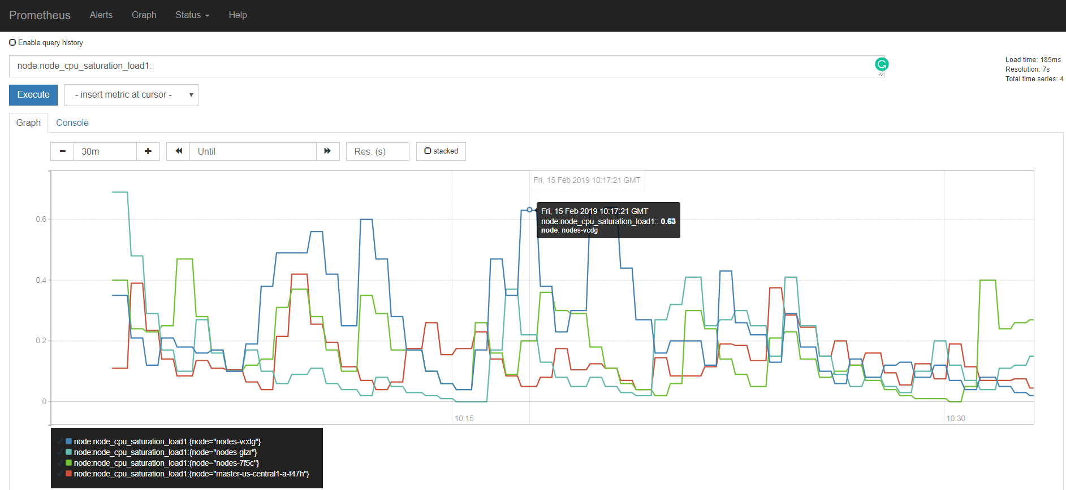
Resource Metric: Kubernetes Memory Usage
Expression:
sum(container_memory_usage_bytes{container_name!="POD",container_name!=""})
This will give us the total memory usage for all pods in the cluster
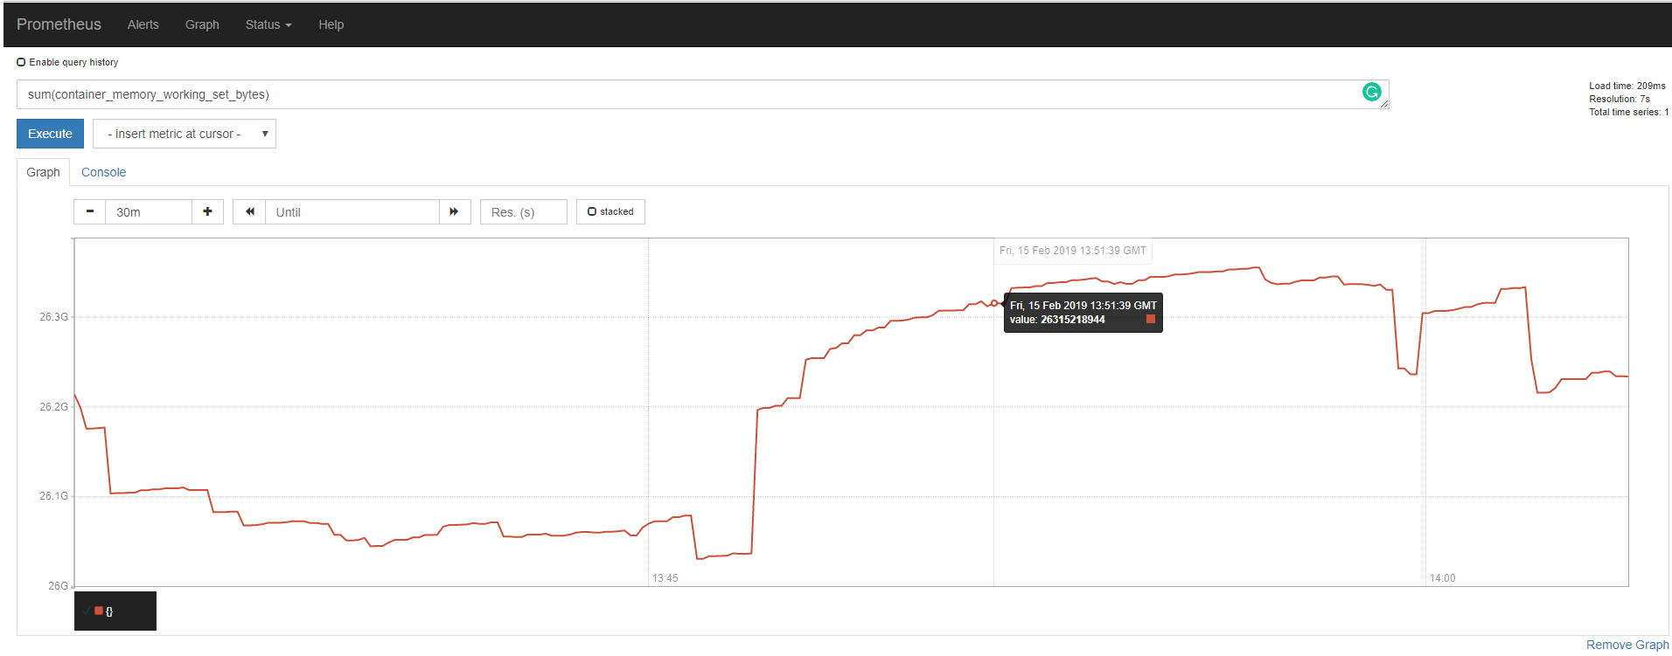
Resource Metric: Kubernetes Node Memory Usage
Expression:
sum(container_memory_usage_bytes{container_name!="POD",container_name!=""}) by (node)
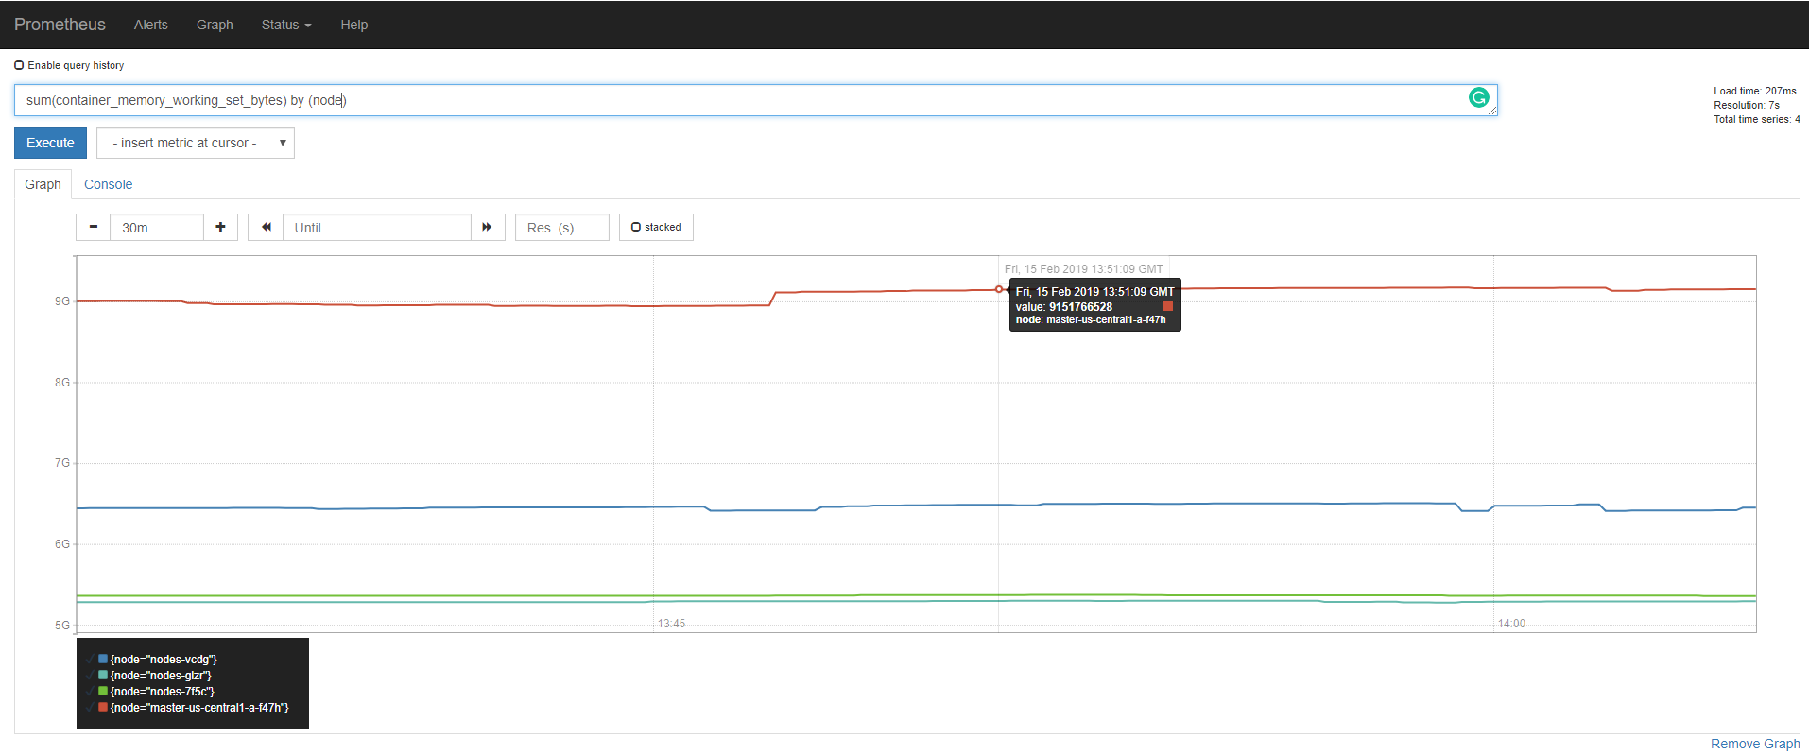
Resource Metric: Kubernetes Memory Requests
Expression:
sum(kube_pod_container_resource_requests_memory_bytes)
This will give us the total memory requests for all pods in the cluster
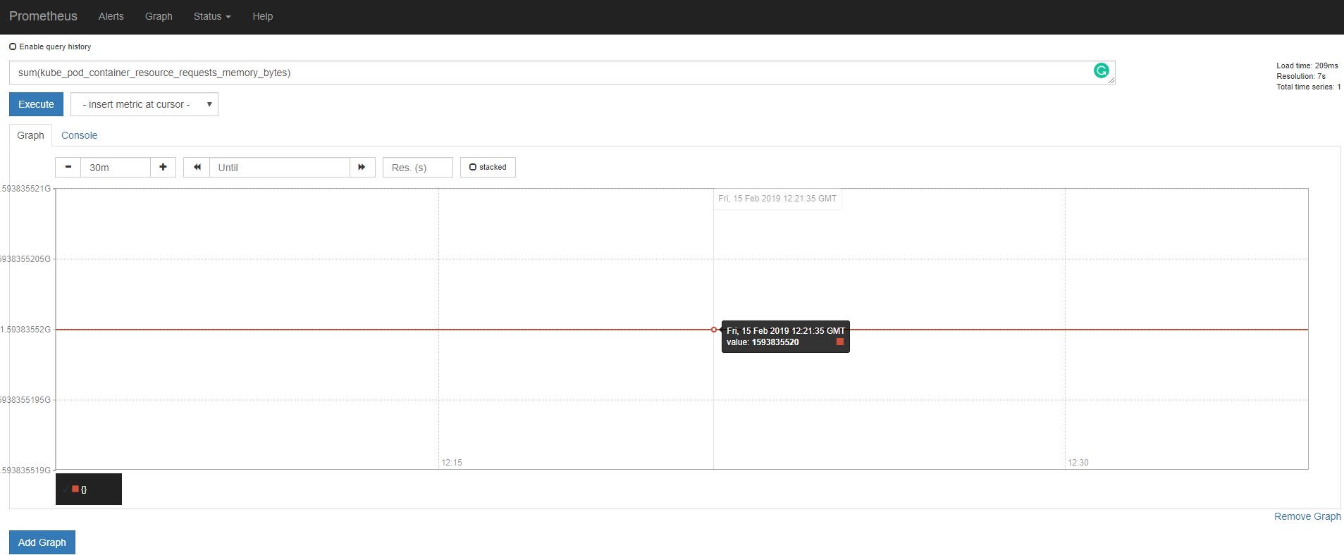
Resource Metric: Kubernetes Node Memory Requests
Expression:
sum(kube_pod_container_resource_requests_memory_bytes) by (node)
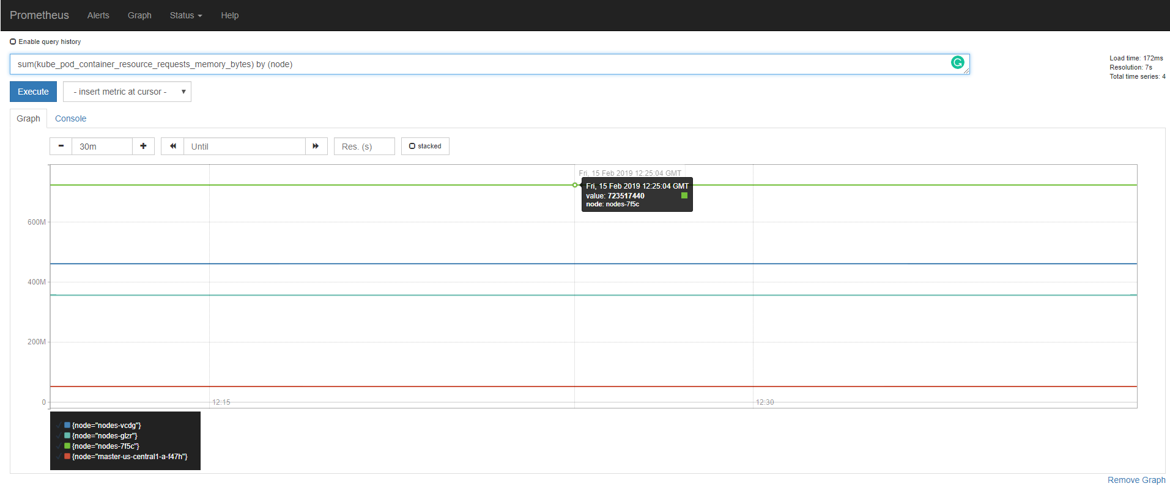
Resource Metric: Kubernetes Memory Limits
Expression:
sum(kube_pod_container_resource_limits_memory_bytes)
This will give us the sum of memory limits for all pods in the cluster
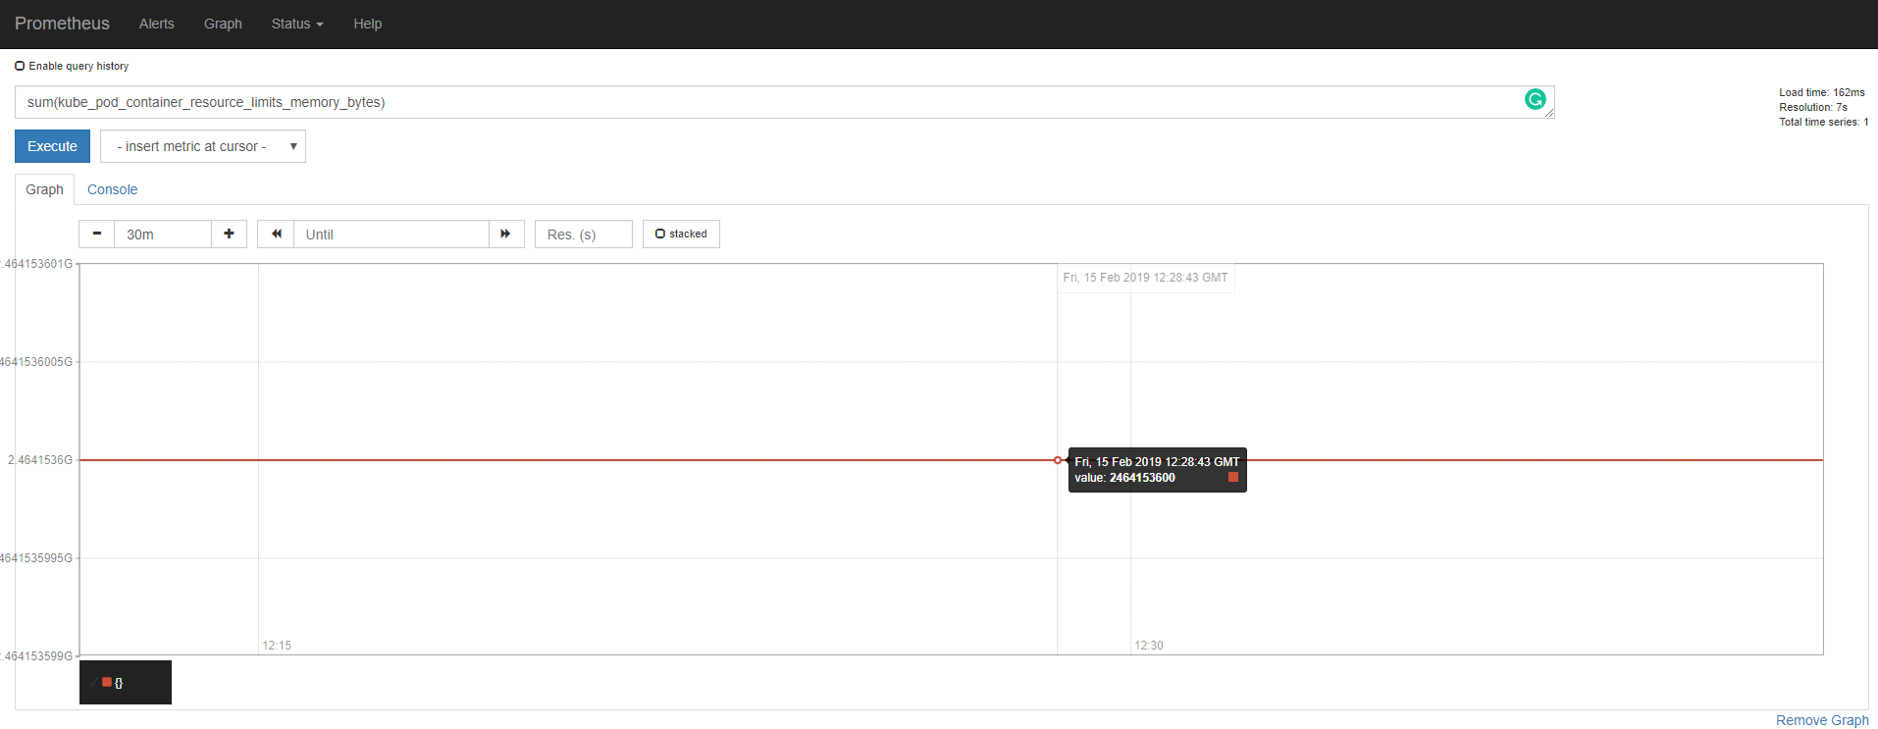
Resource Metric: Kubernetes Node Memory Limits
Expression:
sum(kube_pod_container_resource_limits_memory_bytes) by (node)
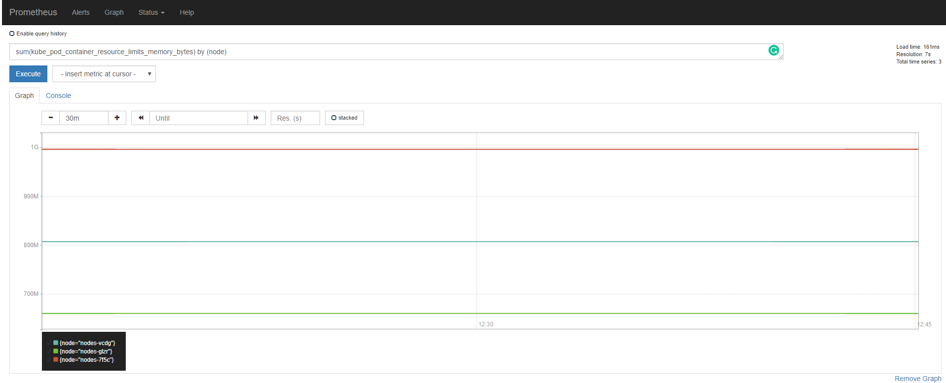
Resource Metric: Kubernetes Memory Limit Commitment
Expression:
(sum(kube_pod_container_resource_limits_memory_bytes) / :node_memory_MemTotal:sum)*100
This will give us the memory limit commitment for the entire cluster.
Conclusion
In this blog post we outlined an extensive list of Kubernetes resource metrics, the importance of monitoring them as well as setting up the tools required. In the next installment, we will look at further Prometheus resource metrics and also deploy Grafana for more user friendly dashboards.
The list of metrics we considered for this blog post are based on hardware and OS metrics, the distinct hardware and software abstractions Kubernetes introduces and it’s resource management model. What we did not consider are organizational imperatives driven by the need to understand resource allocation, usage and utilization based on custom organizational groupings. These custom groupings can range from customers and clients to teams, applications and departments.

