PROJECT REPORT
E-Commerce Sales & Customer Analytics Dashboard
An end-to-end analytics project using SQL Server, Excel and Power BI on the Olist Brazilian E-Commerce dataset

Item | Details
Prepared by | Syed Ubedullah Basha
Date | October 2026
Dataset | Olist Brazilian E-Commerce Public Dataset (Kaggle)
Analysis period | January 2017 – August 2018
Tools | SQL Server (SSMS), Microsoft Excel, Power BI Desktop
Repository | github.com/syed-ubedullah/Olist-Ecommerce-Analytics-Dashboard
LinkedIn | linkedin.com/in/syed-ubedullah-basha

Contents
1 Executive Summary
2 Project Objectives and Scope
3 Dataset Overview
4 Tools and Technologies
5 Project Workflow
6 Data Engineering in SQL Server
7 Data Model
8 DAX Measures and Calculated Columns
9 Dashboard Design System
10 Dashboard Pages
10.1 Executive Overview
10.2 Sales & Product
10.3 Customer Analytics
10.4 Delivery & Satisfaction
10.5 Key Insights
11 Key Findings and Recommendations
12 Validation and Data Quality
13 Challenges and Solutions
14 Limitations and Future Work
15 Repository Structure and How to Reproduce
A Appendix A: SQL Scripts
B Appendix B: DAX Code

1. Executive Summary
This report documents the complete, end-to-end build of an e-commerce analytics solution, from raw CSV files to a five-page interactive Power BI dashboard. The project uses the public Olist Brazilian E-Commerce dataset and covers sales performance, products and sellers, customer retention, and delivery performance and satisfaction for the period January 2017 to August 2018.
The raw data was imported into SQL Server, cleaned and reshaped into analytical views, modelled as a star schema in Power BI, visualised across five pages with a consistent design system and page navigation, and finally validated by reconciling the headline numbers across SQL, Excel and Power BI.

Headline numbers
R$ 13.18M  Total revenue (delivered orders) | 96.2K  Delivered orders | 93.1K  Unique customers
3.0%  Repeat customer rate | 91.9%  On-time delivery rate | 4.16  Average review score

Headline findings
- Growth then plateau: monthly revenue grew about 9x during 2017 (R$ 112K in January to R$ 988K in November) and then stayed around R$ 830K–980K per month through 2018.
- Geographic concentration: São Paulo generates about 38% of revenue, and São Paulo, Rio de Janeiro and Minas Gerais together contribute about 63%.
- Weak retention: only 3.0% of customers placed a repeat order, yet repeat customers spend about 1.9x more (R$ 260 versus R$ 138).
- Delivery drives satisfaction: on-time orders average 4.3 stars, while orders delivered 8 or more days late average 1.7 stars. Late deliveries spiked to 14.3% in November 2017, 16.0% in February 2018 and 21.4% in March 2018.
- Freight matters: shipping adds about 17% on top of product revenue, ranging from 8.4% (Watches & Gifts) to 23.7% (Furniture Decor).

What was delivered
- SQL Server scripts: import fixes, two analytical views, validation queries and analysis queries.
- A Power BI report (.pbix) with five navigable pages, a star-schema data model and a DAX measure library.
- An Excel workbook used to cross-validate key numbers and to build pivot summaries.
- A GitHub repository with README, screenshots and this report in Word and PDF format.

2. Project Objectives and Scope
The goal was to build a professional, decision-oriented dashboard for an online marketplace and to document every step of the process, so that the work is reproducible and the numbers can be trusted.
Area | Business question | Dashboard page
Sales performance | How are revenue and orders trending, and which states and categories drive them? | Page 1
Products and sellers | Which categories sell best, how heavy is freight, and how concentrated is the seller base? | Page 2
Customers | How many customers come back, and which customer segments are most valuable? | Page 3
Delivery and satisfaction | How reliable is delivery, how does lateness affect reviews, and which regions are slowest? | Page 4
Decision support | What should the business do next, based on the evidence? | Page 5

Scope
- In scope: delivered orders, January 2017 to August 2018, amounts in Brazilian Real (R$), tables for customers, orders, order items, products, sellers, reviews and category translation.
- Out of scope for this version: payment-method analysis, review text analysis, geolocation mapping and forecasting. These are listed as future work in Section 14.

3. Dataset Overview
The Olist Brazilian E-Commerce Public Dataset, published on Kaggle, contains roughly 100,000 orders placed on the Olist marketplace between 2016 and 2018, spread across several relational CSV files. Eight of these files were imported into SQL Server.
Table | Rows | Used for
olist_customers_dataset | 99,441 | Customer IDs, city and state; customer_unique_id identifies repeat buyers
olist_orders_dataset | 99,441 | Order status and purchase, approval and delivery timestamps
olist_order_items_dataset | 112,650 | Price, freight, product and seller for every item sold
olist_products_dataset | 32,951 | Product category
olist_sellers_dataset | 3,095 | Seller location
olist_order_payments_dataset | 103,886 | Imported for completeness; not used in the current dashboard
olist_order_reviews_dataset | 99,224 | Review scores for the satisfaction analysis
product_category_name_translation | 71 | English names for product categories

Key data decisions
- Geolocation file excluded: it holds about one million rows and state and city columns were sufficient for the analysis.
- customer_unique_id instead of customer_id: customer_id changes with every order, so repeat purchases are only visible through customer_unique_id.
- Analysis window January 2017 to August 2018: the source data for 2016 and for the end of 2018 is sparse or incomplete, so a Date filter keeps the comparisons fair.
- Delivered orders only: revenue and delivery metrics are based on orders with status delivered.

4. Tools and Technologies
Tool | How it was used
SQL Server and SSMS | Database creation, CSV import, data type and null handling, data quality fixes, analytical views and validation queries
Microsoft Excel | Cross-validation of revenue, orders and customers using formulas on data loaded from SQL Server; pivot tables and charts for monthly revenue, top categories and top states
Power BI Desktop | Data model, Power Query steps, DAX measures, five-page report, theme, slicers and page navigation
DAX | Date table, customer-level table, segmentation columns and the KPI measure library
Git and GitHub | Version control and project documentation: README, scripts, screenshots and this report

5. Project Workflow
The project was completed in six phases. Each phase produced a concrete output that the next phase depended on.
Phase | Name | What was done | Output
1 | Planning and setup | Selected the Olist dataset, defined business questions, created the project folder structure (raw data, SQL, Excel, Power BI, screenshots) and fixed a colour palette and typography. | Folder structure, design rules
2 | SQL data engineering | Created the olist_ecommerce database, imported eight CSV files, set data types and nullability, verified row counts, fixed the category translation header issue and created the vw_order_items view. | Clean tables, view, SQL scripts
3 | Power BI data model | Connected to SQL Server in Import mode, added an Order Date column, built a Date table, related the tables as a star schema and created a measures table and a custom theme. | Data model
4 | Dashboard build | Built four analysis pages. For customer and delivery analysis, added a customer-level table (Dim_Customer) and a second view (vw_orders) with a second fact table (Fact_Orders). | Pages 1 to 4
5 | Validation | Reconciled row counts, total revenue, orders, customers and repeat customers between SQL Server, Excel and Power BI. | Validation workbook and queries
6 | Polish and documentation | Added page navigation, per-page insight boxes, the Key Insights page, a PDF export, screenshots, a README, the GitHub repository and this report. | Final dashboard and repository

6. Data Engineering in SQL Server

6.1 Database and import
A database named olist_ecommerce was created and eight CSV files were imported using the SSMS Import Flat File wizard. Table names were kept exactly as generated so that all later scripts could reference them directly.

6.2 Data type and nullability decisions
The wizard infers data types from the first rows of each file, which can fail on larger values or on columns that are blank further down. The following adjustments were made during import.
File | Adjustment | Reason
Orders | Five timestamp columns set to datetime2; approval and delivery date columns made nullable | Orders that were not delivered have no delivery date
Order items | price and freight_value set to float; shipping_limit_date set to datetime2 | Accurate money values and dates
Products | Numeric columns (weight, dimensions, name and description length, photos) widened to int; all nullable | Some weights exceed the smallint range, and some values are blank
Payments | payment_value set to float | Accurate money values
Reviews | Comment title and message set to nvarchar(max) and nullable | Comments are long and often empty

6.3 Row count verification
After import, row counts of all tables were compared against the expected file sizes and all of them matched (see the table in Section 3). The category translation table showed 72 rows instead of 71, which led to the data quality issue described next.

6.4 Data quality issue: header imported as data
In the category translation file the wizard treated the header line as a data row. The columns were named column1 and column2, and the first row contained the text product_category_name. As a result the view could not find the English category column. The fix was to rename the two columns with sp_rename and delete the header row, which left the correct 71 rows (script in Appendix A).

6.5 Analytical views

vw_order_items (item level)
- Joins orders, customers and order items, and left-joins products and the category translation table.
- Category falls back to the original Portuguese name, and then to unknown, when no English name exists.
- Filters to delivered orders. Result: 110,197 rows, 96,478 orders and total revenue of R$ 13,221,498.11 before the dashboard date filter.

vw_orders (order level)
- One row per delivered order, with delivery_days, delay_days against the estimated date, an is_late flag and the review score.
- Some orders have more than one review, so the review score is averaged per order. This keeps one row per order and prevents duplicated counts.
- Orders without a delivery date are excluded. Result: 96,470 orders, 12.5 average delivery days, 8.1% late and an average review score of 4.16.

6.6 Validation and analysis queries
Two further scripts were saved with the project. The validation queries hold the row count check and the repeat customer check. The analysis queries reproduce the dashboard logic in SQL: monthly revenue and orders, top categories and states with revenue share, one-time versus repeat customers, review score by delivery status and slowest states by average delivery days.

7. Data Model
The Power BI model follows a star schema with two fact tables, because the item-level data and the order-level data have different grains. Keeping them separate avoids double counting of delivery and review metrics.
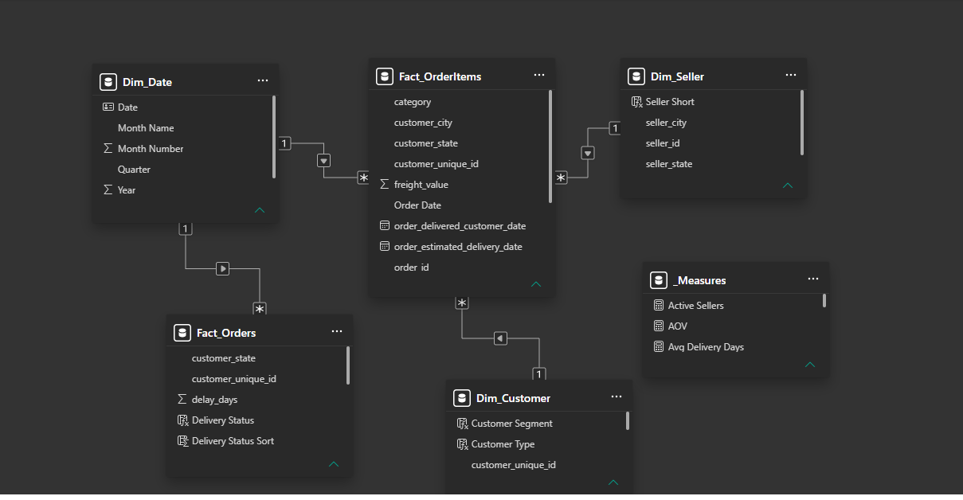
Figure 1: Power BI data model (model view)
Table | Description
Fact_OrderItems | One row per order item, loaded from vw_order_items. Holds price, freight, category, seller, customer and Order Date.
Fact_Orders | One row per delivered order, loaded from vw_orders. Holds delivery days, delay days, late flag, review score and state.
Dim_Date | Calendar table from 2016-01-01 to 2018-12-31 created in DAX and marked as the date table. Includes Year, Month Number, Month Name (sorted by month number), Year-Month and Quarter.
Dim_Seller | Seller ID, city, state and a short seller label.
Dim_Customer | Calculated table at customer level with Orders, Revenue, First Order and Last Order for January 2017 to August 2018, plus segmentation columns.
_Measures | Container table that holds all DAX measures.

Relationships
From (one side) | To (many side) | Type
Dim_Date[Date] | Fact_OrderItems[Order Date] | One to many, single
Dim_Seller[seller_id] | Fact_OrderItems[seller_id] | One to many, single
Dim_Customer[customer_unique_id] | Fact_OrderItems[customer_unique_id] | One to many, single
Dim_Date[Date] | Fact_Orders[Order Date] | One to many, single

Modelling notes
- Power BI automatically created an order_id relationship between the two fact tables. It was deleted because it produced two filter paths from Dim_Date and caused an ambiguity error.
- Dim_Customer is calculated once at refresh, so it does not react to the Year, Quarter or State slicers. For that reason Page 3 has no slicers.
- Customers are identified with customer_unique_id, not customer_id.

8. DAX Measures and Calculated Columns
All measures live in the _Measures table and use explicit number formats (currency for money, whole numbers for counts, percentages for rates).

Sales and product measures
Measure | Definition | Used on
Total Revenue | Sum of item price | Pages 1, 2, 5
Total Orders | Distinct count of order_id | Pages 1, 5
Total Customers | Distinct count of customer_unique_id | Pages 1, 5
AOV | Total Revenue divided by Total Orders | Page 1
Latest MoM % | Revenue of the latest month versus the previous month | Page 1
Items Sold | Row count of Fact_OrderItems | Page 2
Avg Item Price | Total Revenue divided by Items Sold | Page 2
Total Freight, Avg Freight | Sum of freight, and freight per item | Page 2
Freight % of Revenue | Total Freight divided by Total Revenue | Page 2
Active Sellers, Revenue per Seller | Distinct sellers, and revenue divided by sellers | Page 2

Customer and delivery measures
Measure | Definition | Used on
Customer Count | Row count of Dim_Customer | Page 3
Repeat Customers | Customers with more than one order | Pages 3, 5
Repeat Rate % | Repeat Customers divided by Customer Count | Pages 3, 5
Avg Orders per Customer | Average of Orders in Dim_Customer | Page 3
Avg Revenue per Customer | Average of Revenue in Dim_Customer | Page 3
Delivered Orders | Row count of Fact_Orders | Page 4
Avg Delivery Days | Average of delivery_days | Page 4
Late Delivery %, On-time % | Late orders divided by delivered orders, and its complement | Pages 4, 5
Avg Review Score | Average of the per-order review score | Pages 4, 5
Low Review % | Share of reviewed orders with a score of 2 or below | Page 4

Calculated columns and tables
Object | Purpose
Order Date (Power Query) | Date part of order_purchase_timestamp, used to relate fact tables to Dim_Date
Seller Short (Dim_Seller) | Short label such as S-4869f7 for readable seller charts
Customer Type (Dim_Customer) | Repeat when Orders is greater than 1, otherwise One-time
Recency Days (Dim_Customer) | Days between last order and 31 August 2018
First Order Month (Dim_Customer) | Year-month of the first order, for the new customers chart
Customer Segment (Dim_Customer) | Five segments based on orders, recency and revenue (Section 10.3)
Delivery Status and Sort (Fact_Orders) | On time, or late in three buckets, with a sort column for correct ordering
Review Stars (Fact_Orders) | Review score rounded to whole stars for the distribution chart

The full code for the main objects is in Appendix B.

9. Dashboard Design System
A fixed design system was defined before building the pages, so that all five pages look like one product.
Swatch | Name | Hex | Use
 | Dark Navy | #0B2545 | Header bar, titles, recommendations panel
 | Blue | #1D4E89 | Primary chart colour, accent bars
 | Teal | #00A6A6 | Secondary chart colour
 | Orange | #F28C28 | Highlight only: selected page, key accents
 | Green | #2E9E6B | Positive result (on-time)
 | Red | #D64545 | Negative result (late)
 | Light Blue | #8FB8DE | Soft fills and subtitles
 | Slate Grey | #5C6B7A | Labels and secondary text
 | Light Grey | #F4F6FA | Page background

Design rules
- Typography: Segoe UI throughout, with semibold titles in dark navy.
- Layout: a 1280 px wide canvas, a navy header with title, subtitle and navigation buttons, a row of KPI cards, then charts on a 20 px margin grid.
- Charts: at most two or three colours per chart, gridlines removed, data labels on, descriptive chart titles.
- Colour discipline: orange is reserved for highlights, green and red only for good and bad outcomes.
- Navigation: a page navigator in every header. The selected page is shown in orange. Page names are short (Overview, Sales, Customers, Delivery, Insights).
- Insight boxes: every analysis page ends with a short Key Insights text box, so the reader gets the message without interpreting charts.
- Theme file: the palette was saved as a Power BI theme JSON, so that new visuals automatically use the same colours.

10. Dashboard Pages
The report has five pages. Pages 1, 2 and 4 respond to the Year, Quarter and State slicers. Page 3 uses a fixed customer table and has no slicers. All numbers below cover January 2017 to August 2018.

10.1 Executive Overview
Purpose: give a one-screen view of business size, growth and where revenue comes from.
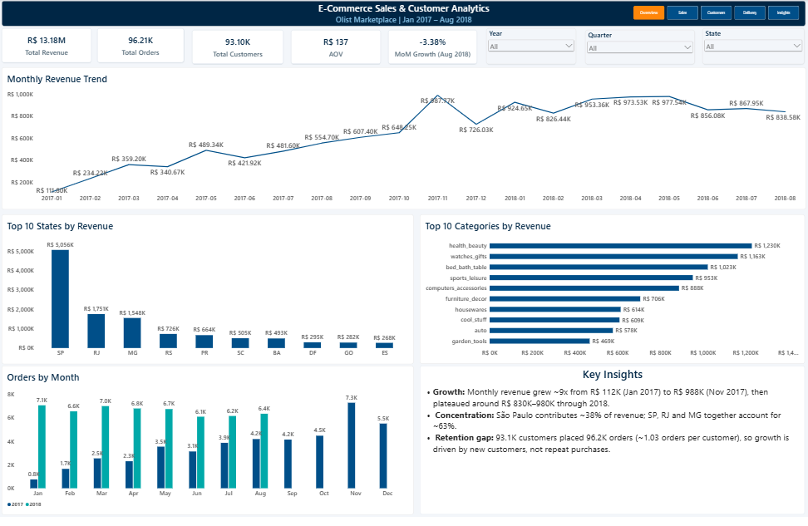
Figure 2: Page 1 – Executive Overview
Total Revenue | Total Orders | Total Customers | AOV | MoM Growth (Aug 2018)
R$ 13.18M | 96,211 | 93,104 | R$ 137 | -3.38%
Delivered orders in the analysis window. MoM growth compares August with July 2018.
Visuals: monthly revenue trend, top 10 states, top 10 categories and orders by month for 2017 and 2018.
Key insights
- Revenue grew about 9x in 2017, from R$ 112K in January to R$ 988K in November, then plateaued at roughly R$ 830K–980K per month in 2018.
- November 2017 was the strongest month with 7.3K orders, followed by a dip to R$ 726K in December.
- São Paulo contributes about 38% of revenue (R$ 5.06M), and São Paulo, Rio de Janeiro and Minas Gerais together contribute about 63%.
- The top five categories contribute about 40% of revenue and the top ten about 62%.
- August 2018 revenue was 3.4% below July, which is one month and fits the broader plateau.

10.2 Sales & Product
Purpose: show which products sell, what shipping costs, and how dependent the marketplace is on a few sellers.
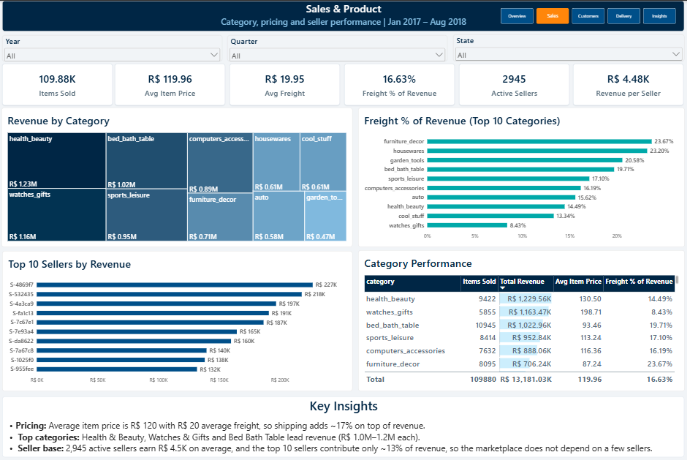
Figure 3: Page 2 – Sales & Product
Items Sold | Avg Item Price | Avg Freight | Freight % of Revenue | Active Sellers | Revenue per Seller
109,880 | R$ 119.96 | R$ 19.95 | 16.63% | 2,945 | R$ 4.48K

Freight share of revenue, top 10 categories by revenue
Category | Freight % | Category | Freight %
furniture_decor | 23.67% | computers_accessories | 16.19%
housewares | 23.20% | auto | 15.62%
garden_tools | 20.58% | health_beauty | 14.49%
bed_bath_table | 19.71% | cool_stuff | 13.34%
sports_leisure | 17.10% | watches_gifts | 8.43%

Key insights
- Health & Beauty (R$ 1.23M), Watches & Gifts (R$ 1.16M) and Bed Bath Table (R$ 1.02M) lead revenue.
- Shipping adds about 17% on top of product revenue, from 8.4% for Watches & Gifts up to 23.7% for Furniture Decor.
- The top 10 sellers contribute only about 13% of revenue, so the marketplace does not depend on a few sellers.
- An earlier scatter chart of price versus freight was replaced with a freight percentage bar chart, because a few high-priced outlier categories distorted the axes.

10.3 Customer Analytics
Purpose: measure retention and identify customer segments worth targeting.
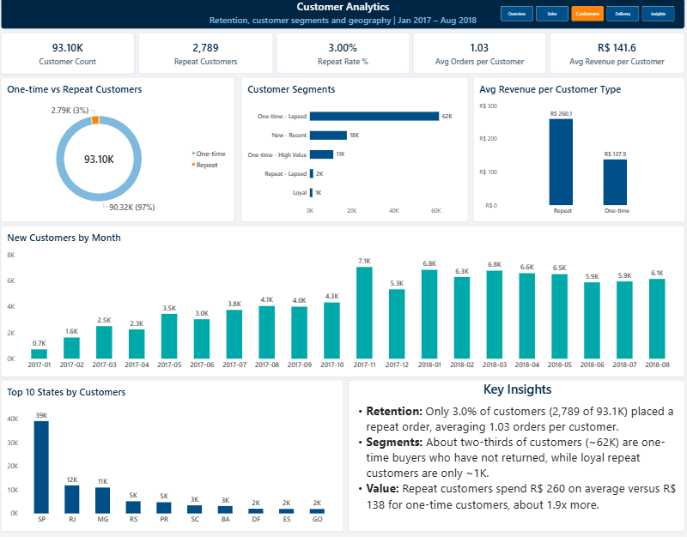
Figure 4: Page 3 – Customer Analytics
Customer Count | Repeat Customers | Repeat Rate % | Avg Orders per Customer | Avg Revenue per Customer
93,104 | 2,789 | 3.00% | 1.03 | R$ 141.6
Average revenue per customer is R$ 260.1 for repeat customers and R$ 137.9 for one-time customers.

Segment definitions
Recency is measured against 31 August 2018, the last date in the data. Segment sizes are read from the dashboard and rounded.
Segment | Rule | Approx. size
Loyal | More than one order, last order within 180 days | ~1K
Repeat – Lapsed | More than one order, last order older than 180 days | ~2K
New – Recent | One order, placed within the last 90 days | ~18K
One-time – High Value | One order older than 90 days, with revenue of R$ 200 or more | ~11K
One-time – Lapsed | All remaining one-time customers | ~62K

Key insights
- Only 3.0% of customers (2,789 of 93.1K) placed a repeat order, with 1.03 orders per customer on average.
- About two-thirds of customers (~62K) are one-time buyers who have not returned.
- Repeat customers spend R$ 260 on average versus R$ 138 for one-time customers, about 1.9x more.
- About 11K one-time customers spent R$ 200 or more in a single order, which makes them a priority win-back group.
- New customer acquisition peaked at 7.1K in November 2017 and stayed at roughly 6–7K per month through 2018.
- São Paulo holds about 39K customers (~42%), followed by Rio de Janeiro (12K) and Minas Gerais (11K).

10.4 Delivery & Satisfaction
Purpose: connect delivery performance with customer satisfaction and find where delivery is slow.
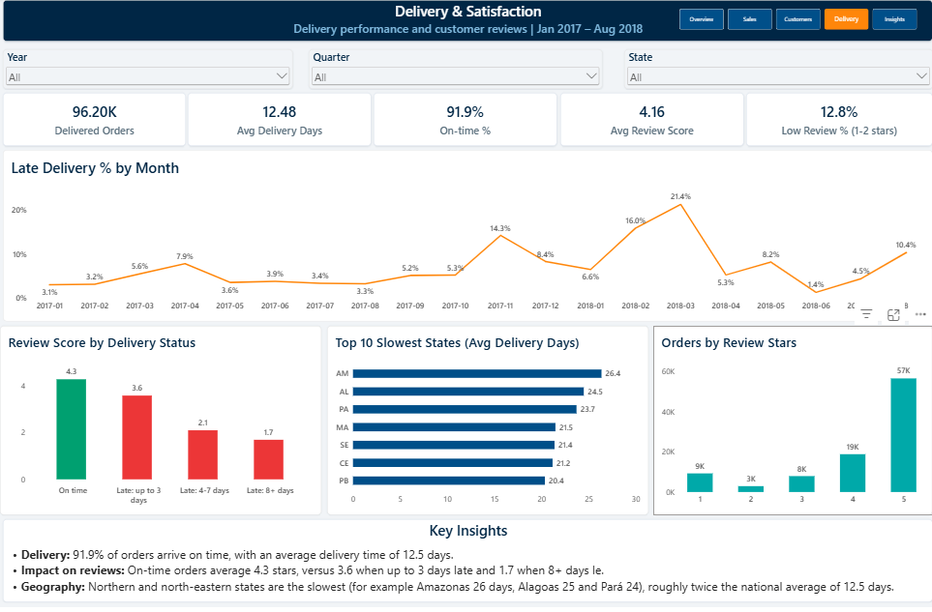
Figure 5: Page 4 – Delivery & Satisfaction
Delivered Orders | Avg Delivery Days | On-time % | Avg Review Score | Low Review %
96.20K | 12.48 | 91.9% | 4.16 | 12.8%
On-time means delivered on or before the estimated date. Low review means a score of 2 or below.

Review score by delivery status
Delivery status | Orders | Avg review score | Change versus on time
On time | 88,381 | 4.3 | –
Late: up to 3 days | 3,160 | 3.6 | -0.7
Late: 4–7 days | 1,802 | 2.1 | -2.2
Late: 8+ days | 2,860 | 1.7 | -2.6

Late delivery rate by month (peak months)
Month | Late % | Comment
November 2017 | 14.3% | First spike
February 2018 | 16.0% | Second spike
March 2018 | 21.4% | Highest of the period
August 2018 | 10.4% | Latest month, elevated
All other months | 1.4% to 8.4% | Typical range

Slowest states by average delivery days, with order counts
State | Region | Orders | Avg delivery days | Note
RR | North | 40 | 29.9 | Low volume
AP | North | 67 | 27.2 | Low volume
AM | North | 145 | 26.4
AL | North-east | 396 | 24.5
PA | North | 942 | 23.7
MA | North-east | 713 | 21.5
SE | North-east | 332 | 21.4
CE | North-east | 1,273 | 21.2
AC | North | 80 | 21.0 | Low volume
PB | North-east | 516 | 20.4
The national average is 12.5 days. RR, AP and AC have fewer than 100 delivered orders each, so their averages are less reliable. The order counts come from the SQL analysis query. The dashboard chart applies a minimum of 100 delivered orders, so it shows only AM, AL, PA, MA, SE, CE and PB.
Key insights
- 91.9% of orders arrive on time, with an average delivery time of 12.5 days and an average review score of 4.16.
- Lateness is costly: reviews fall from 4.3 stars on time to 3.6 when up to 3 days late, 2.1 when 4–7 days late and 1.7 when 8 or more days late.
- Northern and north-eastern states are the slowest: Amazonas 26.4 days, Alagoas 24.5, Pará 23.7, Maranhão 21.5 and Ceará 21.2, against 12.5 days nationally. Roraima, Amapá and Acre also rank among the slowest but have fewer than 100 orders each.
- Of the 7,822 late orders, 2,860 (about 37%) were 8 or more days late, and those orders average only 1.7 stars.
- About 59% of orders receive 5 stars, but 12.8% receive 2 stars or less.
- Late deliveries spiked in November 2017, February 2018 and March 2018. The data does not state the cause.

10.5 Key Insights
Purpose: summarise findings for decision makers on a single page.
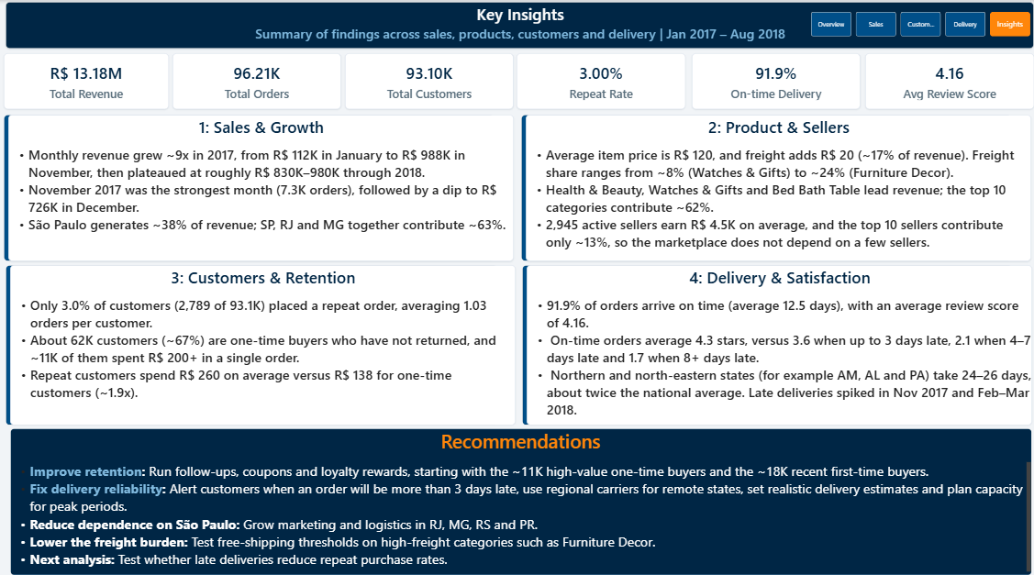
Figure 6: Page 5 – Key Insights and Recommendations
The page combines six headline KPIs, four insight panels (sales and growth, product and sellers, customers and retention, delivery and satisfaction) and a recommendations panel. The same findings are described in detail in Section 11.

11. Key Findings and Recommendations

11.1 Findings
Theme | Finding | Evidence
Growth | Fast growth in 2017, plateau in 2018 | R$ 112K (Jan 2017) to R$ 988K (Nov 2017); about R$ 830K–980K in 2018
Geography | Revenue is concentrated in São Paulo | SP about 38%; SP, RJ and MG about 63%
Categories | Revenue is spread across several categories | Top 5 about 40%, top 10 about 62%
Sellers | No dependence on a few sellers | 2,945 active sellers; top 10 about 13% of revenue
Freight | Shipping is a meaningful cost | 16.6% of revenue; 8.4% to 23.7% by category
Retention | Customers rarely return | 3.0% repeat rate; 1.03 orders per customer; ~67% one-time and lapsed
Customer value | Repeat customers are worth more | R$ 260 versus R$ 138 average revenue
Delivery | Most orders arrive on time, but peaks fail | 91.9% on time; late rate 14.3%, 16.0% and 21.4% in peak months
Satisfaction | Lateness strongly lowers reviews | 4.3 stars on time versus 1.7 stars when 8+ days late; about 37% of late orders are 8+ days late
Regional logistics | Northern and north-eastern states are slow | AM 26.4, AL 24.5, PA 23.7 days versus 12.5 nationally (RR, AP and AC are slower but have fewer than 100 orders)

11.2 Recommendations
# | Recommendation | Why | KPI to track
1 | Improve customer retention | Only 3.0% repeat. Start with about 11K high-value one-time buyers and about 18K recent first-time buyers using follow-ups, coupons and loyalty rewards. | Repeat Rate %
2 | Fix delivery reliability | Delays of more than 3 days sharply reduce satisfaction. Alert customers about delays, use regional carriers for remote states and set realistic delivery estimates. | On-time %, Avg Review Score
3 | Plan for peak periods | Late deliveries spiked in November 2017 and in February–March 2018. Prepare carrier capacity ahead of such periods. | Late Delivery % by month
4 | Reduce dependence on São Paulo | About 38% of revenue comes from one state. Grow marketing and logistics in RJ, MG, RS and PR. | Revenue share by state
5 | Lower the freight burden | Freight reaches 23.7% of revenue in some categories. Test free-shipping thresholds on high-freight categories such as Furniture Decor. | Freight % of Revenue

Next analysis: test whether customers who received a late delivery are less likely to place a second order. The current data shows both effects but does not link them.

12. Validation and Data Quality
Numbers on a dashboard are only useful if they can be trusted, so the key metrics were reconciled across the three tools.
Check | What was compared | Result
Import row counts | All eight imported tables against expected counts (for example orders 99,441 and order items 112,650) | Matched
Translation table fix | Row count before and after removing the header row (72 to 71) | Fixed
Revenue and orders at load | SQL view total (R$ 13,221,498.11 and 96,478 orders) against Power BI before the date filter | Matched
Headline KPIs in the analysis window | Revenue R$ 13.18M, orders 96,211 and customers 93,104 in Power BI against SQL and the Excel validation sheet | Matched
Repeat customers | SQL query (2,789 repeat customers out of 93,104) against Power BI Page 3 | Matched
Analysis queries | SQL results for state and category revenue shares, one-time versus repeat customers (90,315 and 2,789) and review score by delivery status against the dashboard | Matched
Delivery metrics | SQL view (96,470 orders, 12.5 days, 8.1% late, 4.16 score) against Page 4 (96.20K, 12.48, 91.9% on time, 4.16) | Consistent; Power BI applies the date filter
Late-delivery spikes | Monthly late rate read from the Page 4 chart after fixing the axis order | Confirmed

The difference between R$ 13.22M in SQL and R$ 13.18M on the dashboard is explained by the date filter (January 2017 to August 2018), which removes 2016 and the final months of 2018.

13. Challenges and Solutions
Several problems came up during the build. They are recorded here because they show how the final model was shaped.
Problem | Cause | Solution
View failed with invalid column names | The translation CSV header was imported as a data row, and columns were named column1 and column2 | Renamed the columns, deleted the header row and rebuilt the view
Risk of failed imports | The wizard inferred small integer types and non-null columns from the first rows (for example product weight, blank approval dates) | Widened numeric columns to int and allowed nulls where values can be blank
Ambiguous path error between tables | Power BI auto-created an order_id relationship between the two fact tables, giving two paths from Dim_Date | Deleted the automatic relationship and related each fact table to Dim_Date separately
Duplicate rows from reviews | Some orders have more than one review | Averaged the review score per order in vw_orders to keep one row per order
Repeat purchases invisible | customer_id changes with every order | Used customer_unique_id for all retention analysis
Seller Short produced a single-value error | It was created as a measure, but it needs a value per row | Recreated it as a calculated column on Dim_Seller
Syntax error in the MoM measure | Variable names clashed with DAX names | Renamed the variables with a v_ prefix
Line chart in the wrong order, odd labels | The axis was sorted by value and display units were set to thousands on a percentage | Sorted by Year-Month ascending and set display units to none
Slowest-states ranking led by tiny states | RR, AP and AC have fewer than 100 orders, so their averages are unreliable | Checked order counts in SQL and added a minimum-orders filter to the state chart
Unreadable scatter chart | A few outlier categories stretched the axes | Replaced it with a freight percentage bar chart for the top 10 categories

14. Limitations and Future Work

14.1 Limitations
- Static customer table: Dim_Customer is calculated at refresh and does not respond to the Year, Quarter and State slicers.
- Lapsed definition: customers are called lapsed relative to 31 August 2018, the last date in the data. Some of them may have returned afterwards.
- Small states: RR, AP and AC have only 40, 67 and 80 delivered orders in the period, so their average delivery times are less reliable.
- Delivered orders only: cancelled and unavailable orders are not analysed.
- Review scores: scores are averaged per order, and orders without a review are excluded from the average.
- Correlation, not causation: the link between late delivery and low reviews is observed in the data, but other factors may also play a role.
- Currency: all amounts are in Brazilian Real and are not converted.

14.2 Future work
- Test whether late delivery reduces the probability of a second purchase, using a cohort analysis.
- Analyse payment methods and instalments using the imported payments table.
- Add text analysis of review comments to explain low scores.
- Analyse seller-level delivery performance and add a geographic map.
- Publish the report to the Power BI Service with scheduled refresh, and use Python for forecasting or cohort retention.

15. Repository Structure and How to Reproduce
Olist-Ecommerce-Analytics-Dashboard/
|-- README.md
|-- dashboard/
| |-- Ecommerce_Dashboard.pbix
| |-- Ecommerce_Dashboard.pdf
|-- sql/
| |-- 01_setup_and_view.sql
| |-- 02_validation_queries.sql
| |-- 03_analysis_queries.sql
| |-- 04_delivery_view.sql
|-- excel/
| |-- Ecommerce_Validation.xlsx
|-- screenshots/
|-- docs/
|-- Ecommerce_Analytics_Project_Report.docx
|-- Ecommerce_Analytics_Project_Report.pdf

The raw Kaggle CSV files are not stored in the repository. The dataset is credited to Olist and linked in the README.

How to reproduce
- Download the Olist Brazilian E-Commerce dataset from Kaggle.
- Create a SQL Server database named olist_ecommerce and import the eight CSV files with the same table names.
- Run 01_setup_and_view.sql, 02_validation_queries.sql and 04_delivery_view.sql in SSMS, and compare the results with the expected counts in this report.
- Open Ecommerce_Dashboard.pbix in Power BI Desktop and point the SQL Server data source to your instance.
- Refresh the data and check the headline KPIs on the Key Insights page against Section 12.

Appendix A: SQL Scripts

A.1 Fix for the category translation table
USE olist_ecommerce;
GO
EXEC sp_rename 'dbo.product_category_name_translation.column1',
'product_category_name', 'COLUMN';
EXEC sp_rename 'dbo.product_category_name_translation.column2',
'product_category_name_english', 'COLUMN';
GO
DELETE FROM dbo.product_category_name_translation
WHERE product_category_name = 'product_category_name';
GO

A.2 Item-level view
CREATE OR ALTER VIEW dbo.vw_order_items AS
SELECT o.order_id, c.customer_unique_id, c.customer_state, c.customer_city,
o.order_status, o.order_purchase_timestamp,
o.order_delivered_customer_date, o.order_estimated_delivery_date,
oi.product_id, oi.seller_id, oi.price, oi.freight_value,
COALESCE(t.product_category_name_english,
p.product_category_name, 'unknown') AS category
FROM dbo.olist_orders_dataset o
JOIN dbo.olist_customers_dataset c ON o.customer_id = c.customer_id
JOIN dbo.olist_order_items_dataset oi ON o.order_id = oi.order_id
LEFT JOIN dbo.olist_products_dataset p ON oi.product_id = p.product_id
LEFT JOIN dbo.product_category_name_translation t
ON p.product_category_name = t.product_category_name
WHERE o.order_status = 'delivered';

A.3 Order-level view
CREATE OR ALTER VIEW dbo.vw_orders AS
SELECT o.order_id, c.customer_unique_id, c.customer_state,
o.order_purchase_timestamp, o.order_delivered_customer_date,
o.order_estimated_delivery_date,
DATEDIFF(DAY, o.order_purchase_timestamp,
o.order_delivered_customer_date) AS delivery_days,
DATEDIFF(DAY, o.order_estimated_delivery_date,
o.order_delivered_customer_date) AS delay_days,
CASE WHEN o.order_delivered_customer_date >
o.order_estimated_delivery_date THEN 1 ELSE 0 END AS is_late,
r.review_score
FROM dbo.olist_orders_dataset o
JOIN dbo.olist_customers_dataset c ON o.customer_id = c.customer_id
LEFT JOIN (SELECT order_id, AVG(CAST(review_score AS FLOAT)) AS review_score
FROM dbo.olist_order_reviews_dataset GROUP BY order_id) r
ON o.order_id = r.order_id
WHERE o.order_status = 'delivered'
AND o.order_delivered_customer_date IS NOT NULL;

A.4 Repeat customer validation
SELECT SUM(CASE WHEN n > 1 THEN 1 ELSE 0 END) AS repeat_customers,
COUNT(*) AS customers
FROM (SELECT customer_unique_id, COUNT(DISTINCT order_id) AS n
FROM dbo.vw_order_items
WHERE order_purchase_timestamp >= '2017-01-01'
AND order_purchase_timestamp < '2018-09-01'
GROUP BY customer_unique_id) t;

Appendix B: DAX Code

B.1 Date table
Dim_Date =
ADDCOLUMNS(
CALENDAR(DATE(2016,1,1), DATE(2018,12,31)),
"Year", YEAR([Date]),
"Month Number", MONTH([Date]),
"Month Name", FORMAT([Date], "MMM"),
"Year-Month", FORMAT([Date], "YYYY-MM"),
"Quarter", "Q" & QUARTER([Date])
)

B.2 Customer-level table
Dim_Customer =
CALCULATETABLE(
SUMMARIZE(
Fact_OrderItems,
Fact_OrderItems[customer_unique_id],
"Orders", DISTINCTCOUNT(Fact_OrderItems[order_id]),
"Revenue", SUM(Fact_OrderItems[price]),
"First Order", MIN(Fact_OrderItems[Order Date]),
"Last Order", MAX(Fact_OrderItems[Order Date])
),
Fact_OrderItems[Order Date] >= DATE(2017,1,1),
Fact_OrderItems[Order Date] <= DATE(2018,8,31)
)

B.3 Customer columns
Customer Type = IF(Dim_Customer[Orders] > 1, "Repeat", "One-time")

Recency Days = DATEDIFF(Dim_Customer[Last Order], DATE(2018,8,31), DAY)

Customer Segment =
SWITCH(
TRUE(),
Dim_Customer[Orders] > 1 && Dim_Customer[Recency Days] <= 180, "Loyal",
Dim_Customer[Orders] > 1, "Repeat - Lapsed",
Dim_Customer[Recency Days] <= 90, "New - Recent",
Dim_Customer[Revenue] >= 200, "One-time - High Value",
"One-time - Lapsed"
)

B.4 Delivery status column (Fact_Orders)
Delivery Status =
SWITCH(
TRUE(),
Fact_Orders[is_late] = 0, "On time",
Fact_Orders[delay_days] <= 3, "Late: up to 3 days",
Fact_Orders[delay_days] <= 7, "Late: 4-7 days",
"Late: 8+ days"
)

B.5 Selected measures
Total Revenue = SUM(Fact_OrderItems[price])
Total Orders = DISTINCTCOUNT(Fact_OrderItems[order_id])
AOV = DIVIDE([Total Revenue], [Total Orders])
Freight % of Revenue = DIVIDE([Total Freight], [Total Revenue])
Repeat Customers = CALCULATE(COUNTROWS(Dim_Customer), Dim_Customer[Orders] > 1)
Repeat Rate % = DIVIDE([Repeat Customers], [Customer Count])
Late Orders = CALCULATE(COUNTROWS(Fact_Orders), Fact_Orders[is_late] = 1)
Late Delivery % = DIVIDE([Late Orders], [Delivered Orders])
On-time % = 1 - [Late Delivery %]
Low Review % =
DIVIDE(
CALCULATE(COUNT(Fact_Orders[review_score]), Fact_Orders[review_score] <= 2),
COUNT(Fact_Orders[review_score]))

Latest MoM % =
VAR v_MaxDate = MAX(Dim_Date[Date])
VAR v_CurStart = DATE(YEAR(v_MaxDate), MONTH(v_MaxDate), 1)
VAR v_PrevStart = EDATE(v_CurStart, -1)
VAR v_Cur = CALCULATE([Total Revenue], ALL(Dim_Date),
Dim_Date[Date] >= v_CurStart, Dim_Date[Date] <= v_MaxDate)
VAR v_Prev = CALCULATE([Total Revenue], ALL(Dim_Date),
Dim_Date[Date] >= v_PrevStart, Dim_Date[Date] < v_CurStart)
RETURN DIVIDE(v_Cur - v_Prev, v_Prev)

