PROJECT REPORT
Retail Sales Analytics Dashboard
An end-to-end Power BI project on sales, profit, product, customer and regional performance

Tools: Power BI · SQL · Excel
Data: Superstore retail orders, 9,994 order lines, January 2014 – December 2017
Dashboard: 4 interactive report pages with slicers and business insights

Prepared by
Syed Ubedullah Basha
Data Analyst | Power BI Developer | SQL Developer
linkedin.com/in/syed-ubedullah-basha · github.com/syed-ubedullah
08/08/2025

1. Executive Summary
This project analyses four years of retail order data (2014–2017) in Power BI and presents the results in a four-page interactive dashboard. It is designed to help a business leader answer four questions quickly: how are sales and profit trending, which products and categories earn their keep, who are the most valuable customers, and which regions perform best.

Headline Metrics
₹1.94M  Total Sales | ₹222.16K  Total Profit | 4,172  Total Orders | 11.48%  Profit Margin
17.57%  Average Discount | 792  Total Customers | ₹463.82  Average Order Value | 2014–2017  Analysis Period

Key Takeaways
- Healthy but uneven profitability. The business earns an 11.48% margin on ₹1.94M of sales, but Furniture converts only about 2% of its ₹642K sales into profit, compared with 15–17% for Office Supplies and Technology.
- Technology drives the business. It leads both sales (₹734K) and profit (₹125K). Copiers alone contribute the highest sub-category profit (₹52K).
- Tables are loss-making. Tables generate about ₹197K in sales but lose around ₹17K, and Bookcases and Supplies are also slightly negative.
- Strong seasonality. Sales peak in November (₹292K), with December and September also strong; January and February are the weakest months.
- West and East lead. West (₹582K) and East (₹576K) together generate more than 59% of total sales, while Central earns the lowest profit despite mid-range sales.

2. Project Overview

Objective
Build a clean, decision-ready Power BI report on top of a properly modelled dataset, so that sales performance, profitability, product mix, customer value and regional performance can be explored from a single file.

Scope
- Data preparation, validation and cleaning using Excel, SQL and Power BI
- A star-schema data model with a fact table, four dimension tables and a dedicated measures table
- DAX measures for sales, profit, margin, discount, orders, customers and average order value
- A four-page dashboard with KPI cards, charts, a map, slicers and written business insights on every page

Intended Audience
Sales managers, regional heads and business leadership who need a fast, visual summary of performance and a clear view of where to act.

3. Dataset
The source is a retail orders dataset (Superstore) with one row per order line. The file is included in this repository as Retail_Sales_Analytics_Dashboard.csv.
Property | Detail
Size | 9,994 rows × 21 columns
Period | 3 January 2014 – 30 December 2017
Data quality | No missing values and no duplicate rows
Date format | M/D/YYYY (Order Date, Ship Date)
File encoding | Windows-1252 / Latin-1 (use encoding="latin-1" when reading with pandas)

Columns
Group | Columns | Description
Order | Row ID, Order ID, Order Date, Ship Date, Ship Mode | Order identity, dates and shipping method
Customer | Customer ID, Customer Name, Segment | Who bought; Consumer, Corporate or Home Office
Location | Country, State, City, Postal Code, Region | Delivery location; Region is East, West, Central or South
Product | Product ID, Product Name, Category, Sub-Category | Furniture, Office Supplies and Technology, with 17 sub-categories
Financials | Sales, Quantity, Discount, Profit | Revenue, units, discount rate and profit per order line (negative profit means a loss)

4. Measures
All KPIs on the dashboard are DAX measures stored in the All Measures table.
Measure | Definition | Dashboard value
Total Sales | Sum of Sales across the filtered order lines | ₹1.94M
Total Profit | Sum of Profit across the filtered order lines | ₹222.16K
Profit Margin % | Total Profit divided by Total Sales | 11.48%
Average Discount % | Average discount rate applied | 17.57%
Total Orders | Distinct count of Order ID | 4,172
Total Customers | Distinct count of customers | 792
Average Order Value | Total Sales divided by Total Orders | ₹463.82

Values are shown with no slicer selected (Year, Category, Segment and Region set to All).

5. Data Model
The report is built on a star schema. A single fact table holds the order-line transactions, and four dimension tables describe customers, geography, products and dates. Each dimension connects to the fact table with a one-to-many relationship, and every measure lives in a separate table named All Measures.
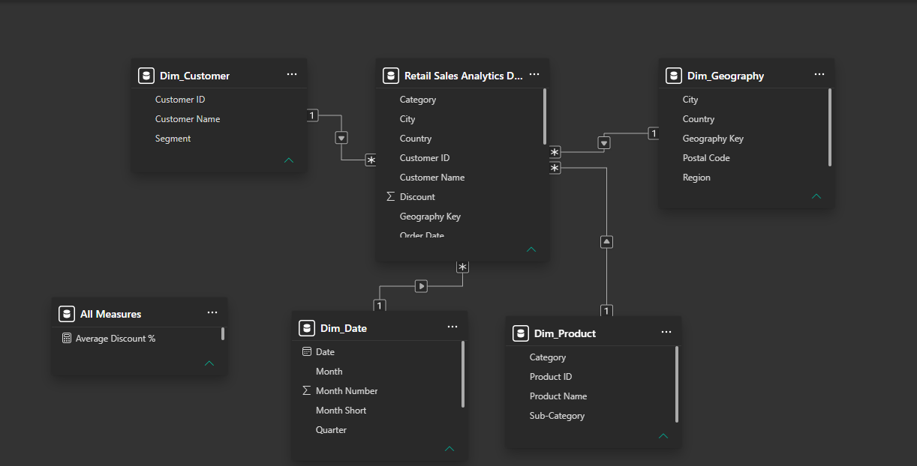
Figure 1: Power BI data model (star schema)
Table | Role | Key fields
Retail Sales Analytics Dashboard | Fact | Order ID, Order Date, Sales, Quantity, Discount, Profit and keys to each dimension
Dim_Customer | Dimension | Customer ID, Customer Name, Segment
Dim_Geography | Dimension | Geography Key, City, State, Region, Country, Postal Code
Dim_Product | Dimension | Product ID, Product Name, Category, Sub-Category
Dim_Date | Dimension | Date, Year, Month, Month Number, Month Short, Quarter
All Measures | Measure table | Total Sales, Total Profit, Profit Margin %, Average Discount %, Total Orders, Total Customers, Average Order Value

Benefits of this design: slicers filter every visual consistently, dimension attributes are stored once, and measures are easy to find, reuse and maintain.

6. Dashboard Walkthrough
The report has four pages. Each page has its own slicers and ends with a Key Business Insights panel that summarises the main message in plain language.

6.1 Executive Overview
Purpose: A one-page health check of the business.
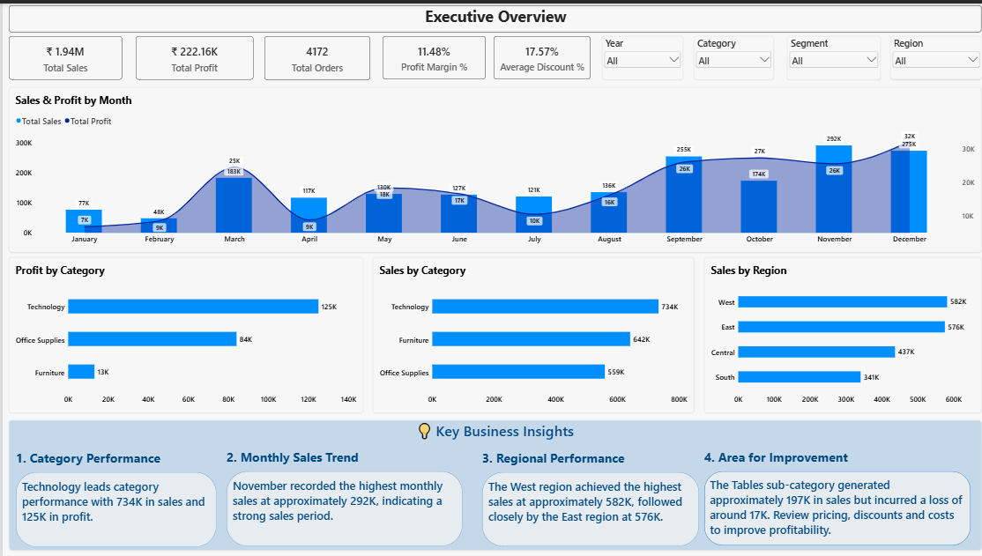
Figure 2: Executive Overview page
Visuals: five KPI cards, Sales & Profit by Month (combo chart), Profit by Category, Sales by Category, Sales by Region, and dropdown slicers for Year, Category, Segment and Region.
What the page shows
- Technology leads on both sales (₹734K) and profit (₹125K); Furniture is second on sales (₹642K) but last on profit (₹13K).
- Monthly sales peak in November at about ₹292K, followed by December (about ₹275K) and September (about ₹255K).
- West (₹582K) and East (₹576K) are close at the top, with Central (₹437K) and South (₹341K) behind.

6.2 Sales & Product Analysis
Purpose: Find the products and sub-categories that earn money, and those that lose it.
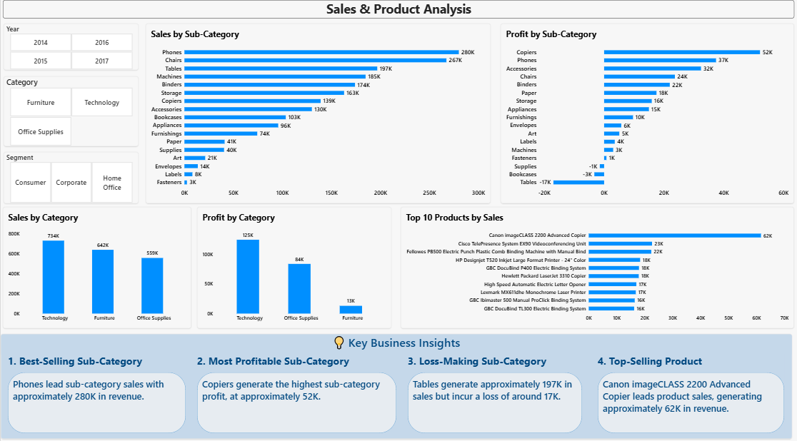
Figure 3: Sales & Product Analysis page
Visuals: Sales and Profit by Sub-Category, Sales and Profit by Category, Top 10 Products by Sales, and tile slicers for Year, Category and Segment.
What the page shows
- Phones (₹280K) and Chairs (₹267K) are the best-selling sub-categories.
- Copiers earn the highest profit (₹52K), followed by Phones (₹37K) and Accessories (₹32K).
- Three sub-categories lose money: Tables (about −₹17K), Bookcases (about −₹3K) and Supplies (about −₹1K).
- The Canon imageCLASS 2200 Advanced Copier is the top product at about ₹62K, far ahead of the next product (about ₹23K).

6.3 Customer Analysis
Purpose: Understand who the customers are and which ones create the most value.
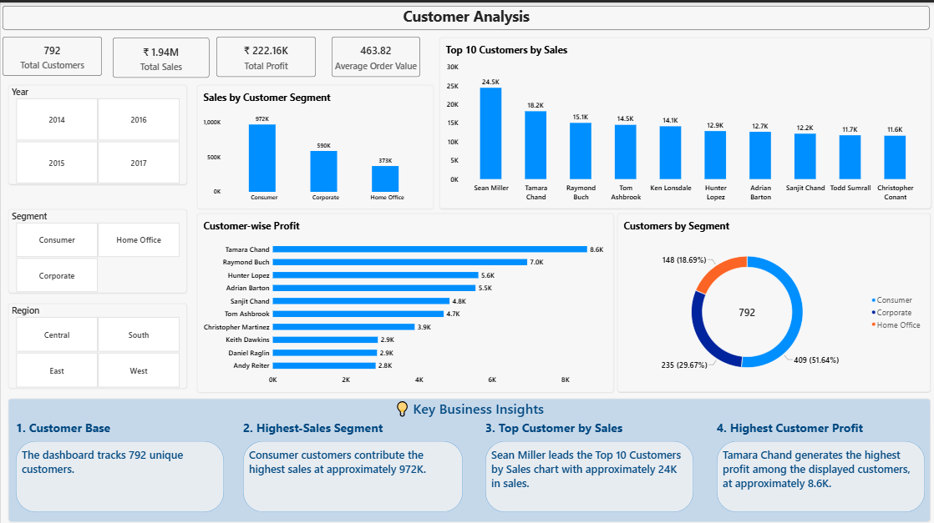
Figure 4: Customer Analysis page
Visuals: KPI cards (Total Customers, Total Sales, Total Profit, Average Order Value), Sales by Customer Segment, Top 10 Customers by Sales, Customer-wise Profit, a donut chart of Customers by Segment, and slicers for Year, Segment and Region.
What the page shows
- The dashboard tracks 792 customers with an average order value of ₹463.82.
- Consumer is the largest segment: about ₹972K in sales and 409 customers (51.64%), ahead of Corporate (₹590K, 235 customers) and Home Office (₹373K, 148 customers).
- Sean Miller is the top customer by sales (about ₹24.5K), but does not appear among the top 10 customers by profit.
- Tamara Chand is the most profitable customer (about ₹8.6K), followed by Raymond Buch (₹7.0K) and Hunter Lopez (₹5.6K).

6.4 Regional Performance
Purpose: Compare regions, states and cities on sales and profit.
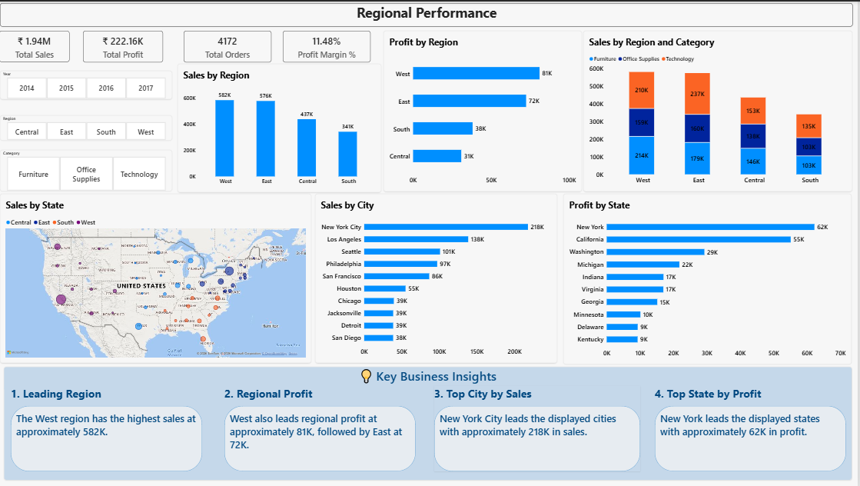
Figure 5: Regional Performance page
Visuals: KPI cards, Sales by Region, Profit by Region, Sales by Region and Category (stacked), a state-level map, Sales by City, Profit by State, and slicers for Year, Region and Category.
What the page shows
- West leads on both sales (₹582K) and profit (₹81K); East follows with ₹576K sales and ₹72K profit.
- New York City is the top city by sales (about ₹218K), ahead of Los Angeles (₹138K) and Seattle (₹101K).
- New York is the top state by profit (about ₹62K), followed by California (₹55K) and Washington (₹29K).
- Technology is the largest category in East (₹237K); West is the most evenly split between Furniture (₹214K) and Technology (₹210K).

7. Insights Summary
Area | Finding | Source page
Profitability | Overall margin is 11.48%. Furniture earns about 2% on ₹642K of sales, versus about 17% for Technology and 15% for Office Supplies. | Executive Overview
Seasonality | November is the strongest month (₹292K); January (₹77K) and February (₹48K) are the weakest. | Executive Overview
Products | Phones lead sales (₹280K); Copiers lead profit (₹52K). Tables lose about ₹17K on ₹197K of sales. | Sales & Product Analysis
Top product | Canon imageCLASS 2200 Advanced Copier sells about ₹62K, roughly 2.7 times the next product. | Sales & Product Analysis
Customers | Consumer drives about half of sales and customers. The top customer by sales is not among the top 10 by profit. | Customer Analysis
Regions | West and East account for more than 59% of sales. Central has the lowest profit (₹31K) despite ₹437K in sales. | Regional Performance
Locations | New York City is the top city by sales; New York is the top state by profit. | Regional Performance

Percentages and ratios in this table are calculated from the values shown on the dashboard.

Recommendations
- Fix Furniture profitability. Review pricing, discounts and costs on Tables and Bookcases; Furniture earns about 2% margin against 15–17% elsewhere.
- Grow the high-margin lines. Prioritise Copiers, Phones and Accessories, which together deliver the largest sub-category profits.
- Plan around seasonality. Stock up and campaign ahead of September–December, and use targeted offers to lift the weak January–February period.
- Review the Central region. Central converts about 7% of sales into profit, against about 14% in West; check discounting and cost drivers there.
- Look beyond sales when managing customers. Review the profitability of high-sales accounts, and protect the most profitable customers such as Tamara Chand and Raymond Buch.
- Reduce dependence on one product. One copier model contributes about ₹62K; keep availability high and build bundles with related supplies.

8. Conclusion & Next Steps
The dashboard turns raw order lines into a clear story: Technology and the West and East regions carry performance, Furniture (especially Tables) drags on profit, and sales are concentrated in the last quarter of the year. Every page is interactive, so users can slice by year, category, segment and region to explore these patterns themselves.

Possible Enhancements
- Add year-over-year growth and a discount-versus-profit view to explain the loss-making products
- Add drill-through pages from category to product and from region to city
- Publish the report to Power BI Service with scheduled refresh
- Add tooltips and bookmarks for a guided executive view

9. Tools Used
Tool | How it was used
Power BI | Data modeling (star schema), DAX measures, and a four-page report with KPI cards, combo, bar, column, donut and map visuals, slicers and cross-filtering
SQL | Querying and validating the retail order data and supporting the analysis
Excel | Reviewing and preparing the source CSV data

About the Author
Syed Ubedullah Basha · Data Analyst | Power BI Developer | SQL Developer
LinkedIn: linkedin.com/in/syed-ubedullah-basha · GitHub: github.com/syed-ubedullah · Email: syedubedullahbasha@gmail.com

