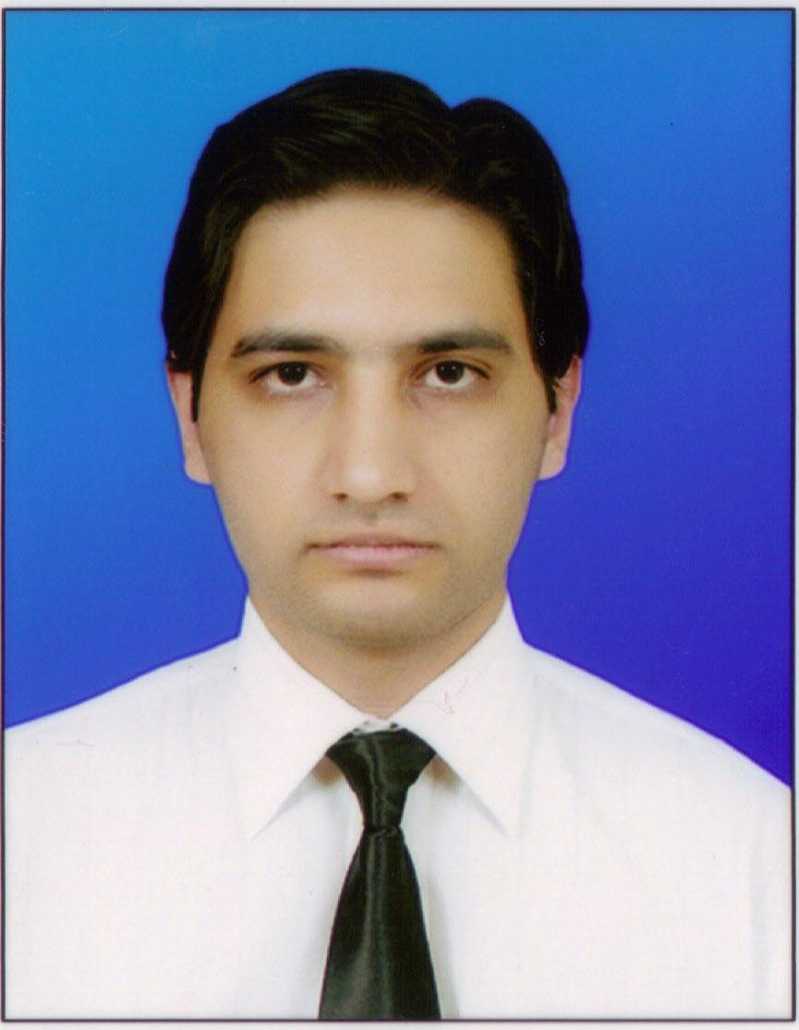 | Syed Umar Bokhari  Mobile: 03005757019  Permanent Address: Shahbaz Town Phase #1  Street #18/179 Quetta, Pakistan  Email: umar482@gmail.com  Getafreelancer Id: umar482

education  ExpErience  skills  CLIENT  TESTIMONIALS  Finished  Projects  interests  references | Currently a Student of MIT (Master of Information Technology) in Virtual University of Pakistan.  BBIT ( Bachelor of Business and Information Technology)  Pearl Institute of Management and Information Technology Quetta.  F. S. c ( Pre- Engineering )  Tameer-i-nau college Quetta.  Matriculation  F. G. Public School Quetta Cant.  Degree in Computer Basics  SuperTech Computers Shahbaz Town Quetta  Worked as a Php Developer in 4Dee technologies Lahore. 28th June to 28th September 2010, Now doing outside consulting for the company.  Worked as a Php and Flash developer in Aspire Solution Islamabad. November 3rd 2008 to April 3rd 2009.  Working as a freelance developer mainly on Freelancer.com. GAF Id: umar482 profile link: http://www.freelancer.com/users/1296172.html  Teaching Computer subjects at The Chiltan College of Commerce and Information Technology from Oct 2006 to Oct 2007, Also Developed MIS system for the Same Institute.  Worked as a Sales Representative for PTCL Phone Directory Advertising Campaign 2006-2007.  Worked as the Manager on Book Land Jinnah Road Quetta (Largest supplier of Books in Balochistan and to Government Libraries).  Web Development and Multimedia  Developing websites and multimedia Projects in: PHP/Mysql, HTML 4 & 5, CSS, JavaScript, Adobe Flash Cs5 Action script 3, Microsoft Silverlight, Ajax, Good Knowledge of CMS and Blog Systems such as, Drupal, Joomla, Wordpress etc with completed live projects. Also very efficient with Jquery with completed projects.  Mobile Programming  FlashLite Contents including Presentations, Themes, Games, Dynamic Maps, and Web Browsers. Also webapps/widgets built in Html 4 and 5 with Javascript.  Networking  Skilled in establishing Server based networks (wired and wireless). A good understanding of Network administration and troubleshooting. Also aware of Network security threats and able to counter and remove them.  Computer and Operating Systems  Able to Install, Setup and Network all the popular Operating Systems like, all versions of Windows, Linux distributions such as Ubuntu and Fedora, Also the Latest version of Mac Os.  Desktop Programming  Experienced in working with Microsoft Visual Studio 2010 C#, able to develop simple to complex programs that work over a network, also able to develop structured database applications with Oracle and Sql Server.  Profile link : http://www.freelancer.com/users/feedback_1296172.html  “The project was completed within good time and to a good standard, with good attention to detail and help for the client. The developer went out of their way to do more than required to complete the project to the clients requirements and did more than originally mentioned in the project brief without charge. A very hard working, loyal and dedicated freelance”  Rating 10/10  Mathew milines  “As usual, excellent. Will work with this service provider again. Thanks umar!”  Rating 10/10  Mathew milines  “Very professional, very good communication it did an excellent work and worries about the comprehension of the customer. I would work with him once again”  Rating 10/10  Oliver  “It's a great freelance, he makes a very professional work, i will work with him again.”  Rating 10/10  Oliver  www.midmarketer.com.  www.ondemandinformation.com  www.jackdelight.com.sg  www.ukbifold.co.uk  www.eduwebads.com  www.libertinesecurity.com  www.poledesign.co.uk  plus many more listed on my freelancer.com profile  Profile link : http://www.freelancer.com/users/feedback_1296172.html  3D game: developed a 3d game using Blender3d and python scripting. Full details can be viewed on this link. I shared several versions of this game with pakgamers community.  http://www.pakgamers.com/forums/pakistani-games-developers/3864-help-me-make.html  Demo applications of the technologies mentioned above can be provided upon request.  Networking and Network Security, Computer and Mobile programming.  References will be provided upon request.

