FuseTwo — Bug: Management advertiser detail deep-link bounces
The old advertiser-detail deep-link no longer opens the record — it silently redirects to the Advertiser Overview. Reproduced on both dev and staging. Prepared by Syed Shah, QA. 31 August 2026.
Severity: Medium | Area: Management portal — advertiser detail routing | Environment: dev and staging (management.stg.fusetwo.com)

Steps to reproduce
- Open the management portal and sign in (Windows SSO).
- In a browser, navigate directly to the old detail URL: https://management.stg.fusetwo.com/advertiser/detail/1062551 (any valid advertiser id).
- Observe the page that loads.
- Now navigate to https://management.stg.fusetwo.com/advertiser/1062551 and compare.
Expected: The detail deep-link opens the advertiser's detail page (or redirects to the current detail route). A deep-link should never silently drop the id.
Actual: /advertiser/detail/{id} redirects to /advertiser/overview — the advertiser is not opened. The working route is now /advertiser/{id}. There is no redirect from the old path to the new one, so any saved link, bookmark or automation that used /advertiser/detail/{id} silently lands on the wrong page.

Evidence
- /advertiser/detail/1062551 -> /advertiser/overview (BOUNCED — detail not open)
- /advertiser/1062551 -> /advertiser/1062551 (opens — Actions button visible)
- The search-result row links the advertiser id to /advertiser/{id}, confirming the new route; the old /advertiser/detail/{id} is no longer served.
- Reproduced 5/5 times on dev and again on staging.

Screenshots
Old route /advertiser/detail/1062551 → bounced to Advertiser Overview
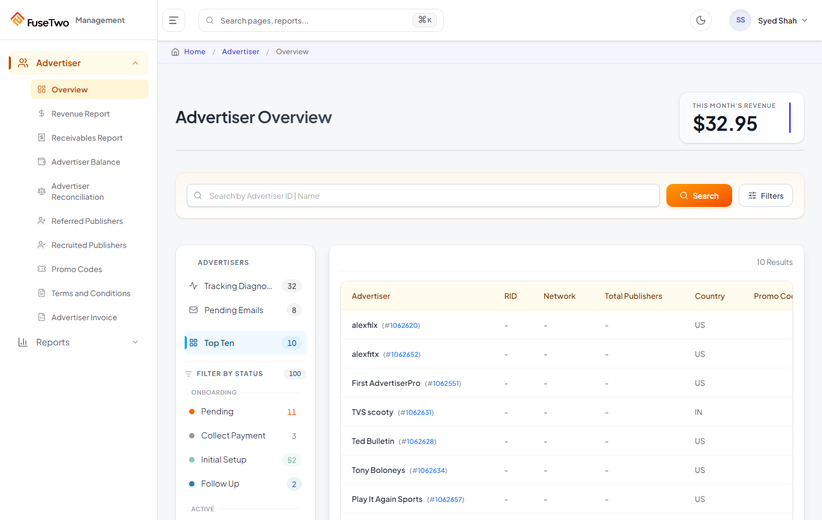
New route /advertiser/1062551 → advertiser detail opens correctly
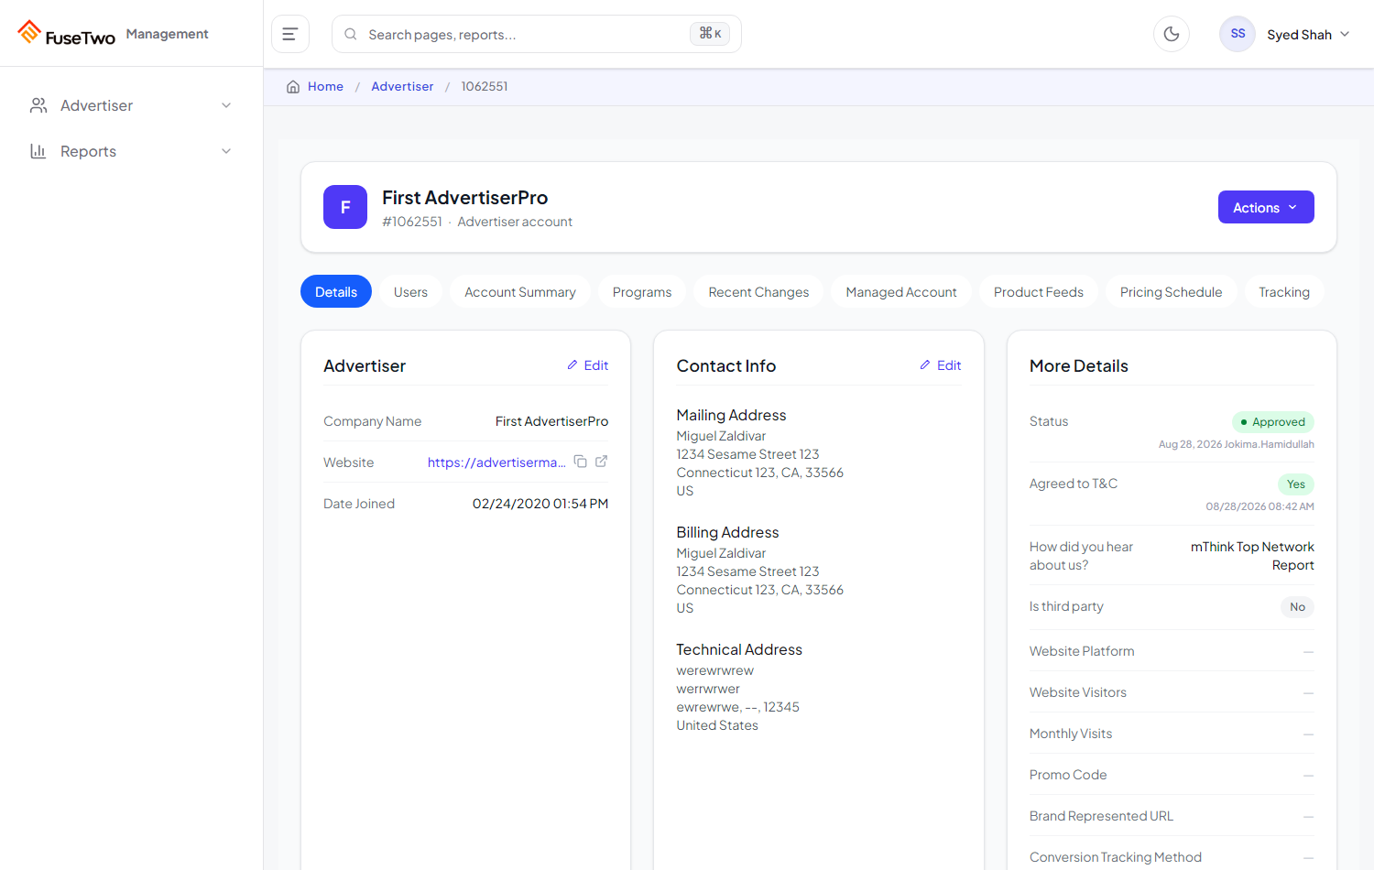

Screen recording
A screen recording of the reproduction (staging) is saved at:
docs/bug-video/mgmt-detail-route-bounce-staging.webm
The .webm plays in Chrome/Edge/VLC (double-click, or drag into a browser tab). It shows the old route bouncing to Overview, then the new route opening the detail.

Impact
- Saved links / bookmarks to /advertiser/detail/{id} no longer work.
- Any automation or integration using the old route silently lands on Overview.
- Fix: add a server/SPA redirect from /advertiser/detail/{id} to /advertiser/{id}.

