FuseTwo — Bug Report
Defects found during QA automation. Each has steps to reproduce, expected vs actual, evidence and (where captured) a screenshot. Prepared by Syed Shah, QA. As of 28 August 2026, dev environment.

ID | Severity | Title | Area
BUG-1 | High | Programs API returns HTTP 500 across the whole app | Advertiser platform — Programs API
BUG-2 | High | Status-change notification e-mails are not delivered | Management — Advertiser status change
BUG-3 | High (Security) | Signup accepts a wrong CAPTCHA | Advertiser signup — step 1
BUG-4 | Medium | $50 vs $100 monthly minimum mismatch | Advertiser Collect Payment page vs Management Pricing Schedule
BUG-5 | Low | Email confirmation page shows success for an invalid token | Advertiser e-mail confirmation
BUG-6 | Low | 'Required field*' helper appears after valid input | Advertiser signup — step 1

BUG-1: Programs API returns HTTP 500 across the whole app
Severity: High | Area: Advertiser platform — Programs API | Environment: dev (advertiser 1062551)
Steps to reproduce
- Sign in to the advertiser platform.
- Open any of: Dashboard, Programs, Campaigns, Creatives, Coupons & Offers, Products, Reports > Sales Detailed, Reports > Clicks Detailed.
- Watch the network calls (or the browser console).
Expected: GET /api/{advertiserId}/programs returns 200 with the program list (or an empty list), and the page shows no error.
Actual: GET /api/1062551/programs returns HTTP 500 {"errorMessage":"Oops! Something went wrong. Please try again in a few moments."} on every one of those pages, and the browser console logs an error. Reproduced consistently on repeated loads.
Evidence: Response body: 500 {"result":null,"errorMessage":"Oops! Something went wrong..."}. The request is authenticated (valid Bearer token), so this is a server-side crash, not an auth failure. Note: correlates with the account not being Approved (currently Initial Setup) — but the API should degrade gracefully, not 500.
Screenshot: programs.png
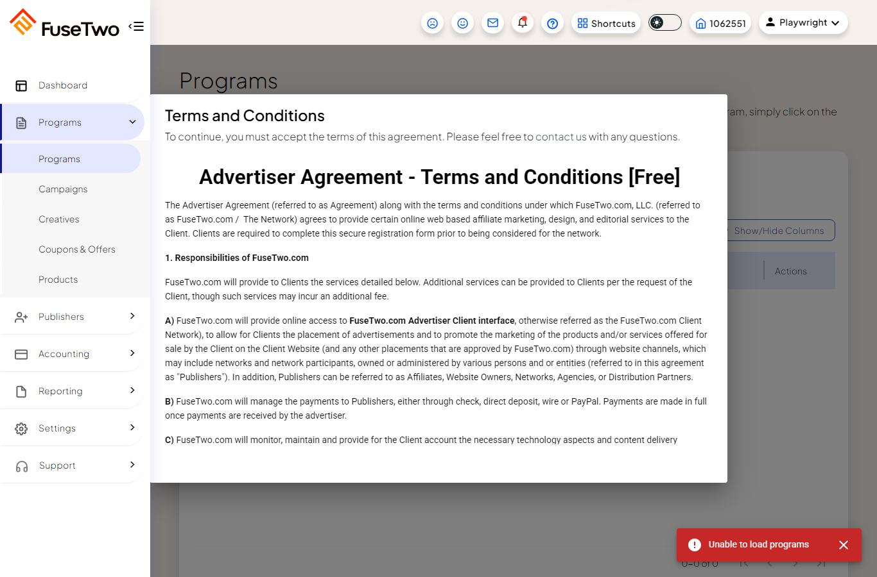

BUG-2: Status-change notification e-mails are not delivered
Severity: High | Area: Management — Advertiser status change | Environment: dev
Steps to reproduce
- Open an advertiser in the management portal.
- Actions > Change Status, pick a new status, submit.
- In the 'Advertiser Email Notification' dialog, choose a template and click Send.
- Check the advertiser's inbox.
Expected: The chosen template e-mail is delivered to the advertiser.
Actual: Send reports success and the dialog closes, but no e-mail arrives. Across many status changes plus an explicit Send, zero notifications were delivered within 3 minutes, while the signup 'Verify Your Email' consistently arrives within a minute (so the mail path itself works).
Evidence: Verified by reading the real QA mailbox (Outlook) after each Send.

BUG-3: Signup accepts a wrong CAPTCHA
Severity: High (Security) | Area: Advertiser signup — step 1 | Environment: dev (relates to #681)
Steps to reproduce
- Open /signup.
- Fill step 1 with valid details but type a deliberately wrong CAPTCHA.
- Click Continue.
Expected: Registration is blocked and stays on step 1 with a CAPTCHA error.
Actual: Registration advances to step 2 (Company Information) despite the wrong CAPTCHA. Ticket #681 is marked Done on the board but still reproduces on dev.
Evidence: Automated: e2e/Onboarding/testSignup.spec.ts 'a wrong CAPTCHA is rejected'.

BUG-4: $50 vs $100 monthly minimum mismatch
Severity: Medium | Area: Advertiser Collect Payment page vs Management Pricing Schedule | Environment: dev (#762)
Steps to reproduce
- Move an advertiser to 'Collect Payment' and sign in as them, OR open the Collect Payment / Pricing Schedule page.
- Compare the monthly minimum shown to the advertiser with the management Pricing Schedule.
Expected: The monthly minimum is the same in both places.
Actual: The advertiser-facing Collect Payment page shows a $50 monthly minimum while the management Pricing Schedule shows $100. Customer-facing discrepancy.
Evidence: Screenshot from the onboarding stage capture.
Screenshot: 2-CollectPayment.png
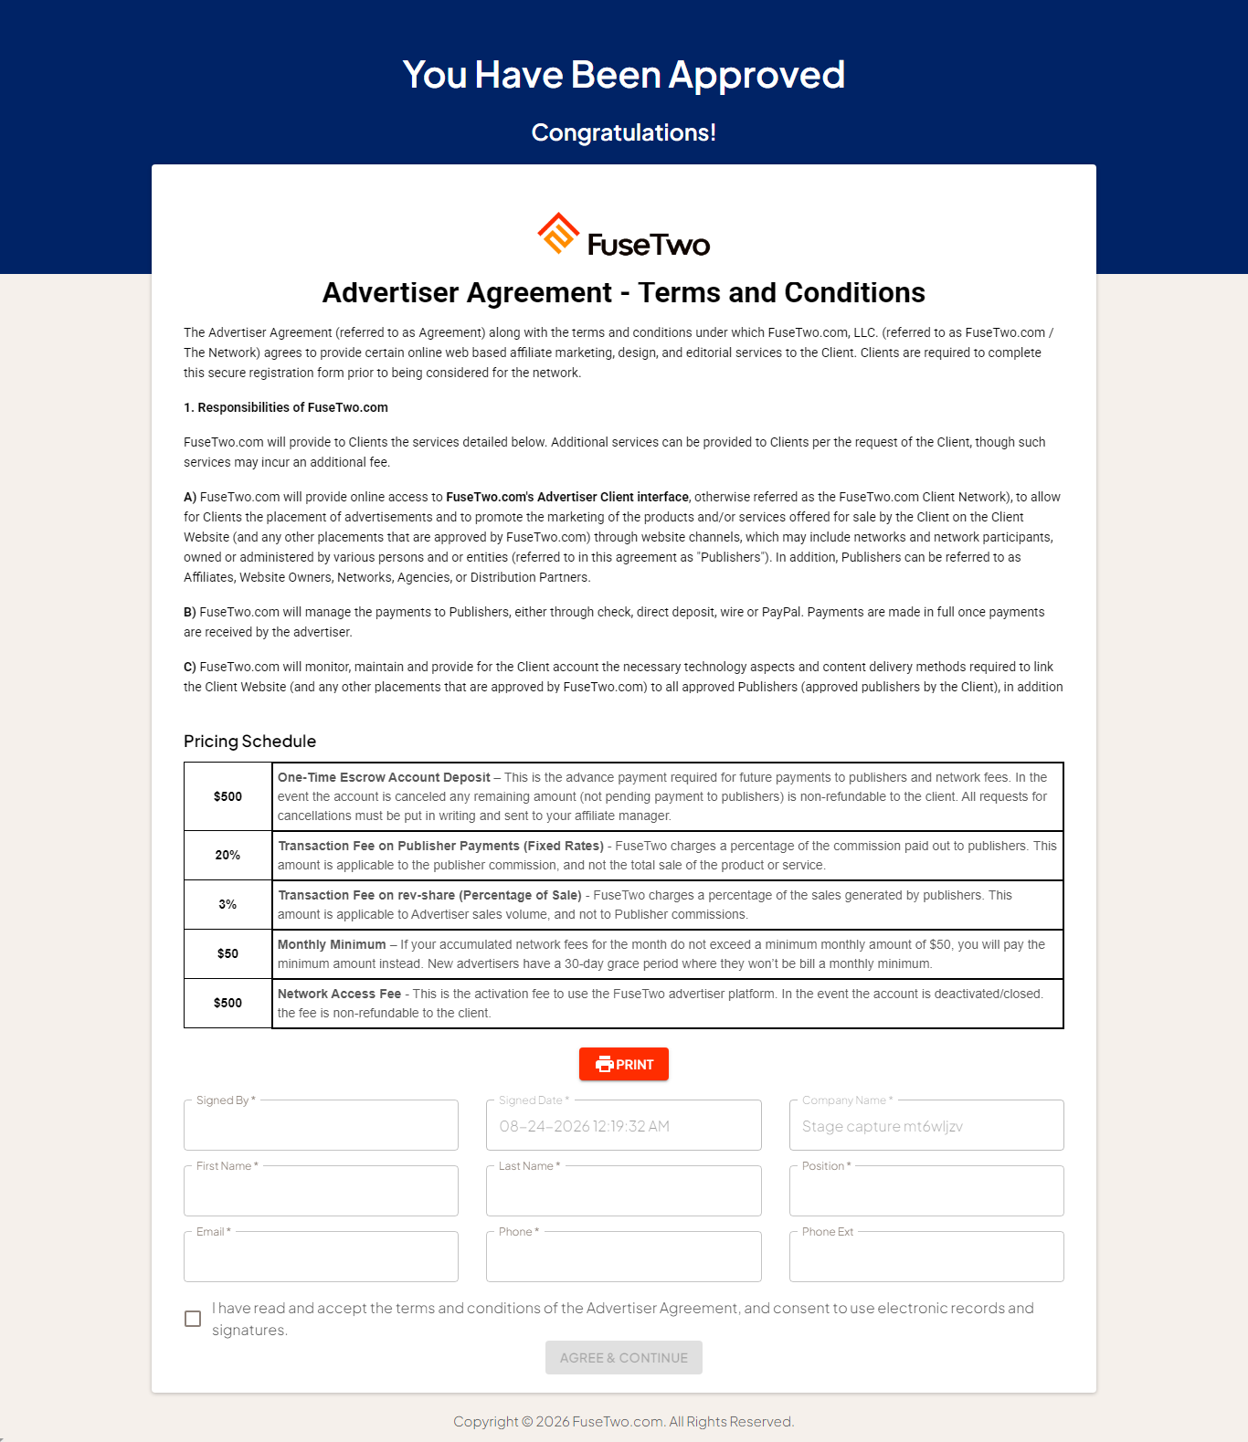

BUG-5: Email confirmation page shows success for an invalid token
Severity: Low | Area: Advertiser e-mail confirmation | Environment: dev
Steps to reproduce
- Register a new advertiser but do not open the verification e-mail.
- Build the confirmation URL yourself: /emailconfirmation?userref=<base64(email)>.
- Open it.
Expected: An invalid/forged token is rejected (no success message).
Actual: The page shows 'Your email has been verified!' even for a forged token. Sign-in stays blocked (the account is not actually verified), so it is not an auth bypass — but the success message on an invalid token is misleading.
Evidence: Scripted probe; base64(email) is the entire token, with no signature or expiry.

BUG-6: 'Required field*' helper appears after valid input
Severity: Low | Area: Advertiser signup — step 1 | Environment: dev (#686)
Steps to reproduce
- Open /signup.
- Type a valid value into a field (e.g. First Name).
- Observe the helper text.
Expected: No 'Required field*' helper is shown for a field with valid input.
Actual: The 'Required field*' helper appears after a valid value is entered and does not hide.
Evidence: Automated: e2e/Onboarding/testSignup.spec.ts (#686).

